ANNUAL REPORT 2018

GUYANA SCHOOL OF AGRICULTURE

Executive summary
The Guyana School of Agriculture performed creditably during the year 2018. The School continued to build on initiatives undertaken in 2017. In summary, these related to:
- Continued work on Curriculum Reform. Reformed curriculum was introduced in the 2018/2019 academic year for the one year Certificate programmes (Forestry and Agro-Processing) and the first year of the two year programmes; Certificate and Diploma in Agriculture and Diploma in Animal Health and Veterinary Public Health. Courses for the second year of these programmes are currently being reviewed by the Curriculum Review Committee.

- Ongoing pursuit of accreditation with the National Accreditation Council, and registration with the Council for Technical and Vocational Education and Training (CTVET).

- Continued work attachments for graduates. 86 graduates were placed on a one month attachment during August 2018.

- Strengthening of linkages with local institutions: Preparation of draft MOUs with sister agency, the National Agricultural Research and Extension Institute, and the Kuru Kuru Cooperative College.

- Completion of capital projects amounting to G$11M. These included the construction of a 4,200 square feet shade house which will serve as a useful model to provide training in protected agriculture, procurement of a pasteurizer, chiller, oven and refractometer for the Agro-Processing Unit, meat saw and plucking machine for the Livestock Farm and textbooks for the Library.

- Providing specialized training in Agro-Processing for 50 youths from the ten Administrative regions of Guyana.

Other significant achievements made during 2018 include:
- Graduating ninety seven (97) students at the School’s 54th Graduation Exercise.

- Admission of one hundred and twenty six students for the 2018/2019 academic year.

- Providing career guidance for several hundred visiting students.

MISSION

“To promote and support the development of sustainable Agriculture and Forestry through technological advancement and the theoretical and practical training of individuals pursuing careers in Agriculture and Forestry.”

VISION

The vision is that in another approximately ten years (2010-2020), the institution becomes one of the foremost regional training institutions whose faculty will be in the forefront of repositioning agriculture and forestry locally, in the Caribbean and further afield through technical, managerial and entrepreneurial competencies.

OBJECTIVES

To offer theoretical and practical training in Agriculture.
To develop, manage and operate farms and undertakings of an agricultural nature, i.e. to operate commercial farms and undertakings in accordance with good farming practice.

ADMINISTRATION

During the period under review, the Guyana School of Agriculture was governed by a Board which comprised of the following persons:

Board of Governors
Chairman | Dr. Thomas Richmond
Vice Chairman | Dr. R.S. Surujbally, A.A
Member | Dr. Pat Ann Francis
Member | Mr. Nizam Hassan
Member | Mr. George Jervis
Member | Ms. Monique Ifill
Member | Mr. David Fernandes
Member | Mr. Denzil Roberts
Member | Ms. Trecia Garnath
Member | Mr. Quacy Bremner
Member | Dr. Jean David
Member | Mr. Brian Greenidge

Ms. Roxanne Hazel served as Secretary to the Board.

STAFF COMPLEMENT

91 employees comprised the staffing strength of the Guyana School of Agriculture in 2018; 81 at Mon Repos and 10 at Essequibo. Supervision continues to be provided by the respective Departmental Heads.

APPOINTMENTS

Five (5) appointments were made during 2018. These included Ms. Banowattie Lhakram, Confidential Secretary, Mr. Osbert Carmichael, Farm Supervisor, Mr. Eldon Vaughn, Driver, Mr. Kumar Ramroop, Accounts Clerk and Mr. Kenroy Johnson, Labourer.

In addition to these, one (1) scholarship awardee from the Public Service Ministry, who was placed at the Ministry of Agriculture, was seconded to the School. He is Mr. Madainey Humphrey.

RETIREMENT

There were no retirements during the reporting period.

RESIGNATION

There were two resignations during the reporting period. These were Ms. Bibi Amjad, Confidential Secretary and Mr. Rohit Geer, Driver.

PROMOTION

Ms. Stacia Nelson-McDonald, from Research Technician to Assistant Manager – FPU.

NON-RENEWAL OF CONTRACT
The contract of the Principal was not renewed, while that of Mr. Cornel Fraser, Livestock Farm Supervisor, was determined.
OUTREACH PROGRAMMES/PUBLIC RELATIONS
The institution took part in career/knowledge fairs sponsored by the Ministry of Education and the Ministry of Public Health. These fairs served as good outreach activities to students from Secondary Schools and also out of School youths, as the institution used the opportunity to advertise the programmes it offers.
Many educational institutions, ranging from nursery, primary and secondary schools, visited during the year from the various administrative regions to become familiar with the operations of the School and to obtain assistance with their CXC SBA assessments.

- SCHOOL TOURS
School Tours represent a robust method of attracting young people to selected areas of training. The School has always actively supported school tours to its operations. For the reporting period the following statistics give a succinct view:
- No. of Schools/Study Tours to GSA - 28
- Total number of students accommodated - 1959
- Number of parents - 428
- Number of teachers - 160
February was the most popular month for study tours. Nursery, Primary and Secondary schools visited during the year, with a greater number of Secondary schools doing so.
- CAREER FAIRS
TABLE 2:
# | ACTIVITY | AGENCY | DATE
1 | University of Guyana’s Annual Career Fair/Open Day | University of Guyana | February 16, 2018
2 | President’s College Annual Career and Open Day | President’s College | February 22, 2018
3 | Regional Education Department, Region 4, STEAM Fair | Education Department of the Regional Democratic Council, Region 4 | March 5-6, 2018
4 | Lions Club of Durban Park Annual Career Fair | Lions Club of  Durban Park | April 27, 2018
5 | Uncapped Agro-Processing Exhibition | Guyana Manufacturers & Services Association | April 29, 2018
6 | Harmony Village | Ministry of Social Cohesion | April 12, 2018
7 | Essequibo Chamber of Commerce Annual Exhibition | Essequibo Chamber of Commerce | April 20-21, 2018
8 | Leonora Technical and Vocational Training Centre’s Career Fair and Trade Day | Leonora Technical and Vocational Training Centre | May 23, 2018
9 | Ministry of Public Health’s ‘Health Expo 2018’ | Ministry of Public Health | May 30 – June 2, 2018
10 | Career Guidance Fair | Department of Education, Region 3 | September 21, 2018

STAFF TRAINING AND DEVELOPMENT
Staff members attended short courses, workshops, seminars at which they received training and development in a number of areas. Staff members who benefitted are shown in table 3.
Table 3: Shows the names of the staff members and the activity they participated in.
# | NAME | ACTIVITY | AGENCY | DATE
1 | Ms. Patrina Haynes | Workshop: Issues related to the processing of coconut water. | Government Analyst Food and Drug Department | March 12 – 16, 2018
2 | Mr. Oscar Glasgow | CANQATE Annual General Meeting | Guyana Chapter of the Caribbean Area Network for Quality Assurance in Tertiary Education | March 28, 2018
3 | Dr. Dindyal Permaul | Visit to Barbados:  Establishment of a Food and Nutrition Security Institute at the University of Guyana | University of Guyana | April 26 -29, 2018
4 | Ms. Natashia Ramdhani | Training for Persons with Disabilities (PWD) | Council for TVET | April 19, 2018
5 | Mr. Osbert Nurse | Workshop: ‘Strengthening technical capacities to mainstream and monitor Rio Convention implementation through policy coordination’. | Department of the Environment, Ministry of the Presidency | April 27, 2018
6 | Mr. Seeraj Samsundar | Technical forum: ‘Bio-Beds in Agriculture: A Good Practice for Health and Environmental Protection’ | IICA | May 3, 2018
7 | Dr. Randy Domer | Technical forum: ‘Importance of Assessing the Impact of Disaster on the Livestock Sector and Presentation of a course on Good Emergency Response Practice’ | IICA | May 22, 2018
8 | Dr. Dexter Allen | Foot and Mouth Disease Simulation Exercise in Mabaruma, Barima-Waini, Region 1. | GLDA,  PAHO/WHO | May 11-13, 2018
10 | Mr. Ulie Timmerman | Workshop: REDD+ Stakeholder Communication Consultation | Ministry of Natural Resources | May 16, 2018
11 | Mr. Oscar Glasgow Mr. Ulie Timmerman Ms. Shemika Pereira | Social Cohesion Day | Ministry of the Presidency, Department of Social Cohesion | May 10, 2018
12 | Dr. Dindyal Permaul | Workshop: Developing a unified Theory of Change’. |  | May 22 – 24, 2018
13 | Mr. Osbert Nurse | National Consultation on Family Farming | IICA | June 21, 2018
14 | Ms. Tenesha Hale | Records Management Training | Ministry of Agriculture | July 24 - 25, 2018
15 | Ms. Shemika Pereira | Training Course: ‘Building Capacities of Amazon Cooperation Treaty Organization (ACTO)’ | Forestry Training Centre Inc.
16 | Mr. Corcell Nelson Mr. Denroy Sam | Basic and Intermediate Levels of the Pest Control Operations Training Programme | Pesticide and Toxic Chemicals Control Board | October 23, 2018
17 | Mr. Osbert Nurse | Training programme in China on ‘Green House Vegetable Cultivation Techniques for Developing Countries’ | Department of the Public Service, Ministry of the Presidency | October 10, 2018 to November 3, 2018.
18 | Dr. Randy Domer  Mr. Lokesh Lall | 2018 Overseas Training Course on ‘Aquaculture Technology for Guyana’. | Fisheries Department of the Ministry of Agriculture | December 11, 2018

FINANCE AND CAPITAL WORKS

FINANCE

REVENUE

The school recorded a total recurrent revenue of $ 451,379,000 during the period January to
December 2018, of this amount $ 321,000,000 represented the recurrent subvention from
Central Government. While the remaining sum of $ 130,379,000, represented funds generated
from the School operations. The breakdown of the remaining $ 130,379,000 which was
recorded as revenue from operations is as follows:

School Fees and Fines |  |  |  |  | 42,543,000
Rental of Buildings |  |  |  |  | 292,000
Miscellaneous Receipts |  |  |  |  | 9,242,000
5% Arrears -Received from Gov't |  |  |  |  | 11,540,000
Sales -Livestock Farm |  |  |  |  | 46,866,000
Sales -Crop Farm |  |  |  |  | 3,243,000
Sales -Agro Processing Unit |  |  |  |  | 6,817,000
Security Service |  |  |  |  | 9,360,000
EXPENDITURE

Total recurrent expenditure during the period was $ 400,010,000.

Employment costs for the period was recorded as $ 223,472,000.
This figures also included the payment of $ 11,540,000 increase in wages and
salaries arrears for 2018.

Wages and Salaries amounted to $ 177,808,000 while overhead expenditure amounted
$ 45,664,000.
Other charges for the period were recorded as $ 176,538,000. The breakdown is as
follows:

L / Stock – Expenses |  |  |  |  | 32,467,000
Expenses – Agro Processing Unit |  |  |  |  | 7,493,000
Expenses – Crop Farm |  |  |  |  | 2,374,000
Medical Supplies |  |  |  |  | 48,000
Laboratory & Academic Supplies |  |  |  |  | 72,000
Office Material & Supplies |  |  |  |  | 2,575,000
Newspapers & Periodicals |  |  |  |  | 481,000
Fuel & Lubricants |  |  |  |  | 4,099,000
Maintenance of Building  Maintenance of Infrastructure |  |  |  |  | 6,015,000  2,216,000
Transportation, Travel & Postage |  |  |  |  | 5,927,000
Utility Charges |  |  |  |  | 11,945,000
Other Goods & Services Purchased |  |  |  |  | 51,534,000
Other Operating Expenses |  |  |  |  | 29,781,000
Subsides & Contributions |  |  |  |  | 11,179,000
Old age Pension |  |  |  |  | 8,292,000

CAPITAL WORKS

Capital Expenditure was $ 11,000,000 at the Mon Repos Campus.

A number of activities were carried out under the Capital Works Programme. These included:

Mon Repos

- Construction of Shade House - $ 2,000,000
- Purchase of Oven - $ 2,383,000
- Purchase of Refractometer (1-50º brix) - $ 300,000
- Purchase of Refractometer (50-90º brix) - $ 300,000
- Purchase of Library Collections (Books) - $ 2,000,000
- Purchase of Pasteurizer - $ 1,713,000
- Purchase of Plucking Machine - $ 400,000
- Purchase of Chiller - $ 665,000
- Purchase of Meat Saw - $ 200,000
- Purchase of Freezer - $ 1,039,000
TOTAL $ 11,000,000

MAINTENANCE

General maintenance works were undertaken throughout the year in all areas of the School. Some of these included:

- Construction of twenty-five (25) new stools for the Biology Laboratory.
- Painting of the Computer Laboratory.
- The floor of the Auditorium was painted.
- The roof of the wash bay of Female Dormitory 20 was replaced.
- Maintenance of lighting and plumbing systems in the dormitories.
- Repairs to cupboards in all dormitories.
- Repairs to the ceiling and doors of the male and female washrooms in the Administrative building.
- Painting of male and female washrooms in the Administrative building.
- Painting of the Washroom in the Cafeteria.
- Installation of the Kimberley Clark soap dispenser, toilet paper dispenser and hand towel dispenser in the Administration Building, Cafeteria and Workers Lounging Area.
- Painting of entire Cafeteria – General Stores Sub Unit.
- Replacement of mesh around exterior and interior windows of stores.
- Rehabilitation of the General Stores was undertaken.
- Painting of the Poultry Processing Unit on the Livestock Farm.
- Painting of Dairy fences.
- Servicing of roofs of pens on the Livestock Farm.
- Construction of barricades to section of poultry pens section off.
- Replacement of BRC fabric in the Dry Sow Section.
- Construction of two concrete trestles for the drip irrigation systems on Crop Farm 2.
- Treatment of buildings for termites.
- Rehabilitation of the aged MF365 Tractor was undertaken.
- Works on the rehabilitation of the internal roadway between the L-Shaped Dorm and Crop Farm 2 was accomplished.
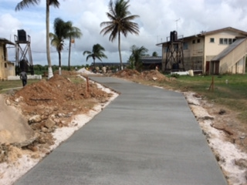
Rehabilitated Roadway

- Guyana School of Agriculture/National Drainage and Irrigation Authority

The National Drainage and Irrigation Authority made available an excavator to the School to facilitate rehabilitation of the drainage and irrigation channels leading to and on the Crop Farm. This excavator commenced work at the beginning of the December 2018 and was resident at the Campus.

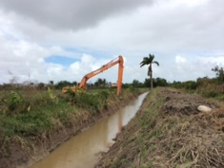

DONATION
Transfer of assets from PROPEL (Promotion of Regional Opportunities for Produce through Enterprises and Linkages) to GSA

The PROPEL project in Guyana which was funded by the Government of Canada will be coming to a close on December 13, 2018. As part of the process, PROPEL will be transferring assets to key partners.
The Guyana School of Agriculture was proposed and was the recipient of a substantial portion of the project’s furniture and other ancillary items.

ACADEMIC
ASSOCIATION AND COLLABORATION WITH OTHER TERITARY INSTITUTIONS
- Guyana School of Agriculture/Kuru Kuru Co-operative College

A meeting was held on Tuesday, December 10, 2018 between the members of the Board of Directors of the Kuru Kuru Co-operative College (KKCC) and the School’s Management to identify areas where the two institutions could collaborate. The KKCC team was led by the Chairman of its Board of Directors, Mr. Ed Caesar, while the GSA team comprised of the Chairman of the Board of Directors, Dr. Thomas B. Richmond, the Director of Administration, Dr. Dexter Allen, the Director of Academic Affairs, Mr. Oscar Glasgow and the Assistant Manager, Agro-Processing Unit, Ms. Stacia Nelson-McDonald. Possible areas of collaboration identified included:

- GSA providing technical assistance to the college in relation to the preparation and start-up of KKCC’s Fruit and Vegetable Processing Plant at Manchester Village, East Coast Berbice.

- GSA providing training to KKCC Agriculture Staff on post-harvest handling and storage of farm produce.

- GSA providing theoretical and practical training for KKCC’s students in the areas of animal and crop husbandry.

- KKCC providing academic support to GSA staff in the areas of Co-operative Management, Human Resource Management, Photography and Videography, Leadership and Project Management.
- KKCC providing training to GSA for the management of the School’s Thrift Society.

- KKCC and GSA collaborating to provide training for members of communities within the East Berbice, Corentyne in the areas of crop management, fruit and vegetable cultivation and post-harvest handling of fruit and vegetables.

The areas of collaboration are to be articulated in a Draft Memorandum. The second meeting is scheduled for mid January, 2019.

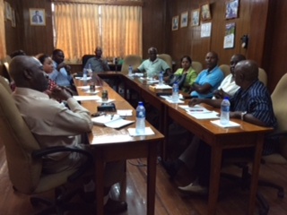
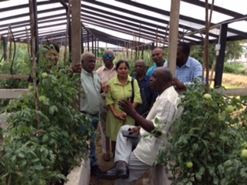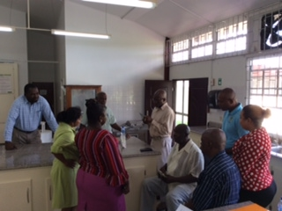
2. Curriculum Review
The curriculum review process commenced in November 2016 and continued in 2018.
Implementation of the review curriculum for all one year certificate programmes and
the first year of the two year Certificate and Diploma programmes commenced in
the 2018/2019 academic year (September 2018). Works on courses for the second
year of the two year programmes by the Curriculum Review Committee is ongoing.
These courses will be implemented in the 2019/2020 academic year.

3. Attachments-Placement of Students

A total of 86 students were placed at various private and public sector agencies for a period of one month in August 2018, so that they could gain exposure to actual work settings. Fifteen agencies supported the School in this endeavour.
# | INSTITUTIONS | NO. STUDENTS PLACED
1 | Guyana Rice Development Board (GRDB) | 15
2 | Institute of Private Enterprise Development (IPED) | 5
3 | Ministry of Agriculture, Hydromet Department | 4
4 | Agro-IN | 3
5 | NAREI | 3
6 | Regional Democratic Council #10 | 5
7 | Banks DIH | 2
8 | Sterling Products Limited | 2
9 | Hope Coconut Limited | 3
10 | Ministry of Agriculture, Fisheries Department | 2
11 | Guyana Forestry Commission | 28
12 | Regional Democratic Council #6 | 2
13 | Caribbean Chemicals | 2
14 | Roopan Ramotar | 2
15 | Ministry of Public Health | 8
 | TOTAL | 86

4. Training Programme

The School, through its Agro-Processing Facility conducted three training programmes
in Agro-Processing during the reporting period.

These programmes brought in significant revenue for the School $ 7,519,850. Table
below provides details on these programmes:

# | Title of Programme | Date | No. of Participants | Sponsor | Revenue Generated
1 | Food Safety  Plant Sanitation  Production of Condiments  Preservation of Meats | August 6 – 9, 2018 | 25 | Office of Youth Empowerment, Ministry of the Presidency | $ 3,350,000
2 | Food Safety  Plant Sanitation  Production of Condiments | August 27 –  30, 2018 | 25 | Office of Youth Empowerment, Ministry of the Presidency | $ 3,300,000
3 | Value Addition in Coconuts | August 13 – 17, 2018 | 30 | National Cocunut Stakeholder Platform and the ITC. | 819,880
 |  |  |  |  | $ 7,519,850

Training in Agro-Processing sponsored by the Office of Youth Empowerment

5. HOSTING OF ACTIVITIES

- NAREI’s Research Conference

The School’s hosted the National Agricultural Research and Extension Institute’s Research Conference during the period October 22 – 23, 2018. This Conference was held in the School’s Plant Science Building under the theme ‘Agriculture: Guyana’s pathway to a Green Economy’. The feature address was delivered by the Hon. Noel Holder, Minister of Agriculture. Dr. Oudho Homenauth, CEO of NAREI, delivered the opening address. Keynote presentations were also made by Dr. Patrick Chesney, Chairman of the Board of Directors of NAREI, Mr. Reuben Robertson, Country Representative, Food and Agriculture Organisation and Mr. Wilmot Garnett, Country Representative, Inter-American Institute for Co-operation on Agriculture (IICA), during the opening session.

- 9th Biannual Beekeeping Congress

The Guyana Apiculture Society accepted a request from the Association of Caribbean Beekeeping Organization (ACBO) to host the 9th Biannual Beekeeping Congress in Guyana. This event was held at the Guyana School of Agriculture’s Plant Science Building from November 19 – 23, 2018.

The Hon. Noel Holder, Minister of Agriculture, delivered the feature address and also declared the Congress open. The opening session of the Congress was chaired by Mr. Neil Grant, Chairman of the Guyana Apiculture Society.

Staff and students of the School participated in this event. Two groups of students participated in the Mangrove and Rainforest Beekeeping field tours on the third day of the Congress.

A presentation of reading material on Apiculture was made to the Chief Executive Officer of the School by Mr. Gladstone Solomon of ACTO on the second morning of the Congress.

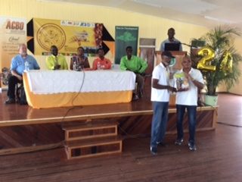

6. OTHER ACTIVITIES

- Observance of International Day of the Forests

The Ministry of Natural Resources in collaboration with the Guyana Forestry Commission hosted an event on March 21, 2018 in observance of International Day of the Forest. Ten students and one lecturer represented the institution at this event which was held at the Umana Yana, Georgetown.

- Green State Development Strategy

The Principal, who represented the School on the Green State Development Strategy Multi Stakeholder Group #1 – Green and Inclusive Structural Transformation, attended a number of meetings during the reporting period. Contributions were made towards the elaboration of the GSDS Document. These related to:
- Positive effects of conservancies
- Legal Factors affecting Guyana’s Agriculture
- Commodity Exchange for Rice
- Stock Exchange
- Developing of land grant university/colleges with emphasis on agricultural research and extension
- Expansion of land settlement schemes
- Efficient use of fresh water resources

- Meeting with new CUSO International Volunteer

The CEO, Principal, Director of Administrative and the Director of Academic Affairs met with Ms. Rhonda Morrison, the new CUSO International Volunteer, who has been assigned to provide support to the National 4H Steering Committee. Ms. Morrison replaces Ms. Alexandra Abdelwahab whose term of office ended in February 2017. Discussions centred around the functioning and composition of the National 4H Steering Committee, support for current 4H clubs and start-up of new 4H clubs. Ms. Morrison also met with the President and Vice-President of the GSA 4H club.
7. ACADEMIC PROGRAMS
- Course Offerings
Courses offered in the various programmes during the period under review were as follows:
- Diploma in Agriculture - 35
- Diploma in Animal Health and
Veterinary Public Health - 39
- Certificate in Agriculture - 32
- Certificate in Forestry - 22
- Certificate in Agro-Processing - 20
The Institution continues to pride itself in its provision of enhanced practical training through the operation of the Crop and Livestock Farms and the Agro Processing Unit in which students are involved on a daily basis. Students spend two terms of farm practicals at the Livestock Farm. The Crop Farms are used as an outdoor laboratory where students carry out simple experiments. It is also used to demonstrate that crop farming can bring in good income. Some of the skills training that were delivered included the operation and care of the brush-cutter, cleaning and operating spray cans, compost making, operation of the tractor, preparation of seedling beds, use of seedling boxes, identification of plants by scientific names, the care and handling of tools and the installation and operation of the sprinkler irrigation system.
Similarly, the Livestock Farm provides the students with various skills related to care and management of poultry, cattle, swine, sheep and goats. Skills include common disease identification and treatment, ration formulation and feeding, stock handling and movement, slaughtering and butchering, breeding management, hygiene and sanitation, pasture establishment and management as well as record keeping and assessments.

Student Enrolment

A total of one hundred and twenty six (126) new students were enrolled at the two campuses for the 2018/2019 academic year; 95 at Mon Repos and 31 at Essequibo. Students came from all Administrative regions.

A total of seventy seven (77) students continued into their second year at both Campuses; 70 at Mon Repos and 7 at Essequibo.

The total number of students at both Campuses was 203. The new academic year commenced on September 3, 2018.

- Activities Per Programme
- Animal Health and Veterinary Public Health Programme

Field training activities included visits to various animal production enterprises. Some of these included the Georgetown Municipal Abattoir and Bounty Farm Ltd.’s Poultry Farms and Poultry Processing Plant, Pritipaul Singh Investments Ltd. Fish Processing Plant and the Guyana Livestock Development Authority’s Livestock Farm.

As part of their ambulatory cycle, students visited and participated in the daily veterinary activities at the Pets 2000 Clinic operated by Veterinarian, Dr. Nicholas Waldron. Students also made visits to other animal production facilities accompanied by veterinarians attached to the Animal Health Programme.

(ii) Diploma and Certificate in Agriculture
Students in the Diploma and Certificate in Agriculture programmes were involved in training on a daily basis. Several field trips were undertaken. These included trips to the Guyana Rice Development Board’s Rice Research Station

at Burma, Mahaicony and Fairfield Rice Inc. to observe field and grading exercises. Bounty Farm Limited, to observe commercial poultry practices, Guyana Marketing Corporation Packing Facility at Sophia to observe the preparation and packaging of produce for export. Visits were also made to Sterling Products Ltd. and Edward B. Beharry Limited to observe the various aspects of the production process and the Guyana Livestock Development Authority’s hatchery.
(iii) Certificate in Forestry
Students in the Certificate in Forestry programme were involved in some extended and very meaningful field trips. These included a three day visit to Yarrowkabra, Linden/Soesdyke Highway at the Forestry Commission’s Educational Training facility, to familiarise themselves with the operations of the GFC, two weeks at Manaka on the Essequibo River at the Forestry Training Centre’s Inc., where they were trained in reduced impact logging. Students were exposed to Forest Management and Planning, Surveying, Skid trail and Alignment, Block Demarcation, Tree identification and cutting, use the chain saw and the Global Positioning System (GPS).

(iv) Certificate in Agro-Processing

Students in the Agro Processing programme were involved in training on a daily basis. Several field visits were undertaken. These included visits to supermarkets, the Food and Drug Department, Banks DIH’s, Dairy Plant, the National Milling Company, the Demerara Distillers Ltd. and Sterling Products Ltd.

(v) Remedial Programme

Remedial classes in English and Mathematics continued for first year students who did not meet the required level of proficiency on entry into the institution.

- STUDENT ASSESSMENT
Students were assessed in course work, mid-term and end of term examinations which were held throughout the academic year and culminated with the School’s 54th Graduation exercise which was held on Friday, August 3, 2018. It was chaired by the Dr. Thomas Richmond, Chairman of the GSA Board of Directors. The feature address was delivered by the Honourable Minister of Agriculture, Hon. Noel Holder. The Charge to the graduands was delivered by Professor Michael Scott, Deputy Vice Chancellor, Academic Engagement, University of Guyana and Ms. Delma Nedd, Permanent Secretary, Ministry of Agriculture distributed the Diplomas and Certificates. Dr. Dexter Allen, Chief Executive Officer (ag) delivered the Chief Executive Officer’s Report in the absence of the CEO who was on Annual Vacation Leave.
The overall assessment showed that:
THE DIPLOMA IN AGRICULTURE (Mon Repos) produced 37 graduating students:

Distinction - 1
Higher Credit - 11
Lower Credit - 1
Pass - 24

THE DIPLOMA IN AGRICULTURE (Essequibo) produced 5 graduating students:

Distinction - 0
Higher Credit - 2
Lower Credit - 0
Pass - 3

THE DIPLOMA IN ANIMAL HEALTH AND VETERINARY PUBLIC HEALTH produced 6 graduating students:

Distinction - 0
Higher Credit - 0
Lower Credit - 0
Pass - 6

THE CERTIFICATE IN AGRICULTURE produced 13 graduating students:

Distinction - 0
Higher Credit - 1
Lower Credit - 0
Pass - 12

THE CERTIFICATE IN FORESTRY (Mon Repos) produced 19 graduating students:

Distinction - 5
Higher Credit - 9
Lower Credit - 1
Pass - 4

THE CERTIFICATE IN FORESTRY (Essequibo) produced 12 graduating students:

Distinction - 6
Higher Credit - 4
Lower Credit - 0
Pass - 2

THE CERTIFICATE IN AGRO-PROCESSING produced 5 graduating students:

Distinction - 1
Higher Credit - 2
Lower Credit - 0
Pass - 2

The total number of graduating students was 97.

THE AWARD OF THE GOLD MEDAL

To be awarded the Gold Medal, one has to perform outstandingly in the areas of academic work, practical work and campus community service. Unfortunately, no one met the criteria this year to be awarded the Gold Medal.

THE CHIEF EXECUTIVE OFFICER’S PRIZE

This award is given to the best graduating student in any of the two year programmes offered by the institution at its Mon Repos Campus. This prize was presented to Student Alleema Shahabudeen with 81.15 %.

THE CHAIRMAN’S PRIZE

This award is given to the best graduating student in any of the two programmes offered by the institution at its Essequibo Campus. This prize was presented to Student Vernon Dash with 85.81 %.

THE PRINCIPAL’S PRIZE

This award is given to the best graduating student in the Diploma in Agriculture programme offered by the institution at its Essequibo Campus. This prize was presented to Student Raul Persaud with 77.39%.

- FACULTY AND STAFF
Continuing lecturers were Dr. Dexter Allen, Mr. Oscar Glasgow, Ms. Grace Parris, Ms. Shemika Pereira, Ms. Mechelle Lutchman, Mr. Seeraj Samsundar, Mr. Ulie Timmerman, Mr. Osbert Nurse, Dr. Randy Domer and Ms. Nikita Singh. The services of thirty two (32) part time lecturers were utilized during the period.

10. COUNSELLING
Individual counselling sessions were conducted by the Academic Counsellor to deal with issues relating to students’ academic performance, coping with the volume of work, classroom participation, adjusting to life on campus and other personal problems. Preparation and monitoring of class registers were also done by the Academic Counsellor who also participated in disciplinary matters involving students.

11. LIBRARY

The Library benefitted significantly from a donation of 15 agricultural related texts from WUSC Caribbean (PROPEL) in collaboration with Scotia Bank, (Guyana) during May 2018. The texts received are listed in the table below.

# | AUTHOR/EDITOR | TITLE | PUBLISHER | DATE OF PUBLICATION | No. of Copies
1 | Pond, W.G | Swine Production and Nutrition | AVI Publishing Co. | 1984 | 1
2 | Pond, W.G | Basic Animal Nutrition and Feeding. 5th ed. | John Wiley and Sons | 2005 | 1
3 | Culpin, Claude | Farm Machinery | Read Books Limited | 2013 | 1
4 | Triplehorn, Charles A. | Borror and Delong’ Introduction to the Study of Insects. 7th ed. | Brooks/Cole, Cengage Learning | 2005 | 1
5 | Agrios, George | Plant Pathology | Elsevier Inc | 2005 | 1
6 | Hester, R. E. (ed.) | Environmental Impacts of Modern Agriculture | Royal Society of Chemistry | 2012 | 1
7 | Clewer, Alan G. | Practical Statistics and Experimental designs for plant and Crop Science | John Wiley and Sons | 2001 | 1
8 | Paull, Robert E. | Tropical Fruits Volume 1. 2nd ed. | CAB International | 2011 | 1
9 | Paull, Robert E. | Tropical Fruits, Volume 2. 2nd ed. | CAB International | 2012 | 1
10 | Bell, Donald B. | Commercial Chicken, Meat and Egg Production. 5th ed. | Springer Science & Business Media | 2001 | 2
11 | Martin, John H. | Principles of Field Crop Production. 4th ed. | Pearson Education Inc. | 2006 | 1
12 | Ownley, Bonnie H. | Plant Pathology: Concepts and Laboratory Exercises. 3rd ed. | Taylor & Francis Group | 2017 | 1
13 | Gillespie, James R. | Modern Livestock and Poultry Production. 8th ed. | Delmar, Cengage Production | 2010 | 1
14 | Gullan, P.J. | The Insects: An Outline of Entomology. 5th ed. | John Wiley and Sons | 2014 | 1

Purchase of books, periodicals and audiovisual materials, were made from monies appropriated for this purpose in the School’s budget.
Staff engaged in routine activities including book repairs, dusting, shelf reading, newspaper clipping/filing, cataloguing and classification. The Library also assisted in preparations for the School’s outreach programmes.

12. EXTRA CURRICULAR ACTIVITIES
Students and Staff were involved in several extra-curricular activities during the reporting period. These activities included:
- GSA’S CULTURE DAY EVENT
Annual Culture Day activity was held on Thursday, March 8, 2018 in the School’s Plant Science Building from 12:00h. This activity allowed students to showcase the culture of the six peoples of Guyana. The displays and performances of the groups depicting the various cultures were of a very high quality. The East Indian culture, which was portrayed by the Diploma in Animal Health and Veterinary Public Health Years 1 and 2 and the Certificate in Agro-Processing was adjudged the winner. The Africans, portrayed by the Certificate in Agriculture Years 1 and 2 students, took the second position, while the Europeans, portrayed by the Certificate in Forestry students, took the third position.

The judges were Ms. Yvonne Abrams, Mrs. Flora Cumberbatch and Ms. Mayfield Benjamin.

- STUDENT COUNCIL ELECTIONS
Elections for office bearers of the Student Council at both campuses were held on October 24, 2018 and the results were published on October 26, 2018. The persons elected to serve on the executive body of the Council for the academic year 2018 - 2019 are as follows:
MON REPOS CAMPUS

PRESIDENT: Anfernee Rutherford
VICE PRESIDENT: Rashleigh Charles
TREASURER: Andy Bansgopaul
SECRETARY: Damalie Cromwell
ASSISTANT SECRETARY: Christina Cheeks
SPORTS REPRESENTATIVE: Demelza Nicholas
FOOD REPRESENTATIVE: Quincy Roberts

ESSEQUIBO CAMPUS

PRESIDENT: Raveena Benn Seecharran
VICE PRESIDENT: Khaimwattie Hamchandra
TREASURER: Aliando Webb
SECRETARY: Shukdeo Naithram
ASSISTANT SECRETARY: Trimane Austin
SPORTS REPRESENTATIVE: Lance Roberts

Meeting with Student Council
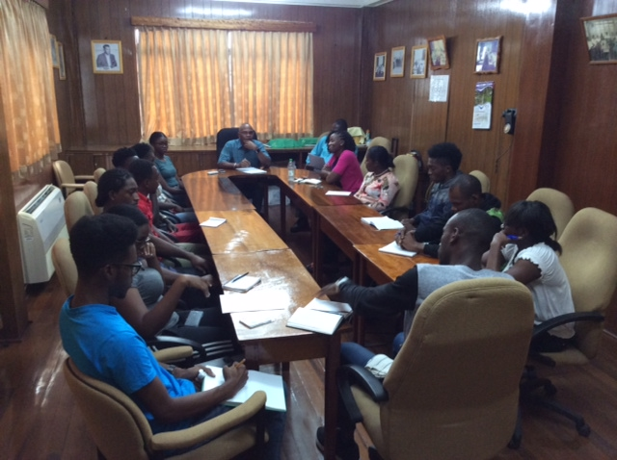

- AGRICULTURE MONTH ACTIVITIES

The School participated in a number of activities in observance of Agriculture Month 2018. These included:
Table 7.
 | Activity | Location | Date
1 | Interfaith Service | Ministry of Agriculture Head Office | September 30, 2018
2 | Guyana Rice Development Board’s Open Day | Burma Rice Research Station, Mahaicony | October 3, 2018
3 | IICA’s Open Day | Head Office, 64 Brickdam, Georgetown | October 4, 2018
4 | National Tree Day and Commissioning of Tumeric Processing Factory | Ebini, Region #10  Hosororo, Region # 1 | October 5, 2018
5 | Fisheries Department  Tour of Tuna Plant | Tour of Pritipaul Singh’s Tuna Plant at Providence | October 12, 2018
6 | World Food Day | Mainstay/Wayaka, Region # 2 | October 16, 2018
7 | Guyana’s Green Exposition |  | October 18, 2018
8 | Open Day Activities of agricultural agencies along Agriculture Road | GSA, NAREI, GLDA, Satydeow Sawh Aquaculture Station | October 19, 2018
9 | Fitness Walk | Bank of Guyana to MOA’s Head Office | October 20, 2018
10 | NAREI Research Conference | GSA’s Plant Science Building | October 22- 23, 2018
11 | Cook-off competition | MOA compound | October 24, 2018
12 | Long Service Awards Ceremony | National Cultural Centre | October 25, 2018
13 | Essequibo Night | Anna Regina Community Centre Ground | October 26-27, 2018
14 | Inter-Agency Sports Championship | National Park | November 2, 2018
15 | GMC’s Market Day | Durban Park | November 3, 2018

- GSA OPEN DAY

The School’s Open Day was held on October 19, 2018. This activity held under the theme ‘Promotion of Youth in Agriculture’ commenced at 10:00h in the School’s Plant Science Building. This activity targeted 4th and 5th forms from secondary schools and its aims were to stimulate the interest of students in agriculture and to showcase the work done by the various departments of the School. The feature presentation was done by Mr. Arnold DeMendonca, Sustainable Rural Development Specialist at the Inter-American Institute for Co-operation on Agriculture, Guyana Office. Also delivering remarks at this activity were Dr. Steve Surujbally A.A, Deputy Chairman of the School’s Board of Governors and Mr. Oscar Glasgow, Director of Academic Affairs. Ms. Trishana Panchu, Head Perfect of the St. Joseph’s High School, delivered the vote of thanks. This session was chaired by the Chief Executive Officer.

Students and teachers visited the booths hosted by the various departments to showcase the work they do and also the Agro-processing facility and Crop Farms. This activity was well attended.

The staff of the Cafeteria did an excellent job in preparing lunch for the students and teachers especially in light of the fact that many more students attended the activity than were catered for.

- ANNUAL CROSS COUNTRY RACE
The Annual Cross Country race for students was held on June 15, 2018. Mr. Shemar Butts was the winner with a time of 20.49 minute. On the distaff side, Ms. Candace Caesar was the winner with a time of 27.25 minutes.
- ANNUAL INTERHOUSE ATHLETICS CHAMPIONSHIP
The School’s Annual Athletics Championship culminated with the track events which were held on November 9, 2018. Minica House was declared the champion house with 635 points, followed by Vigna on 621 points and Cajanus in the cellar position with 575 points.

Mr. Leroy Dublin and Ms. Demelza Nicholas were adjudged the fastest male and female athletes on campus respectively.

Minica House Vigna House Cajanus House
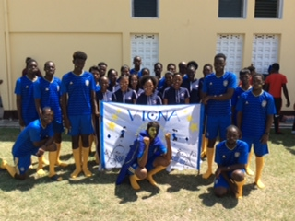

- CHRISTMAS LUNCHEON

The Annual Christmas Luncheon for the students at the Mon Repos and Essequibo Campuses were held on November 30, 2018 and December 7, 2018 respectively. The installation of the executive members of the Students Council to serve during the 2018/2019 academic year and the presentation of prizes won at the Annual Athletics Championship 2018 were done during this activity. The feature address at the Mon Repos and Essequibo Campuses were delivered by the Chairman of the Board of Directors, Dr. Thomas B. Richmond, and the Board Member, Dr. Pat Ann Francis, respectively.
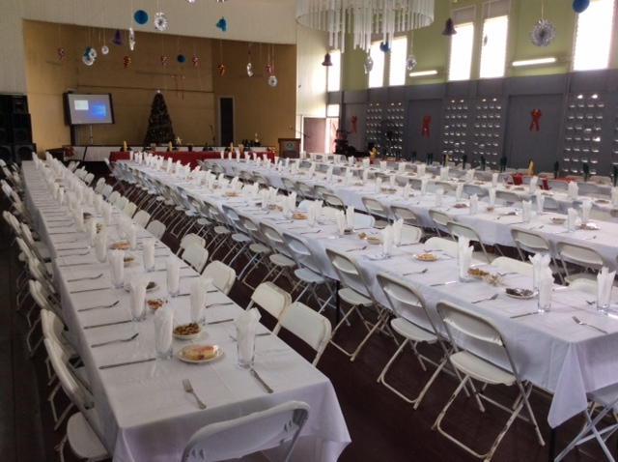

- ANNUAL CHRISTMAS PARTY FOR STAFF

The School did not hold a Christmas Party at the end of the year as is customary. Staff members were of the view that the issuance of a gift voucher would be more tangible. Management acquiesced to this request and used the money it had budgeted for the Christmas Party to issue each staff member with a gift voucher to the value of $ 10, 000. These vouchers were issued on December 14, 2018.

PRODUCTIVE SECTORS
1. LIVESTOCK FARM
REVENUE
Income generated by the Livestock Farm during 2018 was $ 46,866,000. A breakdown by section is shown in table below.
The sale of broilers represented the largest amount of income generated by the LSF garnering 58% of the total revenue generated by the farm, eggs and milk representing 14.7% and 14.4 % respectively.
TABLE 1: MONTHLY REVENUE BY SECTION (2018) – LIVESTOCK FARM
Month | Poultry |  | Swine |  | Dairy |  |  | Small Ruminants | Other | Sub Total
 | Broiler | Eggs | Pigs | Pork | Milk | Beef | Cattle
January | 2,589,810 | 740,120 | 716,400 | 16,000 | 515,300 | 0 | 0 | 143,250 | 14,000 | 4,734,880
February | 2,049,590 | 744,250 | 75,200 | 0 | 560,540 | 0 | 0 | 0 | 1,000 | 3,430,580
March | 1,982,099 | 889,040 | 48,600 | 56,000 | 697,550 | 0 | 0 | 0 | 8,000 | 3,681,289
April | 2,262,195 | 692,154 | 64,000 | 44,600 | 646,100 | 0 | 0 | 0 | 6,000 | 3,715,049
May | 2,319,800 | 648,674 | 132,000 | 66,800 | 686,150 | 0 | 0 | 0 | 1,000 | 3,854,424
June | 2,483,475 | 521,620 | 400,400 | 0 | 537,700 | 0 | 75,000 | 0 | 1,000 | 4,019,195
July | 1,983,870 | 510,650 | 72,000 | 0 | 424,750 | 0 | 110,000 | 0 | 38,000 | 3,139,270
August | 1,949,575 | 493,800 | 681,000 | 175,200 | 569,835 | 92,400 | 30,000 | 0 | 1 | 3,991,811
September | 1,459,405 | 460,950 | 560,000 | 26,800 | 602,363 | 22,860 | 565,000 | 0 | 4,000 | 3,701,378
October | 2,743,549 | 368,500 | 410,000 | 142,000 | 536,690 | 0 | 0 | 0 | 27,000 | 4,227,739
November | 2,134,305 | 376,500 | 132,200 | 173,850 | 536,690 | 0 | 29,000 | 0 | 3,000 | 3,385,545
December | 3,104,370 | 501,940 | 74,900 | 547,640 | 469,760 | 216,400 | 0 | 0 | 70,000 | 4,984,840
TOTAL | 27,061,873 | 6,948,198 | 3,366,700 | 1,248,890 | 6,783,428 | 331,660 | 809,000 | 143,250 | 173,001 | 46,866,000

Dairy
Artificial Insemination
The calves born on the Livestock Farm in 2018 were products of frozen semen sourced from SEMEX in Canada by the Guyana Livestock Development Authority (GLDA). Twenty calves were born (6 males and 14 females).

Provision of breeding stock to livestock rearers.
The farm continued its traditional role of providing breeding stock to livestock rearers.
During the period 14 calves and one (1) yearling were sold for breeding purposes.

During the year six (6) culled cows and one (1) culled heifer were sold as a result of age or non-productivity. In addition, one (1) cow and two (2) steers were slaughtered.

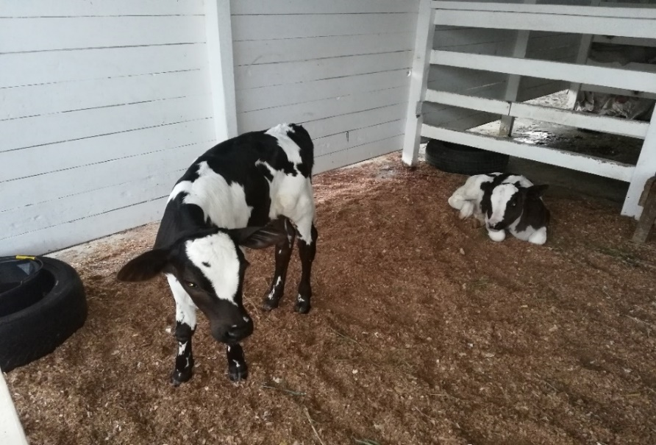
Milk Production
41,596.1 litres of milk were produced during 2018, a decrease of 827.1 litres when compared to 2017 production.
Monthly Milk Production

Figure 1: Chart showing monthly milk production figures 2018.

Figure 2. Showing comparison of yearly milk production.
LEGEND
Blue Bar | 2016
Red Bar | 2017
Green Bar | 2018

Table 2. Showing Monthly Milk Production Data for 2016, 2017 and 2018.
Month | 2016 | 2017 | 2018
January | 2551.4 | 2309 | 3123.15
February | 1956.1 | 3228.6 | 3460.73
March | 2354.7 | 4141.6 | 4342.4
April | 2588.8 | 4854.9 | 4336.2
May | 2620.3 | 5006.1 | 4041.5
June | 2503.7 | 4676.5 | 3339.7
July | 2485.8 | 4221.9 | 3002.6
August | 2525.1 | 3197.6 | 3575.4
September | 2604.3 | 2801 | 3526.1
October | 2831.8 | 3037.7 | 3010.6
November | 2588.8 | 2323.8 | 2833.9
December | 2919.5 | 2624.5 | 3003.8
TOTAL | 30530.1 | 42423.2 | 41596.1

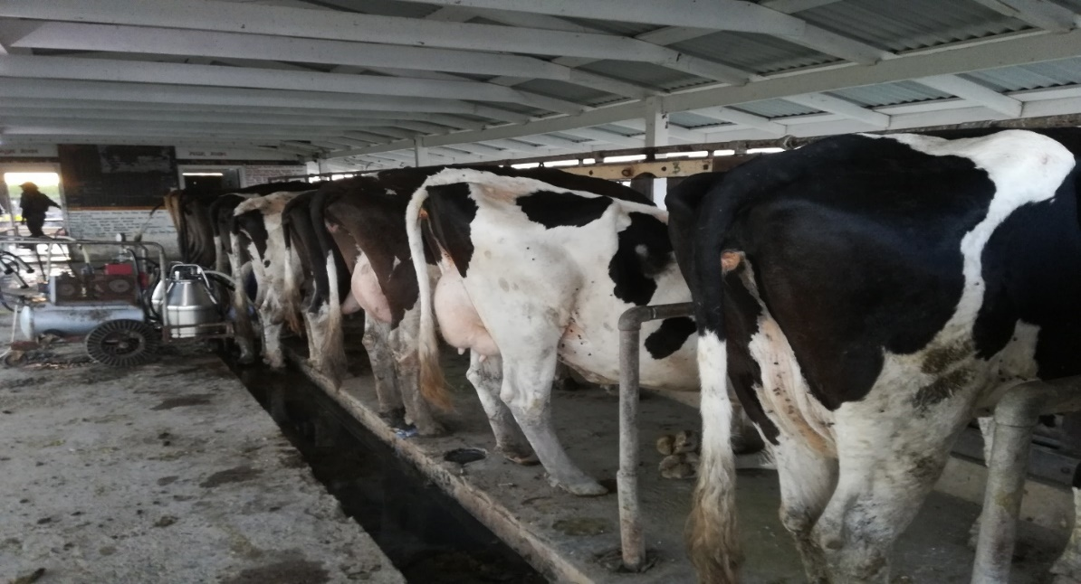
Poultry
Broilers
Twenty-five batches of broilers were reared in 2018, four of which were comprised of 1500 birds, fifteen of 1200 birds and six of 1000 birds. The chicks were sourced from the Bounty Farm Ltd hatchery and came vaccinated in keeping with the flock health protocols.
Mortality percentages ranged between 1.6 and 16.6 with an average of 8.4%.

Figure 3: Chart Showing mortality percentages according to batch 2018.
Few problems of a flock health nature were reported. The high mortality percentages recorded were due to heat stress. This was amplified by the extremely slow movement in the market of birds for more than half of the year. Most mortalities were recorded after the 6th week. However, steps have been taken to reduce the heat in pens, the first being the procurement of two 4 feet industrial fans which were modified and installed in February 2018.
Despite the unforeseen challenges faced for the most part of the year the livestock farm has improved its average mortality percentage from 8.4% in 2017 to 7.1% in 2018. Since it is known mortalities soar after the 6th week, the prompt marketing of the birds is key to reducing mortalities, feed consumption and ultimately cost of production. Cost of Production per kg of live chicken ranges between $320 -$374 with an average of $341.
Layers
Figure 4: Chart showing monthly egg production figures Jan-Dec 2018
This batch of layers was placed on April 29, 2017 and will be culled in February 2019 at an age of 93 weeks. These layers will be replaced by the1500 Hy line Brown pullets that were placed on 25th August, 2018. This batch is expected to begin production in early January, 2019.
Swine
Flock Health
The farm did not experience any major disease problems during the course of the year.
Mortality percentages ranged from 0.4 to 6.4 with an average of 2.96 per month. 91% of mortalities occurred among suckling piglets and 9% among weaners. No mortalities occurred among fatteners, sow’s and boars. The average mortality during 2018 decreased from 3.5% in 2017.

Table 2: Showing monthly mortality according to category in swine during 2018
Month | Piglet | Weaner | Fattener | Sow/Gilt | Boar | % Mortality
Jan | 7 | 1 | 0 | 0 | 0 | 6.04
Feb | 1 | 0 | 0 | 0 | 0 | 1.2
Mar | 1 | 0 | 0 | 0 | 0 | 1.1
Apr | 10 | 0 | 0 | 0 | 0 | 7.3
May | 8 | 0 | 0 | 0 | 0 | 5.7
Jun | 4 | 0 | 0 | 0 | 0 | 2.6
Jul | 7 | 1 | 0 | 0 | 0 | 3.2
Aug | 5 | 2 | 0 | 0 | 0 | 2.9
Sep | 1 | 0 | 0 | 0 | 0 | 0.4
Oct | 3 | 1 | 0 | 0 | 0 | 1.9
Nov | 5 | 0 | 0 | 0 | 0 | 2.4
Dec | 2 | 0 | 0 | 0 | 0 | 0.78
Total | 54 | 5 | 0 | 0 | 0 | AVG-2.96

Marketing
The farm continued to supply breeding stock to swine farmers in various parts of the country. During the period, live sales included two hundred and forty weaners, nine fatteners, two young boars and 2 culled boars. Pork sales amounted to two thousand one hundred and seventeen kilograms.
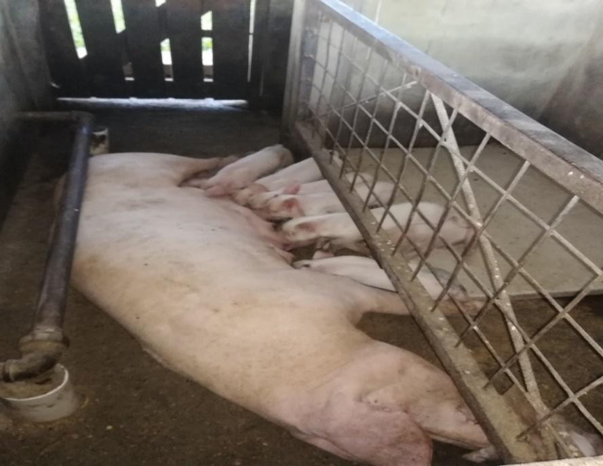

Infrastructural Works.
- Pen # 7A was rehabilitated in September 2018.
- Rehabilitative works continued throughout the various sections, primarily in the swine section.

Staff Development
- Livestock Farm Manager(ag), Dr. Randy Domer was selected by Management of the institution to participate in a two-week training course on AQUACULTURE TECHNOLOGY IN GUYANA held on November 26- December 7. The training course was hosted by a Chinese delegation and the Government of Guyana.

2. CROP FARMS
Revenue generated from the crop farms during the reporting period amounted to three million four hundred and twenty three thousand dollars ($3,423,000). Table below shows the revenue generated in each month of the year.

Month | Sales $
January | 540,000
February | 314,000
March | 278,000
April | 236,000
May | 316,000
June | 167,000
July | 108,000
August | 18,000
September | 49,000
October | 170,000
November | 630,000
December | 417,000
Total | 3,243,000

CROP FARM 1
ACTIVITIES TARGETED
During this period, the Crop Farm 1 focused on the following objectives.
- Cultivation of Butternut squash
- Cultivation of Cucumbers
- Cultivation of Herbs
- Cultivation of Hot Peppers
- Cultivation of Red peas
- Cultivation of Eschallot
- Cultivation of Sweet peppers
- Cultivation of Sweet corn
- Cultivation of Sweet potatoes
- Cultivation of Sorrel
- Training 200 students in six (6) different skill sets, relating to sustainable crop production
- Providing educational tours for ten (10) learning institutions to stimulate more interest in agriculture amongst youths
- Working with other tertiary institutions to provide practical training and cropping area for scientific experiments of students
- Cultivating 90% of the farm area
- Maintaining the farm’s environs
- Achievement of 100% attendance from 95% of students
- Providing the cafeteria and food processing unit with crop produce
CROPS PLANTED DURING THIS PERIOD (2018)

- Butternut squash
- Cucumber
- Herbs
- Hot Pepper
- Pigeon peas
- Red peas
- Shallot
- Sorrel
- Sweet corn
- Sweet Peppers
- Sweet Potato

CROPS HARVESTED DURING THIS PERIOD (2018)

- Butternut squash
- Cherry
- Coconut
- Cucumber
- Red peas
- Shallots
- Sorrel
- Sweet Pepper
- Sweet Potato
- Sweet Corn
- Tomatoes

STUDENTS INVOLVEMENT

Students were actively involved in practicals, and different skills sets, such as harvesting

techniques and practices, land preparation, calibration of farm equipment, planting and transplanting of seedlings etc.

OTHER ACTIVITIES DONE DURING THE PERIOD

- Cleaning and maintenance of main & infield drains
- Manual and Chemical weed control
- Cultural and chemical disease control, while applying the concepts of Integrated Disease Management (IDM) and Integrated Pest Management (IPM).
- Hands on training on the correct steps and procedures to calibrate chemical application equipment. This training also included the correct steps to follow for dosage calculation and the importance of Personal Protective Equipment (PPE).

During December 2018, Crop Farm 1 successfully completed the desilting process of its entire irrigation system. Crop Farm 1 also hosted various tours in 2018, comprising of students from different learning institutions within the education sector.

GENERAL PERFORMANCE

The year 2018 was a very challenging one for Crop Farm 1. Unfavorable weather patterns were the major cause of decreased yields. The farm was also affected by diseases which resulted in a decrease in the production of various crops.

There was a noticeable improvement in students’ attendance and performance in 2018. Students were particularly interested in the various skills set taught on the farm and were anxious to get involved in these exercises.

Reflecting on the performance of Crop Farm 1 in 2018, there is an urgent need to apply modern cropping techniques and systems on the farm. These systems will not only optimize the farms’ production, but will also prepare the students to be more capable to deal with technical situations in the agriculture sector where climate change is evident.

Notwithstanding the loss of crops due to excess precipitation and its negative impact on the farm’s productivity, it also aided in the teaching aspects, where students were able to appreciate the need for advanced technology to remedy current climate constraints.

The crop farm drainage and irrigation systems were rehabilitated in 2018 with significant assistance from the National Drainage and Irrigation Authority through the provision of an excavator for an entire month.

3. CROP FARMS 2 & 3
Abstract of Report
During the reporting period, students were engaged in the cultivation of a wide range of crops. The crops were harvested to supply the School’s cafeteria and the surplus was marketed.
Students were engaged in the various crop husbandry practices of vegetable crops and orchard crop production. They were also exposed to the growing of crops in protected agriculture systems (shade house cultivation).
Students were trained in aspects of Integrated Pest Management. The production of crops was done in a manner that is in keeping with Good Agriculture Practices (GAP).
Skills Training
Students were engaged in the following:
- Land Preparation
- Fertilizer Application
- Weed Management
- Insect Pest Management
- Disease Control
- Harvesting Methods
- Postharvest Management
- Water Management
- Pruning
- Mulching
- Composting
- Protected Agriculture
- Operation of Farm Equipment
Protected Agriculture
The primary objective of this type of agriculture practice is to engage students in a type of agriculture production system that is resilient to climate change. Students were able to gain experience by growing crops that are suitable for this kind of conditions (shade house/hydroponic cultivation). Some crops give better output than other under the shade house/hydroponic cultivation. The leafy vegetables usually give higher output under the protected agriculture system.

Large shade house Small shade house
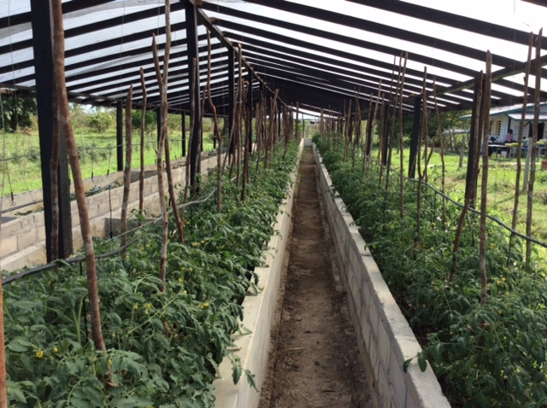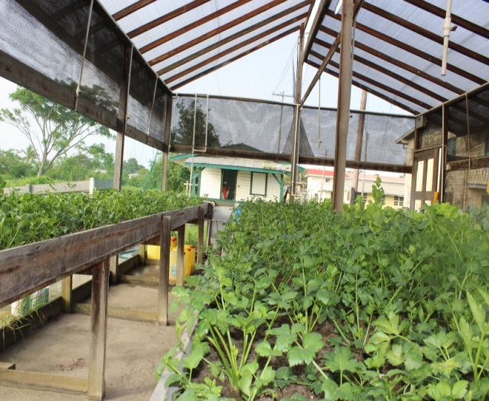
Crops Cultivated

COMMON NAME | BOTANICAL NAME
Baulanger | Solanum melongena
Sweet pepper | Capsicum anuum
Squash | Lagenaria siceraria
Pumpkin | Cucurbita maxima
Ochro | Abelmoschus esculantus
Poi | Basella alba
Pak choi | Brassica chinensis
Pumpkin | Cucurbita maxima
Hot pepper | capsicum frutescens
Passion fruit | Passiflora edulis
Cucumber | Cucumis sativus
Bora | Vigna unguiculata sesquipedalis
Celery | Apium graveolens
Cabbage | Brassica capitate
Lettuce | Lacuta sativa
Chives | Allium schoenoprasum

In addition to the crops cultivated, several orchard crops were maintained and harvested.

General Overview
The management of the Crop Farm 2 has been able to engage the students in the perquisite training that is required by the School. Students were engaged in the cultivation of a wide range of crops and in the process they were engaged in the husbandry practices that are associated with the cultivation of those crops.
During the dry period, measures were put in place to ensure that crops were cultivated to ensure that students were able achieve the perquisite training.
A section of the Crop Farm inundated with water
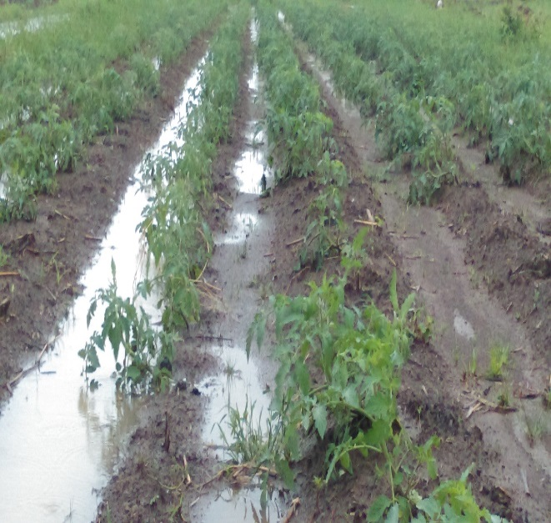
Mitigation Measures
The Management of the School has been very supportive and has been working with the Crop Farms to put measures in place to mitigate the effect of flooding.
Mitigation measures include the following:
- Digging of drains – This will allow the beds to become more elevated and it will facilitate efficient drainage.
- Construction of koker at strategic location on the Crop Farms - This will allow for greater control over the water whenever the farms are flooded.
- Construction of a Shade House - This will serve to provide training in relation to climate resilient measures to mitigate the effect of climate change.
In addition, there will be greater storage capacity to enhance the availability of water during the dry season.
Agronomic Practices
During the routine Agronomic/ Crops Husbandry practices, the students are able to be engaged in the various skills training as stated earlier including; fertilizing of crops, pest and disease management and harvesting of crops. The agronomic practices are in keeping with Good Agricultural Practices (GAP).

Seedling Production
The primary objective is to produce seedlings for the School’s Farm. In the nursery, seedlings are germinated and hardened before they are transferred to the fields.
Visits to the Crop Farm
Students and teachers from various schools visited the Crop Farm. The Farm facilitates students from the various schools and also tertiary institutions to collect specimen and data for the purpose of research projects and assignments.
Special Projects
These projects involved the growing of non-traditional varieties crops including broccoli, sweet pepper, butternut squash and purple lettuce. In addition, students were able to conduct trials using the appropriate experimental designs such as Complete Randomized Design and the Paired Comparison.
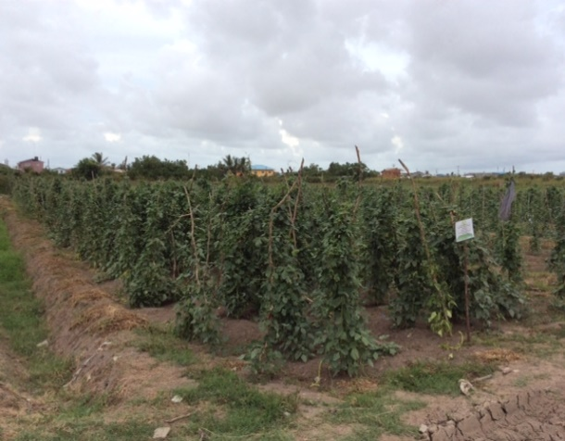
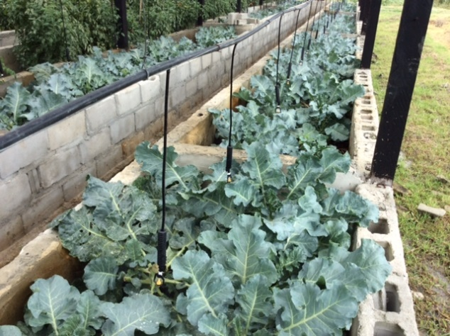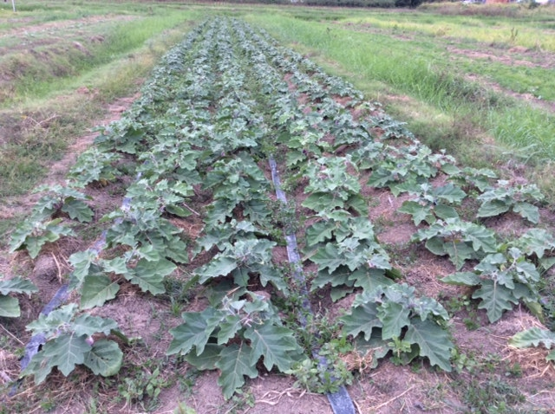

4. AGRO PROCESSING UNIT
Academic Activity
The Agro Processing Unit facilitated the second year Diploma and Certificate in Agriculture classes in their practical sessions in Agro Processing during the reporting period. For the Essequibo campus, the Manager travelled to the region and conducted those practical sessions there. Students from both campuses were exposed to the making of Jams, Jellies, Sauces, Preserved Seasonings (Dehydrated & Bottled), Preserved Fruits and Vegetables, Dairy Products (cheese and yogurt) and Preserved Meats (Ham, Chicken Ham, Pickled Pork, Salt Beef, Salted Fish)
Diploma in Agriculture
Students were asked to research and develop new products for the local market. New products produced by students were virgin coconut oil infused with lemon grass, fruit popsicles, instant soup mix, tasso (dried beef), boulanger wine, carambola tea bags, pineapple wine and instant puri mix. These products were displayed at an exhibition held on March 13, 2018 for Mon Repos Campus and March 10, 2018 for Essequibo Campus, where management and staff members viewed the exhibits and purchased items that were on display. The following are scenes from exhibitions held on both campuses:
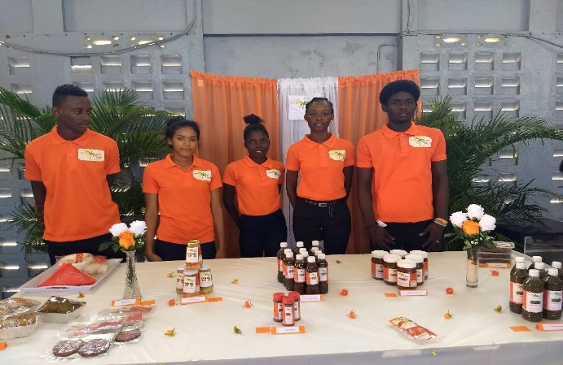 | 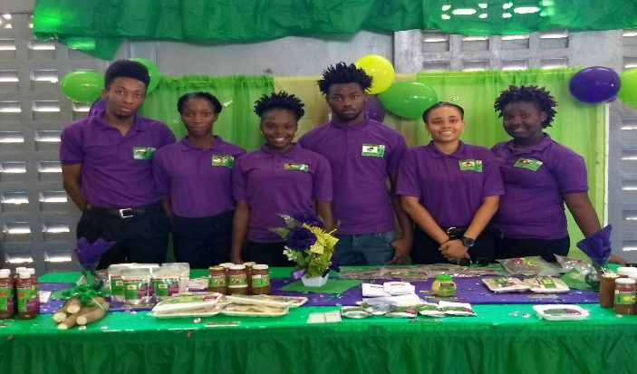
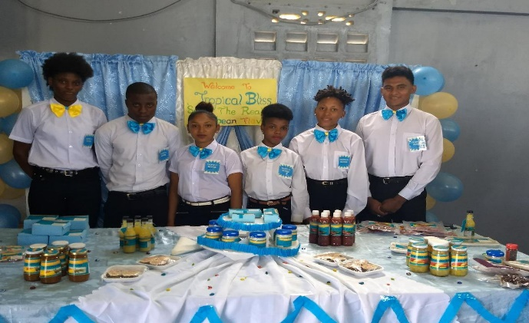 | 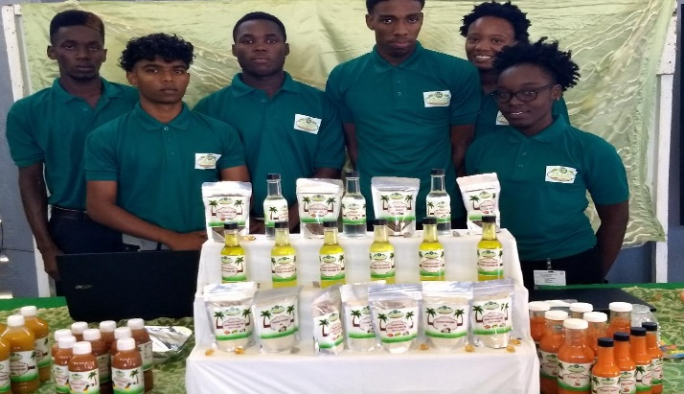
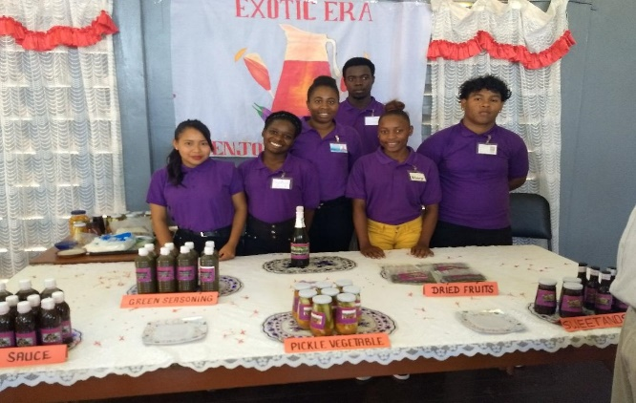 | 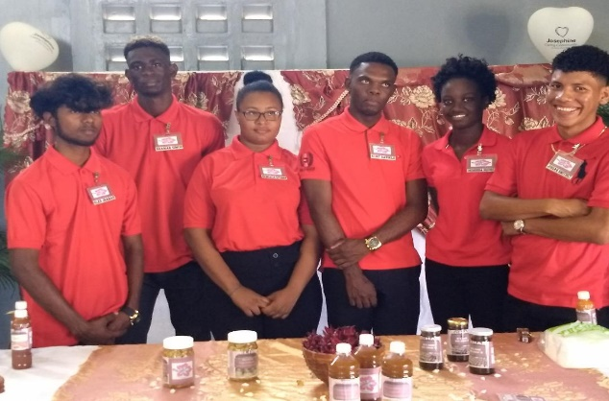
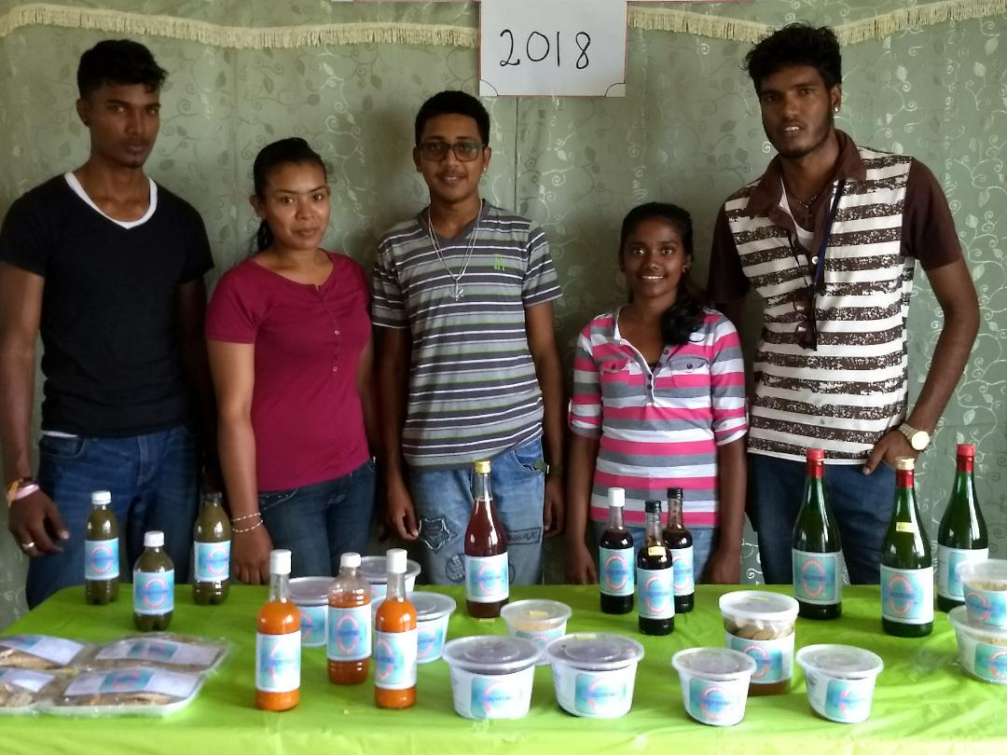

Certificate in Agriculture

Students were also taught to preserve fruits, vegetables, meats and milk. In addition, students developed new products from local products. Products developed were mango BBQ sauce, mango candy, soursop jelly and soursop & ginger tea bags. These were displayed at an exhibition held on March 12, 2018 in the School’s Auditorium.
The highlights of the Exhibition are as follows:
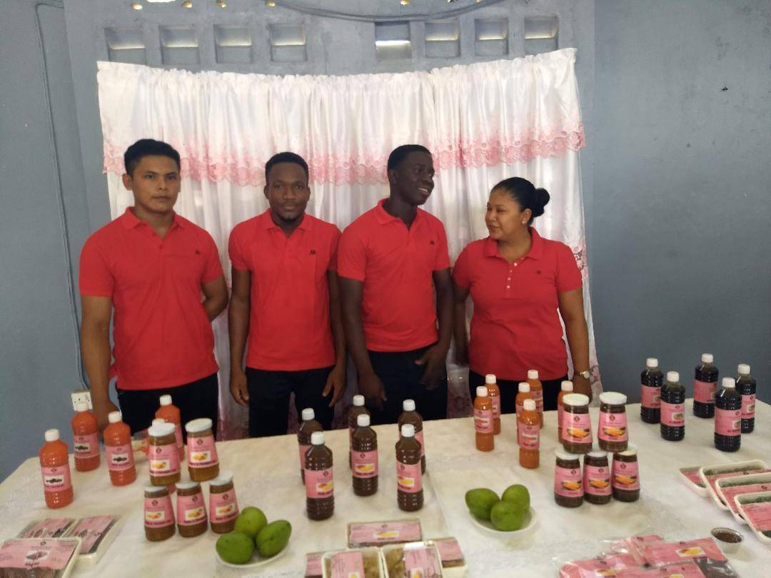 | 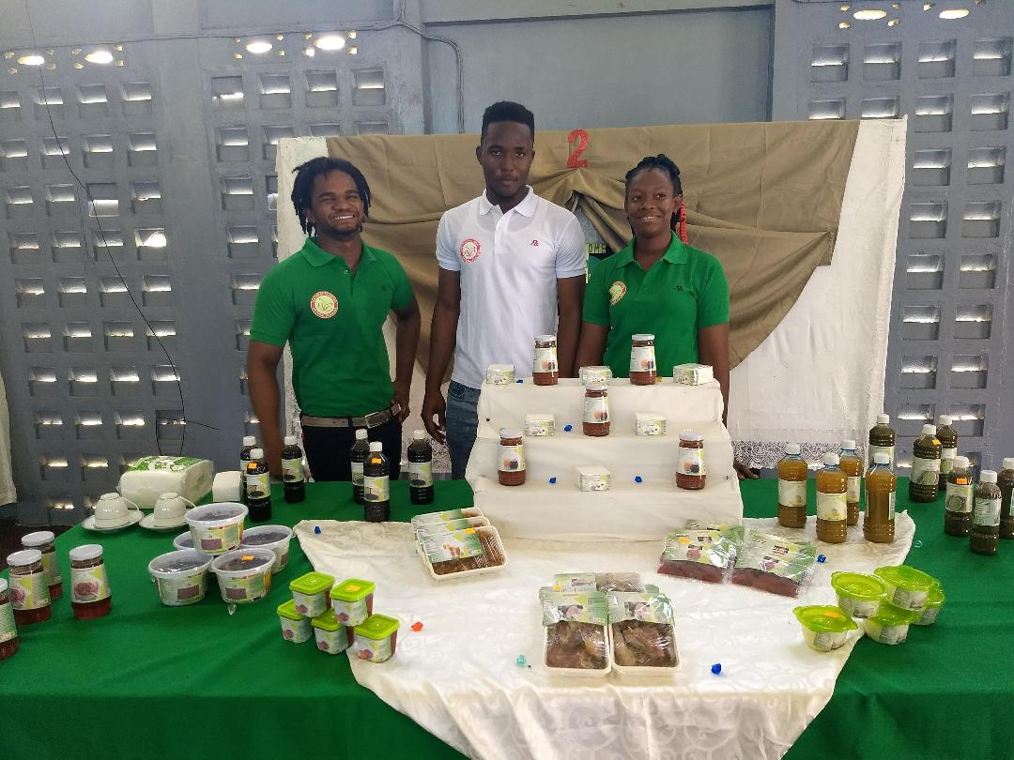
The students were taken on a number of field trips to better understand commercial production. Field trip were made to Banks DIH Ltd, National Milling Company by students from the Mon Repos Campus, Essequibo Campus visited the Golden Brook Coconut Oil Factory at Charity.
Certificate in Agro Processing

The Certificate in Agro Processing students completed their programme during the reporting period. They were involved in the packaging of plantain flour, porridge mix and smarty baby porridge. They also labelled, porridge mix, all purpose sauce, golden apple BBQ sauce produced by the department during the reporting period. Products developed were gluten free pasta, sweet potato beef burger, cinnamon butter, coconut flakes, mango scented coconut oil, and a protein shake. These were displayed at an exhibition held on November 26, 2018 in the School’s Auditorium.

The highlights of the Exhibition are as follows:
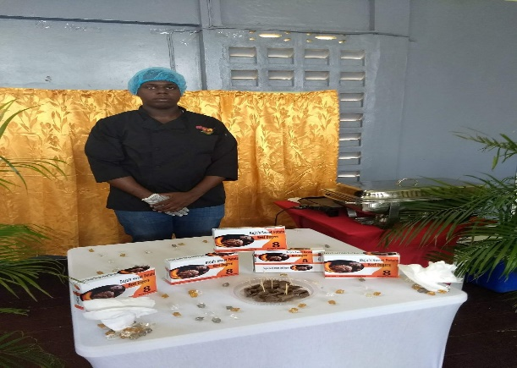  Sweet Potato Burger | 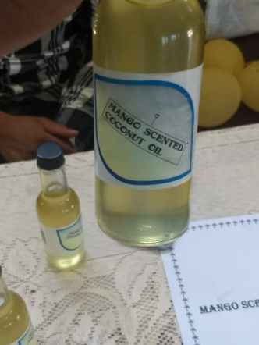  Mango scented coconut oil
Gluten free Pasta | 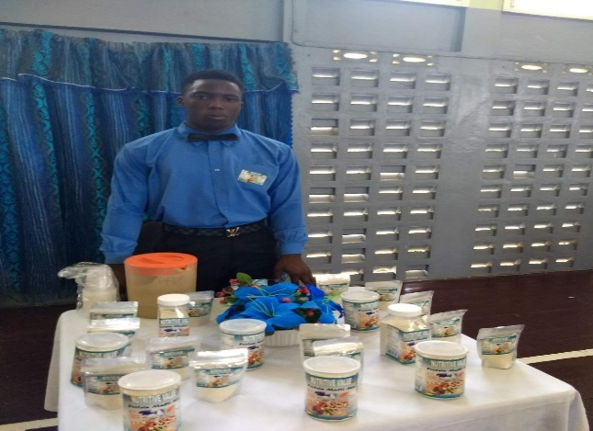  Protein Shake
Cinnamon butter | 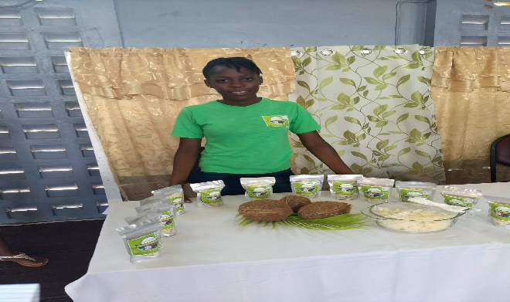  Coconut flakes

Production
During the reporting period the department generated an income of six million eight hundred and seventeen thousand dollars (G$6,817,000).
Income generated during January to December 2018.
Month | Revenue
January | 759,000
February | 383,000
March | 641,000
April | 445,000
May | 550,000
June | 530,000
July | 222,000
August | 410,000
September | 365,000
October | 782,000
November | 624,000
December | 1,106,000
TOTAL | 6,817,000

Other Activities
Students from a number of schools visited the facility during the year. These included, Mahaicony Secondary School, Abram’s Zuil Secondary and Aurora Secondary School and Presidents’ College among others.
During the reporting period, the department participated in several exhibitions hosted by various organisations. (Table 1)

Table 1: Agro Processing Facility Activities for the year 2018

ACTIVITY | VENUE
University of Guyana Career Fair | University Campus
President’s College Career Fair | President’s College
Lion’s Club of Durban Park Career Fair | Girls’ Guide Pavilion
Ministry of Agriculture Career Guidance Fair | D’urban Park
Independence Farmers’ Market Day | D’urban Park
Canje Secondary Career Fair | Canje Secondary, Berbice
World Food Day | Mainstay, Essequibo
GSA Open Day | GSA, Mon Repos
Farmers’ Market Day | D’urban Park
Ministry of Agri. Cook Off Competition | Head Office, MOA
MMA/ADA open day | West Coast Berbice
Harmony Village | Main Street
Ministry of Education Career Fair | Pouderoyen, WBD
Farmers’ Market Day | D’urban Park
Green Expo | Providence, EBD

Products displayed and sold were porridge mix, plantain flour, breadfruit flour, banana flour, mixed fruits, preserved carambola and candied papaw golden apple BBQ sauce, all purpose sauce. Samples distributed were porridge mix with rice porridge, banana cake, breadfruit cake, porridge mix cake, golden apple BBQ sauce, all purpose sauce and spicy relish, rice flour mattai, rice cookies.
Training
The Facility conducted three training programmes during the reporting period. Two were sponsored by the Ministry of the Presidency, that earned the school $6.7 million dollars, where fifty youths were trained in Product development. The other training was sponsored by Alliances for Action: (Guyana), through the Coconut Industry Development for the Caribbean Project funded by the European Union. A total of thirty five coconut farmers and other persons interested in coconut, were trained in the Value Addition & Food Safety of Coconut Products. This earned the school ($819,850).
Staff members were also trained in Customer Care sponsored by the Department of the Public Service, Ministry of the Presidency during the reporting period.
Staff Matters
Staff members proceeded on annual leave at various times during the year and all of the annual leave for the year 2018 was utilized. On staff at the Agro processing Unit are eight (8) persons. The following is a summary of the staff at the Agro processing Facility:

 | Name | Designation
1 | Grace Parris | Lecturer / Manager
2 | Stacia Nelson McDonald | Assistant Manager
3 | Patrina Haynes | Crop Extension Officer
4 | Marian Stewart | Processing Assistant/Demonstrator
5 | Akeem Williams | Processing Assistant/Demonstrator
6 | Tamera Lewis | Processing Assistant/Demonstrator
7 | Kaye Rodrigues | Cleaner /Processing Assistant
8 | Delroy Nelson | Labourer

Appendix 1
STUDENT ENROLMENT (Academic Year 2017/2019)
MON REPOS CAMPUS
PROGRAMME | Males | Females | TOTAL
Diploma in Agriculture Yr.1 | 18 | 16 | 34
Diploma in Animal Health & V.P.H Yr. 1 | 12 | 11 | 23
Certificate in Agriculture Yr. 1 | 8 | 6 | 14
Certificate in Forestry | 8 | 9 | 17
Certificate in Agro-Processing | 1 | 6 | 7
TOTAL | 47 | 48 | 95

ESSEQUIBO CAMPUS
Programme | Male | Female | TOTAL
Diploma in Agriculture Year I | 11 | 4 | 15
Certificate in Forestry | 10 | 6 | 16
TOTAL | 21 | 10 | 31

CONTINUING STUDENTS
MON REPOS CAMPUS
PROGRAMME | Males | Females | TOTAL
Diploma in Agriculture Yr.2 | 25 | 17 | 42
Diploma in Animal Health & V.P.H Yr. 2 | - | 7 | 7
Certificate in Agriculture Yr. 2 | 9 | 12 | 21
TOTAL | 34 | 36 | 70

ESSEQUIBO CAMPUS

Programme | Male | Female | TOTAL
Diploma in Agriculture Year II | 4 | 3 | 7
TOTAL | 4 | 3 | 7

Appendix 2

LIST OF GRADUATES 2018

MON REPOS CAMPUS

DIPLOMA IN AGRICULTURE

# | NAME | GENDER | GRADE
1 | BOLLERS, Akeem | M | Pass
2 | CARMICHAEL Osbert | M | Higher Credit
3 | WILLIAMS, Martique | M | Higher Credit
4 | BEST, Sophia | F | Lower Credit
5 | BHARRAT, Jeenarine | M | Pass
6 | BOWEN, Esther | F | Higher Credit
7 | CHINTAMANIE, Heramanie | M | Pass
8 | DANIELS, Kurt | M | Pass
9 | EDWARDS, Eksi | F | Higher Credit
10 | GEORGE, Nefrititi | F | Pass
11 | GRANT, Shaquille | M | Higher Credit
12 | HALEY, Jameraquai | M | Pass
13 | HALLEY, Joel | M | Pass
14 | HARCOURT, Alpha | F | Higher Credit
15 | HERCULES, Noel | M | Pass
16 | JAPAL, Alex | M | Pass
17 | JHAMAN, Glen | M | Pass
18 | JOSEPH, Keneshia | F | Pass
19 | KITAMAN, Nichillicia | F | Higher Credit
20 | LEWIS, Teisha | F | Pass
21 | LONDON, Kaydoesa | F | Pass
22 | MARKS, Tenesha | F | Pass
23 | MENTORE, Tashana | F | Higher Credit
24 | MOORE, Kishawn | M | Pass
25 | PAULINO, Sylvester | M | Pass
26 | RAMBHARRAT, Sobrina | F | Pass
27 | ROBERTS, Kerrianne | F | Pass
28 | RODRIGUES, David | M | Higher Credit
29 | SAMPSON, Joel | M | Pass
30 | SCOTLAND, Geron | M | Pass
31 | SCOTT, Tavia | F | Higher Credit
32 | SEMPLE, Milton | M | Pass
33 | SHAHABUDEEN, Alleema | F | Distinction
34 | SIMON, Shamar | M | Higher Credit
35 | SMITHET, Josiah | M | Pass
36 | SQUIRES, Deshinna | F | Pass
37 | STUART, Leana | F | Pass

CERTIFICATE IN AGRICULTURE

# | NAME | GENDER | GRADE
1 | FERNANDES, Alexis | F | Pass
2 | BENJAMIN, Toshon | F | Higher Credit
3 | BOBB, Juma | M | Pass
4 | CHARLES, Olis | M | Pass
5 | COOPER Kenduce | M | Pass
6 | CRAWFORD, Teaddie | F | Pass
7 | HARRIS, Enecia | F | Pass
8 | HAYNES, Vince | M | Pass
9 | LEWIS, Densley | M | Pass
10 | LONDON, Dornel | M | Pass
11 | NASH, Ufer | M | Pass
12 | O'SULLIVAN, Orin | M | Pass
13 | TAPPIN, Tawny | F | Pass

DIPLOMA IN ANIMAL HEALTH & VETERINARY PUBLIC HEAALTH

# | NAME | GENDER | GRADE
1 | HENRY, Vincent | M | Pass
2 | BREMNER, Ronique | F | Pass
3 | CAMPBELL, Akeem | M | Pass
4 | FRASER, Anna | F | Pass
5 | KERSTEN, Leah | F | Pass
6 | WALTERS, Melryc | M | Pass

CERTIFICATE IN FORESTRY

# | NAME | GENDER | GRADE
1 | BAKER, Emilika | F | Pass
2 | BOWEN, Curtly | M | Higher Credit
3 | CAESAR, Candacie | F | Pass
4 | CHESTER, Simeon | M | Distinction
5 | DAVID, Derissa | F | Higher Credit
6 | DAVIDSON, Tolesha | F | Higher Credit
7 | DOWNER, Randolf | M | Distinction
8 | FOX, Minnifia | F | Pass
9 | FRASER, Andrew | M | Pass
10 | GILL, Andrea | F | Higher Credit
11 | HARRIRAM, Lisa | F | Higher Credit
12 | KOMAR, Rajwan | M | Distinction
13 | LEACH, Orlando | M | Higher Credit
14 | ROSE, Afyia | F | Distinction
15 | SAMPSON, Kellecia | F | Higher Credit
16 | SIMON, Carl | M | Distinction
17 | SUKHDEO, Adrion | M | Higher Credit
18 | WALKER, Nikita | F | Lower Credit
19 | WILLIAMSON, Omar | M | Higher Credit

CERTIFICATE IN AGRO PROCESSING

# | NAME | GENDER | GRADE
1 | CRAWFORD, Lawrence | M | Higher Credit
2 | HUNTE, Devon | M | Distinction
3 | LEWIS, Ashantia | F | Pass
4 | PELLEW, Tasmin | F | Pass
5 | PRINCE, Vestie | F | Higher Credit

ESSEQUIBO CAMPUS
DIPLOMA IN AGRICULTURE

# | NAME | GENDER | GRADE
1 | CHULIE, Muneshwari | F | Pass
2 | PERSAUD, Raul | M | Higher Credit
3 | RESALLY, Shailendra | M | Pass
4 | SABAR, Bibi Nafeeza | F | Higher Credit
5 | SINGH, Bisham | M | Pass

CERTIFICATE IN FORESTRY

# | NAME | GENDER | GRADE
1 | BENJAMIN, Caleb | M | Distinction
2 | CHESTER, Alvan | M | Distinction
3 | DASH, Vernon | M | Distinction
4 | ETWAROO, Preya | F | Distinction
5 | FERNANDES, Lesa | F | Higher Credit
6 | GOOCHARAN, Tarina | F | Higher Credit
7 | HENDRICKS, Kimberley | F | Higher Credit
8 | NARINE, Pulwattie | F | Distinction
9 | PERSAUD, Thaveena | F | Pass
10 | RAMJIT, Puneshwar | M | Pass
11 | SMITH, Ronaldo | M | Higher Credit
12 | SUKHAI, Joel | M | Distinction

Appendix 3

 | GUYANA SCHOOL OF AGRICULTURE
 | List of Employees - 2018
 | MON REPOS
 | NAME OF EMPLOYEE
No. | SURNAME | FIRST NAME | DESIGNATION
1 | Greenidge | Brian | Chief Executive Officer
2 | Allen | Dexter | Director of Administration
3 | Glasgow | Oscar | Director of Academic Affairs
4 | Ramdhani | Natashia | Academic Counselor/Lecturer
5 | Parris | Grace | Lecturer/FPU Manager
6 | Pereira | Shemika | Lecturer/Assistant Farm Manager
7 | Timmerman | Ulie | Lecturer/Assistant Farm Manager
8 | Lutchman | Mechelle | Lecturer/Farm Manager
9 | Samsundar | Seeraj | Lecturer/Assistant Farm Manager
10 | Singh | Nikita | Lecturer/Assistant Farm Manager
11 | Nurse | Osbert | Assistant Farm Manager/Lecturer
12 | Domer | Randy | Veterinarian/Lecturer (MOA)
13 | Squires | Melissa | Library Supervisor
14 | Hazel | Roxanne | Matron/Admin. Asst.
15 | Jones | Peter | Warden/Admin. Asst.
16 | Persaud | Soomdat | Accountant
17 | Nelson | Stacia | Assistant Manager, Agro Processing Facility
18 | Bernarai | Bryan | C/Farm Supervisor
19 | Fraser | Cornel | L/Stock Farm Supervisor
20 | Jessamy | Ian | Maintenance Supervisor
21 | Rodney | Jacqueline | Head Cook (Ag)
22 | Richardson | Voneta | Laboratory Technician
23 | Warner | April | Laboratory Technician
24 | Sankar | Sanjay | Marketing Officer
25 | Persaud | Gaytri | Confidential Secretary
26 | Spencer | Risa | Assistant Accountant
27 | Hale | Tenesha | Typist Clerk
28 | Loaknauth | Alisa | Typist Clerk
29 | James | Folake | Senior Accounts Clerk
30 | Braithwaite | Rennautta | Library Assistant
31 | Roopnaraine | Durga Davi | Library Assistant
32 | Petrie | Wesley | Office Assistant
33 | Nunes | Joel | Stockman
34 | Aaron | Troy | Labourer
35 | Aaron | Clarence | Equipment Operator
36 | Benjamin | Colin | Labourer
37 | Bovell | Lewani | Maid
38 | Calder | Brian | Senior Carpenter
39 | Solomon | Yonnette | Cafeteria Assistant
40 | Bovell | Joel | Cafeteria Assistant
41 | Hamer | Felicia | Maid
42 | Harry | Juelle | Cook
43 | Henry | Cleveland | Electrician
44 | Mc Pherson | Joan | Cafeteria Assistant
45 | Nelson | Ronald | Labourer
46 | Barker | Esther | Cafeteria Assistance
47 | Paul | Oloufemi | Carpenter
48 | Persaud | Mohan | Labourer
49 | Johnson | Holly | Labourer
50 | Hooper | Beverley | Cook
51 | Sauers | Lionel | Maintenance Supervisor
52 | Shewram | Gangadai | Labourer
53 | Singh | Thakurdai | Cafeteria Assistant
54 | Singh (2) | Sugrim | Equipment Operator
55 | Softleigh | Yvonne | Senior Maid
56 | Thomas | Sean | Carpenter
57 | Williams | Trivfoza | Maid
58 | Cummings | Amos | Labourer
59 | Stewart | Marian | Food Processing Assistant/Demonstrator
60 | Rodrigues | Kay | Cannery Assistant
61 | Haripersaud | Sushila | Cafeteria Assistant
62 | Bishundat | Harry Ram | Labourer
63 | McDonald | Josh | Farm Supervisor
64 | Bruce | Corwyn | Farm Supervisor
65 | Lewis | Tamera | Food Processing Assistant/Demonstrator
66 | Williams | Akeem | Food Processing Assistant/Demonstrator
67 | Nelson | Corcell | Farm Supervisor
68 | Jones | Howard | Farm Supervisor (MOA)
69 | Sam | Denroy | Farm Supervisor (MOA)
70 | Blackman | Dawn | Cook
71 | Dennis | Stephen | Driver
72 | Balgobin | Puranand | Driver
73 | Vhaughn | Eldon | Driver
74 | Seeram | Bhagwat | Tractor Operator
75 | Westfield | Juwan | Farm Supervisor
76 | Haynes | Patrina | Crop Extension Officer (MOA)
77 | Johnson | Kenroy | Labourer
78 | Alleyne | Junior | Labourer
79 | Lhakram | Banowattie | Confidential Secretary
80 | Ramroop | Kumar | Accounts Clerk
81 | Carmichael | Osbert | Farm Supervisor
 | ESSEQUIBO CAMPUS
1 | Persaud | Kavendra | Lecturer
2 | Dookhit | Kevin | Lecturer
3 | Samad | Safraz | Lecturer
4 | Ramdass | Horatio | Lecturer/Farm Manager
5 | Glen | Sabiena | Lecturer (MOA)
6 | Ragunauth | Marvin | Lecturer
7 | Lawrie | Aloma | Library Assistant
8 | Allicock | Sunita | Accounts Clerk
9 | Lall | Lokesh | Farm Supervisor
10 | John | Natalye | Maid

TOTAL NUMBER OF EMPLOYEES

Mon Repos – 81 employees
Essequibo – 10 employees

