Guyana Geology & Mines Commission
Annual Report 2014

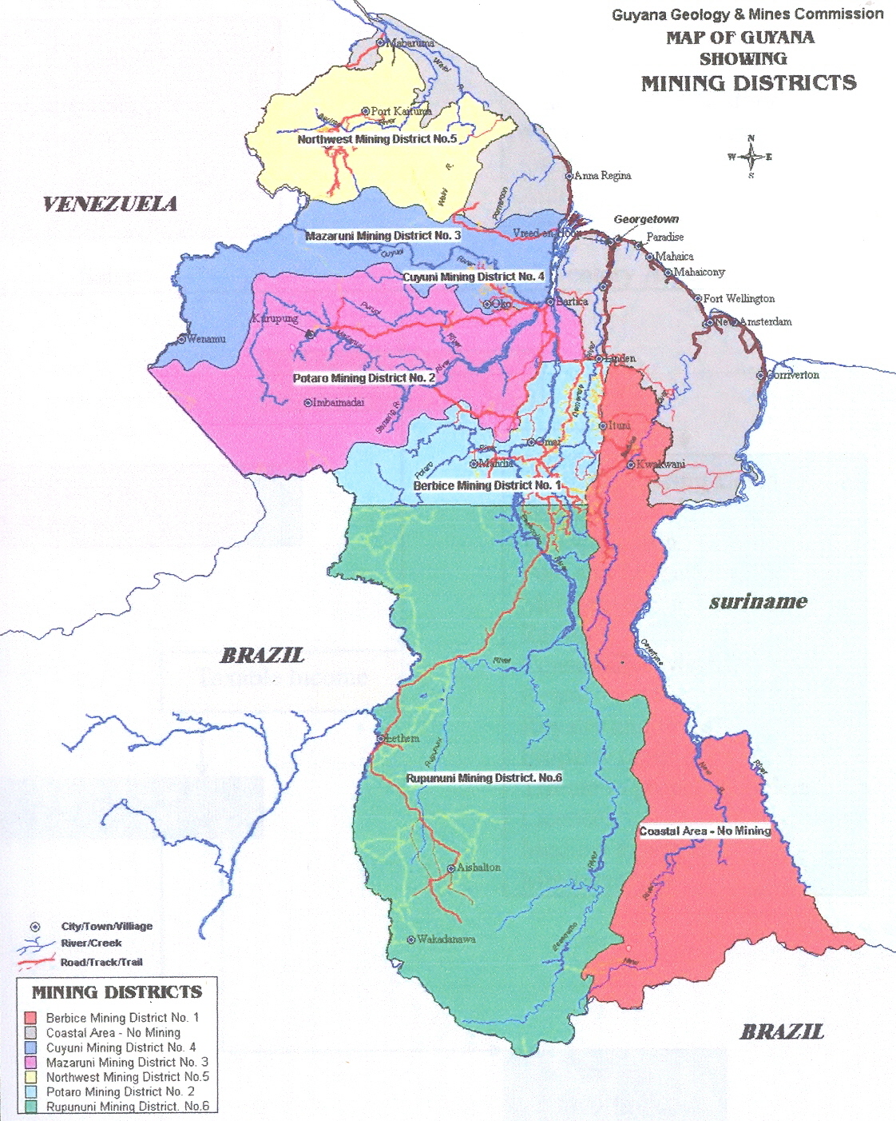
Table of Contents

EXECUTIVE SUMMARY 4
BOARD OF DIRECTORS 7
OFFICE OF THE COMMISSIONER 8
GEOLOGICAL SERVICES DIVISION 8
LAND MANAGEMENT DIVISION 11
SPECIAL PROJECTS UNIT 12
MINES DIVISION 13
ENVIRONMENT DIVISION 31
PETROLEUM DIVISION 37
ADMINISTRATION & HR DIVISION 39
IT DEPARTMENT 41
LEGAL DIVISION 42
AUDIT DIVISION 43
FINANCE & AUDIT DIVISION 44
CONCLUSION 45

EXECUTIVE SUMMARY
2014 was an interesting time for the Guyana Geology and Mines Commission (GGMC) which managed a steady and measured outlook. Unaccustomed challenges emerged such as industrial action for emoluments by the Guyana Public Service Union’s GGMC Branch which resulted in the adoption of a salary evaluation and compensation scheme that was based on performance. There were persistent constraints due to infrastructure realities so that staffing compliments could not be achieved, along with unwelcome media attention. However, the operational and technical aspects of the Commission remained focused on regulatory and compliance undertakings as these aspects were the most visible and subject to the most public comment. Providing support were the regional exploration; engineering and mineral processing experimentation; which were aimed to offer assistance to the sector. To these ends, roving patrols, compliance sweeps, investigations in response to complaints and routine tours by Mines Officers in the field were executed to impose and influence orderly conduct in the sector. Meanwhile, regional geochemistry and geological projects were completed and many demonstrations of useful mercury free recovery systems were done, all with good execution but only modest results of acceptance.
A downturn in gold and commodity prices in general served to unsettle the mainstream subsectors. Bauxite operations and promoted ventures such as in new bauxite projects and manganese development were casualties during 2014, advancing little if any at all and awaiting better times for capital inputs. Fortunately, a flattening of petroleum prices did not have a similar effect on the petroleum exploration ventures in Guyana as key programmes remained on target and new venture interests were sustained. The large scale gold operations such as Aurora Gold Mine and Karouni Gold Mine also remained committed despite the economic environment. Such strategic developments were on a scale and cycle that were less sensitive to the prevailing situation than the smaller outfits that constituted the foundation of Guyana’s mining sector and which were responsible for all of the gold and diamonds declared.
Gold declaration only achieved 387,508 ozs of the budgeted 450,000 ozs. That was ~ 86% of budget and ~80% of 2013 declaration. Diamond declarations were robust at 99,850 carats, exceeding the budget by ~ 65% and exceeding 2013 declaration by ~ 78%. Declared production for Bauxite stood at ~1.60 million tonnes being just ~ 57% of budget and on par with 2013 declared production which was ~5% higher. The shortfall in bauxite was also evident for nearly all the varieties of produced bauxite. The companies will have to overcome realities in addition to demand and price if their performances are to improve and they are to remain economically viable. Quarry materials have had a fairly good year with stone in particular exceeding budget by ~75% with 840,387 tonnes declared. A strong local demand from the construction and infrastructure sectors created ripe conditions for the quarrying business to consolidate. The sand extraction for 2014 was ~ 4.1 million tonnes, being ~39% more than budget and ~78% higher than 2013. The Loam extraction for 2014 was 0.1 million tonnes, being ~68% more than budget and ~5% higher than 2013. Sand and loam producers were more stringently looked at in 2014 after delinquency among operators for the payment of royalties required Board intervention to curb the practice. Improvements were observed by the end of 2014.
Notwithstanding the overall state of affairs in the sector, the GGMC financials were healthy. Revenue budget was revised to G$9,357 million and actual revenue was G$8,729 million which was ~93% budget and ~8% more than what was for 2013. A cautious outlook for the budgeted price of gold by GGMC cushioned the effects of assumptions on the Commission’s financial performance. In addition; business on account of petroleum for example, generated some unexpected revenue which compensated somewhat for the ordinary “solid” minerals performance
The sector itself still remained very relevant to the economy, being approximately 11.8% of GDP and a main source of foreign exchange earnings. In terms of other aspects of the national economic profile, the fact that the sector still generated much interest and business could not be ignored. For example, there were 3,550 new applications for land claims and 949 new applications for river claims in 2014. There were 3,519 dredge licenses issued in 2014. On the petroleum business side, discussions were held with new venture companies such as Eco ( Atlantic Guyana Inc., Tullow Guyana B.V., and Mid Atlantic Guyana Inc. who were interested in the offshore exploration; and the preparation by Esso Exploration And Production Guyana Ltd., et. al to drill in the deep water offshore; and CGX Resources with their 2D/3D seismic survey and geo technical work offshore; and the persistence by Repsol et. al in their processing and interpretation following their geophysical surveys in 2013; all pointed to opening opportunities in this understated petroleum sector where revenue for 2014 stood at ~ G$1.1 billion.
With the previous comments being sourced from certain Divisional metrics, it is probably convenient now to follow with the others:
The GeoSevices Division executed two significant regional geochemistry projects at Aruwai and Wakadanawa to identify prospective mineralized areas to fuel new venture interest and also rendered assistance to miners to inform on recovery methods and tailings management. Massive cleanup exercises at Puruni Landing, Tamakay Landing, Kurupung and other locations should not be unheralded. These along with successful reclamation work using hydroponics for cash crop development were projects of the Environmental Division that also spearheaded the partnership between GGMC and World Wildlife Fund (WWF) for “A National Action Plan for Mercury Scoping Project”.
The response by Land Management Division with the previously referred to Auction and Lottery making tenure available, in addition to their critical effort in preserving ISO certification for their management processes should be sufficient for that Division’s recognition in this summary.
Special Projects Unit provided oversight of the rehabilitation of interior roads of which Micobie and Tumatunari, Matthews Ridge to Baramita and Aranka were strategic. Nearly G$1.1billion was allocated to road infrastructure in 2014. The Special Project’s Unit also had purview for facilities under construction for GGMC at Lethem, Olive Creek, Aranka and Eclipse Falls.
As the Mines Division’s monitoring and regulating details confronted the scourge of poor mining practices, unlawful operations and such issues, the attitude of disrespect for the instruments of law and order were very evident. With nearly 70% of the prospecting licenses visited found to have some level of associated illegal activity, the use of citations and Cease Work Orders for example, to deal with these matters were of very limited effect. Operators treated these administrative and legal tools with little regard. Persistence by the GGMC was a key to effectiveness but not a sustainable option for broad application.
As the Engineering and Inspectorate details performed their functions, the Mineral Processing Unit involved mining clusters in Northwest District, Omai, Frenchman and Mahdia with non- mercury alternatives for gold recovery such as the “Gold Kacha”, “Gold Cube”, and Floatation Cells. These methods could improve recovery beyond the 40% levels of the current popular methods using mercury.
The Petroleum Division’s relevance was also previously referred to as heightened exploration for oil and gas continued in earnest during 2014.
The Administrative and Human Resources functions of the GGMC were challenged as staff welfare issues took centre stage. Salaries and wages were hot issues for industrial action. The maintenance of the assets of the Commission was another challenge since multiple stations were being worked on simultaneously, all to meet the needs of the field staff in particular.
Training and Development were much more rewarding by comparison as a new batch of GGMC scholarship students graduated from the University of Guyana with degrees and diplomas in the geo/environmental sciences. There were also other graduates with diplomas in Finance, Management, and such. Internal Training in GIS specialties and the Mining Law were added accomplishments during 2014
The Audit and Finance Division although quite separate and independent were collectively astute in their oversight and stewardship of the Commission’s systems and finances. Field inspections of the Commission’s operations were increased by about fifty (50) percent, providing a useful governance function for the Commission. The remote operations, mainly the Mines Inspectorate functions received support from the IT Department which brought improved cyber connectivity between HQ and most operating stations.
Legal Division was quite busy with more than fifty (50) actions effectively handled during 2014. A fair share were injunctions against the Commission. By the time an injunction was heard, the perpetuation of the offence would have been opportunistically effected, diminishing the enforceability of the mining statutes.
Legal Division was the lead Division for the Commission’s Anti Money Laundering/Countering Financial Terrorism and Financial Transparency Initiatives. In addition, in-house legal training was provided by Legal Division.
Notwithstanding the previous accounts, it was clear that the mining sector was faced with a rapidly changing field of play. The response was a lobby for relief through policy adjustments and incentives but these were not conclusively responded to during 2014. The Commission itself was at the forefront with unprecedented ridicule directed at it. The need for sure footed remedial responses by the Commission came in the form of a systems review and the decision to craft a five (5) year strategic plan by the Board of Directors at the Commission; of which the former resulted in an Inception Report and the latter, a plan which pointed to technical solutions in the face of the issues of environment taking a high national priority. For example, the avoidance of deforestation; the acceptance of the Minamata Convention to ban mercury trade and therefore, to have mercury free gold recovery; the reduction of turbidity in rivers and the improvement in the conditions within the Mining Districts by better adherence to the Mining Statutes were loud messages that could not be ignored. The Commission financially supported the Guyana Mining School And Training Centre Inc. which was a possible solution to foster certifiable skills development for the sector. A special Land Reclamation Committee to target reclamation of mined out areas was also financed by GGMC. These being responses to observed issues that required attention.
In 2014, therefore, the Commission arrived at a point where it was recognized that the recovery of the sector in its various forms had to be spearheaded from a strong, technology savvy, primary stakeholder, mindful of a rules based standpoint; with good governance and transparency being fundamental instruments of operation and function. The Commission had no alternative but to set rudder and embark on its course for the improvement of a mining sector that in 2014 battled the odds to remain conspicuously relevant in the Guyana economic and development landscape
THE COMMISSION (BOARD of DIRECTORS) 2014
- Mr. Clinton Williams - Chairman
- Capt. Gerry Gouveia - Vice-Chairman
- Mr. Omkarananda Lochan - Director
- Mr. Evan Persaud - Director
- Mr. John Applewhite-Hercules - Director
- Mr. Terrence Adams - Director
- Mr. Tom Dalgety - Director
- Mr. Patrick Harding - Director
- Mr. Michael George - Director
- Mrs. Prema Ramanah- Roopnarine - Director
- Mr. Tasreef Khan - Director
- Mr. Derrick John - Director
- Mr. Rene Duesbury - Observer
- Mr. Anantram Balram - Observer
- Mr. Courtney Ramsay - Observer
- Ms. Yvonne Pearson - Observer
- Mr. Peter Ramotar - Observer
- Col. Khemraj Persaud - Observer

OFFICE OF THE COMMISSIONER – RESEARCH, PLANNING AND MONITORING DEPARTMENT
The Research, Planning and Monitoring Depart is an expansion of the Economist’s office which forms part of the Commissioner’s Secretariat. With space as a constraint it is undermanned but still managed to gather data on mining and mining related activities during 2014 in order to prepare the statistic reports and analyses of supply, demand, production, employment and other related variables. This information is utilized by other agencies such as Foreign Trade, Ministry of Finance and researchers for their own reporting. Typically, sectorial assessment for the extractive industries by the World Trade Organization, International Monetary Fund and International Development Bank who measure indicators such as Foreign Direct Investment may utilize the data captured by this department.
The Head of Department remained a member of the Aluminosilicates Committee (formerly the Bauxite Development Unit) which is to have a broad scope but still assist with all aspects of bauxite mining in Guyana. During 2014 this aspect of the Departments’ function was not as active as in the prior year probably due to a waning initiative of the Unit. As a member of the Tender Procurement committee, the Head of Department provided useful support in the several tenders which were advertised for the GGMC. In addition, the Department assisted in ongoing coordination and aligning of strategic initiatives between the MoNRE and GGMC.
During 2014, the training and development opportunities were not plentiful as in the year before. Notably though, there was Oil and Gas Business training sponsored by the US Energy Governance and Capacity Initiative. The Department is still relatively new (formed May 2012) and this could have contributed to the tentativeness in the performance during 2014.
GEOLOGICAL SERVICES DIVISION
Geological Services Division (GSD) undertook geological field work to investigate the geology and mineral resources across the country. From these projects, relevant geological reports become available to the public and guide the fortunes of the more serious operators in the sector. The GSD also monitors and provides technical assistance to miners who are small and medium scale operators.
The GSD has at its disposal, the Petrographic, Bullion Assay and Chemical Laboratory which aid their mission. These services are also available to external customers. In 2014 these Laboratories accomplished chemical analyses for geological projects, gold assays for Guyana Gold Board and some gold refining. However, in all areas, the limitations of the laboratory function were evident. This has to be properly addressed through a commitment to properly accommodate and modernize these laboratories.
Notwithstanding, during 2014 the majority of the work programme for the GSD was accomplished. The matrix succinctly represents the particulars.
2014 work programme and outcomes
PROJECTS | ACTIVITY | REMARKS
Regional Geochemistry Projects at Aruwai and Kopang | To investigate geology and mineral potential in the Greenstone Belt | Both projects were accomplished
Technical Assistance to Mining sector Programme (TAMSP) | To provide technical advice to miners on effective exploration and mining techniques to improve mineral recovery and improve compliance | Outreach projects accomplished in Kurupung Mining District #3; Lower Cuyuni MD #4; in particular was the gold particle characterization and analyses for District 4
Prospecting Licence Monitoring and Investment | To verify prospecting activities conducted by PL holders. | Focus on defaulting PL holders was achieved with 14 visited in Mining Districts 3 & 4.
Geological Training Programme | To improve these skill sets for the officers. | This was achieved using Omai as the field base.
GIS Training for field and certain training for Laboratory Staff | To improve these skill sets for those officers | This was not achieved due to coordinating constraints.
Diamond Investigating | To verify production records and determine diamond prospects for certain areas. | The authentication of submissions for Diamond exports was achieved. Mining District 3 was the focus for prospects.
UG Final Year Research | There were 4 such projects, Chronology and Stratigraphic Relationship of the Plakarapan Intrusions; magnet survey at Rewa; Multielement Geochemistry Survey Au, ReE, Cotan. | The projects were well done and duly recognized by the UG.

Map showing the Project Area Map for Aruwai Geochemical Project
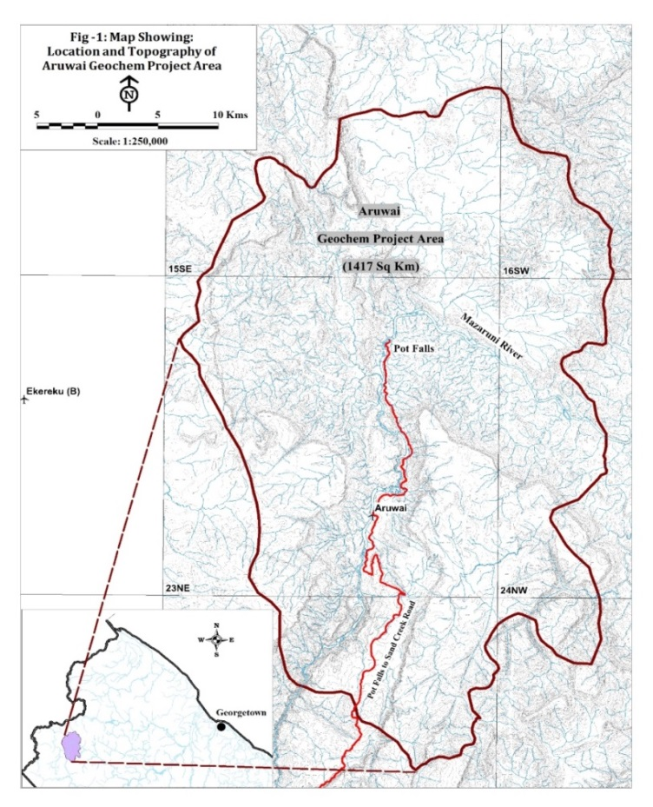

Map showing the Project Area Map for Kopang Geochemical Project
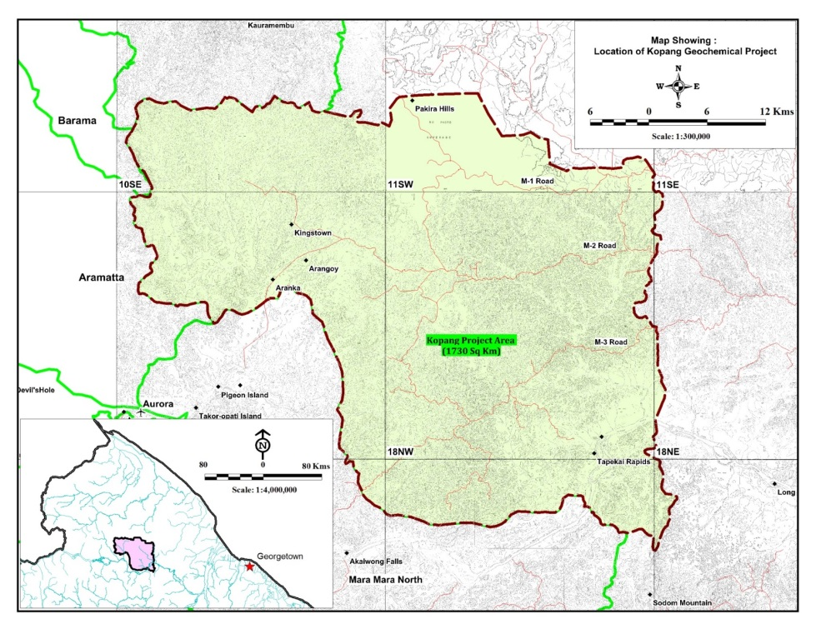

The Geological Service Division is a favourite for tours to GGMC by schools and there were at least three (3) in 2014 although individual student interest numbered nine hundred (900). Additionally, the GSD has worked hard in the facilitating of the Peer Review of Guyana’s Kimberly Process Certification Scheme at which Guyana was given very complimentary reviews.
Geological Service Division performed quite well.
LAND MANAGEMENT DIVISION
The Land Management Division (LMD) promotes and supports increased and diversified mineral exploration and development, while meeting standards. The LMD seeks to optimize revenues from tenure lotteries and auction of properties. The ISO 9001/2008 Quality Management Systems provide the standing operating procedures for the processes under LMD purview. Those are the treatment of applications for the products of property management such as Prospecting Licences, Prospecting Permits etc.
In order for better service delivery vital space had to be found for a growing staff and they spread into the GSD main office area where with modification, the LMD staff are better housed and documents better secured.
The GGMC of which the LMD is a very key Division in the ISO QMS, made good in 2014 for another period. A brief outlay of the outcomes by the LMD for 2014 is provided in the spread sheet which follows:
Process | Medium Scale Prospecting Permit | Mining Permit | Mining Licence | Prospecting Licence | Quarrying Licence | PGGS
Applications  Renewals  Grants | 2916  4329  1905 | 980  1330  1191 | 2  8  - | 23  40  8 | 12  4  - | 1  -  -
Cancellations Sent  Published | 238  238 | - | - | - | - | -
Intentions To Grant  Sent  Published | 2014  1886 | 1544  138 | -  - | 37  32 | 10  10 | -  -
Recall  Sent  Published | 45  45 | 3  3 | -  - | 4  4 | -  - | -  -
Transfers  Sent  Published | -  - | 119  109 | -  - | 4  5 | -  - | -  -
Amendments  Sent  Published | 50  54 | 89  94 | -  - | 5  3 | -  - | -  -
LMD took advantage of Legal Services Division to advance training in the various aspects of Mining Act and Regulations that pertained to the various processes and benefitted also from individual self-development initiatives. Project management was one such area and Public Management another.
Due to the coming on stream of several large scale projects vis Aurora Gold Mines, Kaburi Gold Mines, petroleum exploration drilling by Esso; in order to avoid delays in the processing of fiscal concessions a dedicated liaison officer was introduced. This was a useful initiative even though invariably if there was a delay it was not at the GGMC.
The LMD continued with their role in the Amerindian Local Title process. It was important that GGMC keep track of the proposals for extensions of titles so that miners would not be unduly affected. Unavoidably, this process continued to be an area of tension between miners and Amerindians.

SPECIAL PROJECTS UNIT
Special Projects Unit (SPU) has responsibility for the oversight of the Commission’s projects such as construction and maintenance of Commission’s properties as well as construction and maintenance of mining infrastructure. The SPU works closely with the Work Services Group, Ministry of Works.
During 2014 several key developments were completed and they are listed below.
Projects | Project Sum  G$ | Value Completed End 2014  G$ | Remarks
Aremu Road Rehab Phase 1 | 129.1 million | 52 million | Completed
Brian Sucre Junction – Micobie end Tumatumari Rehab | 89.6 million | 27 million | Completed
Matthews Ridge Beramuta Road | 85.9 million | 60 million | Completed
Arakaka- Manikura -18 miles Road Rehab | 104.6 million | 73 million | completed
GGMC Office Building and Boat House at Bartica | 84.2 million | 53.3million | In Progress
Mines Station and Living Quarters –Aranka# (A) | 68.8 million | 32.4million | In Progress
Mines Station and Living Quarters –Aranka# (B) | 62.4 million | 44.5 million | In Progress
Mines Station and Living Quarters –Olive Creek | 63./5 million | 53.7 million | In Progress
Mines Station and Living Quarters –Lethem | 70.6 million | 52.1 million | Completed
Mines Station and Living Quarters –Eclipse Falls Top | 71.6 million | 68.2million | In Progress
Mines Station and Living Quarters –Arau/Eterengbang | 80.8 million | 62.1million | In Progress
Puruni Road - Rehab | 142.2million | 47.1 million | In Progress
Brian Sucre Junction-Mahdia Road - Rehab | 79 million | 69million | Completed
Oku Bridge | 19 million | 17.5million | Completed
Tamakay Road | 65 million | 65 million | In Progress
TOTAL | 1215.3 million | 756.9 million

Please note that in relation to projects 1 -4, commencement dates were in 2013 at various times. All incomplete projects are intended to rollover to 2015.
The Special Projects Unit from introspection in 2014 observed that there were limitations in their technical abilities especially as it related to process standards and projects were encountering difficulties with the availability of building materials. These areas will require special strategies to deliver improvement such as training, material mapping and materials laboratory. A very important special project that was unfortunately set back was the building of the new GGMC head office. Administrative and other procedural technicalities surrounded those projects that were somewhat outside of the Unit.
Otherwise, the SPU was able to achieve fair output for their efforts during 2014.
MINES DIVISION

The Mines Division consists of five Sections: Technical, Surveying, Inspectorate, Mineral Processing Unit and Clerical. This Division is responsible for regulating, monitoring and recording of all mining and quarrying activities of Small, Medium and Large Scale operations. The Mines Division administers the application and issuance of Claim and River Location Licenses for Small Scale mining and the technical terms and requirements of Quarry and Large Scale Mining Licenses. It also facilitates the implementation of internationally acceptable mining standards, practices and culture.
The regulation and monitoring of all mining and quarrying activities and administration of Claims and River Location Licenses form a major part of the work of Mines Division; a substantial part of which is carried out by technical staff members which are based at the District Mining Stations and Substations. These activities, together with the complimentary regulatory activities carried out by the Clerical Section, constituted an important aspect of Mines Administration and Regulation, budgeting and collection of royalties, rentals, fees and fines due under the Mining Act 1989.
In 2014, the Mines Division discharged its responsibilities contributing to revenue protection; providing technical assistance to miners in the critical area of mining, improved mineral recovery and tailings management.
Mines Technical
Mainly large and medium scale mining activities are regulated through technical inspection tours and the promotion of technical development of the mining sector. Emphasis on increasing the knowledge and awareness level of miners on exploration methods, quantifying reserves, improving recoveries, alternatives to mercury use were all key activities.
In order to meet Strategic Objectives while enforcing compliance with the Mining Regulations and meeting and maintaining international standards in Environmental Management (EM), the Commission has been increasing the number of field stations and the presence of field officers in the Mining Districts.

Planned Activities for 2014
Mines Technical Section planned thirty-six (36) technical inspections, ten (10) quantity surveys and two (2) research projects. Technical inspections comprise quarterly visits to five (5) of the Mining Districts, while the quantity surveys comprise quarterly visits to Essequibo, Demerara and Berbice to survey all operating sand and loam pits, stone quarries and clay pits. The Mines Technical Section completed thirty-four (34) technical inspections while eight (8) quantity surveys and sand pit inspections were done.
Summary of Compliance Monitoring and Evaluation
The Compliance Monitoring and Evaluation Campaigns for each quarter targeted all the mining operations within the six Mining Districts. The major features of each campaign focused on the following:
- General Regulation of all Mining Operations in accordance with the Mining Act of 1989 and Regulations;
- Turbidity of discharged effluent (tailings management);
- Mercury use (use of retort and using mercury in closed system on the final concentrate);
- Hygiene (garbage disposal and toilets/latrines);
- Camp and mine safety;
- Buffer areas (mining in protected areas);

In cases where non-compliance was observed, Citations/Warnings/Cease Work Orders were issued, and recommendations for charges made.

Dredges Monitored
The breakdown of the dredges/operations monitored in each Mining District (per quarter) is shown in the figure below.

Diagram depicting the total amount of dredges/operations monitored in 2014

Diagram showing the total amount of Ceased Work Orders issued in Mining District in 2014
Campaign Constraints and Recommendations
Annual refresher training prior to deployment caused some delays in start-up. Inadequate availability of transportation assets restricted random revisits to reinforce prior actions taken. Recommendations from the activities were:-

- Gazette the landing at Sand Hills. Shops have been operating there for over six years and provide vital services to mining areas such as Oko, Black Water and Baramalli.
- Courses on mining and environmental practices and regulatory requirements needed to increase the education and awareness of miners.
- More emphasis by mine operators need to be placed on the design, construction, operation, maintenance and decommissioning of tailings dams and tailings ponds.

Surveying Section
Objectives | Target for Year | Actual | Percentage | Remarks
Monitoring and Inspection of  Sand & Loam Pit and Stone Quarry surveys | 14 | 18 | 129 | All planned surveys at Essequibo, Demerara, Bartica and Berbice were completed.
Claims Verification | 1,800 | 1,413 | 79 | Good achievement in this area.
Ad-hoc Surveys | - | 14 |  | These surveys became necessary to solve various boundary disputes.
Demarcation of Boundaries | - | 6 |  | These occurred mostly at Omai where SMP blocks in disputes had to be demarcated.
Regularisation of Landings | 4 | 8 | 200 | Regularisation of Landings throughout the country continued during the year.

During the year under review the following should be noted in addition:
- Average staff field occupancy per month was 70%.
- The implementation of the Quarry Monitoring Unit, resulted in an overall increase in output.
- Adhoc Surveys were in all mining districts; these included boundary surveys, occupation for engineering works, testing of the CORS project and flyovers.
- Some of the Landings regularised were Arangoy, Eyelash, Big Creek, Five Star, Puruni, Tiger Creek and Marudi.
- With respect to claim licences:
- One hundred and sixty-six (166) claims were recommended for claim licence and sent for descriptions in Land Management division
- Sixty-seven (67) claims were deemed abandoned
- Three hundred (300) claims were recommended for claim licence and sent to Commissioner for approval
- One hundred and sixty-six (166) claims were deemed null and void
- Fourteen (14) claims were recommended for an alternative area.
- Verification staff targeted claims within proposed Amerindian Villages: Batavia, Kariako, Eclipse Falls Top, Four Miles, Kangaruima / Asaru, Tassarene, Kambaru/Ominaik, Karisparu and Parabara. This was done to safe guard miners rights to claims within the villages if and when titles were issued for them.
- The Jamaican Consultants “Spatial Innovations” who were establishing eight (8) Continuous Operating Reference Stations (CORS)/ GPS receiver control at: Mahdia, Eclipse Falls Top, Lethem, Olive Creek, Supernaam, Georgetown, Linden and New Amsterdam.
- During the year consultations for Amerindian Land Titling (ALT) projects continued throughout the country: Rockstone, Eclipse Falls Top and Four Miles, Betheny, Mashabo, and Capoey. Wakapau, Akawini and St. Monica.
Finally, during the year under review, Surveyors were a part of the Dispute Resolution Committee and the National Action Plan Alignment (NAPA) Project, at the Guyana Land and Surveys Commission, and also played a part in the Rescue Coordination team at Cheddi Jagan International Airport Timehri.
The alleviation of the space issue confronting the GGMC could provide opportunity for better service from all quarters in the Commission.

Sand Inspections - 2014
Compliance Inspections were conducted by Engineers at the end of each quarter for the year 2014. These inspections covered all quarrying operations (sand, stone, and loam) in Berbice, Essequibo, and Demerara. Eight (8) operations were inspected, two (2) were non-operational.
All Sand mining activity was placed into six categories.
NO | Class | Number of pits
1 | Sand Exports | 2
2 | Demerara Sand Pits- Conveyance Slip System | 10
3 | Expecting waivers | 2
4 | Non-operational Sand Pits | 2
5 | Berbice Sand Pits | 2
6 | Essequibo Sand Pits (Areas) | 3

Table showing, sand extraction industry placed in different categories.
The total amount of loam and sand extracted, amounted to four million, two hundred and ninety-eight thousand and twenty eight tons (4,298,028.44), this total tonnage attracted a total royalty of ($64,470,427). It was also recorded that only 27.5% of the total royalties incurred was recovered ($17,276,767). There were extractions that were expected to be covered by waivers which no doubt contributed to this situation but a conveyance slip system was implemented to improve royalty recovery. The following diagrams relate to the situation.

Graph showing, royalties plotted against time for the Demerara Sand Pits. NB. The gap between, ideal and actual started to close on implementation of the Conveyance slip system.

Class | Extracts for 2014  (tons) | Royalty Retrieved  (%) | Royalties Outstanding
Export Sand Pits | 205,076.30 | 41.22 | $2,137,894
Demerara Sand pits(Conveyance Slips System) | 1,065,722.77 | 60.03 | $6,388,129
Government Waivers | 2,363,960.68 | 12.09 | $31,171,267.20
Un-operational Sand Pits | 342,193.61 | 9.16 | $4,662,271
Berbice Sand Pits | 34,511.58 | 111.55 | -$59,826
Essequibo Sand Pits | 286,563.50 | 12.68 | $3,753,203
All Classes(Collectively) | 4,298,028.44 | 26.79 | $47,193,660
Table showing, classes of extraction against, tonnage extracted; percent royalty retrieved; outstanding royalties

Pie chart showing, royalties outstanding by class of extraction.
It was noted during the inspection of the Essequibo sandpits that, some degree of regularization was needed to ensure that the royalties were collected for the extractions that were currently on-going. Most extraction currently being done on the Essequibo coast is by Amerindian Reservations: Capoey and Mainstay. Sensitizations were conducted with respect to, prerequisites for sand mining activities, and royalties payable to the government derived from sand mining activity.
During the sensitization of the Amerindian Reservation, cease work orders were issued on several occasions for non-payment of royalties, and extracting sand without the permission from the Guyana Geology and Mines Commission. Regardless of the amount of cease work orders issued in Amerindian reservations for noncompliance, they continue to operate outside of the confines of the law. It is a popular belief by Amerindian people that, Amerindian Titled lands are not controlled by the laws of Guyana for mining.
The figure below shows a computation done to assess the profitability of conducting surveys on all quarrying operation, inclusive of Stone quarries around Guyana. It was observed, although there was a decrease in revenue collection before the end of the third quarter, the overall revenue collected was above the operating cost, but fall far below the expected royalty collection for most of the year. In view of the above, the overall sand operations were not profitable, but some degree of improvement was observed.

Graph showing, one measure of Profitability: Operating cost and revenue generated
After the implementation of a conveyance slip system, it was observed that the quantities surveyed, and the quantities declared by operatives using the slip system varied tremendously. However, it is believed, that sandpit operators are under declaring, and truck operators transport quantities greater than what the stipulated weight on the truck capacity statess. Never-the-less;
- The Conveyance Slip system was proven to be effective, since it narrowed the existing gap, with respect to royalty payments;
- It is believed that, sand pit operators are not fully aware of the quantity of sand being delivered to truckers at the sand pits, but, merely rely on averages.
For 2015, enforcement of the Conveyance Slip system should be encouraged however, half year seminars from the QMU should be done, to work with sand pit operators to educate on all aspects of their operations so that this can enhance compliance.

QUARRIES INSPECTION FOR 2014

There are currently five stone quarry operations within the Mazaruni and Essequibo Rivers, these Stone quarries collectively extracted a total of 375,559 tons of stone, this among the extraction will attract a total royalty of $9,388,975. As of the end of the year 2014, only 87.5% of the total royalties incurred was recouped.
Quarries | 1st Quarter  ($) | 2nd Quarter  ($) | 3rd Quarter  ($) | 4th Quarter  ($) | Total Royalties  ($)
Toolsie: St Mary’s | 406,400 | 372,300 | 1,795,675 | 611,450 | 3,185,825
BK International | 371,100.00 | 484,350 | 845,750 | 532,925 | 2,234,125
Baracara:Monkey Jump | Nil | 148,650 | Nil | Nil | 148,650
Baracara:Big Hope | 1,122,475 | 325,925 | 831,200 | 957,250 | 3,236,850
Durban Quarries | Nil | 188,125 | Nil | 395,400 | 583,525
Total | 1,899,975 | 1,519,350 | 3,472,625 | 2,497,025 | 9,388,975
Table showing, royalties incurred by the various Stone Quarries

Pie chart showing, royalties incurred by percentage

Graph showing royalty payment for the stone quarries

MINES INSPECTORATE
In 2014, Mines Inspectorate Section succeeded in reaching all of the major mining areas in Mining Districts # 1, 2, 3, 4, 5 and 6 with the strength of Seventy-eight (78) Officers, Eight (8) Community Mines Rangers and four (4) Clerks. The Mines Inspectorate Section carried out the day to day administration and regulation of Small and Medium Scale gold and diamond mining operations in the Mining Districts, working from the permanent Mining Stations, and Sub-Stations set up in response to needs or level of mining activities.

This means that the Mines Inspectorate administers and regulates most mining operations in Guyana, since Small and Medium Scale Gold and Diamond Mining Operations account for most mining operations. Mines Inspectorate Section also plays a significant role in the laying of charges, procedures for out of court settlement and prosecution of offences under the Mining Act and Regulations.

Two (2) newly built Mining Stations were completed and opened at Olive Creek and Lethem which were operated by the Mines Inspectorate Section. Duties carried out included inspections of Goldsmiths’ Premises; inspection of Small and Medium Scale gold and diamond mining (dredging) operations and shops in Mining Districts; issuance of Licences to trade in Gold or Precious Stones (Trading Licences) and Residential Permissions in Mining Districts; and Verification of Claims and River Locations in Mining Districts. Inspections of dredging operations and shops are directly linked to monitoring and protection of revenue, while Verification of Claims and River Locations promotes orderly mining and reduces opportunity for raiding or unlawful working of Claims and River Locations.

The Inspectorate found constraints to operations were, access to transportation, inadequate staffing levels for the operations in the field and communication between field and HQ.

Ceased Work Orders Issued for the Year 2014

MINERAL PROCESSING UNIT
The Mineral Processing Unit (MPU) has the responsibility for designing, testing and demonstrating improved mineral recovery for Small and Medium Scale gold and diamond mining operations. Other responsibilities include testing and determining other valuable minerals than can be produced with gold and diamonds as by-products or co-products and testing the potential for utilization of economic minerals found in Guyana. Activities for improving mineral recovery are linked to optimizing tailings management.
Several critical areas were engaged by the Mineral Processing Unit. Work in the lab and field to test and demonstrate enhanced recovery options that do not utilize mercury was actively pursued. The use of borax as an alternative to mercury was introduced as a trial but had only partial appeal due to the type of gold grains, washing skills and scale of operation. The testing was done in collaboration with a visiting consultant from Denmark.
Cyanidation, floatation and the use of various pilot scale concentrations were also field demonstrated in the Mahdia, Frenchman, Northwest District and Puruni locations.
Tailings management and turbidity control were also areas of demonstration, education and awareness initiatives by the Mineral Processing Unit where stakeholders such as Guyana Gold and Diamond Miners Association were encouraged to participate.

MINES CLERICAL
The Mines Clerical Section is responsible for facilitating the critical responsibilities that relate to the promotion of legality within the mining sector and include the issuing and renewing of dredge licenses and registration credentials, trading licenses, certificates of registration, prospecting permits, mining privileges, business and residential permissions and claim licenses.
SUMMARY FOR YEAR 2014

Complaint | 0
Challenges | 0
Court matters currently before Hearing Officer | 31
Trading Licences | 290
Renewal of Goldsmith Licences | 105
New Goldsmith Applications | 0
Business Permissions | 205
Residential Permissions | 100
Dredge Registration | 836
Dredge Renewals | 2683
Dredges Licenced | 3519
Dredge Transferals | 33
Dredges Scrapped | 10
Certificate of Registration | 370
Prospecting Permits Small Scale | 949
Mining Privileges | 3,236
Claim Applications - Land | 3550
Claim Applications - River | 949
Exportation of Diamonds (Metric Carats) | 90,960.84
Processing of Claim Licences | 641
Duplicate Licences | 3
Specified Machinery | 338.00
Claims Transfers | 19

GOLDSMITH'S LICENCES ANNUAL, 2014

 | Renewals | New Licences | Arrears Paid | TOTAL
East Coast Demerara | 16 | 0 | 0 | 16
East Bank Demerara | 7 | 0 | 0 | 7
West Coast Demerara | 13 | 0 | 0 | 13
West Bank Demerara | 3 | 0 | 0 | 3
Georgetown | 18 | 0 | 0 | 18
Berbice | 41 | 0 | 0 | 41
Linden | 0 | 0 | 0 | 0
Essequibo | 2 | 0 | 0 | 2
Bartica | 5 | 0 | 0 | 5
Mazaruni | 0 | 0 | 0 | 0
TOTAL | 105 | 0 | 0 | 105
 | 2013 |  |  | TOTAL
East Coast Demerara | 8 | 1 | 0 | 9
East Bank Demerara | 3 | 0 | 0 | 3
West Coast Demerara | 5 | 1 | 0 | 6
West Bank Demerara | 1 | 0 | 0 | 1
Georgetown | 13 | 1 | 0 | 14
Berbice | 3 | 0 | 0 | 3
Linden | 5 | 0 | 0 | 5
Essequibo | 18 | 0 | 0 | 18
Bartica | 7 | 0 | 0 | 7
Mazaruni | 0 | 0 | 0 | 0
TOTAL | 63 | 3 | 0 | 66
Variance | 42 | -3 | 0 | 39

DREDGE REGISTRATION FOR THE YEAR 2014
Suction Size | 1 | 2 | 3 | 4 | 5 | 6 | Total | Fig. 2013 | Variance
2" | 0 | 0 | 0 | 0 | 0 | 0 | 0 | 1 | 1
3" | 0 | 0 | 0 | 0 | 0 | 0 | 0 | 3 | -3
4" | 4 | 98 | 110 | 64 | 80 | 5 | 361 | 576 | -215
5" | 0 | 14 | 17 | 6 | 9 | 0 | 46 | 67 | -21
6" | 2 | 71 | 119 | 107 | 64 | 9 | 372 | 635 | -263
8" | 0 | 17 | 15 | 8 | 8 | 1 | 49 | 91 | -42
10" | 0 | 1 | 1 | 0 | 0 | 0 | 2 | 6 | -4
12" | 0 | 0 | 0 | 2 | 0 | 0 | 2 | 2 | 0
14" | 0 | 1 | 0 | 1 | 0 | 0 | 2 | 4 | -2
16" | 0 | 1 | 1 | 0 | 0 | 0 | 2 | 1 | 1
18' | 0 | 0 | 0 | 0 | 0 | 0 | 0 | 0 | 0
Total | 6 | 203 | 263 | 188 | 161 | 15 | 836 | 1386 | -550
DREDGES TRANSFERRED 2014
 | Mining District |  |  |  |  |  |  | YTD Comparative
Suction size | 1 | 2 | 3 | 4 | 5 | 6 | Total | Fig. 2013 | Variance
2" | 0 | 0 | 0 | 0 | 0 | 0 | 0 | 0 | 0
3" | 0 | 0 | 0 | 0 | 0 | 0 | 0 | 0 | 0
4" | 1 | 3 | 0 | 0 | 0 | 0 | 4 | 9 | -5
5" | 0 | 1 | 1 | 0 | 0 | 0 | 2 | 4 | -2
6" | 1 | 5 | 1 | 4 | 2 | 1 | 14 | 42 | -28
8" | 0 | 2 | 0 | 0 | 2 | 0 | 4 | 4 | 0
10" | 0 | 0 | 0 | 0 | 0 | 0 | 0 | 7 | -7
12" | 0 | 0 | 0 | 3 | 0 | 0 | 3 | 8 | -5
14" | 0 | 3 | 2 | 1 | 0 | 0 | 6 | 11 | -5
16" | 0 | 0 | 0 | 0 | 0 | 0 | 0 | 3 | -3
 | 0 | 0 | 0 | 0 | 0 | 0 | 0 | 0 | 0
Total | 2 | 14 | 4 | 8 | 4 | 1 | 33 | 88 | -55

DREDGES SCRAPPED FOR THE YEAR 2014
 | Mining District |  |  |  |  |  |  |  |  |  |  |  |  | YTD Comparative
Suction size | 1 |  | 2 |  | 3 |  |  | 4 |  | 5 |  | 6 | Total | Fig. 2013 | Variance
2" | 0 |  | 0 |  | 0 |  |  | 0 |  | 0 |  | 0 | 0 | 0 | 0
3" | 0 |  | 0 |  | 0 |  |  | 0 |  | 0 |  | 0 | 0 | 0 | 0
4" | 0 |  | 0 |  | 0 |  |  | 0 |  | 0 |  | 0 | 0 | 4 | -4
5" | 0 |  | 0 |  | 0 |  |  | 0 |  | 0 |  | 0 | 0 | 3 | -3
6" | 0 |  | 1 |  | 4 |  |  | 1 |  | 0 |  | 0 | 6 | 23 | -17
8" | 0 |  | 0 |  | 0 |  |  | 1 |  | 0 |  | 0 | 1 | 1 | 0
10" | 0 |  | 0 |  | 0 |  |  | 2 |  | 0 |  | 0 | 2 | 0 | 2
12" | 0 |  | 0 |  | 0 |  |  | 0 |  | 0 |  | 0 | 0 | 1 | -1
14" | 0 |  | 1 |  | 0 |  |  | 0 |  | 0 |  | 0 | 1 | 1 | 0
16" | 0 |  | 0 |  | 0 |  |  | 0 |  | 0 |  | 0 | 0 | 1 | -1
18" | 0 |  | 0 |  | 0 |  |  | 0 |  | 0 |  | 0 | 0 | 0 | 0
Total | 0 |  | 2 |  | 4 |  |  | 4 |  | 0 |  | 0 | 10 | 34 | -24
DREDGES LICENCED FOR YEAR 2014
 | Mining District |  |  |  |  |  |  |  |  |  |  |  |  | YTD Comparative
Suction size | 1 |  |  | 2 |  |  | 3 |  | 4 |  | 5 | 6 | Total | Fig. 2013 | Variance
2" | 0 |  |  | 0 |  |  | 0 |  | 0 |  | 0 | 0 | 0 | 1 | 0
3" | 0 |  |  | 0 |  |  | 3 |  | 0 |  | 0 | 0 | 3 | 5 | -2
4" | 6 |  |  | 315 |  |  | 301 |  | 150 |  | 173 | 21 | 966 | 1247 | -281
5" | 0 |  |  | 82 |  |  | 139 |  | 42 |  | 27 | 6 | 296 | 372 | -76
6" | 3 |  |  | 402 |  |  | 572 |  | 474 |  | 394 | 40 | 1885 | 2343 | -458
8" | 0 |  |  | 81 |  |  | 57 |  | 32 |  | 53 | 10 | 233 | 295 | -62
10" | 0 |  |  | 2 |  |  | 11 |  | 0 |  | 1 | 0 | 14 | 22 | -8
12" | 0 |  |  | 18 |  |  | 14 |  | 17 |  | 0 | 0 | 49 | 45 | 4
14" | 0 |  |  | 24 |  |  | 14 |  | 5 |  | 2 | 0 | 45 | 47 | -2
16" | 1 |  |  | 13 |  |  | 5 |  | 1 |  | 1 | 0 | 21 | 20 | 1
18' | 0 |  |  | 0 |  |  | 0 |  | 0 |  | 1 | 0 | 1 | 0 | 1
Total | 10 |  |  | 937 |  |  | 1116 |  | 721 |  | 652 | 77 | 3513 | 4397 | -883

DREDGES RENEWED FOR YEAR 2014
 | Mining District |  |  |  |  |  |  |  |  | YTD Comparative
Suction size | 1 |  | 2 |  | 3 | 4 | 5 | 6 | Total | Fig. 2013 | Variance
2" | 0 |  | 0 |  | 0 | 0 | 0 | 0 | 0 | 0 | 0
3" | 0 |  | 0 |  | 3 | 0 | 0 | 0 | 3 | 2 | 1
4" | 2 |  | 217 |  | 191 | 86 | 93 | 13 | 602 | 671 | -69
5" | 0 |  | 68 |  | 122 | 36 | 18 | 7 | 251 | 305 | -54
6" | 1 |  | 331 |  | 453 | 367 | 330 | 32 | 1514 | 1708 | -194
8" | 0 |  | 64 |  | 42 | 24 | 45 | 9 | 184 | 164 | 20
10" | 0 |  | 1 |  | 10 | 7 | 1 | 0 | 19 | 30 | -11
12" | 0 |  | 18 |  | 14 | 16 | 1 | 0 | 49 | 65 | -16
14" | 0 |  | 23 |  | 14 | 4 | 0 | 0 | 41 | 45 | -4
16" | 0 |  | 12 |  | 5 | 1 | 1 | 0 | 19 | 21 | -2
18" | 0 |  | 0 |  | 0 | 0 | 0 | 0 | 0 | 0 | 0
Total | 3 |  | 734 |  | 854 | 541 | 489 | 61 | 2682 | 3011 | -329
CERTIFICATE OF REGISTRATION, MINING PRIVILEGES, PROSPECTING PERMITS (SMALL SCALE) ANNUAL 2014
 | MINING DISTRICTS
ITEMS | 1 |  | 2 |  | 3 |  | 4 |  | 5 |  | 6 | G/Town |  | TOTAL |  |  |  | 2013 |  |  | Variance
Certificate of Registration | 0 |  | 0 |  | 0 |  | 0 |  | 0 |  | 0 | 370 |  | 370 |  |  |  | 318 |  |  | 52
Mining Privilege | 0 |  | 0 |  | 0 |  | 0 |  | 0 |  | 0 | 3236 |  | 3,236 |  |  |  | 3,098 |  |  | 138
Prospecting Permits (Small Scale) | 0 |  | 33 |  | 18 |  | 52 |  | 11 |  | 0 | 808 |  | 922 |  |  |  | 1028 |  |  | -106

ANNUAL CLAIM LICENCES PROCESS- 2014
Mining | CLAIM TYPE |  |  | 2014 |  | Variance
District | Gold and  Precious Stones | River  Locations | Total | Gold and  Precious Stones | River  Locations | Gold and  Precious Stones | River  Locations
No.1 | 61 | 161 | 222 | 6 | 49 | 55 | 112
No.2 | 690 | 150 | 840 | 174 | 62 | 516 | 88
No.3 | 1289 | 208 | 1497 | 268 | 136 | 1021 | 72
No.4 | 703 | 208 | 911 | 309 | 170 | 394 | 38
No.5 | 770 | 136 | 906 | 82 | 105 | 688 | 31
No.6 | 37 | 86 | 123 | 6 | 84 | 31 | 2
TOTAL | 3550 | 949 | 4499 | 845 | 606 | 2705 | 343

STATISTICS BY SUB HEADS - YEAR 2014
DESCRIPTION | Total
Tributes - Gold - ozs | 0
- Diamonds - MC | 0
Application for Registration of Dredges | 836
Registration Fees (Specified Equipment) | 338
Transfer (Dredges) | 33
Challenges | 0
Transfer of Claims | 19
Certificate of Registration | 370
Application Fees for Claims (River) | 949
Application Fees for Claims (Land) | 3,550
Application Fees for Prospecting Permit (Small) | 949
Mining Privileges | 3,236
Prospecting Permits | 949
Goldsmith Licences | 105
Trading Licences | 290
Duplicate Licences | 3
Dredge Licences | 3,519
Gold & Precious Stones Claim Licences | 12,507
River Claim Licences | 4,979
Business Permission | 205
Residential Permission | 100
Exportation of Diamonds(Metric Carats) | 90,960.84
Processing of Claim Licences | 641

The year 2014 can be considered as a very successful year for the Mines Division since there were no major setbacks in the implementation of the Division’s mandate. Both Technical and Clerical staff members from the Inspectorate section were distributed throughout the different Mining Districts in order to facilitate the monitoring and inspection of large, medium and large scale operations, in addition to the sale of relevant permits and license.
The Mines Technical Section was prominent in dealing with various methodological aspects of environmental management, sluice box technological improvement and training, tailings management and other educational seminars and outreach activities. In addition, technical assistance was given to miners in order to promote sustainable exploitation in Large Scale operations, quarries and sand and loam pit operations.
The Mineral Processing Unit conducted testing and implementation of floatation devices, cyanidation, and tailings management. This Unit was successful in, in field workshops and technical assistance outreaches were done at NWD, 14 Miles Issano, Ekereku, Frenchman, Kurupung, Quartz Hill, and in Mahdia (St. Elizabeth, Jumbie and Salbora) regarding sluice box design and operational parameters.
With the addition of new recruits to the Inspectorate Section, the Commission has filled an important capacity gap in the Division for service to miners in small, medium and large scale operations.
The Division remained committed to facilitating sustainable mining practices; safeguarding the health and wellbeing of miners; educate and interact with miners for facilitating prolonged development in the Mining Sector.

ENVIRONMENTAL DIVISION

In the performance of Environmental Management, Strategic Objectives pursued were; to promote good practice to achieve minimal levels of pollution, reduce mine accidents, and comply with standards and the law; to promote good practice by building knowledge, practical skills, information and data bases in OHS management in GGMC and among miners; to provide quality service to customers and liaise with key stakeholders.
In exercise of the Environmental Division’s Compliance and Enforcement Monitoring, Potaro Mining District # 2; Mazaruni Mining District #3; Cuyuni Mining District #4; North West Mining District #5; and Rupununi Mining District #6 were covered.
A total of one thousand, nine hundred and thirty nine (1,939) dredging operations were visited. Generally, just under sixty (60) per cent of the operations were in conformance. Depending on the magnitude of the non-conformity, the responding actions were determined. Mostly, efforts to remedy were the outcome but there were occasions when orders to cease work had to be issued and particularly where there were unauthorized operations.
Fortnightly Water Quality Measurements were extracted for lower Essequibo & middle Essequibo River, Kuribrong, upper Cuyuni, middle Cuyuni & lower Cuyuni River, Kurupung, upper Mazaruni, middle Mazaruni and lower Mazaruni River, Barama River, Barima River, Port Kaituma River, Puruni River and Berbice River. Of the one thousand seven hundred and twenty four (1,724) water samples analysed, only thirty-nine (39) percent were within the accepted turbidity range of 30 NTU. Cuyuni River, Groete Creek and Kaituma River have been particularly problematic while Kurupung and Essequibo Rivers (at sections) required continuous attention with only modest results being achieved from the interventions attempted such as suspension of operations due to the carrying capacity of the river being exceeded.
In context, perhaps the issue of mercury has a somewhat better picture. The use of retorts was evident in just over half of the operations visited. In addition the inappropriate use of mercury was minimal as shown in the chart below.
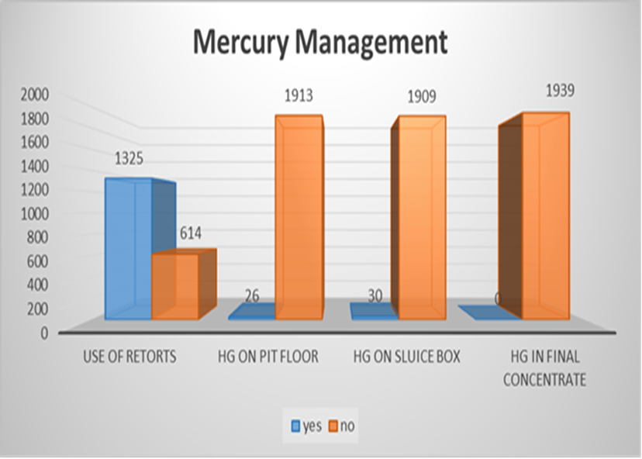
Data gathered by the Division pointed to the issue of sanitation on river dredges as a hazard to be better addressed. A toilet system to render human excreta benign was determined a viable solution which the ED commenced promoting to the four hundred (400) plus larger dredges that can adopt the system.
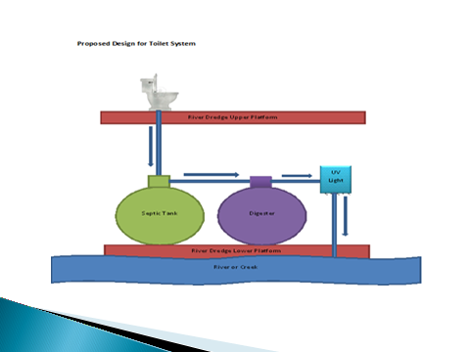
*this Project is expected to be practically implemented by River dredges in 2014-2015
The Environmental Division pursued Hydroponic Gardening in Mahdia as a research project to address mined out areas which have to be reclaimed. Miners and residents in Mahdia were very interested.
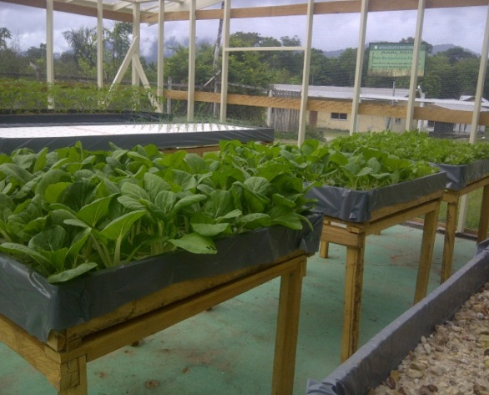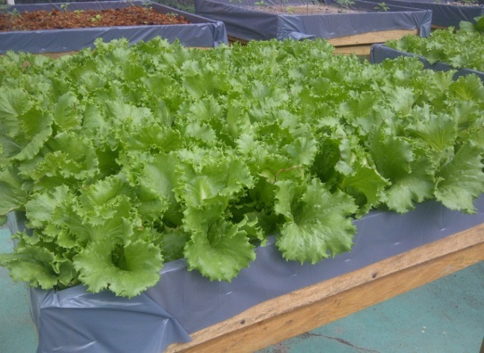
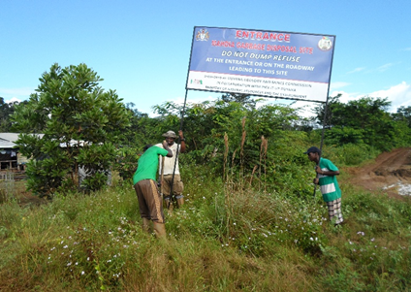  Above: signs being erected by the team | 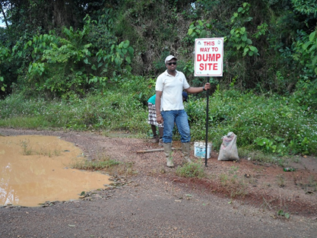  Above: signs erected along the roadway of Mahdia Showing the direction to the dumpsite
The Environmental Division responded to Environmental Investigative Complaints such as involving issues of several unlawful operations in the Kaieteur National Park and along the Amalia Falls access road, which were quickly arrested.

In 2014, the Division embarked on an Environmental Clean- up in Mining Districts between the 12th and 19th July, 2014. New waste disposal facilities were constructed while garbage bins with covers (40) were distributed to dwellers on the landings. Community activists and land dwellers were engaged and issues of the sanitation in the community were highlighted. Mahdia, Port Kaituma and Itaballi were targets for this intervention.
Above: signs being erected by the team | Above: signs erected along the roadway of Mahdia Showing the direction to the dumpsite

OSH Inspections/ Investigations & Mining Accidents:

This was the most difficult task for the Environmental Division as many times avoidable issues were tempted or occurred due to casual attitudes to OSH. The Ministry Of Labour was a useful ally in this area. There were fifteen (15) fatalities due to mining related accidents for the year 2014. Pit-wall failure/ tunnel collapse were the leading causes of fatalities. It was determined that ignorance and/or greed being the catalyst for most of the mine disasters.

Mining District | Number of Fatalities 2014 | Number of Fatalities 2013 | Causes of Accident
1 | 0 | 0 | Nil
2 | 7 | 3 | Pitwall Failure/Drowning
3 | 1 |  | Falling Tree
4 | 0 | 5 | Pitwall Failure
5 | 2 | 3 | Falling Tree/ Drowning
6 | 3 | 1 | Pitwall Failure/Tunnel Collapse
Region 10 Bosai | 2 | 3 | Vehicular
Total | 15 | 15

Within GGMC HQ and Stations, there were also issues where less than the standards enshrined for OSH were to be found, due to insufficient accommodation for workers.
Reclamation work facilitated by the Environmental Division targeted Mahdia and Puruni. With stabilization of mined out areas erosion was abated and turbidity in waterways is alleviated. A total of eight (8) sites along the Puruni River Bank were earmarked for Rehabilitation/Reclamation. At St. Elizabeth the Maintenance of rehabilitation sites St. Elizabeth, Noitgedacht and Block # 27 including the school farm at Mahdia, Potaro MD #2 were continued to be manned by GGMC’s Officers who were stationed at Mahdia.
At the St. Elizabeth reclamation site persons were using a blue water pond as recreational venture with the aim of developing the area for jet skiing, swimming, etc. While eco-tourism can be conceived, the issue of safety as it relates to slope failure, depth and water parameters all need to be signalled to the public. Warning signs were erected in this area.
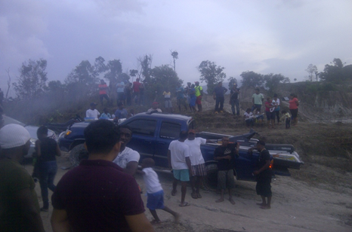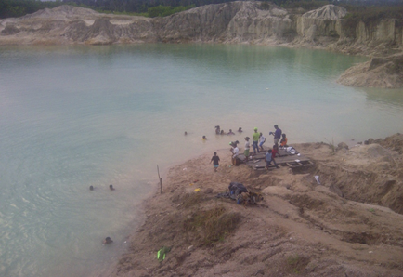

The Environmental Division participated in the annual Mining Week Activities which took place in various locations. The Theme for the year’s celebrations was “Improved Recovery, Reducing Impact, Securing the Future”. Activities that were conducted were; Outreach and Playoffs in Mahdia on 23rd August, 2014, Outreach, Playoffs and mini Concert at Port Kaituma on 27th August 2014, Pre-Pork Knocker Day Mini-Exhibition Bartica on 29th August 2014, Pork
The Guyana Geology and Mines Commission’s Medical Unit collaborated with Mahdia Hospital Staff in the Medical and Health Booth at the Exhibition. They distributed various health pamphlets, posters and fliers; condoms and treated mosquito nets to residents and miners from the Community.
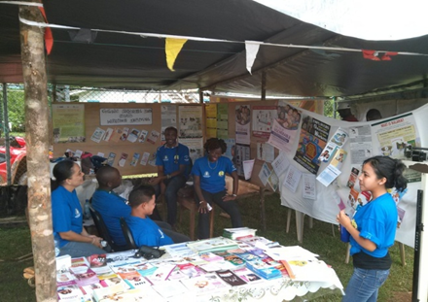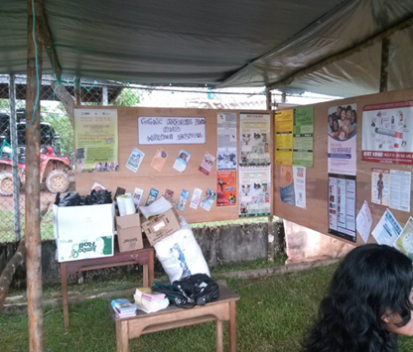

The Environmental Division enjoyed useful stakeholder relations with the World Wildlife Fund, Protected Areas Commission, Environmental Protection Agency and others, in the progress and development of crosscutting issues such as the Low Carbon Development Strategy, Green Economy concepts, mercury free initiatives and preservation of nature reserves. A manifestation of this was the submission of the Progress Report dated June 30, 2014 by the WWF-Guianas for the Project titled “Capacity Building in Environmental Management for the Gold Mining Sector in Guyana”. The issue of mercury abatement; best practices in the mining sector; and the development of a National Action Plan for the sector were aspects of this project.
The Division was represented at Conferences, Seminars and Workshops during 2014. Countries can access support from within the sub region (Brazil) so that they may advance towards the ratification of the Minimata Convention on mercury at the earliest time.

Staffing, Successes, Constraints and Projections
The structure of the Environmental Division is aligned in keeping with the core activities, such as Environmental Research, Environmental and OSH Compliance, Environmental Management, Mine Site Reclamation, Fortnightly water sampling, OSH inspection, Health Care etc. The Division with fourteen (14) officers was seriously under staffed during 2014. Constraints faced in addition were inadequate office space and conditions for maximum output. Never-the-less, there were successes in 2014 in the areas of waste management in communities, reclamation projects, coordinated enforcement in protected areas, important stakeholder alliances and inspections for compliance throughout the sector.
In the final analysis, environmental management in the mining industry should be an ongoing activity, with all products and processes being put under regular review, so that full advantage can be taken to improve on current practice. It should be integrated with all aspects of the Operation’s Management, and it should take account of regulatory standards for environment management that already exist and are further being developed.
Petroleum Division

Petroleum Division completed a significant number of tasks under their programmed activities. In particular the Mara Drilling and Hogg Island Drilling for shallow gas occurrences, the sweep to locate any new occurrences hydrocarbons evidence in the Northwest District and the Gas Storage Facilities Maintenance exercises. In an effort to avoid delays in the field, Drill Section completed a major equipment rehabilitation exercise. The outcomes from these exercises did not yield any significant new clues to onshore indications of hydrocarbons which is the fundamental objective for the area which is poorly explored mainly due to accessibility and associated high risk in achieving positive outcomes hence the Division’s continued effort is to alleviate this reality. Archive Maintenance started early in the 1st Quarter with the imaging of samples/cuttings taken from previous boreholes drilled by Petroleum Division in 2012-2014. This was mostly completed by the end of 2014; but not much more was achieved due to preoccupation with drill equipment and other assigned tasks including monitoring as a number of company driven obligations were achieved.

In particular were; the CGX Demerara block 3D seismic sparse acquisition; the predrilling geotechnical survey by CGX in the Corentyne Block; the environmental baseline and geotechnical survey by Esso over their Liza and Sorubim prospects; the aerial gravity and magnetics survey over the ON Energy Inc. Berbice Block. Processing and interpretation were being done throughout the year by Repsol Exploracion Guyana S.A. and partners Tullow Guyana B.V.,and RWE. Esso Exploration and Production Guyana Ltd. Opened their onshore operations office in November 2014 as a preparation for their drilling functions and new partners Hess Guyana Exploration Limited and CNOOC Nexen Petroleum Guyana Limited were also assisting in the refining of their data interpretation and engineering for their first deep exploration well in deep water to be commenced in early 2015. Meanwhile, Anadarko remained inactive in the light of the Venezuelan navy action of October 2013 which seized their contracted survey vessel.
Onshore work by Nabi Oil and Gas Inc. was experiencing surface access difficulties. Canacol Guyana Inc. in the Takutu Basin has lost interest and this will be formalised in due course.

No new contracts were signed during 2014 but there continued to be genuine interest in the basin. The Oil Quest Technical Evaluation Agreement was ready for signature but was not finalized, the applications by MidAtlantic Guyana Oil Inc. and Eco Atlantic Guyana Inc. for their respective interests were advanced through discussions which commenced in earnest late in 2014.

Implementation of tasks within the Institutional Continuity Activity when compared to 2013, for a number of personnel benefitted from short-term training. Three GGMC staff members have taken advantage of the post-graduate scholarships (REPSOL and TULLOW) in petroleum-related subjects, offered to them; these staff are attending Universities and should complete their studies in September 2015. No other developmental studies commenced during 2014.

Of general interest was the continued work concerning Oil And Gas Policy which involved the Commonwealth Secretariat together with the MoNRE. In March, Drs. James Austin and Harm Van Avendock of the Jackson School of Geosciences, University of Texas at Austin visited GGMC and made presentations on Plate Tectonics and Margins. The duo intended to acquire the attention of the Government of Guyana in participating in a planned regional offshore Plate Tectonics and Margins study to include the Offshore Guyana Basin.

In concluding, the Petoleum Division did accomplish much of its work-programmed tasks. The Lower Pomeroon Surface Resistivity Exercise had to be postponed due to competing monitoring activities for onshore/offshore petroleum companies’ programmes. There was a healthy diet of oil company activity in accordance with their work obligations, in Guyana.

HUMAN RESOURCES AND ADMINISTRATION DIVISION
The Human Resources and Administration Division supports the technical divisions of the Commission in the execution of their mandate.

STAFFING FOR THE PERIOD JANUARY – DECEMBER, 2014
The Staff complement of the Guyana Geology and Mines Commission as at December 31st 2014 was four hundred and twenty-four (424). Employees were attached to the various divisions/departments/sections as follows:

Office of the Commissioner 19
Office of the Deputy Commissioner 6
Geological Services Division 54
Mines Division 152
Finance Division 34
Human Resources & Administrative Division 91
Environmental Division 18
Petroleum Division 9
Legal Services Division 4
Special Projects Division 5
Audit Division 8
Land Management Division 24

STAFF MOVEMENTS
(i) Of the forty-nine (49) new staff employed during 2014, nine (9) were professionals and fifteen (15) were clerical.
(ii) There were seventeen (17) promotions, six (6) resignations, three (3) dismissals and three (3) retirees.
(iii) Twenty (20) staff benefitted from training and development of which ten (10) were for on-going programmes. In-house training was particularly relevant since in some quarters, ISO quality standards were in play.
(iv) Eighteen (18) persons were on scholarship for geo foundation programmes. Six (6) scholarship students graduated in Geological Engineering to join the staff of GGMC.
(v) Eight children of staff received bursary awards for Grade Six Assessment results in 2014.
Staff Actions
GGMC Staff proceeded on strike action during the period November 17 – 21, 2014, under the Guyana Public Service Union to press management for increased salaries. The Board of Directors and the Ministry of Labour brokered terms of resumption on November 21, 2014 wherein staff were to be paid as an interim measure an across the board increase of 8% and management promising to expend all efforts to have a definitive position on the request for payment as presented in the Compensation Management Proposal by SV Jones Associates. Staff resumed duties on November 24th, 2014.
Long Service Awardees For 2014
There were eighteen (18) staff with service of ten (10) to Thirty-five (35) years.
SERVICES DEPARTMENTS
The Commission’s fleet of vehicles continued to be inadequate for the expanded work programme demands and incompatible maintenance and repair turn around schedule to be undertaken by the Mechanic Workshop, especially giving regard to the remote locations of deployment. Even at full stretch, internal support from the Carpentry and Electrical Workshops was satisfactory and reliable during 2014.
Library and Information Department
This department has outgrown its location and suffers from regular flooding. It continues to provide a valuable service to the Commission’s customers. The department also provides outreach during the year and is at the vanguard of the GGMC presence at exhibitions, fairs and town days where fliers, booklets, CDs and Lapidary Products are promoted and sold.
Security
Fortunately there were no major security incidents during the year but there were obvious indicators that the security of the Commission should be upgraded, given the increased interface with the public both at HQ and District Offices where there is no standing security presence.
Registry
The Commission’s central Registry Department executed its responsibilities without undue complaints from their customers; however, the compliment of staff and their coordination have to be continually examined so that the expected efficiency could be maintained.
In closing, the Administration and Human Resources Division were equal to their challenges through 2014 but their functional importance requires some strengthening if the Commission is to continue to cope adequately with their responsibilities.

INFORMATION TECHNOLOGY (IT) DEPARTMENT

The activities of the Information Technology (IT) department for 2014 were guided by the following strategic objectives:

Strategic Objective 1
To develop state-of-the-art administrative, management and information systems in order to achieve greater productivity, accessibility, accuracy, accountability and timeliness in the provision of services, products and reports for external and internal customers and management. Key to the objectives were; a Computerized Human Resources Management System (HRMS) that was rich in functionality, scalable, secure, customizable and easy to use. Information that is stored in such an application includes personal data such as academic qualifications, disciplinary records, employment history. The system was completed and installed; the data input exercise was progressing well; a new GGMC Website, developed with improved usability, using a web content management system (WCMS); the WCMS facilitates the management and maintenance of the website by any user with little knowledge of mark-up and web programming languages.

Strategic Objective 2
To enhance data and information generation, analysis, storage, access, retrieval, reproduction and dissemination, for decision making, policy making, promotion of the Mining and Petroleum Sectors. Key to this objective were; Claims Database Application where the outcome was more efficient management of claims information and accessibility at head office and the various mining stations; Mines Check List application where the outcome was the checklist being successfully computerized; the reports being automatically compiled accessible at head office and across the VPN from the mining stations.

Strategic Objective 3
To support and provide advice for the on-going improvement in an integrated computerized management and information system. Key to this objective were; the implementation of a Virtual Private Network (VPN) between the head office and the various mining stations, the outcome being field access to updated HQ data for claim monitoring; a Satellite Internet Installation for satellite internet service at Issano 14 Mile.

Strategic Objective 4
To develop and retain a range of requisite skills for the efficient and effective application of IT based systems. Although there were no training and development activities planned or executed for the IT Department during 2014, the Department was conscious of the need to attract and retain such a range of skills for sustained development.

LEGAL DIVISON
During 2014, the Legal Division provided support to all the Divisions of the Commission and the offices of the Commissioner and Deputy Commissioner. Support was also extended on occasion to the Ministry of Natural Resources and the Environment and the GGMC Board of Directors.
The type of issues varied. Mostly issues arising were in relation to: dispute over ownership of mineral properties; guidance delivered in the drafting of legal correspondences; actions that were required in the preparation and filing of Affidavits on behalf of the Commission in court disputes; explanations and legal opinions on judicial orders and in relation to memoranda and agreements involving the Commission.
The highlights for 2014 were: the litany of litigation issues that confronted the Commission in addition to on-going matters (there were twenty-six (26) new matters instituted against or involving the Commission while for 2014, there were ten (10) matters completed and at year end 2014 there were fifty-two (52) extant matters involving the Commission); where prosecution was instituted for breaches of Cease Work Orders and Mining without lawful permission, the majority were settled out of court.
The Legal Division did have a strong role in the concluding of the Mineral Agreement for ETK Sandsprings Resources which became a template/specimen for those agreements to follow such as for Troy Resources Guyana Inc. Importantly also, was their input to the interagency discussion on Guyana’s Maritime Zone Regulations pursuant to the Act of 2010.
Legal Division took the lead for GGMC in the issues of the EITI, Anti-Money Laundering/CF and remained the point of reference for the Kimberley Process. The Division was very busy and truly challenged in 2014; a situation that appears will not change therefore, active capacity building relevant to the GGMC on a continuing basis had to be in place.
With the compliment of only two (2) Attorneys-at-Law, one (1) Assistant and one (1) Research Officer, the Division did provide quite well under the circumstances, the important legal function to the Commission and associated parties.

INTERNAL AUDIT DIVISION
The Internal Audit Division is tasked with providing independent and objective assurance designed to add value and improve the GGMC’s operation.
Internal Audit Division carried out Administration Audits for 2014 to test the Human Resource norm and standard practices and internal control procedures which were found short in certain areas and corrected. For example, the Commission does not have any current policy on weapons and ammunitions for persons visiting the Commission which had serious implications for employee’s safety and providing a secure business environment for external customers for both GGMC and the Guyana Gold Board. Similarly, the Work Shop Audits revealed where more attention to administrative procedures were required.
The regular Auction and Lottery for properties by GGMC were at other areas audited. For the scale of the exercise, the Audits indicated a high degree of compliance.
Financial audits were done in 2014. The Payroll, Verification of Balance, Stores and Purchases, Overseas Traveling, were targets. Unfortunately, there were deficiencies revealed in supervisory functions where care of records and completion of documentation should be addressed more stringently.
Field audits conducted in locations such as Eclipse Falls, Bartica and Puruni, indicated that systems were generally in order but care of reporting and chain of custody needed more attention as well as the conformance with the requirements to identify GGMC assets.
The Division’s audits of the ISO systems during 2014, gave support in the interim and ensured that the Commission was prepared for the regular ISO external audits and reviews. While it was typically an extra effort to ensure the internal audit findings were responded to, the rewarding outcome was that the integrity of ISO certification remained in place for 2014.
Special investigations were required when certain geological exhibits went missing. This prompted a special verification of assets in certain areas and the intention to place greater attention to this aspect of audits in order to keep such occurrences to a minimum. The chronic finding has been that attention to documentation was insufficient and especially where it was tied to standing operating procedures that were instituted to avoid items/records being misplaced and/or stolen. All GGMC locations were alerted for better control of this issue.
General recommendations resulted in specific measures such as supervisory checks on compliance with procedures as well as the marking/remarking of all GGMC assets. It was a fair conclusion, therefore, that the Audit Division’s functions were particularly important during 2014 to the managing of GGMC affairs. The commencement and professionalism were commendable attributes of the Division as the work objectives were attended to.
FINANCE DIVISION
Functions and responsibilities of the Finance Division cover areas of Accounts, Stores, Purchasing, Budget and Finance. All these areas functioned quite well during 2014. A critical aspect of their work was Budget and Finance. The 2014 Budget and Work Programme were approved by the Board of Directors at its meeting of December 4, 2013. It was revised on the basis of a half yearly review of actual and budgeted revenues and expenditures for the period January-June, 2014 and approved retrospectively at the Board of Directors’ meeting December, 16, 2014.

Original and Revised Budgeted Figures For Revenue Along With Increases/Decreases
Description | Original Budget | Revised Budget | Inc/Dec
Fees & Fines | $215.4 | $215.0 | 0.4
Permits & Licences | $50.9 | $53.0 | 3.1
Royalties | $5,875.3 | $5,726.0 | (149.3)
Rentals | $2,098.5 | $1,562.0 | (536.5)
Internal Income | $459.3 | $1,033.0 | 573.7
Drilling Income | $0.0 | $.012 | .012
Financial & Admin Income | $336.1 | $768.0 | 431.9
Other Receipts | - | - | -
TOTAL | $9,034.6 | $9,357.0 | 323.3

The revised revenue budget as indicated in the above table was increased by $323.3(M) or 3.6% over the original 2014 revenue budget of $9,034.6(M). This increase was influenced largely by the budgeted increases in Internal Income in the first half of 2014 and Financial and Administrative Income (of which a total of $534.3 M was actually received in the first half of 2014 from lottery and auction).
The table following illustrates, that the revised budget for expenditure was reduced by $1,104.0(M) or by 15.17%, of the original budget of $7,275.2(M). The significant reductions were in the areas of Capital Expenditure and Special Projects. The main reason being that planned capital projects e.g., the High Street building, ($383.2M), the procurement of transportation assets ($229.4M), upgrade of Mineral Processing Laboratory ($114.5M), upgrade of Lapidary building ($20.0M) could not be procured in time thus the adjustments to more achievable estimates for the remainder of 2014.

The Original and Revised Budgeted Figures For Expenditure, Along With Increases/Decreases
Description | Original Budget | Revised Budget | Inc/Dec
Employment Cost | $1,104.7 | $1,012.0 | (92.7)
Transport, Travel & Maintenance | $200.4 | $181.0 | (19.4)
Materials & Supplies | $95.4 | $120.0 | 24.6
Rentals & Professional Services | $200.2 | $145.0 | (55.2)
Information, Publication & Legal Services | $36.6 | $57.0 | 20.4
Utilities, Ins. & Financial Services | $86.4 | $146.0 | 59.6
Field Expenses | $700.4 | $700.0 | (0.4) (0.4)
Welfare & Sundries | $64.2 | $64.0 | (0.2)
Assistance to Mining/Central Govt | $2,488.9 | $2,488.0 | (0.9)
Others | $28.2 | $20.0 | (8.2)
Special Projects | $570.4 | $305.0 | (265.4)
Capital Expenditure | $1,699.4 | $933.0 | (766.0)
TOTAL ROUNDED TO 1 D.P | $7,275.2 | $6,171.0 | (1,104.2)

The actual performance of the Commission for the period January 1 to December 31, 2014, was measured against the revised budget that was approved retrospectively in December, 2014, by the Board of Directors.
The total actual revenue (cash basis) for the period January-December, 2014 amounted to eight billion, seven hundred and twenty nine point six million dollars ($8,729.6M). This amount was six hundred and twenty seven point four million dollars ($627.4M) or 6.7% below the revised budgeted figure of nine billion, three hundred and fifty seven million dollars ($9,357.0M). This unfavourable variance is presented in greater detail in the table below, which shows the actual budgeted revenue amounts, the revised budgeted figures and variances.
Revised Budgeted and Actual Revenue Performance for Year 2014 (In Millions Of Dollars)
Description | Budgeted ($) | Actual ($) | Variance ($)
Fees & Fines | 215.0 | 168.6 | (46.4)
Permits & Licences | 53.0 | 41.2 | (11.8)
Royalties | 5,726.0 | 5,070.5 | (655.5)
Rentals | 1,562.0 | 1,479.2 | (82.8)
Internal Income | 1,033.0 | 1,021.0 | (12.0)
Financial & Admin Income | 768.0 | 646.4 | (121.6)
Drilling Income | .012 | .024 | 0.012
Revenue & Other Receipts | 0.0 | 302.7 | 302.7
TOTAL ROUNDED TO 1 D.P | 9,357.0 | 8,729.6 | (627.4)

The major contributors to the short-fall in total actual revenues were the performance of royalty, with a negative variance of ($655.5M). The shortfall in royalty was largely due to the continued drop in gold prices on the International Market. Another factor was gold declaration of 387,507 ozs which was approximately 62,493 ozs below the anticipate declaration of 450,000 ozs.
A total Actual Expenditure (cash basis) for the period January-December, 2014 amounted to seven billion, one hundred and seventy two point eight million dollars ($7,172.8). This amount is one billion and one point eight million dollars or 16.2% more than the revised budget of six billion, one hundred and seventy one million dollars ($6,171.0M). This unfavourable variance was due to the actual expenditure on items such as Employment Cost, Rentals & Professional Services and Unbudgeted Outflows (a category that comprised of advances to staff to conduct the Commission’s business, refunds on PPMS and withholding taxes deducted from transactions for rental to Inland Revenue Department, which were not budgeted for), alone stood at 2,069.9M.
In this analysis of Actual Expenditure compared with Budgeted Expenditure, there were positive variances in categories such as; Capital Expenditure ($495.0M) resulting from capital works budgeted for in 2014, but were not started or not completed in 2014. This included the High Street building ($200.0M), interior buildings ($89.0M) and Special Projects (278.7M). In addition there were transportation assets that were budgeted for in 2014 but were not purchased in 2014; and a positive variance for Assistance to Mining/Central Government ($157.3M) which is a category of expenditure that the Commission does not have total control over.
Net Cash Inflows/Outflows
Total actual revenue for 2014 amounted to eight billion, seven hundred and twenty nine point six million dollars ($8,729.6). Total actual expenditure amounted to seven billion, one hundred and seventy two point eight million dollars ($7,172.8M). This resulted in an actual net cash inflow of one billion, five hundred and fifty six point eight million dollars ($1,556.8M).
The budgeted revenue for 2014 amounted to $9,357.0M and budgeted expenditure amounted to $6,171.0M, thus resulting in a budgeted surplus of $3,186.0M. It is important to note however, that the net actual surplus of $1,556.8M was arrived at with actual expenditure inclusive, of unbudgeted outflows of $2,069.9M. This analysis is summarized in the following table:

Description | Actual | Budgeted
Revenue | $8,729.6 | $9,357.0
Expenditure | 7,172.8 | 6,171.0
Surplus | $1,556.8 | $3,186.0

Accounts & Audit
In 2014, the Finance Division continued its quest for implementation of the AccPac computerized accounting system. To this end, the 2013 trial balance was installed along with the accounts receivable, accounts payable and inventory control modules.
Stores & Purchasing
For the period of this report, these two departments provided the essential services of procurement of materials, equipment and supplies; and maintained adequate levels of stock items, to complement the Commission’s operations at headquarters, the Lapidary, Research and Development Laboratory and in the fields. Materials, equipment and supplies were issued/consigned to the various mining stations, sub-stations and projects in the mining districts.
In concluding, the Finance Division quite adequately executed its service function to the Commission and external customers during 2014.

CONCLUSION
All the Division, Units and Departments of the GGMC have reported for 2014. The core functions for all have been achieved despite certain common constraints such as transportation, staff numbers and office space. While these conditions may have contributed to the industrial action climate, the driver was remuneration. Notwithstanding, in fairly difficult times the mining sector has managed to hold steady and the GGMC as the regulator can report the same.
Shortcomings in performance were obvious, the evidence of mines accidents and the reported incidents of illegal operations which do not go away are areas of concern. However, in the overall reporting there has been a certain optimism which should be assuring to all.

