THE OFFICIAL GAZETTE 22ND AUGUST, 2017
LEGAL SUPPLEMENT — A

GUYANA

ACT NO. 21 OF 2017

ANTI-MONEY LAUNDERING AND COUNTERING THE FINANCE OF TERRORISM (AMENDMENT) ACT 2017

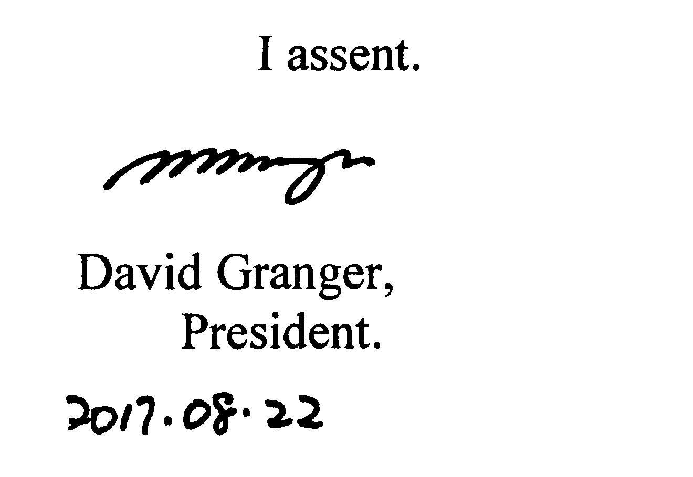

ARRANGEMENT OF SECTIONS

SECTION

1. Short title.
2. Amendment of section 3 of the Principal Act.

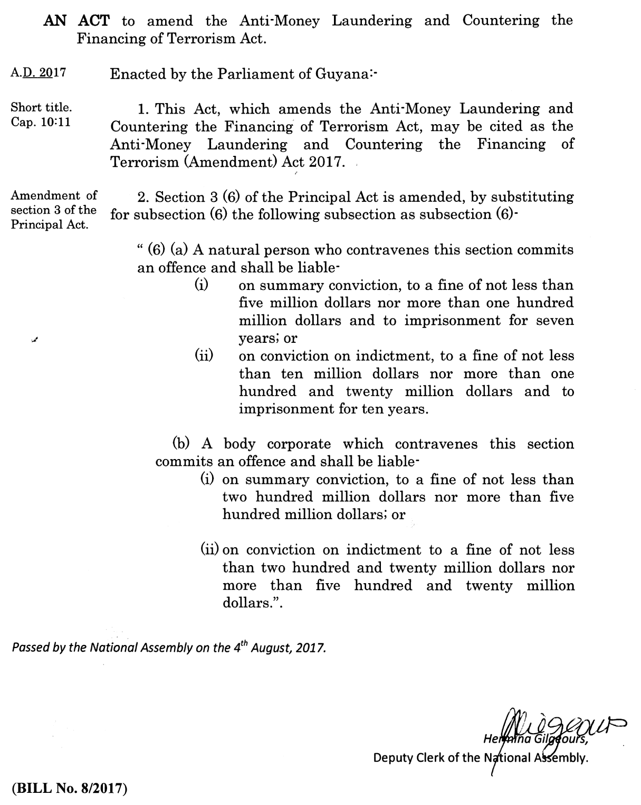

2

