THE OFFICIAL GAZETTE 25TH JANUARY, 2016
LEGAL SUPPLEMENT — A

GUYANA

ACT NO. 4 of 2016

LAW REFORM COMMISSION ACT 2016

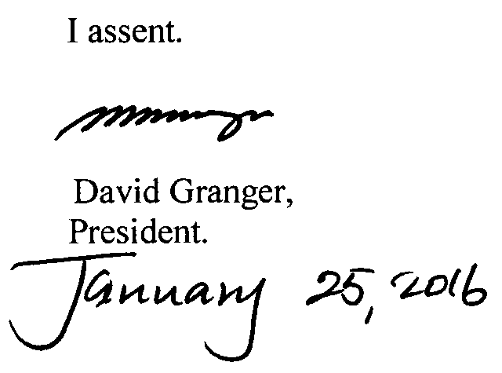

ARRANGEMENT OF SECTIONS

SECTION

1. Short title.
2. Interpretation.
3. Establishment of Law Reform Commission.
4. Appointment and tenure of office.
5. Oath of office.
6. Resignation and termination of appointment.
7. Functions of the Commission.
8. Specialised assistance.
9. Procedure; quorum of the Commission.
10. Officers and employees of Commission.
11. Funds of the Commission.
11A. Budget of the Commission.
12. Chairperson’s report.
13. Annual report.



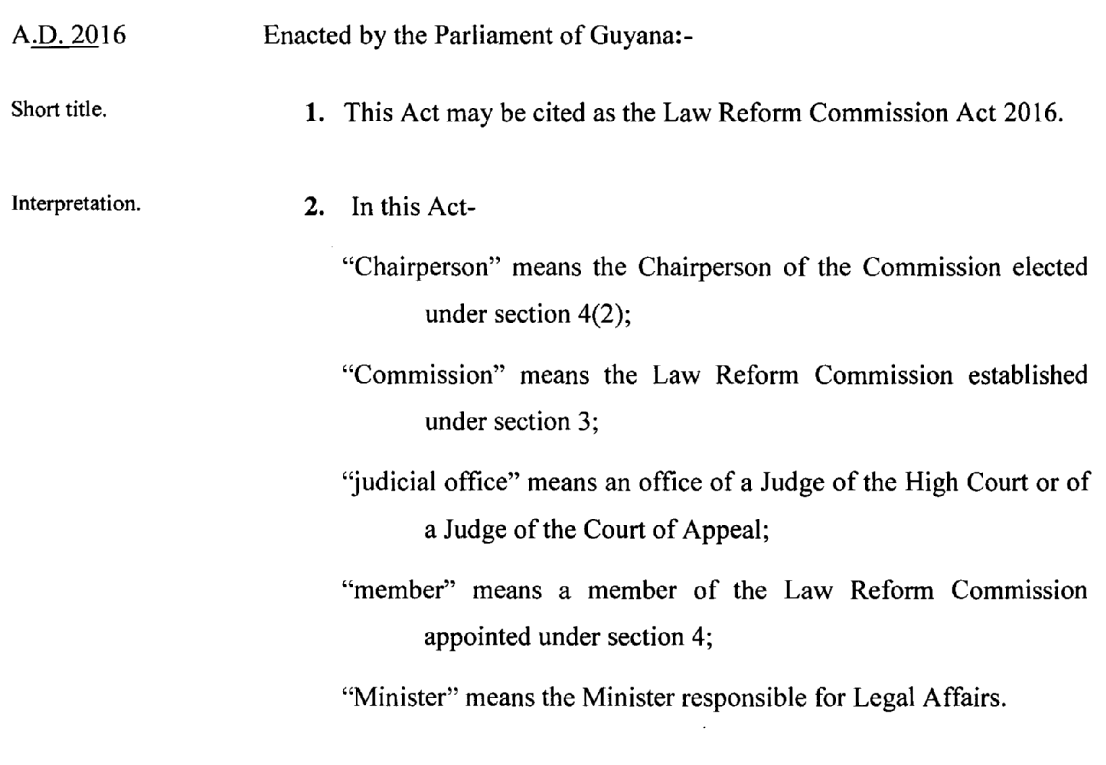

2

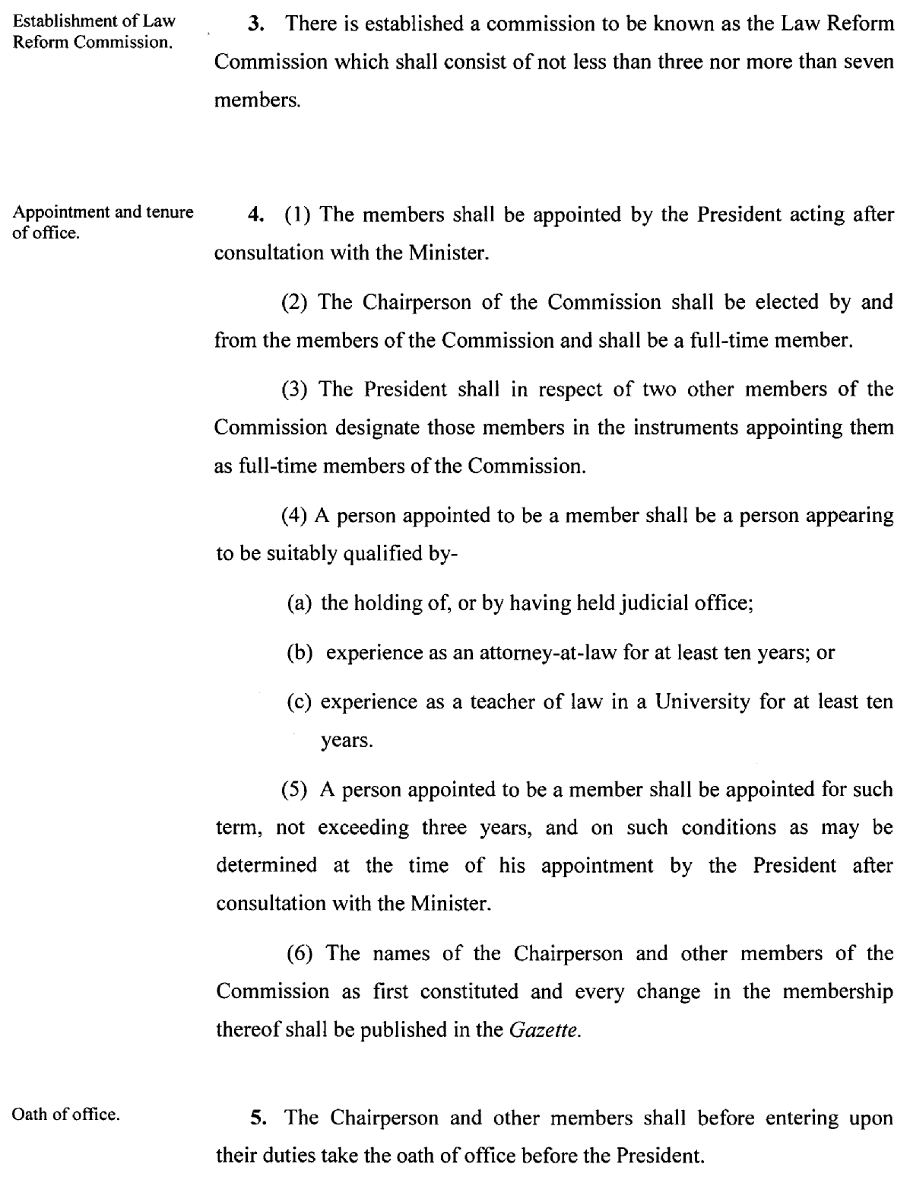

3

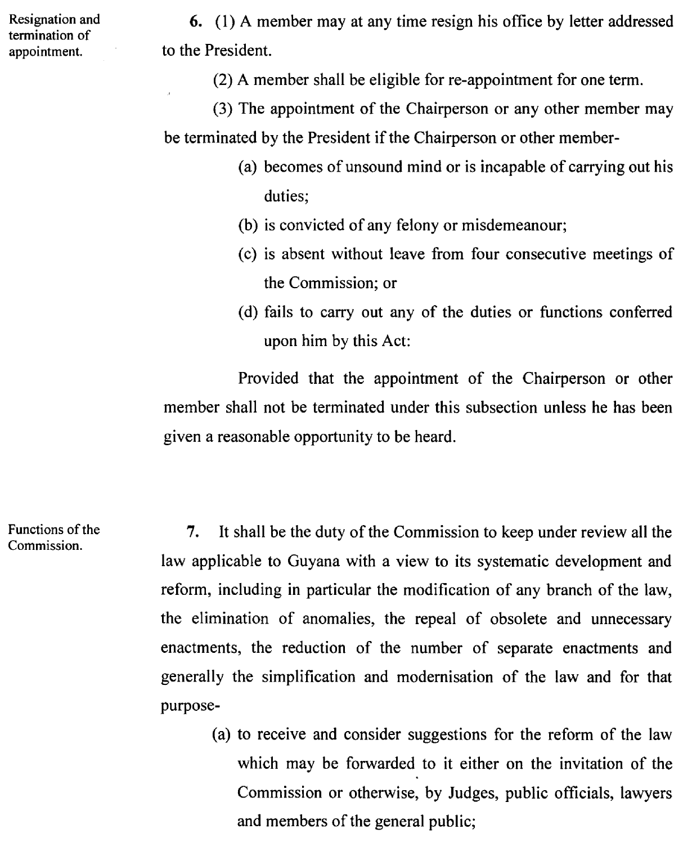

4

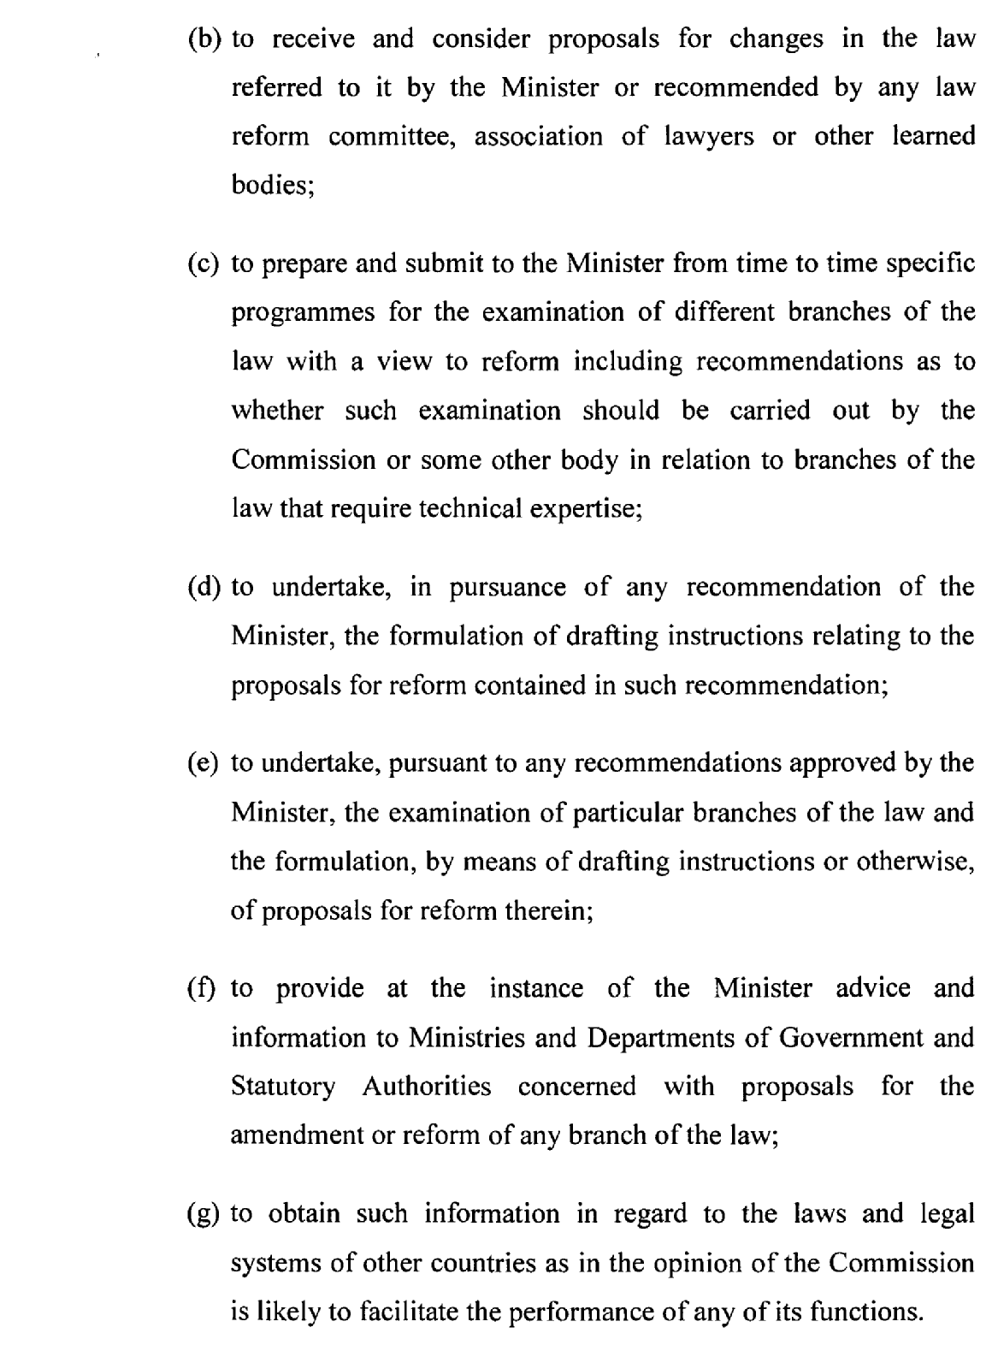

5

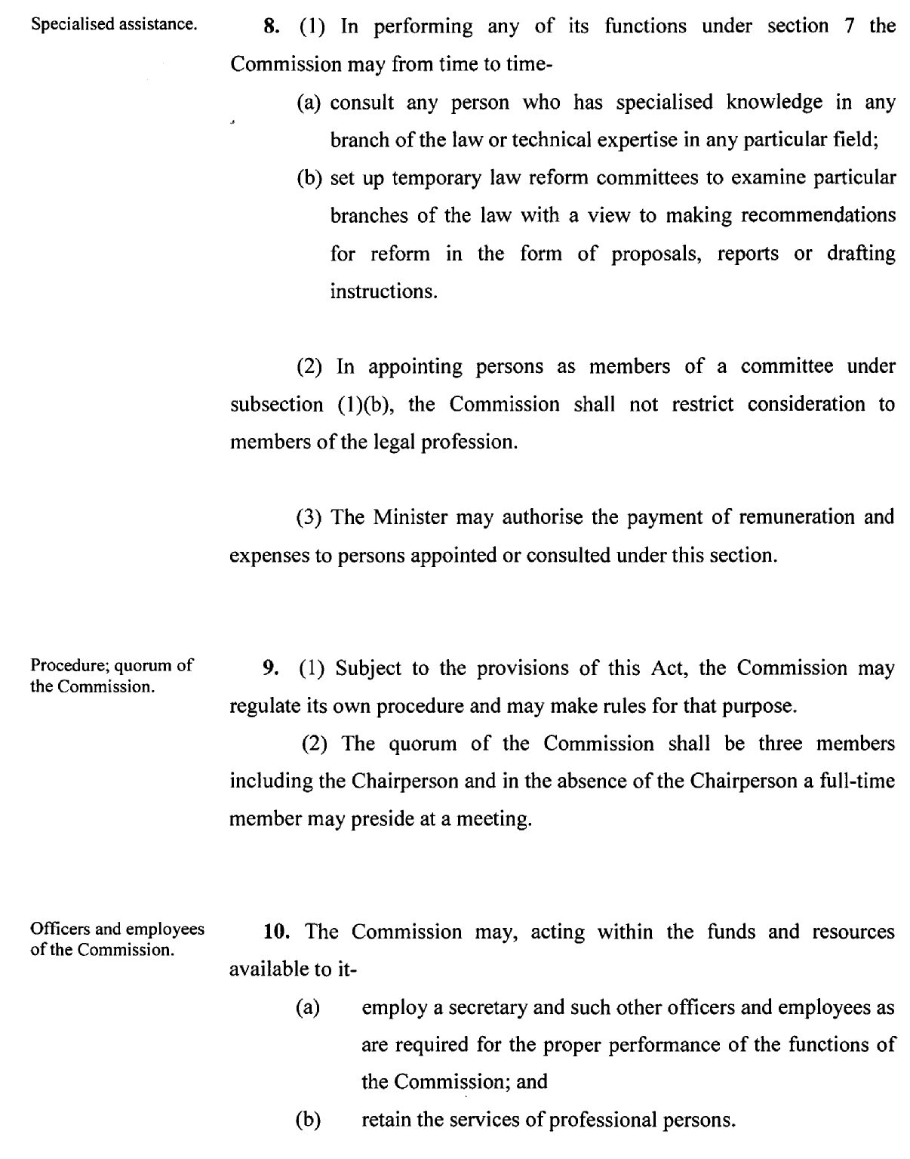

6

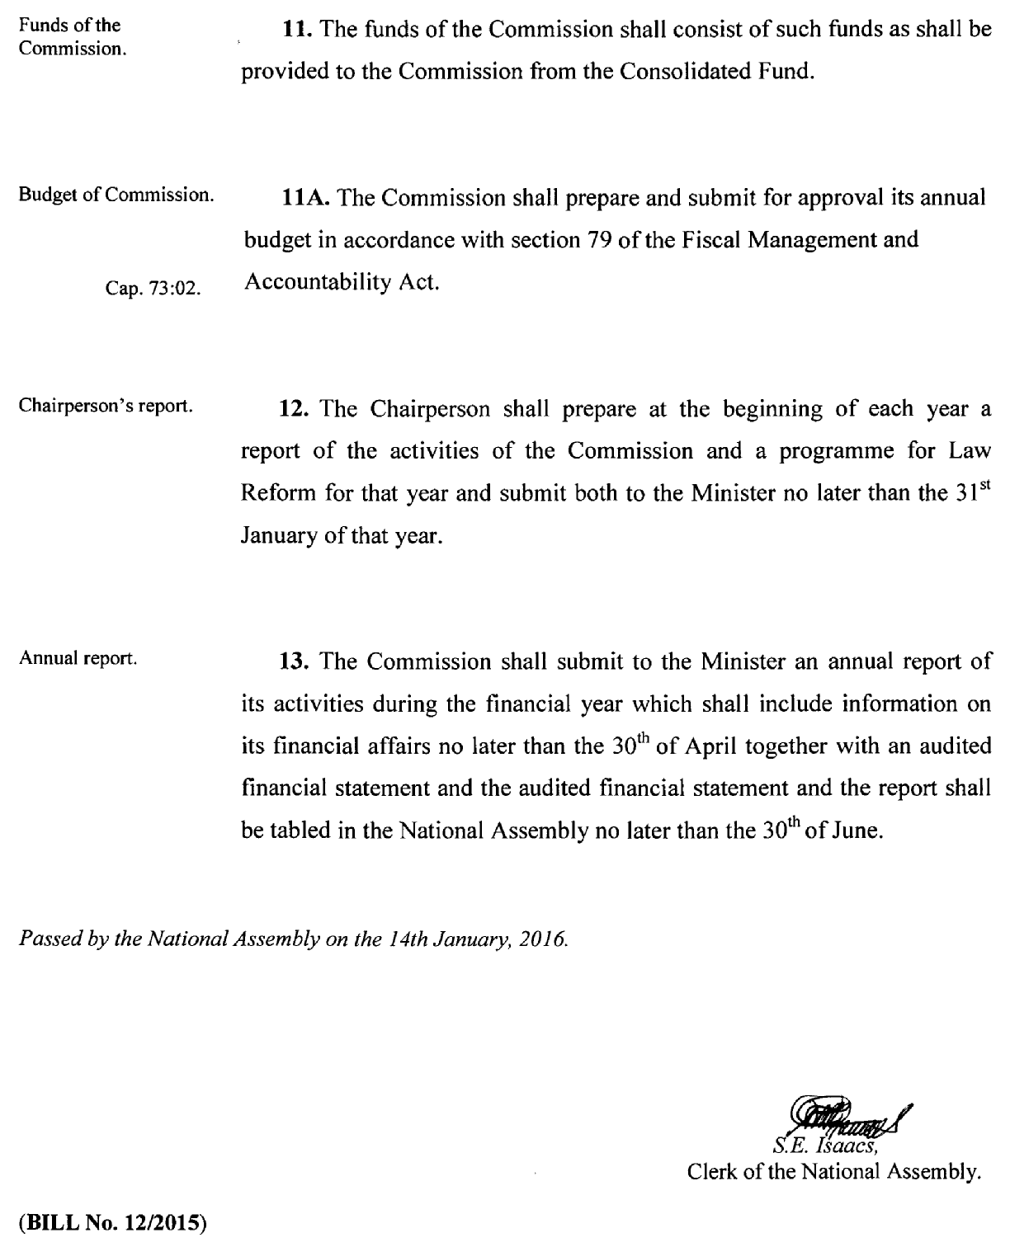

8

