THE OFFICIAL GAZETTE 14TH MARCH, 2016
LEGAL SUPPLEMENT — A

GUYANA

ACT NO. 7 of 2016

MOTOR VEHICLES AND ROAD TRAFFIC (AMENDMENT) ACT 2016

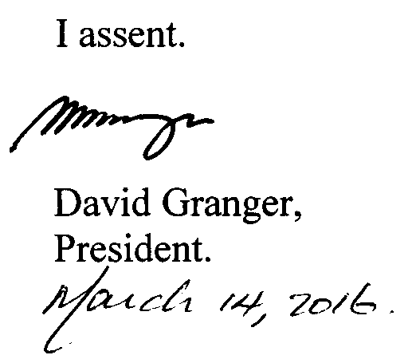

ARRANGEMENT OF SECTIONS

SECTION

1. Short title.
2. Amendment of section 28 of the Principal Act.
3. Amendment of the First Schedule to the Principal Act.

AN ACT to amend the Motor Vehicles and Road Traffic Act.

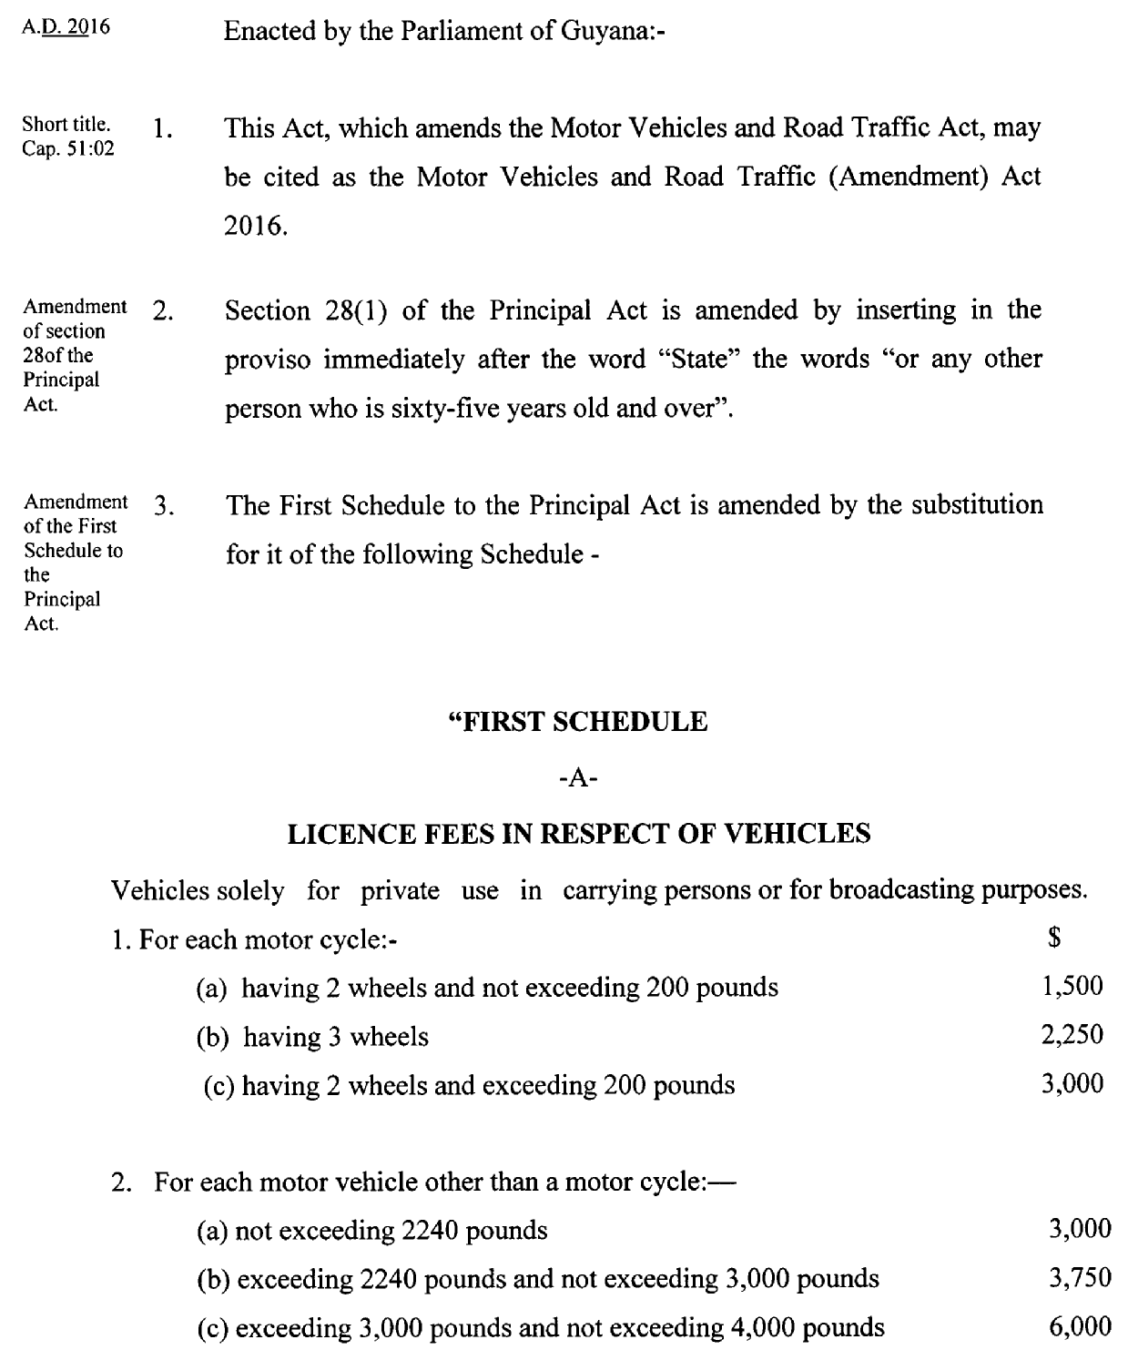

2

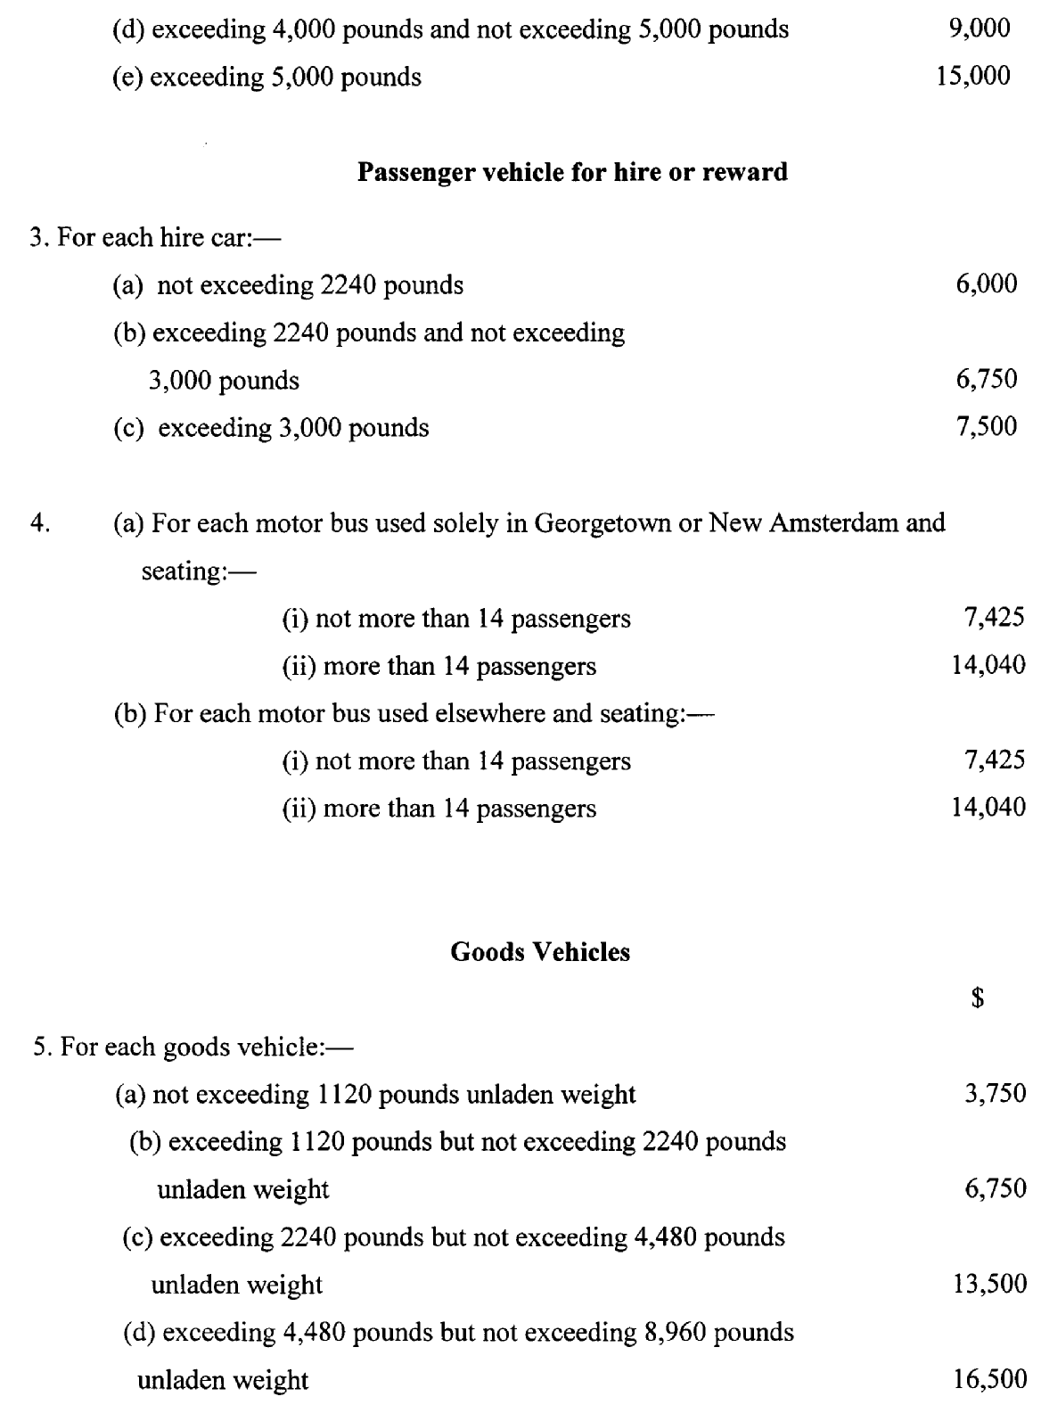

3
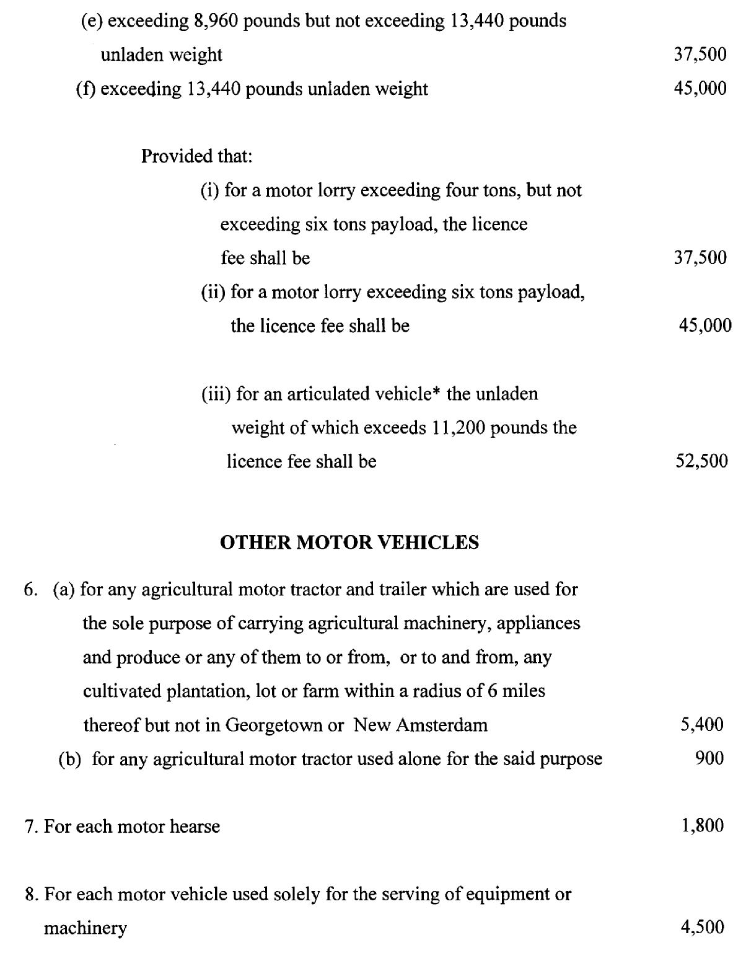

4

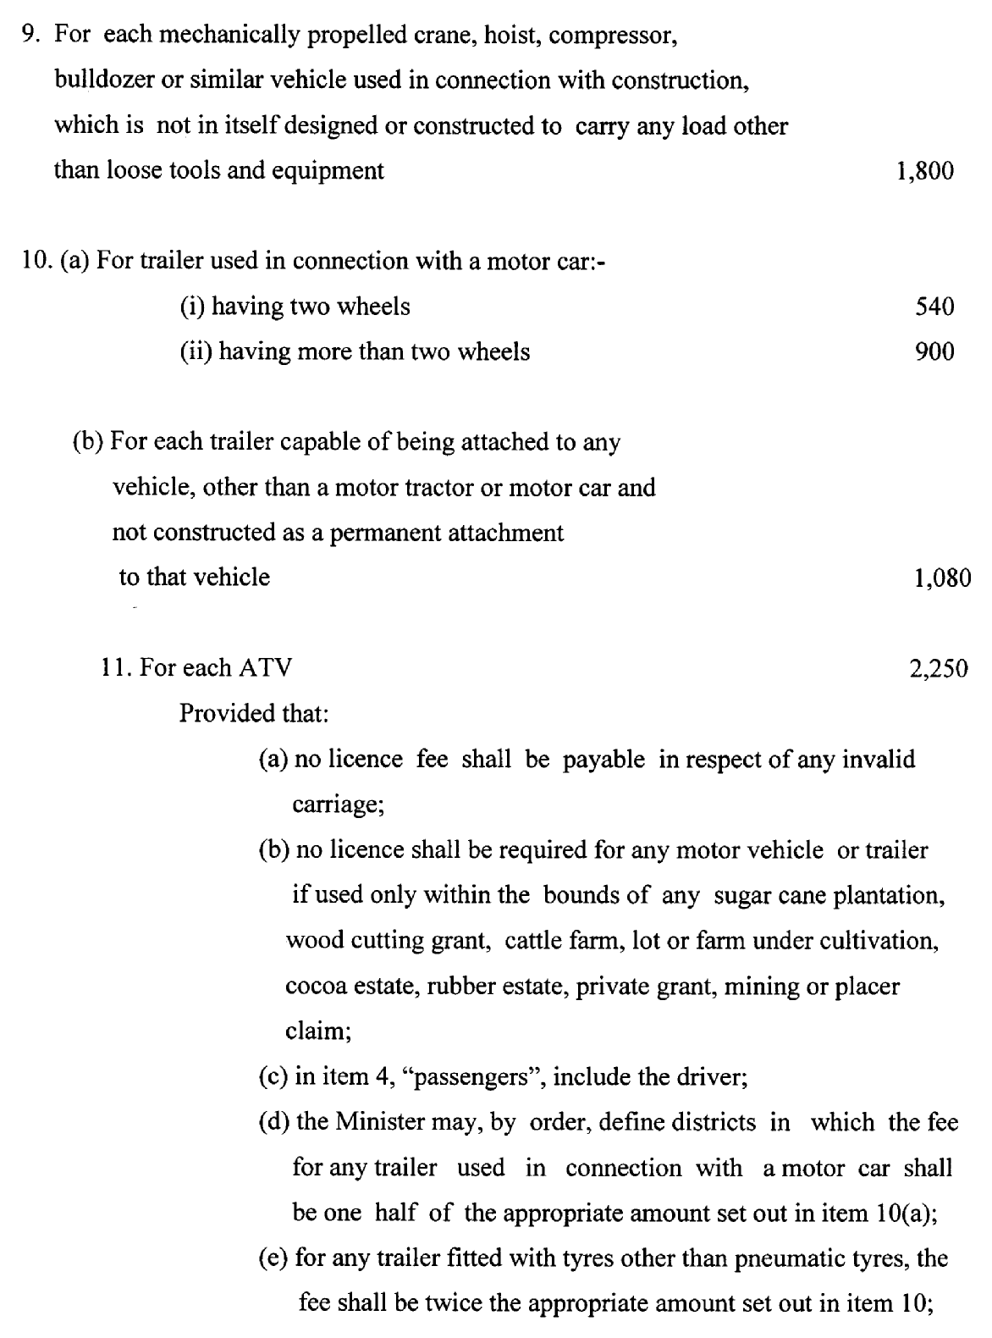

5

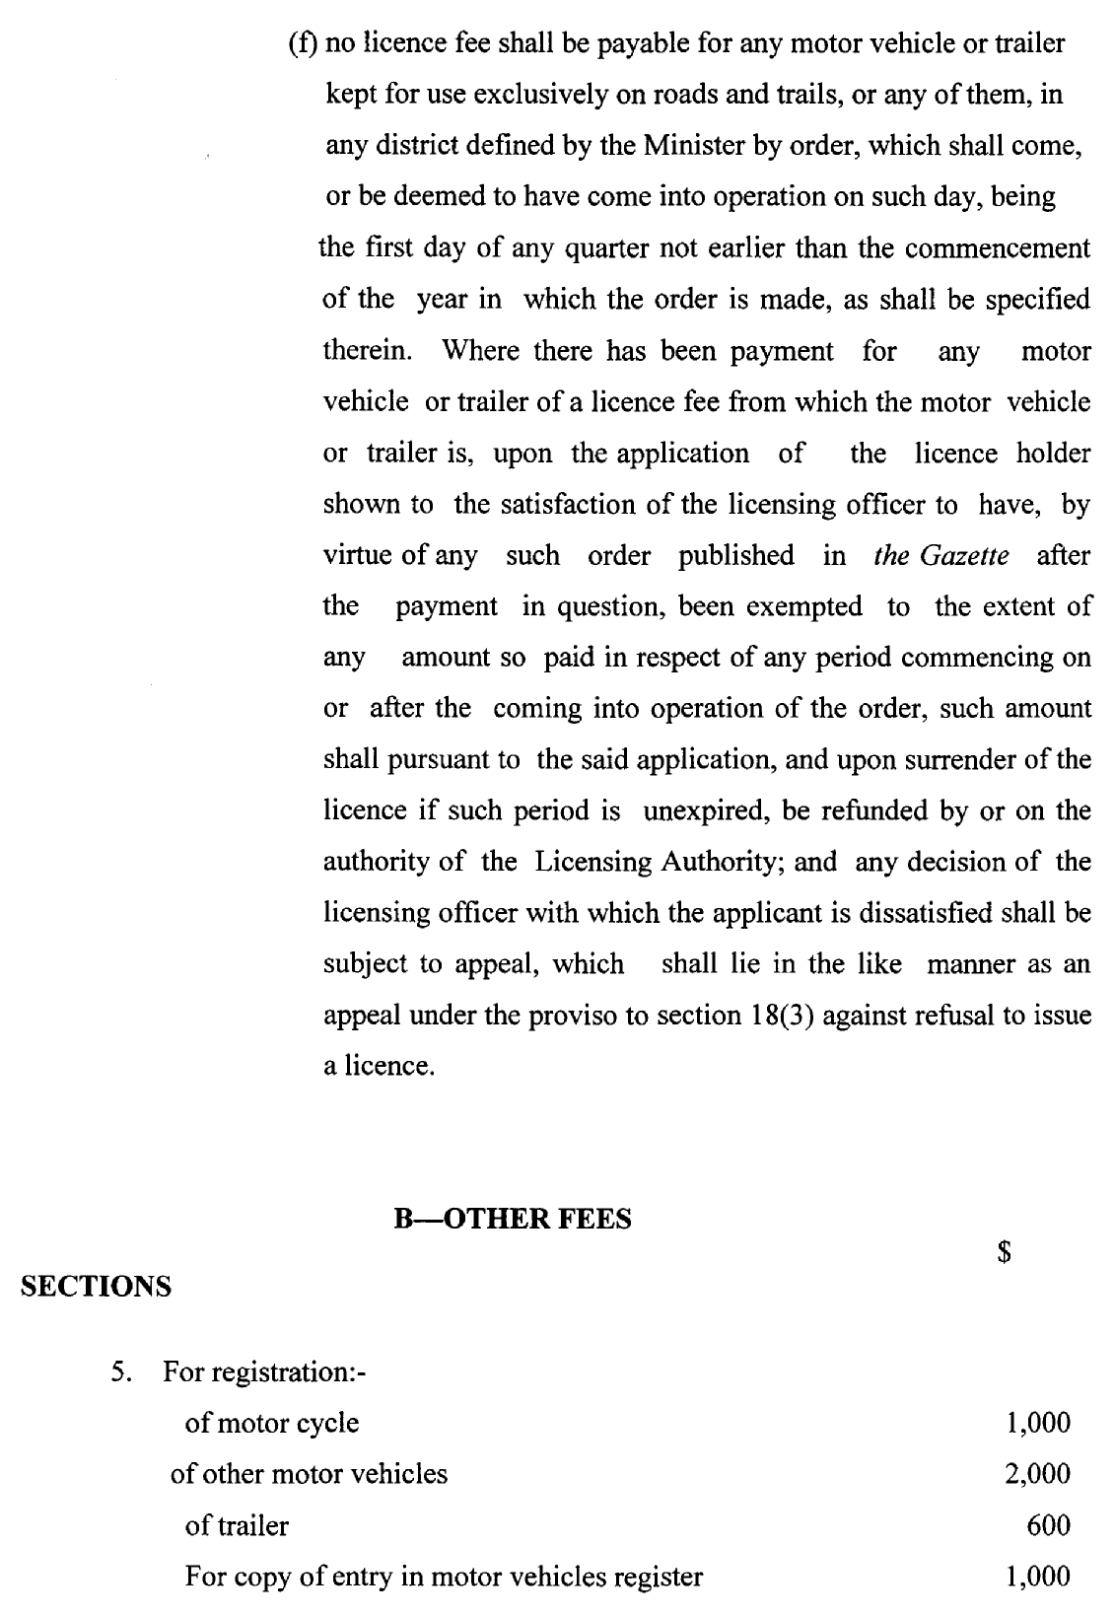

6

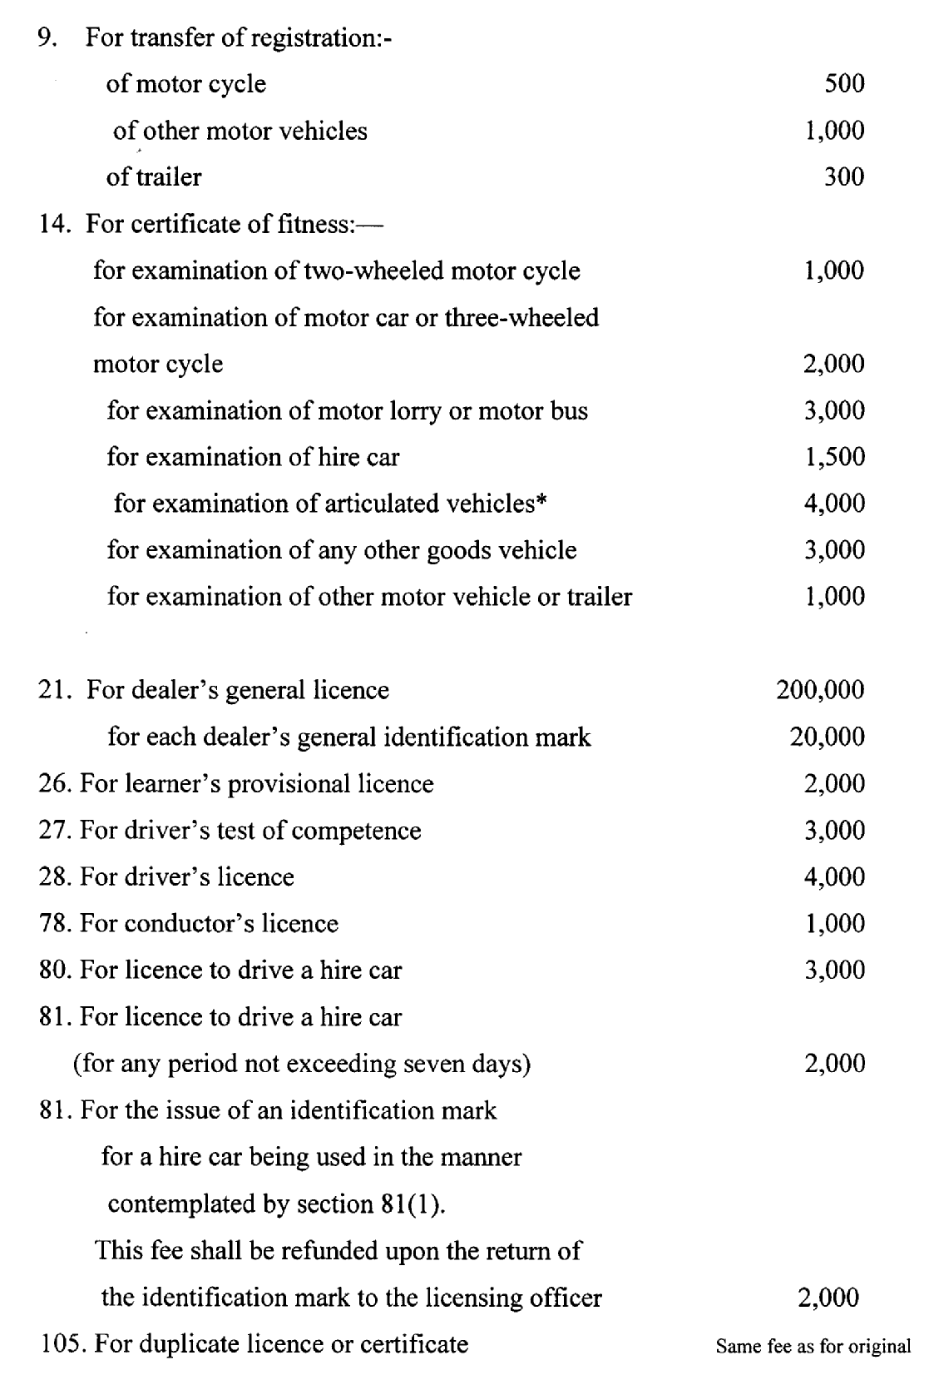

7

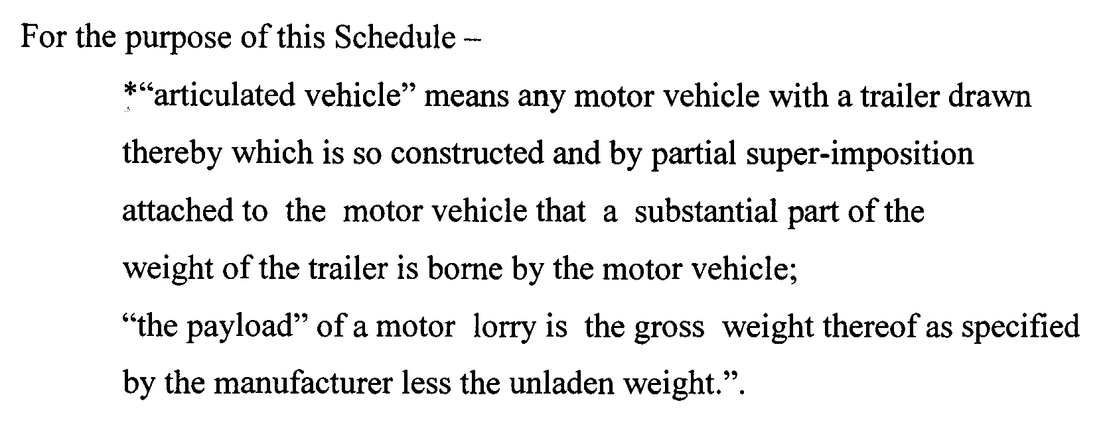

Passed by the National Assembly on the 26th February, 2016.

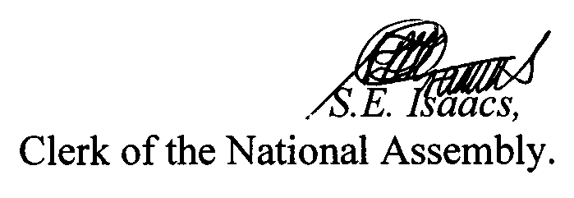

(BILL No. 3/2016)

8

