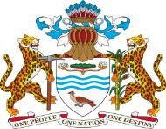

ELEVENTH PARLIAMENT OF GUYANA
FIRST SESSION (2015-2018)
NATIONAL ASSEMBLY

RESOLUTION NO. 95

RESOLVED,
That the Report of the Special Select Committee on the Animal Welfare Bill 2016 – Bill No. 21 of 2016 be adopted.

Passed by the National Assembly on 30th July, 2018

………………………………..
S.E. ISAACS, A.A.,
Clerk of the National Assembly

