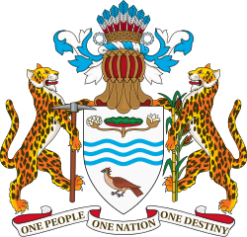

ELEVENTH PARLIAMENT OF GUYANA
FIRST SESSION (2015-2018)
NATIONAL ASSEMBLY

RESOLUTION NO. 68

RESOLVED,
That the Report of the Public Accounts Committee on its examination of the Public Accounts of Guyana for the years 2010 and 2011, respectively be adopted and refer the Report to the Government for consideration.

Passed by the National Assembly on 19th January, 2018.

………………………………..
S.E. ISAACS, A.A.,
Clerk of the National Assembly

