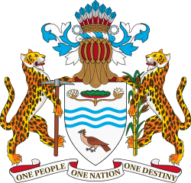

PARLIAMENT
OF THE CO-OPERATIVE REPUBLIC OF
GUYANA

ELEVENTH PARLIAMENT OF GUYANA
FIRST SESSION (2015-2016)
NATIONAL ASSEMBLY

RESOLUTION NO. 26

WHEREAS the Inter-Parliamentary Union (IPU) provides an opportunity to express views on issues of international interest with the aim of bringing about action by Parliaments and provides the forum for the promotion and defense of human rights, which is an essential factor of parliamentary democracy;

AND WHEREAS the Parliamentary Management Committee, at its 13th Meeting, held on Thursday 2nd May, 2014, decided that Guyana should become a Member of the Inter-Parliamentary Union (UPI);

AND WHEREAS the Parliament of Guyana, on 27th May, 2014, made application to the IPU for membership;

AND WHEREAS in order for Guyana’s application for membership to be accepted, the IPU is requesting a resolution of the Parliament of Guyana with respect to Guyana’s application,

/…2
2.

RESOLVED,
That this National Assembly approves of Guyana becoming a Member of the Inter-Parliamentary Union.

Passed by the National Assembly on 10th March, 2016

…………………………………
S.E. ISAACS
Clerk of the National Assembly

