THE OFFICIAL GAZETTE 14TH MARCH, 2016
LEGAL SUPPLEMENT — A

GUYANA

ACT NO. 6 of 2016

FIREARMS (AMENDMENT) ACT 2016

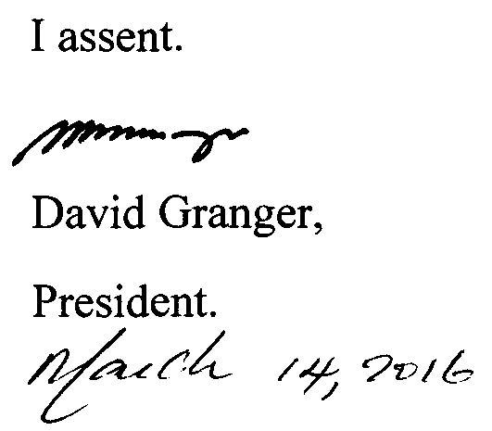

ARRANGEMENT OF SECTIONS

SECTION

1. Short title.
2. Amendment of section 19 of the Principal Act.
3. Amendment of section 24 of the Principal Act.

AN ACT to amend the Firearms Act.

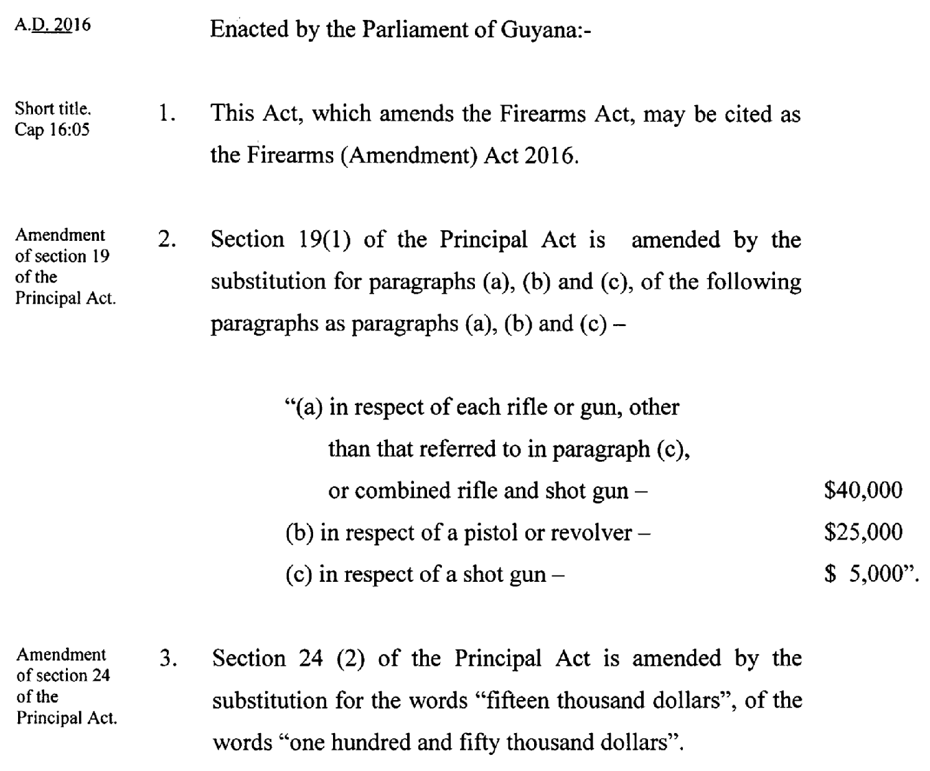

Passed by the National Assembly on the 26th February, 2016.

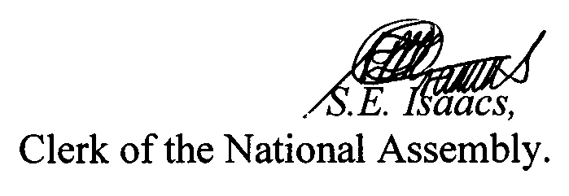

(BILL No. 2/2016)

2

