THE OFFICIAL GAZETTE 16TH JANUARY, 2017
LEGAL SUPPLEMENT — A

GUYANA

ACT NO. 6 OF 2017

INCOME TAX (IN AID OF INDUSTRY) (AMENDMENT) ACT 2017

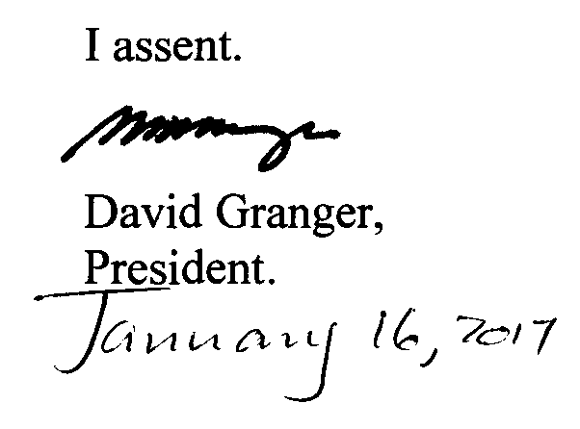

ARRANGEMENT OF SECTIONS

SECTION

1. Short title and commencement.
2. Amendment of the Principal Act.

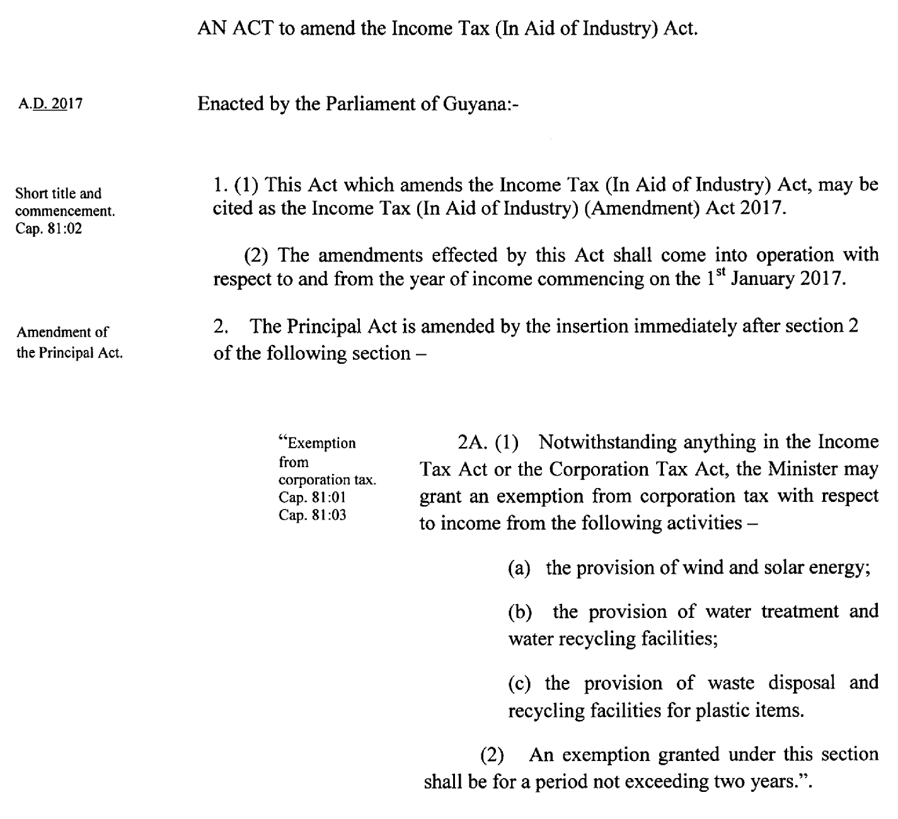

Passed by the National Assembly on the 5th January, 2017.

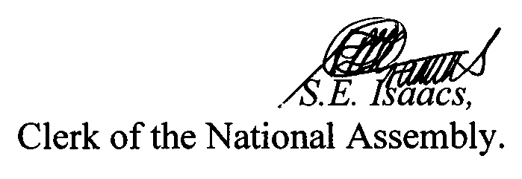

(BILL No. 30/2016)

