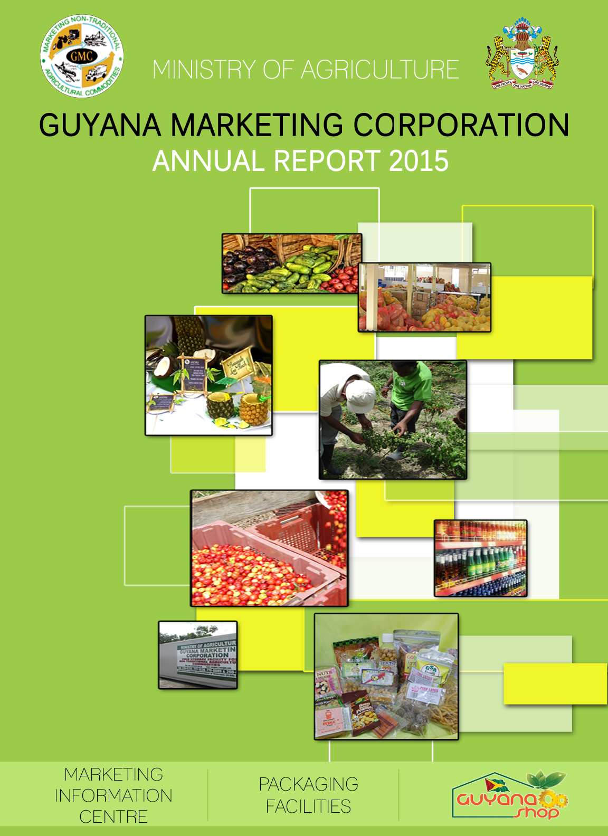


Mission Statement:
Coordinate and facilitate the development and marketing of quality non-traditional agricultural produce and product.

List of Tables
Table I A Quarterly Average Retail Prices for 2015
- Bourda Retail Market
- Stabroek Retail Market

Table I B Quarterly Average Wholesale Prices for 2015
- Bourda Wholesale market
- Parika Farmgate
- Parika Open Market
- Stabroek Wholesale Market

Table II Regional and Extra Regional Export via Timehri during 2015 as compared
with 2013 and 2014.

Table III Regional and Extra Regional Export via Seaports during 2015 as compared
with 2013 and 2014.

Table IV Total Exports of Non-Traditional Agricultural Produce via Air and Seaports during 2015 as compared with 2013 and 2014.
Table V Total Exports of Non-Traditional Agricultural Produce (Fresh and
Processed) for 2015 as compared with 2013 and 2014.

Table VI Total Volume of Produce Exported (by Country) 2012 – 2015
Table VII Central Packaging Facility – Total Volume of Produce Processed for 2015
Table VIII Statistical Highlights of non-traditional Agricultural Exports 2013 – 2015
Table VIV List of Agro-processed Commodities in the Guyana Shop as at December 2015

Table of Contents

List of Tables 3
Table of Contents 4
1.0 Executive Summary 5
2.0 Introduction 8
3.0 Market Information Centre 11
4.0 Agriculture Business Development 21
5.0 Guyana Shop 26
6.0 Packaging Facilities 28
7.0 Price and Export Analysis 32
8.0 Collaboration with International Organization 37
9.0 Administration & Accounting 39
10.0 Board Of Directors 45
11.0 APPENDIX 46

1.0 Executive Summary
In 2015, the Guyana Marketing Corporation (GMC) worked assiduously to coordinate and facilitate the development and marketing of quality non-traditional agricultural produce and products. GMC has three core functioning departments: the Guyana Shop, the Packaging Facilities and the Market Information Centre. Each of department had a specific role to play in achieving the Corporation’s mandate and responsibilities as outlined in the APNU/AFC Manifesto, National Agriculture Strategy 2013 - 2020, GMC’s Services Agreement for 2015 and GMC’s Strategic Plan. These documents provide the core guidelines for the execution of GMC’s activities.

At the Marketing Information Centre (MIC), which is the hub for market and marketing information on non-traditional agricultural produce and products, the staff interacted with 1,179 clients. These clients were able to obtain information such as prices, exports, production, exporting procedures, requirements for exporting to the various countries and marketing advice. The information was disseminated via GMC’s Market and Enterprise Information System (website), telephone and emails. Additionally, information was provided during field visits and to those persons who visited the MIC.
The Market Extension function of GMC was improved significantly as the Corporation sought to improve its coverage across the country. Market Extension Services were provided to farmers and agro-processors in regions 1, 2, 3, 4, 5, 6, 9 and 10. More importantly, the officers at GMC were able to create a number of linkages between farmers and buyers.
During the reporting year, it was observed that there was need to raise awareness of the services offered by GMC and train farmers in areas of Post- Harvest Management, Cost of Production, Good Agricultural Practices, Marketing, Book Keeping, Exporting and Group Development. To this end, awareness and training sessions were held in various areas across the country. Notably, four hundred and forty one (441) farmers were trained in Regions 2, 3, 4, 5, 6 and 10.
Furthermore, the Corporation continued to maintain its export brokerage service and in so doing, three hundred and forty six (346) export documents were prepared. Exporters who were desirous of sending fruits and vegetables, in both fresh and processed form, to the USA were able to complete the US Food and Drug Department Registration at the MIC. These activities were executed under the Corporation’s directive to facilitate and promote the export of non- traditional commodities.
In relation to Agri-business development, there was extensive work done with agro-processors to aid in the acquisition of Government Analyst Food and Drugs Department (GFDD) approvals, improvement in packaging and labels and capacity building and the Corporation facilitated the computation of the nutritional facts labels for agro-processors’ products using the Genesis Software. GMC also functioned as a platform for agro-processors to interact with local packaging companies and other key stakeholders. Additionally, the Corporation hosted an Agro-processors Forum and an Export Facilitation Workshop which targeted agro-processors and exporters, respectively.
There was specific focus on the promotion of the consumption of locally manufactured commodities. To achieve this objective, GMC hosted and participated in several trade shows and exhibitions. There were several promotional events hosted by the Guyana Shop at its Robb Street Location. Agro-processors were invited to participate and showcase their products with members of the public who had a chance to sample and purchase these commodities.
As the Corporation continued to promote the use of local commodities, there were several other promotional activities such as the Agro-Processors Street Fair. The Corporation also made representation at national and international trade fairs and exhibitions such as Linden Expo, Essequibo Nights, Berbice Expo, Business Expo and Guyana Folk Festival. Furthermore, the Guyana Shop continued to undertake its initiative “Taking the Guyana Shop National”. This initiative entails establishing a Public-Private Partnership with owners of supermarkets across the country. By the end of 2015, there were two “Guyana Shop Corners” one each in regions 2 and 6. In addition, a Gondola was placed at a mini mart in region 4. During the year 2015, efforts were made to bring other supermarkets in the various regions onboard. Consequently, meetings were held with personnel from supermarkets in Regions 3, 6, 7, 9 and 10, to determine their level of interest in partaking in the initiative.
Export Promotion continues to be a core function of the Guyana Marketing Corporation. In so doing, GMC continued to facilitate the packaging of produce for export through the provision of its two Packaging Facilities to exporters. In 2015, there were 592 MT of produce prepared at the Central Packaging Facility (CPF) while 62 MT of produce were prepared at the Parika Agro Packaging Facility (PAPF). Additionally, exporters continued to utilize the refrigerated trucks and containers, which are provided by GMC to aid in the promotion of proper post harvest management practices.
Furthermore, the Corporation has been directly involved in facilitating and promoting the export of both fresh and processed commodities. In 2015, Guyana’s exports of non-traditional agricultural commodities totaled 10,999 MT valued at G$1.9 billion or US$ 10 million, which reflected a 27% decrease in exports from 2014. In 2014, exports of non-traditional agricultural commodities totaled 13,922 MT.
In summary, the year 2015 was a very interesting one for Team GMC as they worked assiduously to coordinate and facilitate the development and marketing of quality non-traditional agricultural produce and products. There were successes and challenges; nevertheless, the Corporation continued to put the necessary systems in place in order to provide more efficient and effective services for its stakeholders.

Ida Sealey-Adams
General Manager

2.0 Introduction
2.1 Guyana Marketing Corporation (GMC) is a government corporation established under section 46 of the Public Corporations Act, Cap 19:05 of the Laws of Guyana. The Corporation has been working assiduously over the years to promote the development and export of Guyana’s non-traditional agricultural products to Regional and Extra Regional markets.
The Guyana Marketing Corporation (GMC) is the marketing arm of the country’s Ministry of Agriculture. It is primarily responsible for enabling the growth and development of the fresh and processed products sector. Additionally, it is tasked with promoting the expansion of agri-business investment throughout Guyana, with emphasis on maximizing exports.
The country’s progression towards a more diversified agriculture sector has seen the role of GMC evolve from a ‘facilitator’ to an active player at all levels of the production and marketing chain enabling vital linkages between producers and exporters.
2.2 GMC’s Key Functions
The agency assists farmers, exporters, agro processors and other important stakeholders within the non-traditional agricultural sector with technical advice, assistance for sourcing supplies, harvesting, cleaning, and facilitating logistical arrangements for exports. GMC also provides the Government of Guyana with recommendations on domestic agricultural policy and measures to increase and expand regional and international exports.
2.3 Organizational Structure of GMC
Within GMC there are several departments which work together in order to effectively and efficiently achieve the Corporation’s mandate. These departments include:
- Market Information Centre
- Packaging Facilities
- Guyana Shop
- Administration/Accounts

Figure 1: Functional Structure of GMC

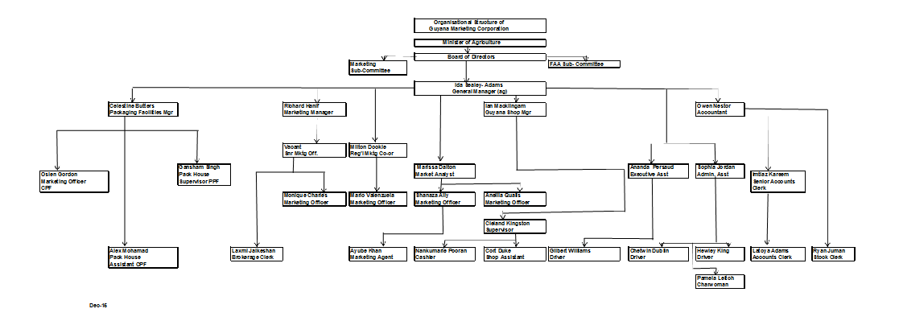
Figure 2: Organizational Structure of GMC

3.0 Market Information Centre
The Market Information Center (MIC) is the hub of information for non-traditional agricultural commodities. It acts as the Ministry of Agriculture’s Market Intelligence on non-traditional agricultural produce and products that are for export markets.

Its core activity is to provide market and marketing information to farmers, exporters, agri-business investors and promote of Guyana’s non-traditional agricultural commodities.

The Marketing Information Centre functions in several capacities, including:
- Gathering and disseminating market information
- Identifying and promoting the economic potential of new non-traditional agricultural products, based on the competitive advantages of Guyana.
- Collaborating with agencies such as NAREI, Plant Health/Quarantine, Pesticides Board, etc., to more effectively address challenges in farming communities
- Providing support to potential investors; regionally and extra-regionally, who desire to invest in Guyana.
- Training of farmers in areas of post-harvest handling, pricing, packaging and labeling, and good agricultural practices, among others.

3.1 Market Advisory
In 2015, GMC continued to function as the nucleus for market and marketing information on non-traditional commodities, through its Market Information Centre (MIC). The staff interacted with 1,179 clients. These clients were able to obtain information such as prices, exports, production, exporting procedures, requirements for exporting to the various countries and marketing advice. The information was disseminated via GMC’s Market and Enterprise Information System (website), telephone and emails. Additionally, information was provided during field visits and to those persons who visited the MIC. Persons were also given an opportunity to visit the Guyana Shop and the Packaging Facilities.

In a bid to ensure that clients were able to access timely and useful information, GMC also printed several brochures and flyers. The Corporation continued to promote its General Services, Packaging Facilities, Cold Storage Facilities, Agricultural Field Crates, Guyana Shop and AMIS Text Messaging Service through the use of brochures and flyers. There is also an informational brochure on the “Guidelines for Establishing an Agro-processing Business”.
Figure 3: GMC Services Brochure
3.1.1 Market Linkages
There were several successful market linkages created between Farmers and Exporters, Farmers and Agro-processors, Exporters and Agro-processors. GMC’s Marketing Officers, Agricultural Officers and Crop Extension Officers acted as the medium for creating the initial link between the relevant stakeholders in a bid to assist them with the marketing of their products.

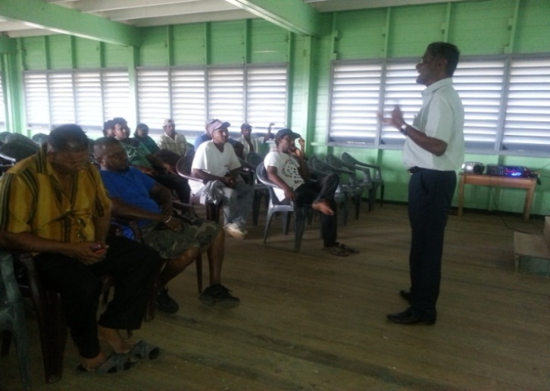
3.1.2 Farmers’ Training and Awareness
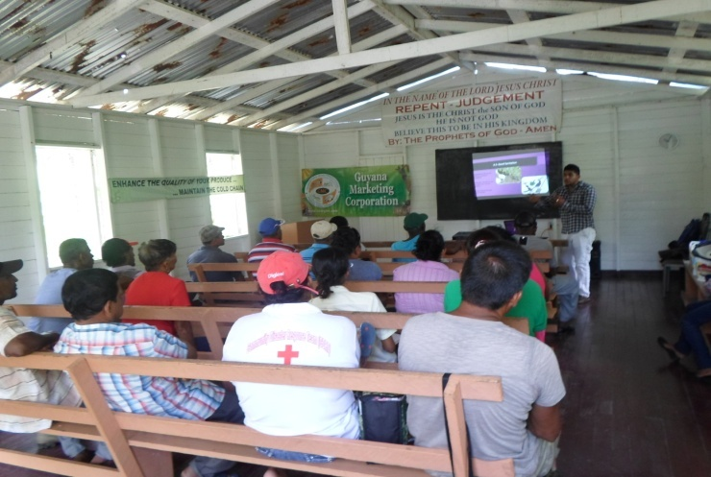
In 2015, the Guyana Marketing Corporation developed seven training modules which were used to train farmers in Regions 2, 3,4,5,6 and 10. During this initiative, four hundred and forty one (441) farmers were trained in areas of Post- Harvest Management, Cost of Production, Good Agricultural Practices, Marketing, Book Keeping, Exporting and Group Development. Additionally, farmers were sensitized about the roles and functions of the Guyana Marketing Corporation.
Figure 4: Training Session in Black Bush Polder
These awareness and training sessions were held for farmers in Upper Pomeroon, Lower Pomeroon, Supenaam Creek, Parika Back, Naamryck Back, Ruby Back, Morasika, Aliki, Berribissiballi, Lanaballi Hog Island, Hague, Canals 1 & 2, Friendship, Craig, Kuru, Kuru, Hillfoot, Laluni, Now or Never (Mahaicony),Cotton Tree, Little Biaboo, Mara, Black Bush Polder, West Watooka and Spike Land.
Figure 5: Training Session in the Pomeroon

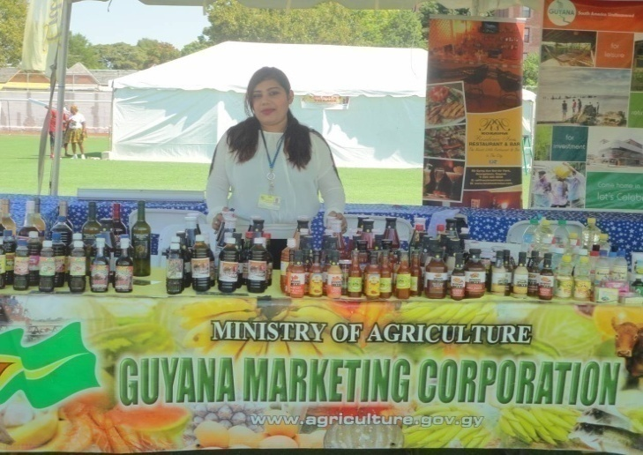
  - Promotion
3.2.1 Trade Fairs/Exhibitions
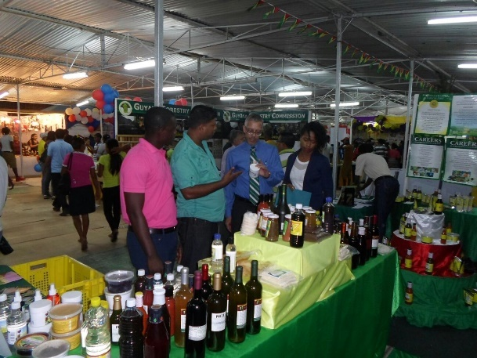
In 2015, the Guyana Marketing Corporation, through the Marketing Information Centre and the Guyana Shop, was involved in numerous promotional activities which sought to encourage the use of locally produced commodities. The staff of GMC participated in the following Trade Fairs/Exhibitions:
Figure 6: GMC’s booth at the Guyana Folk Festival in Brooklyn, New York
- Guyana Folk Festival – Brooklyn, New York
- Berbice Expo & Fair - Albion
- Essequibo Night – Anna Regina
- Linden Expo – Mc Kenzie
- Rupununi Agricultural Expo and Business Forum - Lethem
- Business Expo - Georgetown
- Green Expo - Georgetown
Figure 7: GMC’s booth at Berbice Expo
- PAHO Street Fair - Georgetown
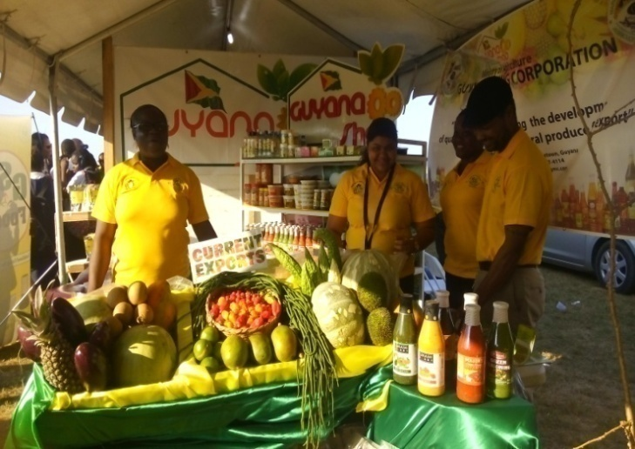
The Corporation also took the opportunity to promote Guyana’s local produce and products by organizing displays at the following events:
- World Food Day - Uivlugt
- GSA Open Day – Mon Repos
- MMA-ADA Community Event - Onverwagt
- Bath Settlement Village Day – Bath
- East Ruimveldt Restoration Fair – East Ruimveldt
- Berbice Town Week - New Amsterdam
Figure 8: GMC’s booth at Uivlugt on World Food Day
- Amerindian Heritage Celebrations – St. Ignatius
- Canjie Secondary School Agriculture Month Open Day
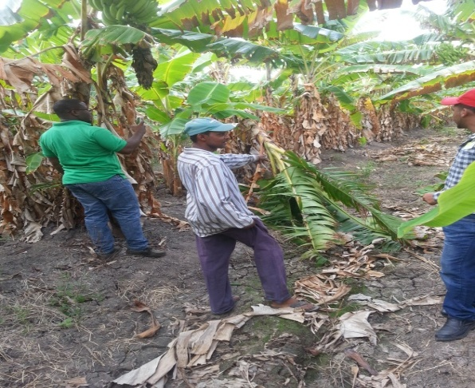
  - Market Extension
BOX 2
Field visits were made to the following areas:
- Helena #1
- Mahaica
- Soesdyke
- Clonbrook
- Kuru Kuru
- Kuru Kururu
- Number 10
- Handsome Tree
- Cotton Tree
- Mahaica Creek
- Little Biaboo
- Big Biaboo
- Crabwood Creek
- Yakasari
- Mibikuri
- Johanna
- Lesbeholden
- Jackson Creek
- Laluni
- Laluni Creek
- Mara
- Mara Retraite
- Lower Kara Kara
- Kara Kara
- West Watooka
- Wisroc
- Christianburg
- Dalawala
- Amelia’s Ward
- Rockstone
- Supenaam Creek
- Lethem
- St. Ignatius
- Tabatinga
- Jacklow
- Plegt Anker

Figure 9: Field visit in Crabwood Creek
BOX 1
Field visits were made to the following areas:
- Arukamai
- Hobodieah
- White Creek
- Waini
- Sacred Heart
- Three Brothers
- Hotaqui
- Wauna
- Kaituma
- Morahwanna
- Kariabo
- Black Water
- Barima
- Unity Square
- Upper Kaituma
- Yarakita
- St. Anslem
- Arukamai
- Kamwatta
- White Water
- Lima
- Paradise
- Supenaam
- Dartmonth
- Hambug
- La Grange
- Canal #1 & #2
- Vive La Force
- Cathrina Sophia
- Maria’ s Lodge
- Free & Easy
- Bonasika
- Hague
- Den Amstel
- Parika
- Naamryck

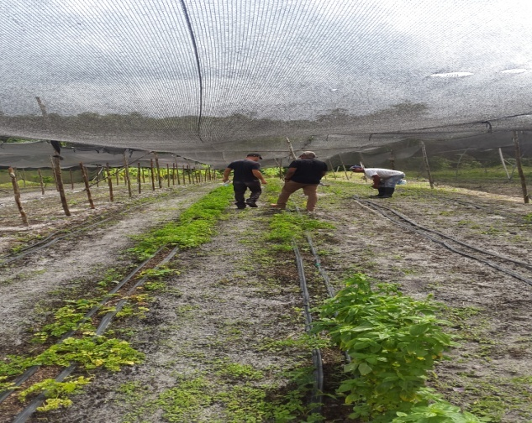
Figure 10: Field visit in Dora

  - Agriculture Market Information System
The Agriculture Market Information System (AMIS) is managed by the Guyana Marketing Corporation (GMC), the marketing agency within the Ministry of Agriculture.
Although this service was officially launched in June 2009, the Ministry of Agriculture, through the Guyana Marketing Corporation has been maintaining various aspects of an agricultural marketing system for over two decades.
There are several components that make up the Agriculture Market Information System. These components include:
3.4.1 Price Collection – Wholesale, retail and farm-gate prices of agricultural commodities are collected from seven markets in Regions 1, 2, 3, 4, and 10 daily or weekly depending on the market operation and major market days. This price information is stored in the FAO AgriMarket Software and it can be retrieved for reporting or dissemination purposes. Excel is also used to produce graphs and charts for reporting purposes.

Guyana Marketing Corporation maintains a record of prices of agricultural commodities from 2005 and is widely used for analysis as well as to provide historical price trends for the key stakeholders.
Figure 11: AMIS Flyer
3.4.2 AMIS - This is a SMS service that is used by exporters, farmers and even consumers for accessing current agricultural commodity prices by sending a text message to 1010 with the name of a specific commodity (produce). The service is managed by MOA/GMC through DIGICEL.
In 2015, there were 57 updates done by the Guyana Marketing Corporation and the service was used 1,140 times.

3.4.3 Collection of Export Data – GMC is also responsible for the collection and monitoring of the export of non-traditional agricultural commodities. This is used to observe the trends of commodities exported from Guyana to regional and extra-regional countries. Information on the types and quantities of agricultural commodities exported is collected from the Guyana Revenue Authority, Caribbean Airlines, Plant Quarantine and GMC’s Packaging Facilities as well as from individual exporters.
Furthermore, under the FAO – TCP Project entitled ‘Support for the Enhancement of the National Agricultural Information System in Guyana’; an Export Information Management Component was designed as part of the GMC Market Information System (GMCMIS). This component allows for the entry of data and it also generates specific reports.

  - Export Brokerage Service
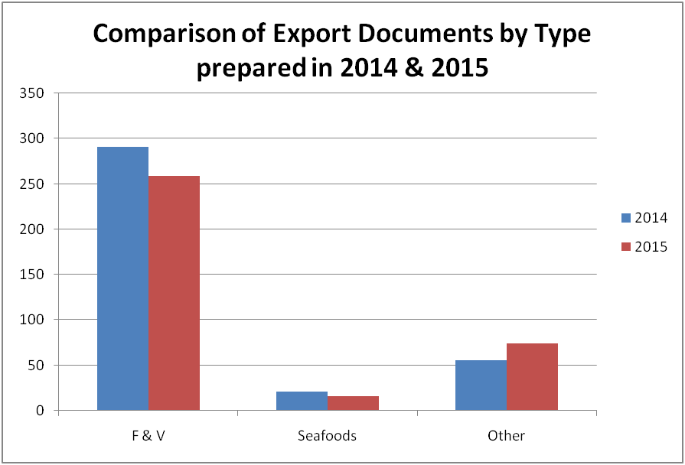
The Corporation has maintained its export brokerage service to all farmers, exporters and agro-processors. During 2015, three hundred and forty six (346) documents were prepared and processed. Of this figure, 74.9% (259) were for fruits & vegetables, while approximately 4.6% (16) of the documents were for the exportation of seafood and the remaining 21.4% (74) were for the exportation of other commodities such as leather craft and virgin coconut oil.
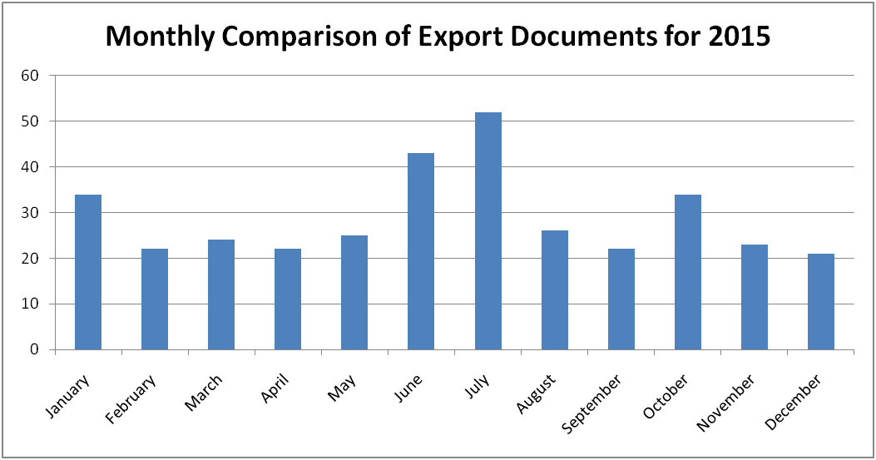
A comparative analysis of the export documents that was prepared in 2014 and 2015 revealed that there was approximately 5.5 % overall decrease in the use of the export brokerage service. In 2015 it was observed that fruits & vegetables & other commodities contributed greatly to the amount of the brokerage revenue as compared to 2014, where fruits & vegetables and sea food contributed to the majority of exports.
Figure 12: Comparison of Types of Export Documents prepared at GMC
Figure 13 shows the comparative analysis of the export documents that was prepared for each month in 2015. It showed that the months of June and July had the highest number of export documents prepared while December had the least number of documents prepared.
Figure 13: Monthly Comparison of Export Documents prepared by GMC

  - Market and Enterprise Information System
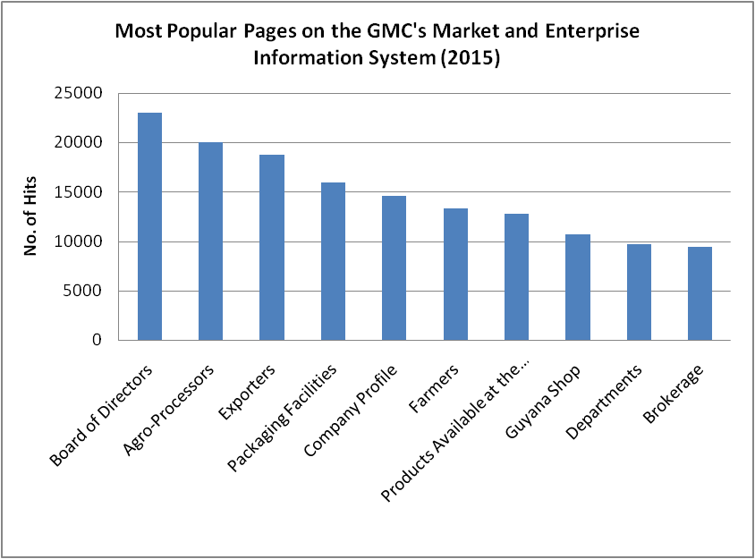
The website is the primary means of disseminating market information. This provides an electronic database with information for producers, buyers and other interested stakeholders. It provides vital information such as marketing and prices.
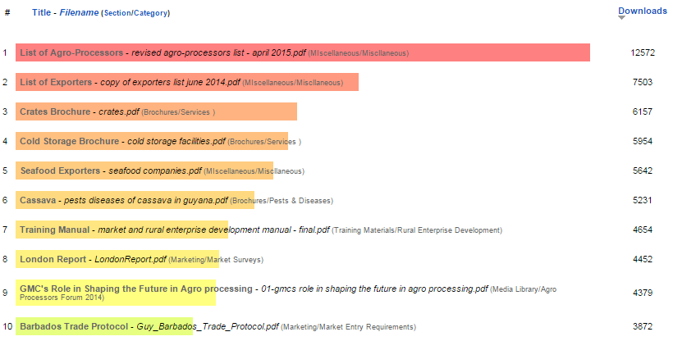
In 2015, clients continued to use the Market and Enterprise Information System as a means of accessing information on the non-traditional crops sector. All of the services that are provided by GMC can be found on the website, for example, Brokerage, Market Analysis, Agri-Business Development, Cold Storage Facility and Market Extension. Moreover, the website is updated regularly; the price data is updated every Monday, Wednesday and Friday.
Figure 14: Most Popular Pages on GMC’s Website

Figure 15: Most Downloaded Files on GMC’s Website

During the reporting year, online clients were mostly interested in obtaining information on the Board of Directors, Packaging Facilities, Agro-Processors, Exporters and Company Profile (see Figure 14). Furthermore, the Agro-Processors’ list, Crates Brochure, Exporters List were among the most downloaded files (See Figure 15).

  - Other Activities
- United States Food & Drug Administration Registration
All persons desirous of exporting food products to the USA must complete a US Food & Drug Administration Registration. In 2015, GMC completed twenty-one (21) registrations for exporters.

4.0 Agriculture Business Development
During the year 2015, the Guyana Marketing Corporation continued to work closely with prospective and current agro-processors by conducting visits to agro-processing facilities, providing assistance in the creation of labels, computing nutritional facts, sourcing of packaging materials, creating market linkages and assisting in promoting their products, among others.
BOX 3: Success Story:
Promoting the development of new, innovative and diversified products
The proprietress of Anne’s Products approached GMC with her current line of products which included pepper sauce, vinegar and achar. At the time, her business was not registered, she was utilizing recycled bottles and her products were only sold in a few supermarkets. Additionally, she was engaged in little promotional activities. After consulting with GMC, Ms. Anne was able to register her business, source new bottles for packaging and she introduced two new products: preserved fruits and lime chunks and pepper, to the market. She was also able to participate in more promotional activities and her products can now be found in a wider number of supermarkets. The proprietress also benefitted for Product Development training on Pepper Making which was organized by GMC in collaboration with GSA.
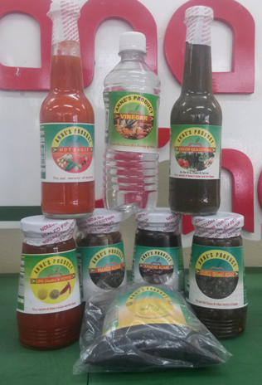
4.1 Updating of GMC’s Agro- processors Database
New agro-processors were included on the agro-processor’s database, while information was revised for existing Agro-processors during the reporting year.
4.2 Visits to Agro-processing Establishments
During 2015, twelve visits were made to agro-processing industries. Three of the visits were done in collaboration with a consultant and supplier of packaging materials and equipment from Trinidad. Agro-processors benefitted from advice on appropriate equipment that can be utilized to improve the efficiency of their current operations.
The objectives of these visits were to ascertain the operations that are carried out at the processing facilities, provide recommendations and technical assistance where necessary to improve the respective business operations.

4.3 Training
A collaborative workshop with the Guyana School of Agriculture was undertaken in June 2015 at the Processing Facility of the institution. Nine agro-processors benefitted from a Pepper Making Demonstration. By the end of 2015, two of the Agro-processors’ pepper sauce were shelved at the Guyana Shop and other retail outlets.

4.4 Collaboration with Agro-processors
Two meetings were organized with agro-processors during 2015. The purpose of the initial meeting was to plan activities for the 2015 Agro-processor’s forum and exhibition for agro-processors. During the second meeting, further discussions were held on the 2015 Agro-processor’s forum, Exhibitions and the development of the ‘Roadmap for the Agro-processing Industry.’

4.5 Collaboration with Agencies

After consultations with agro-processors, five agro-processors attended the seminar on ‘Positioning Your Product in a Competitive Market Place' Seminar on January 26, 2015 at Pegasus Hotel.
This seminar was organized locally by the Guyana Manufacturing & Services Association Ltd. Importantly; the purpose of the seminar was to enlighten producers on the essentials of packaging and labels of products. Presenters at the seminar constituted part of the management team of Prism Communications Limited of Jamaica.
Figure 16: Agro-processors Forum 2015

4.6 Linkages with Service Providers
In an attempt to ensure that agro-processors have access to reliable supplies of packaging materials, through constant negotiations with a supplier of packaging materials, glass jars are now readily available for sale to Agro-processors. Through facilitation with the Corporation, visits by a Trinidadian Consultant were conducted at individual establishments.

4.7 Agro processors’ forum

The annual Agro processors’ forum was held on November 5, 2015 at the International Conference Center organized by the Guyana Marketing Corporation. Approximately fifty persons attended the forum which comprised of officials from the Ministry of Agriculture, Ministry of Business and Investment, Ministry of Social Protection, agro-processors, prospective agro-processors, suppliers of packaging materials, other private sector officials, representatives from regulatory bodies and international organizations.
Figure 17: Participants at the Agro-processors Forum 2015

The day’s activities consisted of three main segments namely; the table top display, formal opening and presentations by key stakeholders and interactions by participants. A major feature of the 2015 Agro-processors forum was the review of the draft Roadmap for the Agro-processing Industry.
Figure 18: Participants and Patrons at 2nd Agro-processors Street Fair

4.8 Agro-Processors Street Fair
The Guyana Marketing Corporation held its Second Annual Agro Processors Street Fair on the October 24, 2015 on Main Street in Georgetown. The one-day street fair was aimed at allowing the agro-processors the opportunity to promote and market what they produce. The day’s activity commenced at approximately 9:00 hrs and concluded at 15:00hrs. The soothing music added to the excitement of the fair. There were twenty five (25) participants including two suppliers of packaging materials who showcased their products.
Figure 19: Participants and Patrons at 2nd Agro-processors Street Fair
The event was successful and allowed the Guyana Marketing Corporation to promote the development of quality non-traditional agricultural commodities. The Agro-processors’ street fair attracted a steady stream of visitors, who were treated to samples and charmed into making purchases. On display were a large number of locally produced food items, beverages, snacks, beauty products such as soaps among other items.
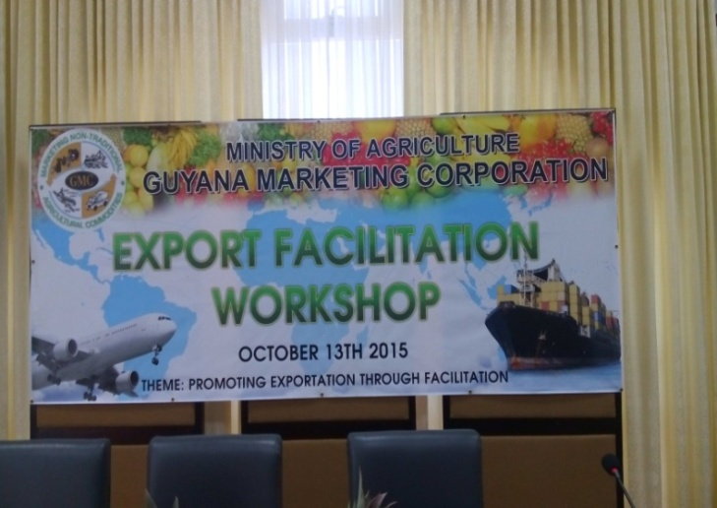
4.9 Export Facilitation Workshop
Figure 20: Export Facilitation Workshop

The Guyana Marketing Corporation has been assiduously working to achieve its mandate of promoting the exportation of Guyana’s non-traditional agricultural crops. Against this backdrop, the Guyana Marketing Corporation hosted its second Export Facilitation Workshop at the Arthur Chung Conference Centre, on October 13, 2015.
This workshop brought together exporters, potential exporters, service providers, representatives from other agencies within the Ministry of Agriculture and farmers. Linkages were also created and there was an increased awareness of local products, export and export services. A total of sixty six (66) participants attended the export facilitation workshop.
Figure 21: Participants at the Export Facilitation Workshop

4.10 Development of a Guide to Good Agro-processing Practice
The Guide to Good Agro-processing Practice (GGAP) was prepared specifically for Agro-processors in the local Agro-processing Industry. This document has been developed to compliment the already existing Code of Practice for Food Manufacturers which was developed by the Government Analyst Food and Drugs Department. The GGAP can be used by both manufacturers of Agro-processed products and Agro-processors who merely re-package agro-processed products. Further, existing Agro-processors can follow this Guide to Good Agro-processing Practice to improve on their business practices while prospective Agro-processors can utilize this document to aid them in transforming their business ideas into fruition.

4.11 The Computation of Nutritional Facts
Figure 22: Screenshot from ESHA Software
The Genesis R&D program was used to compute nutrition facts labels for Agro-processors. This programme was donated to the Guyana Marketing Corporation by the Guyana Chapter of PROPEL (Promotion of Regional Opportunities for Produce through Enterprises and Linkages) which was funded by the Caribbean Hunger Fund. A total of fifty nutritional facts labels were computed, forty four were presented to Agro-processors and six were developed for use by the Guyana Marketing Corporation for World Food Day Exhibition.

5.0 Guyana Shop
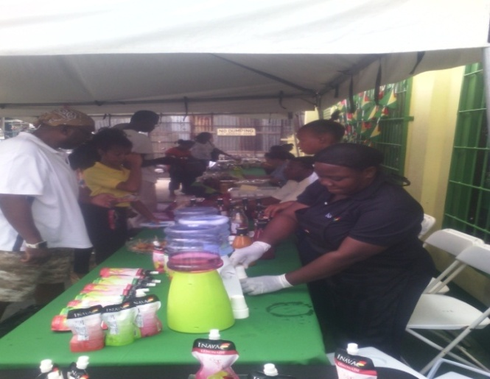
5.1 Promotions
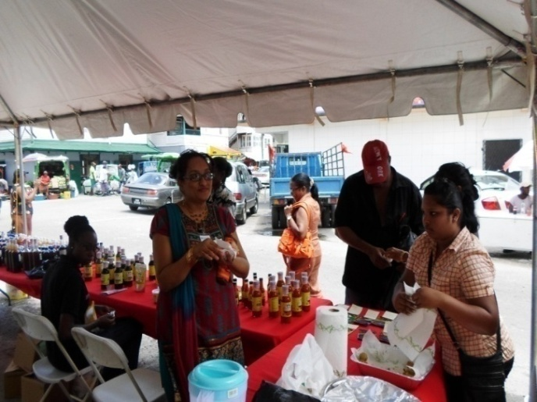
In 2015, the Guyana Shop engaged in several activities to promote and encourage the production and consumption of local commodities. As part of its activities, events were held to coincide with several of the national holidays such as Mashramani, Phagwah, Easter, Emancipation and Christmas. These events which were held at the Robb Street location and it offered manufacturers the opportunity to showcase and sell their products and provide samples for consumers.
Figure 23: Participants and Patrons at the Guyana Shop’s “Mash Mania” Event
There were also promotions organized by individual manufacturers such as INAVA and NAMILCO, which were facilitated by the Guyana Shop. Additionally, in celebration of Easter, the Guyana Shop offered a 10% discount on all items.
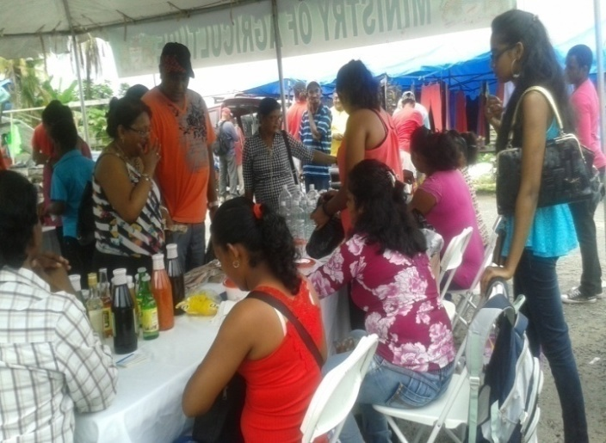
In an effort to extend the shop’s promotional activities and sensitize the community of the locally produced products, the Guyana Shop held its first ‘Tent Event’ away from the Guyana Shop at the Parika Market. Manufacturers were invited to promote and sell their products. Consumers responded well to the initiative and utilized the opportunity to make purchases.
Figure 25: Guyana Shop’s Promotional Event at Parika Market
Figure 24: Participants and Patrons at the Guyana Shop’s Pre Phagwah Event
In December 2015, the Guyana Shop invited agro-processors to participate in individual promotional activities. This was done under the theme “12 Days of Christmas”. The customers of the Guyana Shop utilized the opportunity to purchase from and converse directly with the agro-processors and gave assurance of continued support for their respective products. During this month, the Guyana Shop also prepared several “Gift Baskets” with locally manufactured commodities which were sold to different entities upon request.

5.2 Taking Guyana Shop National
During 2015, the Guyana Shop continued to undertake its initiative “Taking the Guyana Shop National”. This initiative entails establishing a Public-Private Partnership with owners of supermarkets across the country. In 2015, a Gondola with local products was placed at the mini mart of R. Prashad Gas Station which is located in Mon Repos. By the end of 2015, there were ‘Guyana Shop Corners’ established in two locations and gondola at one location.
Additionally, in an effort to further promote the availability, accessibility and consumption of locally produced commodities, the management of the Guyana Shop continued to facilitate meetings with owners of Supermarkets across the country. Such meetings were held with proprietors from Bartica, Bengal, Linden and Parika. Additionally, the Guyana Shop was able to forge arrangements with the owners of retail stores in Bartica and Parika, to promote and sell locally produced commodities which will be supplied by the Guyana Shop. The Guyana Shop Corner will be officially launched at these supermarkets in 2016.
BOX 4: Success Story:
“Taking Guyana Shop National”
In March 2015, a Gondola with locally manufactured products was placed at the Supermarket at R. Prashad Gas Station, which is located in Mon Repos. The Management of the Guyana Shop had met with Mr. Ravindranauth Prasad who expressed interest in having locally manufactured products at his Supermarket. The Supermarket was officially opened on March 22, 2015.

6.0 Packaging Facilities

There are two Packaging Facilities namely; Central Packaging Facility, Sophia and the Parika Agro Packaging Facility, Parika. These Packhouses serve to facilitate the processing of fresh fruits and vegetables for export. At Parika Agro Packaging Facility, a farmer’s walkway is available to assist farmers in the offloading of their produce.
Figure 26: Central Packaging Facility, Sophia
6.1 Improvements at the Packhouses
BOX 5: Success Story:
“Promoting and Coordinating Break Bulk Shipments”
In December 2015, GMC intervened to assist two exporters with shipping their produce after they experienced difficulties with the airline they had initially wanted to use. To this end, GMC facilitated a consolidated shipment where two exporters were allowed to utilize GMC’s Packaging Facility, free of charge, to prepare fresh produce for export via sea in a consolidated container. The container included produce such as watermelon, eddoes, limes and pineapples. The shipment also included agro-processed commodities such as casareep and sauces.

- The drainage system at the Parika Agro Packaging Facility was improved.
- Rehabilitative work was done to the building at the Central Packaging Facility, Sophia
- Five stainless steel tables, two blowers and a floor scale were added to the inventory at the Central Packaging Facility, Sophia
- Two concrete bridges were constructed at the Central Packaging Facility, Sophia

  - Services Offered at the Packaging Facilities
6.2.1 Refrigerated Containers
These were used on the request of exporters, the aim of which was to ensure produce were stored at the correct temperature prior to exportation. Approximately, 145 MT of fruits and vegetables, both fresh and processed, were stored in the refrigerated containers in 2015.
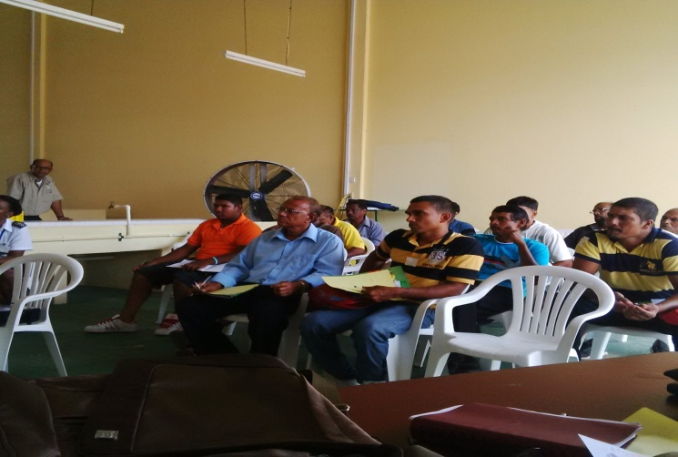
6.2.2 Refrigerated Trucking Service
Exporters continued to use the trucking service to transport their produce from farms to the pack houses or ports of exits. In 2015, there were 51 requests made for the usage of the refrigerated trucks.
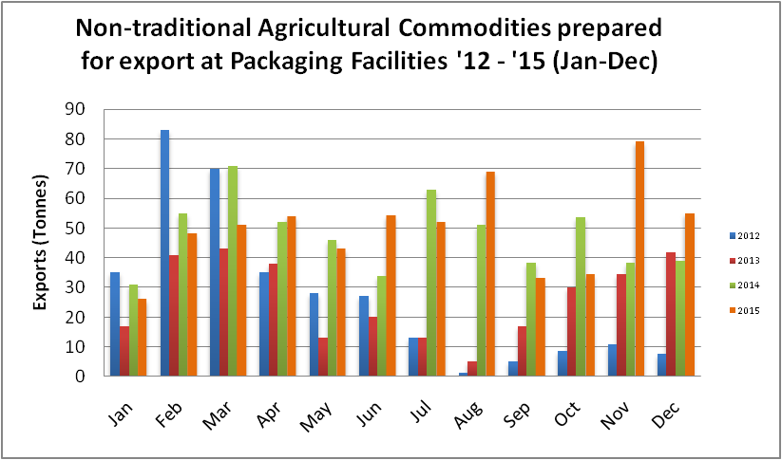
6.2.3 Field Crates
Figure 27: Farmers’ Training at Parika Agro-packaging Facility
The leasing of agricultural field crates was ongoing in 2015. In addition, a training session was conducted to sensitize stakeholders of the uses of these crates.

6.3 Performance of the Facilities during 2015
Figure 28: Non-traditional Agricultural Commodities prepared for export at the Packaging Facilities
In 2015, 537 MT of fruits and vegetables were prepared for export at the Central Packing Facility. A total of ninety two (92) shipments were processed, of which fifty one (51) were for exports via air and forty one (41) were for exports via sea.
BOX 6: Export Destinations
Countries to which produce prepared at the Packaging Facilities were sent:
- Barbados
- Trinidad
- Dominican Republic
- USA
- Canada
- St. Maarten
- Antigua
- United Kingdom

In relation to the Parika Agro Packaging Facility, 62 MT of produce were processed for export from this facility. Twelve (12) shipments were for exports via air while two (2) shipments were for exports via sea.

6.4 Engagements with Stakeholders
During 2015, the staff of the Packaging Facilities continued their engagements with various stakeholders. They attended meetings with the air and sea freight service providers to discuss the problems that affected exporters. Additionally, a meeting was held specifically with exporters in a bid to encourage them to re-establish the Exporters Association.
6.5 Promoting the Services of the Packaging Facility
An Open Day was held at the Central Packaging Facility in October where the public was invited to interact with the personnel of the Packaging Facilities. Additionally, the Manager of the Packaging Facilities participated in a training session at the Parika Packaging Facilities to promote and encourage the use of agricultural field crates.

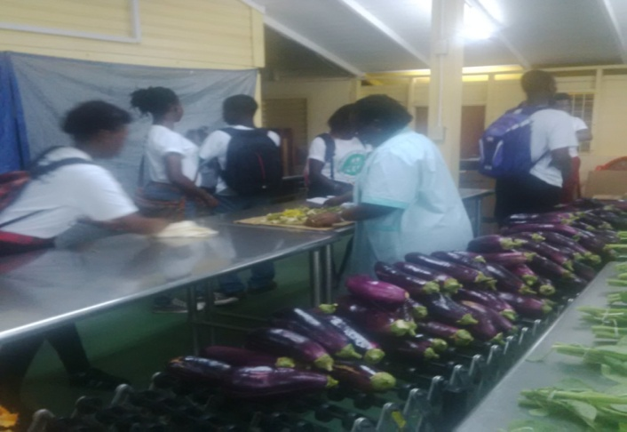
6.6 Visits made to the Pack houses

Consultations were done during the year with prospective and current exporters locally, regionally and extra- regionally. Information on requirements for exporting to various countries, use of the facilities, use of the refrigerated trucks, refrigerated containers and plastic crates, linkage to sources of produce, freight carriers and allowable commodities for respective countries were provided.
Figure 29: GSA Students visiting the Central Packaging Facility
In addition to prospective and current exporters, a total of three hundred thirty seven (337) students visited the Packaging Facilities in 2015. The visitors were given a demonstration on the preparation of fruits and vegetables for export. Information was also provided on the flow of the packaging facility, as well as guidelines for its use, post- harvest handling of the produce and packaging of fruits and vegetables. The students were educated on how to transport fresh produce and how to reduce post harvest losses by utilizing the plastic crates.
Figure 30: Students from J.C. Chandisingh Secondary School visiting the Central Packaging Facility

7.0 Price and Export Analysis
Market Analysis provides essential information on prices, exports and imports to determine the attractiveness and dynamics of non-traditional agricultural commodities in the domestic and international markets. Market Analysts and Marketing Officers collect, monitor, analyze and disseminate information for both fresh and processed commodities within the non-traditional agriculture sector. This information includes price movements, export and import trends which is provided to policymakers and other relevant stakeholders such as exporters, agro-processors, farmers, service providers etc.
7.1 Price Analysis
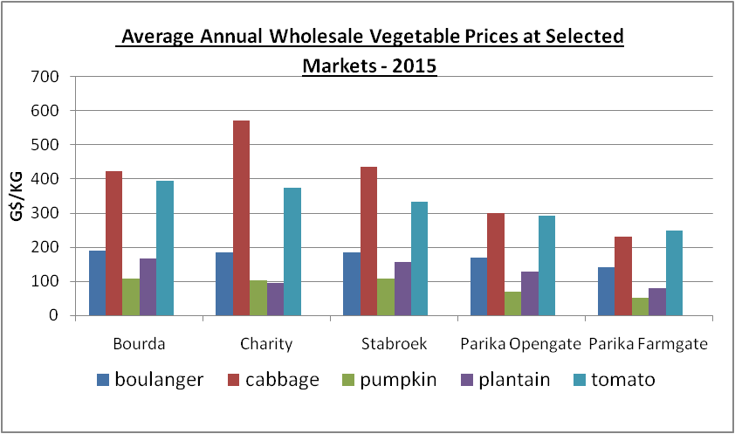
7.1.1 Vegetables
At the wholesale markets under review, the highest prices for most vegetables were recorded in the third quarter of 2015. Evidently, the vegetable that recorded the highest price increase from 2014, at most of the markets, was bora. At Bourda market, bora increased by 85%, while at Stabroek market, the price was 135% higher than that recorded in 2014. Furthermore, at Parika Farmgate and Opengate, there were 30% and 95% increases, respectively. However, the most notable change in the price of bora occurred at Charity market, where the price of the commodity increased by 148% from 2014.
Figure 31: Average Annual Wholesale Vegetable Prices at Selected Markets
There were other notable changes in the prices of vegetables at the markets under review. There were increases in the prices of cabbage (21%) and squash (26%) at Bourda market while at Stabroek market, cabbage and pumpkin increased by 24% and squash increased by 27%. Furthermore, there were significant increases in the prices of cabbage (24%) and pumpkin (27%) while tomatoes and carrots fell by 20% at Parika Opengate. The prices of vegetables at Parika Farmgate were more volatile, there were significant increases in the prices of boulanger (25%), cabbage (31%), cucumber (20%), pumpkin (32%) and corilla (24%) and declines in the prices of tomatoes (22%) and carrots (21%). At Charity market, the prices of cabbage, pumpkin and pak choi increased by 23%, 22% and 30% while the price of calaloo fell by 23%.

7.1.2 Fruits
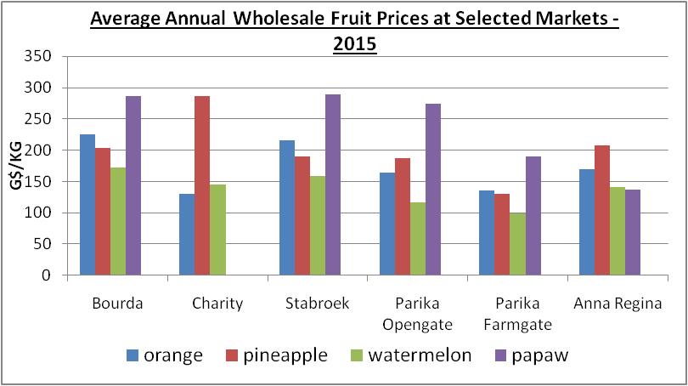
The average wholesale price of fruits at Bourda market has generally increased. The most outstanding increases were evident in the prices of grapefruit (20%), mango (38%) while there was a significant reduction of 20% in the price of avocado. At Stabroek market, there were also some very significant increases. These increases were evident in the prices of tangerine (40%), grapefruit (32%), mango (44%), lemon (29%) and passion fruit (22%). Furthermore, there were significant declines in the prices of golden apple (31%) and avocado (22%). There was also an upward trend evident in the prices of most fruits at Parika Opengate market. Notably, the prices of round lime and breadfruit increased by 22% and 20% respectively. In addition, there were notable reductions in the prices of watermelon (27%) and grapefruit (26%). Fruit prices at Parika Farmgate market have also changed significantly. There was a notable increase in the price of round lime (75%) while there were reductions in the prices of sour fig banana (34%), mamey (22%) and passion fruit (69%). At Charity market, there were significant increases in the prices of tangerine (49%), watermelon (27%), grapefruit (64%), lemon (23%) and bilimbi (68%) while the price of round lime fell by 20%.
Figure 32: Average Annual Wholesale Fruit Prices at Selected Markets

7.1.3 Seasoning
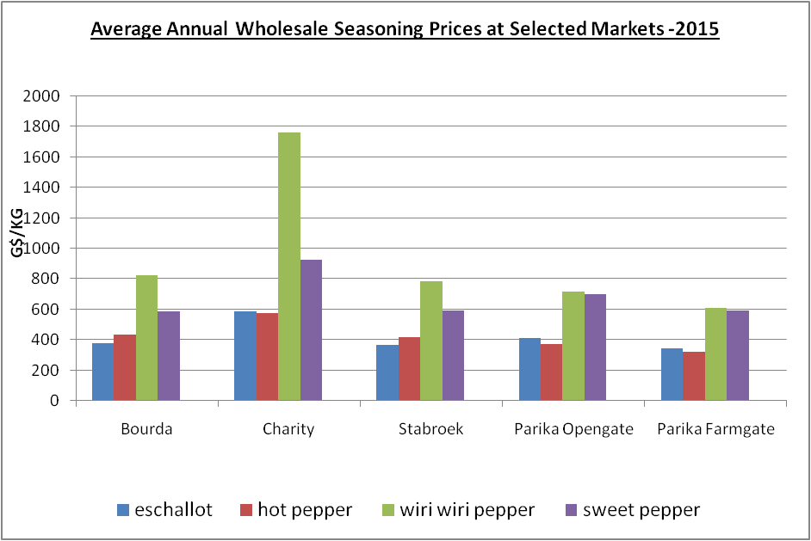
The average wholesale price of seasonings generally increased at Bourda market. The major price increases over the period 2014-2015 were for eschallot (32%), hot pepper (37%) and wiri wiri pepper (28%). There was also a 44% decrease in the price of ginger. Generally, the prices of seasoning also increased at Stabroek market. Notably, there were increases in the prices of eschallot (25%), hot pepper (36%) and wiri wiri pepper (34%) while there was a reduction in the price of ginger (46%). There was a similar trend at Parika Opengate market, the prices of most of the seasonings increased. The most significant increases were evident in the prices of eschallot (29%), hot pepper (34%) and wiri wiri pepper (38%). Additionally, there was a 42% reduction in the price of ginger. At Parika Farmgate market, there were increases in the prices of eschallot (27%), hot pepper (44%) and wiri wiri pepper (52%) while there was a reduction in the price of ginger (41%). At Charity market, seasoning prices have also increased. This was led by hot pepper price which increased significantly by 33% and eschallot which increased by 26%. There was also a 45% decline in the price of ginger.
Figure 33: Average Annual Wholesale Seasoning Prices at Selected Markets

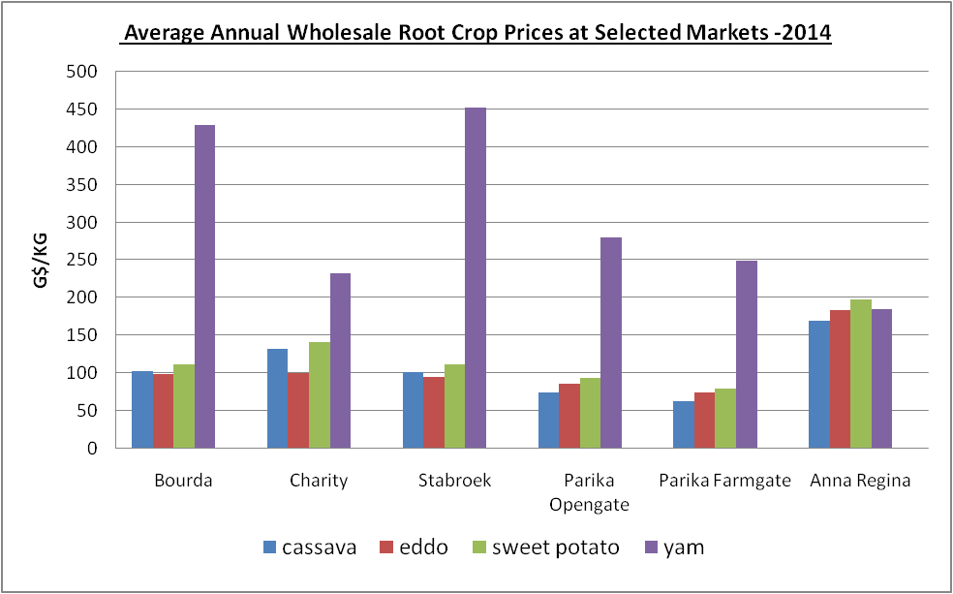
7.1.4 Root Crops
Root crop prices have remained relatively stable over the past year at most of the markets under review. However, there was a notable 22% increase in the price of cassava at Parika Farmgate market while there was a 22% decline at the same market. At Charity market, there was a 26% decline in the price of yam.
Figure 34: Average Annual Wholesale Root Crop Prices at Selected Markets

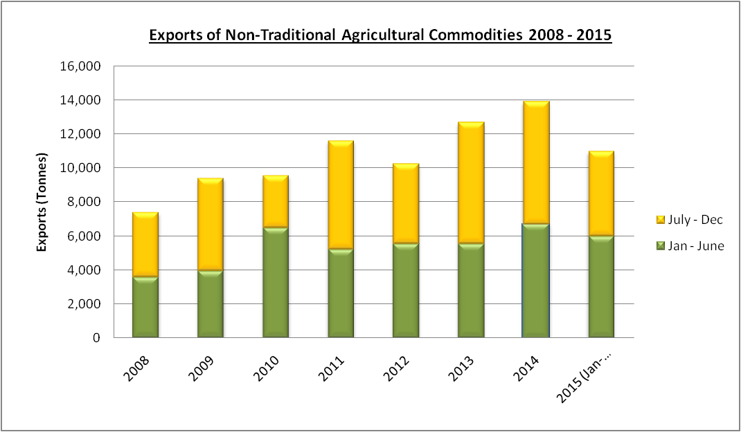
  - Analysis of Exports
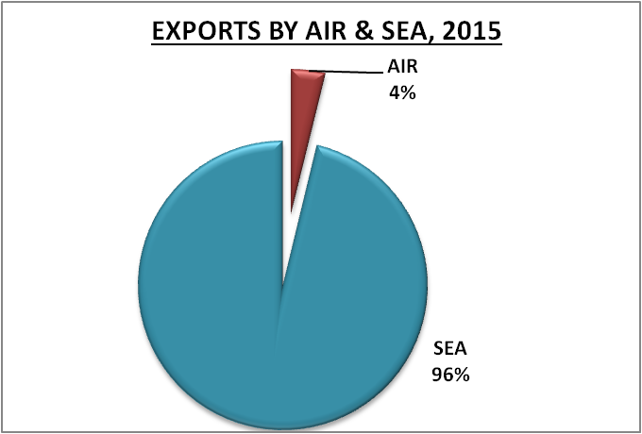
In 2015, Guyana’s exports of non-traditional agricultural commodities have totaled 10,999 MT valued at G$1.9 billion or US$ 9.5 million, which reflects a 21% decrease in exports from 2014. In 2014, exports of non-traditional agricultural commodities totaled 13,922 MT as seen in the Figure 22.
Figure 35: Exports of non-traditional agricultural commodities

Of the total exports, 415 MT or 4% (see Figure 36) was exported by air representing a 43% decrease from 2014. Additionally, 10,584 MT or 96% (see Figure 36) was exported by sea reflecting a 20% decrease from last year.
Figure 36: Exports of non-traditional agricultural commodities
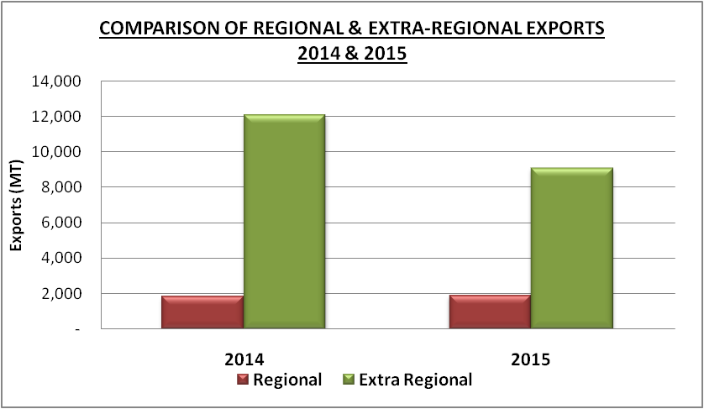
Regional exports accounted for 1,906 MT or 17% and Extra Regional exports totaled 9,092 MT or 83% during 2015. However, in 2014, Regional exports totaled 1,857 MT (13%) and Extra Regional exports totaled 12,065 MT (87%).
Figure 37: Comparison of Regional and Extra Regional Exports

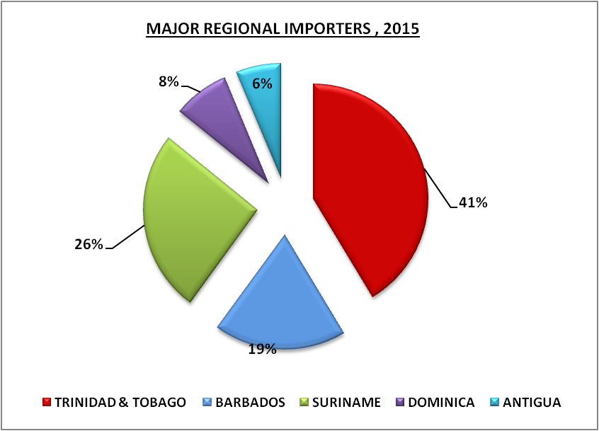
The major importing countries regionally were Trinidad and Tobago (785 MT), Suriname (489MT), Barbados (354MT), Dominica (150 MT) and Antigua (119MT).

Figure 38: Major Regional Importers
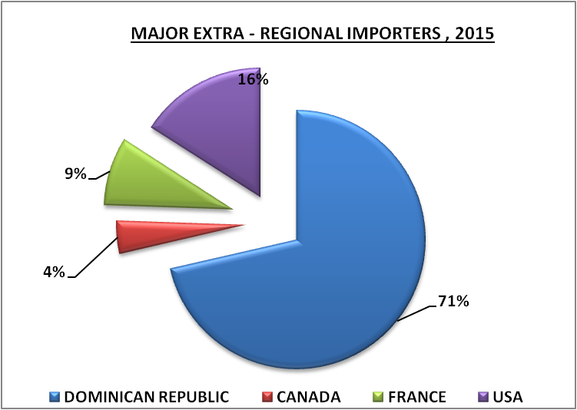
The major importing countries extra-regionally were Dominican Republic (6,489MT), USA (1,448MT), France (775MT) and Canada (373 MT).

Figure 39: Major Extra-Regional Importers
The major fresh commodities exported in 2015 were coconuts (8,093 MT), eddo (218 MT), pumpkin (190 MT), ginger (142 MT), pineapple (134 MT), watermelon (121 MT), mango (102 MT), limes (52 MT), sweet potato (51 MT) and yams (39 MT) while the major processed commodities exported included heart of palm (774 MT), copra (310 MT), crude coconut oil (235 MT), sauces (136 MT), coconut water (135 MT), pepper sauce (38 MT), frozen katahar (33 MT), achar (27 MT), frozen pepper (11 MT) and coconut choka (11MT). Furthermore, a total of forty eight (48) fresh products and thirty (30) processed products were exported in 2015.

8.0 collaboration with international organization
8.1 Projects Executed by Guyana Marketing Corporation

8.1.1 FAO/TCP Project entitled: “Support for the enhancement of the National Agriculture Market Information System in Guyana”
Aim: The project is aimed at enhancing the capacity of the Guyana Marketing Corporation of the Ministry of Agriculture to collect and analyze production data for non – traditional agriculture crops in a timely and consistent manner and to expand the current market information system so that it is capable of providing appropriate, reliable and timely data for detecting price movements of agriculture commodities and for identifying market opportunities for farmers, agro processors and exporters.
FAO Contribution: USD 121,000
Expected Results:
- Finalization of Production Data Collection Strategy for Non – Traditional Agriculture Crops.
- Development of a training curriculum and training of extension officers, crop reporters and price collectors.
- Establishment of a fully functional market information system which will generate:
- Price data in local markets
- Volume data for local markets
- Price data for export markets
- Market requirements for export markets
- Crop forecasts for local production areas
The GMC website will be updated and used for delivery of the information to farmers and persons interested in marketing agricultural produce.
Activities completed:
February 2015: After Ms. Boero reviewed the findings of the Pilot Survey in Region 5, she indicated that some areas needed to be revisited. Consequently a Follow- Up Pilot Survey was organized and executed. Ten Enumeration Districts were revisited, which included approximately 852 households.
March – May 2015: The information obtained during the follow-up Pilot Survey was sent to Ms. Boero. Queries made were answered during this period.
June 2015: After reviewing the information, Ms. Boero sent the estimated number of farms and the weights and formulas to calculate the variables estimated totals and their errors.
August 2015: A Strategy for the Collection of Non-traditional Agriculture Crop production data was submitted to the Ministry of Agriculture.

9.0 Administration & Accounting
9.1 Administration
9.1.1 Employment
Guyana Marketing Corporation prides itself as an equal opportunity provider; employment is based upon the needs of the Corporation and qualifications and experiences of the candidate, regardless of ethnicity, sex, sexual orientation and no discrimination against persons with disabilities. In January 2015, there were forty (40) staff members and at the end of December 2015 there were forty five (45) staff members.
Vacant Positions:
Marketing Department: - Senior Marketing Officer (Parika Agro Packaging
Facility)
- Senior Marketing Officer (Marketing Information
Centre)
Administration: - Office Assistant

Resignation: - Leon Gill, Senior Accounts Clerk: 01/05/2015
- Kimberly Sealey, Brokerage Clerk: 12/06/2015

- Mekheal Hunte, Packhouse Assistant: 31/07/2015

- Suresh Ramrakhan, Accounts Clerk: 09/11/2015

- Alex Mahamad, Packhouse Assistant: 31/12/2015

Transferred: - Khari George, System Development Officer: 12/10/2015
- Nizam Hassan, General Manager: 01/11/2015

Recruitment:
Guyana Marketing Corporation recruited the following persons in 2015:
- Charles Finlayson, Driver: 24/02/2015
- Cort Duke, Shop Assistant: 24/02/2015
- Gilbert Williams, Driver: 20/04/2015
- Richard Hanif, Marketing Manager: 01/05/2015
- Jaishrie Persaud, Stock Clerk: 13/07/2015
- Alex Mohamad, Packhouse Assistant: 03/08/2015
- Mario Valenzuela, Marketing Officer: 17/09/2015
- Oslen Gordon, Marketing Officer: 17/09/2015
- Ryan Juman, Stock Clerk 26/10/2015
- Latoya Adams, Accounts Clerk: 02/11/2015
- Monique Charles, Marketing Officer: 21/12/2015

The following persons were allocated to GMC by the Ministry of Agriculture:
- Jo-Lee Walton, Crop Extension Officer: 02/01/2015
- Ivory Duncan, Public Relations Officer: 18/05/2015
- Victoria Johnson, Planner IV: 15/06/2015
- Don Parkinson, Crop Extension Assistant: 01/09/2015
- Darnsbry Shepherd, Crop Extension Assistant: 01/09/2015
- Deion Harvey, Crop Extension Assistant: 01/09/2015
- Letesha Lindore, Crop Extension Assistant: 01/09/2015

9.1.2 Training/Workshop
DATE | NAME OF PROGRAMME | ORGANIZED BY | HELD AT | ATTENDED BY
January 26, 2015 | Seminar on Positioning your Product in a Competitive Market Place | Caribbean Export Development Agency (CEDA) | Pegasus Hotel, Guyana | Ida Sealey-Adams  Shanaza Ally
January 27 to 29, 2015 | Information, Communications and Technology (ICT) training | Ministry of Agriculture | Hon. Dr. Leslie Ramsammy MP Boardroom, Ministry of Agriculture | Omalita Balgobin
February 9 to 10, 2015 | CARICOM Single Market Spokesperson Workshop | CARICOM | Cara Lodge | Nizam Hassan  Jo-Lee Zammet-Walton
February 4 to 25, 2015 | Information, Communications and Technology (ICT) training | Ministry of Agriculture | Hon. Dr. Leslie Ramsammy MP Boardroom, Ministry of Agriculture | Omalita Balgobin
March4 to 11 and 12 to 18, 2015 | Information, Communications and Technology (ICT) training | Ministry of Agriculture | Hon. Dr. Leslie Ramsammy MP Boardroom, Ministry of Agriculture | Omalita Balgobin
April 9 to 11, 2015 | Coconut Training | National Agricultural Research and  Extension Institute (NAREI) | National Agricultural Research and  Extension Institute (NAREI) | Cosmo Browne  Devin Warner
April 15, 2015 | Processing and Marketing, Development of Cassava | National Agricultural Research and  Extension Institute (NAREI) | National Agricultural Research and  Extension Institute (NAREI) | Milton Dookie  Diana Dodson
No training/workshop was conducted in May, 2015
No training/workshop was conducted in June, 2015
No training/workshop was conducted in July, 2015
No training/workshop was conducted in August, 2015
September 10, 2015 | Monitoring and Evaluation Clinic | United Nations | Georgetown Club | Marissa Dalton
September 10-11, 2015 | Institute of Internal Auditors (IIA) Seminar and Workshop | Institute of Internal Auditors (IIA) Seminar | Regency Suites | Owen Nestor  Leyland Bacchus
September 14 to 18, 2015 | Training of Trainers Workshop | The Food and Agriculture Organization (FAO) and Ministry of Agriculture | Guyana Livestock Development Authority | Devin Warner  Jo-Lee Zammet Walton  Malaika Austin  Whitney Peterkin  Diane Bagot  Vaida Boodhoo  Diana Dodson
September 30, 2015 | National Stakeholder Meeting | Canadian Hunger Foundation (CHF) | Regency Suites | Shanaza Ally-Khan
October 12-31, 2015 | International Training Programme –  Good Governance and Management of Rural Development Programmes | High Commission of India's | National Institute of Rural Development, India | Richard Hanif
November 01-08, 2015 | International Training Programme –  Good Governance and Management of Rural Development Programmes | High Commission of India's | National Institute of Rural Development, India | Richard Hanif
November 3, 2015 | Leadership, Planning and Time Management Workshop | EMPRETEC Guyana | Georgetown Club | Kevin Macklingam
December 01 to 04, 2015 | International Workshop on Technologies for Agro-Industrial Development and Market Diversification for the Cassava Crop | Inter-American Institute for Cooperation on Agriculture (IICA) | Costa Rica | Ida Sealey-Adams
December 16 to 17, 2015 | Capacity Building – Developing the Programme Performance Monitoring Matrix | Monitoring and Evaluation Unit, Ministry of Agriculture | Ministry of Agriculture of Agriculture, Boardroom | Marissa Dalton  Shanaza Ally-Khan

  - Accounting
Guyana Marketing Corporation operates an accounting department which is responsible for managing the finances of the Corporation.
The Corporation’s budget for 2015 was: -
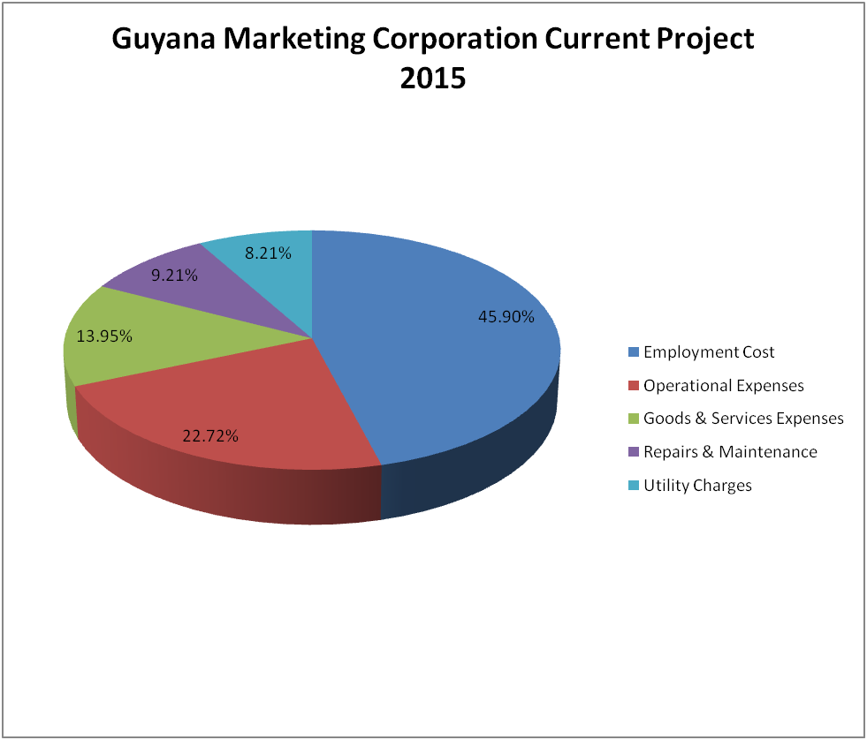

Figure 40: GMC’s Current Project - 2015

10.0 Board Of Directors
Guyana Marketing Corporation's Board of Directors comprises both Public and Private sector individuals. The current board was appointed by Cabinet to serve for the period July 01, 2015 to June 30, 2016.
The Board is made up of the following persons:
- Ms. Michelle Johnson - Chairman
- Ms. Vilma Da Silva – Member
- Mr. Brian Sears – Member
- Mr. Rajdai Jagarnauth – Member
- Mr. Deodat Doodnauth – Member
- Ms. Michalene Wilson – Member
- Mr. Nizam Hassan – Ex-officio Member

11.0 APPENDIX
Table 1A: Quarterly Average Retail Prices for 2015 at the Reported Markets
Table 1A: Quarterly Average Retail Prices for 2015 at the Reported Markets (Cont’d)
Table 1B: Quarterly Average Wholesale Prices for 2015 at the Reported Markets
Table 1B: Quarterly Average Wholesale Prices for 2015 at the Reported Markets (Cont’d)

Table 1B: Quarterly Average Wholesale Prices for 2015 at the Reported Markets (Cont’d)
Table 1B: Quarterly Average Wholesale Prices for 2015 at the Reported Markets (Cont’d)

Table 1B: Quarterly Average Wholesale Prices for 2015 at the Reported Markets (Cont’d)

Table 1B: Quarterly Average Wholesale Prices for 2015 at the Reported Markets (Cont’d)
Table II: Regional and Extra-Regional Exports via Timehri during 2015 as compared with
2013 and 2014
Table III: Regional and Extra-Regional Exports via Seaports during 2015 as compared with 2013 and 2014.
Table IV: Total Exports of Non-Traditional Agricultural Produce via Air and Seaports during 2015 as compared with 2013 and 2014.

Table IV: Total Exports of Non-Traditional Agricultural Produce via Air and Seaports during 2015 as compared with 2013 and 2014. (CON’D)

Table V: Total Exports of Non-Traditional Agricultural Produce Fresh & Processed for 2015 as compared with 2013 and 2014.
Table V: Total Exports of Non-Traditional Agricultural Produce Fresh & Processed for 2015 as compared with 2013 and 2014. (Cont’d)
Table VI: Total Volume of Produce Exported by Country during 2012 -2015 (Tonnes)

Table VII: Central Packaging Facilities – Total Volume of Products Processed for 2015
Table VII: Statistical Highlights of Non-Traditional Agricultural Exports 2013-2015

Table VIV: List of Agro-processed Commodities in the Guyana Shop as at December 2015
* New Products in 2015

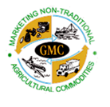

87 Robb & Alexander Streets,
Lacytown, Georgetown, Guyana

Tel: 592-226-8255, 592-225-7808, 592-227-1630 and
592-226-9599

Fax: 592-227-4114
E-mail: info@newgmc.com
Website: www.newgmc.com

The price analysis provides a comparison of the annual average prices in 2014 and 2015.

