
Guyana School of agriculture - ANNUAL REPORT 2015
Ministry of Agriculture


ANNUAL REPORT 2015

GUYANA SCHOOL OF AGRICULTURE

MISSION

“To promote and support the development of sustainable Agriculture and Forestry through technological advancement and the theoretical and practical training of individuals pursuing careers in Agriculture and Forestry.”

VISION

The vision is that in another approximately ten years (2010-2020), the institution will be the foremost regional training centre whose faculty and graduates will be in the forefront of repositioning agriculture and forestry locally in the Caribbean through technical, managerial and entrepreneurial competencies.

During the period under review, the Guyana School of Agriculture was governed by a Board which comprised of the following persons:

Board of Governors
Chairman | Mr. Olato Sam
Member | Mr. Brian Greenidge
Member | Dr. R.S. Surujbally, A.A
Member | Dr. Pat Ann Francis
Member | Mr. George Jervis
Member | Mr. Nizam Hassan
Member | Ms. Prema Ramanah-Roopnarine
Member | Mr. David Fernandes
Member | Mr. Denzil Roberts
Member | Ms. Trecia Garnath
Member | Mr. Quacy Bremner
Member | Dr. Jean David

Ms. Roxanne Hazel served as Secretary to the Board.

PERSONNEL

EMPLOYMENT/APPOINTMENTS

To ensure the smooth functioning of the Institution, a few appointments were made. These included Dr. Dindyal Permaul, Principal, Mr. Soomdat Persaud, Accountant, Ms. Tenesha Hale, Typist Clerk, Ms. Bibi Amjad, Confidential Secretary, Mr. Purnanand Balgobin, Driver and Mr. Josh McDonald, Farm Supervisor.

In addition to these, two (2) scholarship awardees from the Public Service Ministry, who were placed at the Ministry of Agriculture, were seconded to the School. They are:
Clebert Wade, Corcell Nelson.

RETIREMENT/PROMOTION/RESIGNATION/TERMINATION

During the period under review, the following persons retired, resigned, were promoted or were terminated.

RETIREMENT

There were no retirements during the reporting period.

RESIGNATION

Mr. Clennel Petty, Farm Supervisor tendered this resignation during the period under review.

NON-RENEWAL OF CONTRACT

The employment contract for Mr. Bisassar Chintamanie was not renewed. His contract came to an end on December 31, 2015.

DECEASED

- Mr. Nicholson, a former Principal of the Guyana School of Agriculture, died on April 8, 2015. He served at the Guyana School of Agriculture for over 30 years. The last five in the capacity of Principal of the School.

A night of reflection was held for Mr. Desmond Nicholson on Thursday April 16, 2015 at the Ministry of Agriculture.

The funeral service for Mr. Nicholson was held at the Trinity Methodist Church on April 17, 2015. His body was interred at the Le Repentir Cemetery.
- Dr. Kenrick Elias, Senior Veterinary Officer (Retired) and Part-Time Lecturer at the Guyana School of Agriculture died on April 9, 2015. The funeral service for Dr. Elias was held on April 20, 2015 at the Paradise Assembly of God Church, Paradise, East Coast Demerara. His body was interred at the Beterverwagting Cemetery.

A night of reflection, a collaborative effort between the Ministry of Agriculture and the Guyana School of Agriculture was held in his honour on April 17, 2015.

- Ms. Sharon Thomas, Typist Clerk, died on August 12, 2015. Ms. Thomas served the School for 10 years. The funeral service for Ms. Thomas was held on Friday, August 21, 2015 at the Life Spring Cathedral, 1 Q Chateau Margot, East Coast Demerara. Members of staff and the student body attended this service.

OUTREACH PROGRAMMES/PUBLIC RELATIONS
The institution took part in career/knowledge fairs sponsored by the Ministry of Culture, Youth and Sport. These fairs served as good outreach activities to students from Secondary Schools and also out of School youths, as the institution used the opportunity to advertise the programmes it offers.
Many educational institutions ranging from nursery, primary and secondary schools visited during the year from the various administrative regions to become familiar with the operations of the School and to obtain assistance with their CXC SBA assessments.
- Hosting of the Opening ceremony for a Training Programme on Coconuts on April 9, 2015. This training programme resulted from Bilateral Co-operation between the Governments of Guyana and Mexico and was coordinated by the National Agricultural Research and Extension Institute.

- Participation of Mr. Paul Harris, a final year Diploma in Agriculture student, in the United Nations Consultative Youth Forum which was held at the Princess Hotel during the period November 19 - 20, 2014. This forum was held under the theme “Realizing the future we want Post 2015”.

- Participation in the New Guyana Marketing Corporation’s Pre-Easter Exhibition which was held on Thursday, April 2, 2015. Products from the School’s Agro-Processing Unit were displayed at this Exhibition.

- Attendance by Five final year Diploma in Agriculture Programme students, at a lecture by Dr. Naresh Singh, International Development Advisor, on “National Research Economics: It’s importance for Sustainable Development in Guyana on April 15, 2015 at the Education Research Theatre, Turkeyen Campus, University of Guyana.

Dr. Naresh Singh has 30 years of experience as an international development practitioner and advisor, with a special focus on sustainable livelihoods, poverty, environment and legal improvement. He previously served as Principal Advisor at the UNDP HQ on Poverty and Sustainable Livelihoods and before that he was Programme Director for Community Adaptation and Sustainable Livelihoods at the International Institute for Sustainable Development in Canada.

The students who attended were, Paul Harris, Seon Fraser, Quacy Cort, Ashana Alim and Amanda Emptage.

- Participation in the PAHO/WHO Street Fair to commemorate World Health Day 2015 which was held on April 16, 2015 on the avenue of Main Street. The School’s Agro-Processing Unit hosted a booth which showcased the products being produced by the said Unit.

- Hosting of the opening ceremony for the training workshop on Organic Hydroponic and Hydbrid System Growing for Caribbean Schools and Model for local Caribbean Entrepreneurship for School’s farmers, extension officers and underprivileged groupings on April 27, 2015.

- Hosting of the Pesticide, Toxic and Chemicals Control Board, Specialized Fumigation Training Programme from February 2 – 5, 2015.

- Participation of the two Forestry of Lecturers and students from the Certificate in Forestry Programme in activities to observe International Day of the Forests 2015. These activities were conducted by the Guyana Forestry Commission and were held at the Guyana International Conference Centre on Monday, March 23, 2015.

ASSOCIATION AND COLLABORATION WITH OTHER TERITARY INSTITUTIONS
The Guyana School of Agriculture continued its collaboration with the Caribbean Council for Higher Education in Agriculture (CACHE), the Association of Caribbean Tertiary Level Institution (ACTI) Guyana Chapter and the University of Guyana during the reporting period.
Staff Training and Development
Staff members attended short courses, workshops, seminars at which they received training and development in a number of areas. Staff members who benefitted included:
- Mr. Bissasar Chintamanie, Lecturer/Farm Manager who attended a Workshop on January 30, 2015 at the Foreign Service Institute of the Ministry of Foreign Affairs. This workshop focused on the implementation of the CARICOM Trade and Competitiveness Project (CTCP).

- Ms. Grace Parris, Manager-Agro-Processing Unit, participated in a Symposium to commemorate World Health Day 2015. This symposium which was organized by PAHO/WHO in collaboration with its partners in Food Safety, was held on April 6, 2015 at the National Cultural Centre.

- Mr. Osbert Nurse and Ms. Devwattie Dass who participated in a training programme on coconut during the period April 9-11, 2015. This training programme resulted from Bilateral Co-operation between the Governments of Guyana and Mexico and was co-ordinated by the National Agricultural Research and Extension Institute. It sought to renew the focus of coconuts, improving its competiveness and sustainability and maximizing benefits to stakeholders.

- Mr. Bissasar Chintamanie, participated in the HCFC Phase-Out Management Plan-Technical review meeting which was held on April 9, 2015 in the Cara Lodge Conference Room, Georgetown. This meeting sought to highlight the achievements and to discuss the challenges encountered during the implementation of this phase-out plan and to engage stakeholders on the way forward with respect to the implementation of the second phase of the HCFC Phase-Out Management Plan in Guyana. This meeting was a collaborative effort between the Ministry of Agriculture and the United Nations Development Programme.

- The Chief Executive Officer who participated in the Pre-Capacity Building and Product Validation Seminar for Small Ruminants and Cassava which was organized by the Inter-American Institute for Co-operation on Agriculture and held at the Regency Hotel on April 13, 2015.

Under the auspices of the 10th EDF Caribbean Action, IICA is implementing the Agriculture Policy Programme (APP) with focus on the Caribbean and Pacific on behalf of the Caricom countries under an EU/IICA Contribution Agreement.

IICA’s Implementing partners are: The Caribbean Community Secretariat (CARICOM) with the responsibility for the implementation of component 1. Strengthening Regional Agricultural Development Policy and Strategy and the Caribbean Agricultural Research and Development Institute (CARDI) with the responsibility for the implementation of component 2: Improving the transfer and Adoption of Applied Agricultural Production and Processing Research Results and Technologies and where appropriate, generate new Technologies for Target Commodities.

IICA is the Implementing Agency for Component 3: where the primary focus is to improve ‘Market Analysis to Contribute to Agricultural Enterprise Development’, the under which this activity was held.

- Forestry lecturers, Mr. Ulie Timmerman and Ms. Shemika Pereira participated in the Guyana Forestry Commissioner’s REDD+ outreach workshop which was held on April 14, 2015 at the Forestry Training Centre.

- Ms. Grace Parris, Lecturer/Manager, Agro-Processing Unit, who attended a one day workshop on Processing and Market Development of Cassava which was organized by the National Agricultural Research and Extension Institute (NAREI). This workshop, which was held on April 15, 2015 in NAREI’s boardroom, was facilitated by professional and technical research personnel from local and overseas institutions.

- Forestry lecturers, Mr. Ulie Timmerman and Ms. Shemika Pereira, along with students from the Forestry Programme, participated in a training workshop held under the theme “Organic, Hydroponic and Hybrid System Growing for Caribbean Schools and Model for local Caribbean Entrepreneurship for schools, farmers, extension officers and underprivileged groupings” during the period April 27-30, 2015. This training workshop was a collaborative effort between the Organization of American States and the National Agricultural Research and Extension Institute.

- Mr. Osbert Nurse, Lecturer/Assistant Farm Manager, participated in a two day workshop titled ‘Road Map for Market led development of the Coconut and Coconut products sector in Guyana’. This workshop was a collaborative effort between the International Trade Centre (ITC) and the Caribbean Agricultural Research and Development Institute (CARDI) and it was held during the period May, 21 – 22, 2015 at the Grand Coastal Hotel, East Coast Demerara.

The objective of this workshop was to develop a prioritised implementation plan for sustainably improving the profitability of the sector, its productivity and seal scale.

During this two day workshop, specialists from across the value chain in Guyana, CARDI and ITC presented up to date information on regional and international market dynamics, opportunities and performance requirements, plant material availability, new technologies and discussed with participants current Caribbean coconut supply dynamics.

- The Chief Executive Officer who participated in the National Consultation to review fisheries and aquaculture environmental monitoring programmes for supporting the achievement of sanitary and phytosanitary standards under the Fisheries Component of the EU-sponsored Sanitary and Phytosanitary Measures programme of assistance to the CARIFORUM Region.

This consultation facilitated open and broad exchanges among the various stakeholders and agencies concerned towards developing a national position on the way forward for addressing the remaining challenges which will help to realize a fully efficient fisheries and aquaculture SPS monitoring program taking into account national and regional networking needs.

This national consultation was held on Wednesday, June 3, 2015 at the Regency Hotel, Georgetown.

- Mr. Seeraj Samsundar who participated in the First Webinar on Climate Smart Agriculture (USA) Forum for Innovative Co-ordination. This Webinar was the first of a series to be held during 2015. The forum focused on land Restoration. The objective of the Webinar was to raise awareness and share knowledge of climate smart agricultural practices, policies and options for the Caribbean region to build a community of interested and engaged actors, actions at the regional and national levels that can support the integration of climate change considerations into policy, planning, research and institutional co-ordination and interpectoral implementation in the agricultural sector.

This Webinar was held in the boardroom of the Inter-American Institute of Co-operation in Agriculture on June 18, 2015.

- Staff and Students who participated in the Ministry of Agriculture’s Annual Research Conference which was held during the period October 20-22, 2014 at the Guyana International Conference Centre. This conference was held under the theme ‘Consolidating Food and Nutrition Security in the region - Increasing Economic Opportunities and Entrepreneurship for rice and other Agriculture’. The keynote speaker at the opening ceremony for this conference was delivered by Dr. Vyjayantti Lopez, Plant Production and Protection Officer, FAO Sub-Regional Office for the Caribbean which the Feature address was given by the Hon. Dr. Leslie Ramsammy, Minister of Agriculture. Students of the Guyana School of Agriculture performed the jingle they composed for the Health Walk – Eat what we grow, grow what we eat, at the opening ceremony.

Research papers were presented under various topics. These include:

- Production and Marketing of Rice and other Agriculture Products.
- Sustainable Production Systems
- Climate Change Adaptation
- Technology Development

Mr. Bissasar Chintamanie, Lecturer/Farm Manager presented two (2) papers at this conference. They were on “The Role of Research and Technology in Enhancing Family Farms in Guyana” and “The use of Decision Support System for Agro Technology Transfer (DSSAT) to evaluate the potential effect of climate change on rice production in Guyana”.

- The Director of Administration participated in the working sessions of the Task Force on the National Youth Policy and the National Youth Action Plan which was held at the Arthur Chung International Convention Centre on July 3 – 4, 2015.

- The Director of Administration and Lecturer Dr. Randy Domer participated in the Regional Artificial Insemination Training Workshop which was conducted form July 13 – July 17, 2015 at the Guyana Livestock Development Authority by the FAO.

- The Director of Administration, Lecturer Dr. Randy Domer, Livestock Farm Supervisory personnel Joel Nunes and Clebert Wade who participated in an Artificial Insemination training session on swine which was conducted on July 11, 2015 by Dr. Gabrielle Young of Newport Mills Ltd. of Jamaica at the Guyana Livestock Development Authority and the Guyana School of Agriculture.

- Mr. Bissasar Chintamanie would be participating in a one week training programme on ‘Efficient use of rainwater and runoff in Agricultural Activities’ in Panama. This training comes under the IICA/Mexico Technical Co-operation Programme for Agriculture in 2014, 4 staff members benefitted from training under this programme.

- Mr. Seeraj Samsundar, Lecturer, attended a meeting at the FAO Office, 18 Brickdam, Stabroek, Georgetown on September 4, 2015. This meeting sought to address the planning and implementation of activities to commemorate World Food Day 2015 which will be celebrated under the theme ‘Social Protection and Agriculture: Breaking the Cycle of Rural Poverty’. The FAO will also be celebrating its 70th Anniversary as one of the oldest organizations within the United Nations System and is seeking to twin the commemoration with the 70th Anniversary Celebrations.

- Mr. Seeraj Samsundar, Lecturer, attended the launch of the IV International Society for Biodiversity of the Guiana Shield (IBG) which was held on September 10, 2015 at Hermandston Lodge, Peter Rose and Lamaha Streets Queenstown, Georgetown.

The launch was hosted by the Local Organizing Committee of the Guyana Society for Biodiversity and Ecosystem (GBSE), an affiliate of the IBG. The GBSE is a non-governmental, charitable, non-profit organization established to promote conservation research and wise management of biological diversity and eco-system in Guyana and the wider Guiana Shield through collaboration with other partners in the region and beyond. The IV International Congress on Bio-diversity of the Guiana Shield is scheduled for August 8-12, 2016 in Georgetown, Guyana.

- Ms. Grace Parris/Manager, Agro-Processing Unit, and Ms. Stacie Nelson, Demonstrator 2, participated in a Training Workshop on ‘Reduction of Post-Harvest Losses along the Food Chain’ held in the GLDA Boardroom from September 14-18, 2015.

This Training Workshop was convened by the Food and Agriculture Organization in collaboration with the National Agricultural Research and Extension Institute.

This workshop sought to strengthen the capacity of marketing and extension officers and other stakeholders and to raise their awareness to address post-harvest losses thorough training on post-harvest handling of pineapple and cassava, estimation of the cost of the losses and calculation of marketing costs in general. It also focused on enabling participants to understand the major causes of postharvest losses for pineapple and cassava and how to develop solutions to address them.

- Mr. Seeraj Samsundar, lecturer, participated in the Second Webinar hosted by the IICA office in Guyana on September 30, 2015. These Webinars form part of the activities of the Caribbean Climate Smart Agriculture (CCSA) Forum to mark International Year of Soils.

The objectives of the Webinars are to raise awareness and share knowledge of climate smart agricultural practices, policies and options for the Caribbean region and to build a community of interested and engaged actors at the reginal and international levels that can support the integration of climate change considerations into policy, planning, research and institutional coordination and intersectornal implementation in the agriculture sector.

- Mr. Soomdat Persaud, Accountant attended a NPTAB Procurement Symposium and Evaluation Workshop which was held at the Arthur Chung Convention Centre on November 9, 2015.

- Mr. Peter Jones, Warden and Ms. Roxanne Hazel, Matron attended a Conflict Resolution and Professionalism Course on November 23, 2015 in the Boardroom of the Ministry of Agriculture.

- Ms. Natashia Ramdhani, Academic Counsellor and Ms. Mechelle Lutchman, Lecturer attended the Conflict Resolution and Professionals Course on November 25, 2015 in the Boardroom of the Ministry of Agriculture.

- Ms. Grace Paris, Lecturer/ Manager of the Agro Processing Unit represented the country at the 47th Session of the Codex Committee on Food Hygiene in Boston, Massachusetts, USA on November 9-20, 2015.

- Three staff members- Lecturer Ms. Mechelle Lutchman, Kitchen Assistant Ms. Joan M^{c}Pherson and Storekeeper Ms. Barbara Daniels received Long Service Awards at the Ministry of Agriculture’s Long Service Awards Ceremony which was held on November 20, 2015 at the Georgetown Cricket Club Pavillion.

- Mr. Seeraj Samsundar, Lecturer participated in the M & E Training which was held on December 16-17, 2015 in the Main Boardroom of the Ministry of Agriculture.

- Principal Dr. Dindyal Permaul and Director of Administration Dr. Dexter Allen were invited by the Office of the President to the inaugural meeting convened on December 17, 2015 to form the Country Project Management Team (CPMT) for the FAO $1.800,000 Project for the Caribbean ‘Decent Rural Employment Opportunities for Young Women and Men and Participation in the Caribbean Food and Feed System’.

ACADEMIC PROGRAMS
I. Course Offerings
Courses offered in the various programmes during the period under review were as follows:
- Diploma in Agriculture - 35
- Diploma in Animal Health and Veterinary Public Health - 39
- Certificate in Agriculture - 32
- Certificate in Forestry - 22
- Certificate in Agro-Processing - 20
The Institution continues to pride itself in its provision of enhanced practical training through the operation of the Crop and Livestock Farms and the Agro Processing Unit in which students are involved on a daily basis. Students spend two terms of farm practicals at the Livestock Farm. The Crop Farms are used as an outdoor laboratory where students carry out simple experiments. It is also used to demonstrate that crop farming can bring in good income. Some of the skills training that were delivered included the operation and care of the brush-cutter, cleaning and operating spray cans, compost making, operation of the tractor, preparation of seedling beds, use of seedling boxes, identification of plants by scientific names, the care and handling of tools and the installation and operation of the sprinkler irrigation system.
Similarly, the Livestock Farm provides the students with various skills related to care and management of poultry, cattle, swine, sheep and goats. Skills include common disease identification and treatment, ration formulation and feeding, stock handling and movement, slaughtering and butchering, breeding management, hygiene and sanitation, pasture establishment and management as well as record keeping and assessments.

II. Students’ Enrolment

A total of one hundred and forty three (143) new students were enrolled at the two campuses for the 2015/2016 academic year; 125 at Mon Repos and 18 at Essequibo. Students came from all Administrative regions.

A total of ninety (90) students continued into their second year at both Campuses; 80 at Mon Repos and 10 at Essequibo.

The total number of students at both Campuses was 233. The new academic year commenced on September 13, 2015.

Expulsion From School
Two students were expelled from the School following investigations regarding disciplinary infractions. The students expelled were Mr. Joshua Kissoon, from the Certificate in Forestry and Mr. Jason Persaud, from the Diploma in Agriculture Programme, Year 2.
III. Activities Per Programme
A. Animal Health and Veterinary Public Health Programme

Field training activities included visits to various animal production enterprises. Some of these included the Rising Sun Abattoir, the Georgetown Municipal Abattoir, Noble House Seafoods Processing Plant, and Bounty Farm Ltd.’s Poultry Farms and Poultry Processing Plant.

As part of their ambulatory cycle, students visited and participated in the daily veterinary activities at the Pets 2000 Clinic operated by Veterinarian, Dr. Nicholas Waldron. Students also made visits to other animal production facilities accompanied by veterinarians attached to the Animal Health Programme.

The Animal Health students were also invited to participate in a number of field activities organized by the Guyana Livestock Development Authority viz. the Embryo Transplant Programme in cattle.

B. Diploma and Certificate in Agriculture
Students in the Diploma and Certificate in Agriculture programmes were involved in training on a daily basis. Several field trips were undertaken. These included trips to LBI Sugar Estate to observe field operations, the Mechanisation Centre, Research Centre and the Central Analytical and Environmental Monitoring Laboratory, Bounty Farms Limited, to observe commercial poultry practices, Hakh’s Rice Mill at Mahaicony, to observe rice and paddy grading and processing, Guyana Marketing Corporation Packing Facility at Sophia to observe the preparation and packaging of produce for export, the MMA/ADA and the Black Bush Polder Water Management Schemes to observe drainage and irrigation practices and structures.
C. Certificate in Forestry

Field trips were integral to all the programmes, however, students in the Certificate in Forestry programme were involved in some extended and very meaningful trips to Yarrowkabra, Linden/Soesdyke Highway at the Forestry Commission’s Educational Training facility, to Manaka in the Essequibo River, at the Forestry Training Centre’s facility for two (2) weeks where they were trained in reduced impact logging and for which they received special certificates. Students were exposed to Forest Management and Planning, Surveying, Skid trail and Alignment, Block Demarcation, Tree identification and cutting. They also had the opportunity to operate a bulldozer, use the chain saw and the Global Positioning System (GPS).

Field visits were also made to the Barama’s Land of Canaan Sawmill, Liana Canes Interior Ltd., Guyana Furniture Manufacturing Company and Parika Sawmills Limited to expose students to various forms of value added practices.

D. Certificate in Agro-Processing

Students in the Agro Processing programme were involved in training on a daily basis. Several field visits were undertaken. These included visit to supermarkets, the Food and Drugs Department, Banks DIH’s. Dairy Plant, National Milling Company, Demerara Distillers Ltd. and Sterling Products.

E. Remedial Programme

Remedial classes in English and Mathematics continued for first year students who did not meet the required level of proficiency on entry into the institution.

F. Student Assessment
Students were assessed in course work, mid-term and end of term examinations which were held throughout the academic year. The overall assessment showed that:

THE DIPLOMA IN AGRICULTURE (Mon Repos) produced 58 graduating students:

Distinction - 4
Higher Credit - 19
Lower Credit - 3
Pass - 32

THE DIPLOMA IN AGRICULTURE (Essequibo) produced 13 graduating students:

Distinction - 1
Higher Credit - 2
Lower Credit - --
Pass - 10

THE DIPLOMA IN ANIMAL HEALTH AND VETERINARY PUBLIC HEALTH produced
7 graduating students:

Distinction - --
Higher Credit - 2
Lower Credit - 1
Pass - 4

THE CERTIFICATE IN AGRICULTURE produced 16 graduating students:

Distinction - 1
Higher Credit - 4
Lower Credit - 1
Pass - 10

THE CERTIFICATE IN FORESTRY (Mon Repos) produced 24 graduating students:

Distinction - 4
Higher Credit - 15
Lower Credit - --
Pass - 5

THE CERTIFICATE IN FORESTRY (Essequibo) produced 8 graduating students:

Distinction - --
Higher Credit - 2
Lower Credit - 2
Pass - 4

THE CERTIFICATE IN AGRO-PROCESSING produced 12 graduating student:

Distinction - 2
Higher Credit - 4
Lower Credit - 3
Pass - 3

The total number of graduating students was 138.

This is the largest batch of graduates in the history of the School, surpassing the 125 in 2013.

THE AWARD OF THE GOLD MEDAL

To be awarded the Gold Medal, one has to perform outstandingly in the areas of academic work, practical work and campus community service. This year two gold medals was awarded on at the Essequibo Campus and one at the Mon Repos Campus. Ms. Sherifa Valenzuela from the Essequibo Campus and Mr. Paul Harris from the Mon Repos Campus.

THE CHIEF EXECUTIVE OFFICER’S PRIZE

This award is given to the best graduating student in any of the two year programmes offered by the institution at its Mon Repos Campus. This prize went to Student Quacy Cort with 82.80 %.

THE CHAIRMAN’S PRIZE

This award is given to the best graduating student in any of the two programmes offered by the Institution at its Essequibo Campus. This prize went to Student Sherifa Valenzuela with 84.24%.

Graduation was held on Friday, August 7, 2015. It was chaired by Mr. George Jervis, Permanent Secretary, Ministry of Agriculture. The feature address was delivered by the Honourable Minister of Agriculture, Hon. Noel Holder. The Charge to the graduands was delivered by Mr. Olato Sam, Chairman GSA Board of Directors.

G. Faculty and Staff
Continuing lecturers were Dr. Dexter Allen, Mr. Oscar Glasgow, Ms. Grace Parris, Ms. Shemika Pereira, Ms. Mechelle Lutchman, Mr. Seeraj Samsundar, Mr. Bissassar Chintamanie, Mr. Ulie Timmerman, Ms. Devwattie Dass, Mr. Osbert Nurse and Dave Sarran. The services of thirty two (32) part time lecturers were utilized during the period.

H. Counselling

Individual counselling sessions were conducted by the Academic Counsellor to deal with issues relating to students academic performance, coping with the volume of work, classroom participation, adjusting to life on campus and other personal problems. Preparation and monitoring of class registers were also done by the Academic Counsellor who also participated in disciplinary matters involving students.

I. Library
A total of 72 publications were donated to the School during the period. Donors included the FAO, CTA, CFNI, Ministry of Agriculture, IICA, Guyana National Bureau of Standards and The Guyana Book Foundation.
Purchase of books, periodicals and audiovisual materials, were made from monies appropriated for this purpose in the School’s budget.
Staff engaged in routine activities including book repairs, dusting, shelf reading, newspaper clipping/filing, cataloguing and classification. The Library also assisted in preparations for the School’s outreach programmes.
J. Extra Curricular Activities
Students and Staff were involved in several extra-curricular activities during the reporting period. These activities included:
- Participation in the New Guyana Marketing Corporation’s Pre-Easter Exhibition which was held on Thursday, April 2, 2015. Products from the School’s Agro-Processing Unit were displayed at this Exhibition.

- Attendance by Five final year Diploma in Agriculture Programme students, at a lecture by Dr. Naresh Singh, International Development Advisor, on “National Research Economics: It’s importance for Sustainable Development in Guyana on April 15, 2015 at the Education Research Theatre, Turkeyen Campus, University of Guyana.

Dr. Naresh Singh has 30 years of experience as an international development practitioner and advisor, with a special focus on sustainable livelihoods, poverty, environment and legal improvement. He previously served as Principal Advisor at the UNDP HQ on Poverty and Sustainable Livelihoods and before that he was Programme Director for Community Adaptation and Sustainable Livelihoods at the International Institute for Sustainable Development in Canada.

The students who attended were, Paul Harris, Seon Fraser, Quacy Cort, Ashana Alim and Amanda Emptage.

- Participation in the PAHO/WHO Street Fair to commemorate World Health Day 2015 which was held on April 16, 2015 on the avenue of Main Street. The School’s Agro-Processing Unit hosted a booth which showcased the products being produced by the said Unit.

- Hosting of the opening ceremony for the training workshop on Organic Hydroponic and Hydbrid System Growing for Caribbean Schools and Model for local Caribbean Entrepreneurship for School’s farmers, extension officers and underprivileged groupings on April 27, 2015.

- Hosting of the Pesticide, Toxic and Chemicals Control Board, Specialized Fumigation Training Programme from February 2 – 5, 2015.

- Participation of the two Forestry of Lecturers and students from the Certificate in Forestry Programme in activities to observe International Day of the Forests 2015. These activities were conducted by the Guyana Forestry Commission and were held at the Guyana International Conference Centre on Monday, March 23, 2015.

- The School participated in the annual Berbice Exposition under the banner of the Ministry of Agriculture. This exposition was held during the period September 18-20, 2015 at the Albion Community Centre Ground. The School hosted a booth showcasing products from its Agro-Processing Unit and other aspects of the School’s operations. Ms. Marian Stewart and Mr. Akeem Williams from the Agro-Processing Unit were in attendance.

- Students in the Certificate in Forestry Programme from both the Mon Repos and Essequibo Campuses spent three days (September 18-20, 2015) at the Guyana Forestry Commission’s Training facility at Yarrowkabra to gain exposure to forest and forest related activities. The Guyana Forestry Commission provided resource personnel to deal with the technical aspects of the programme.

Students were accompanied by the Forestry Lecturers from both campuses; Mr. Ulie Timmerman and Ms. Shemika Pereira from the Mon Repos Campus and Mr. Kavendra Persaud and Mr. Safraz Samad from the Essequibo Campus.

- Students from the Forestry Programme and their Lecturers, Mr. Colin Timmerman and Ms. Shemika Pereira participated in the Ministry of Education’s annual rally on Friday, October 9, 2015 which was held at the National Park.

- Personnel from the Guyana Forestry Commission gave a guest lecture to students from the Certificate in Forestry Programme on October 12, 2015. This lecture focused on the use of the GPS, compasses, taking bearings from maps and use of maps in forestry. This lecture formed part of the Surveying and Mapping Course of this programme.

- The Chief Executive Officer, Principal and Director of Administration participated in a meeting held on Tuesday October 27, 2015 in the Boardroom of the Ministry of Agriculture to look at project being spearheaded by the ASDU of the Ministry of Agriculture to resuscitate the farm at President’s College at Golden Grove on the East Coast of Demerara. Dr. Dexter Allen was mandated to be part of the working group which was formed. This meeting was held at the request of the Permanent Secretary of the Ministry of Agriculture.

- Dr. Dindyal Permaul, Principal and Dr. Randy Domer, Lecturer participated in a Seminar on Aquaculture and Aquaponics at the Education Lecture Theatre of the University of Guyana. This seminar was conducted by Professor Aweeda Newaj-Fyzul who is part of a team working with the University to introduce its BSc Programme in Aquaculture in the 2016 academic year.

- Students of the Diploma in Animal Health and Veterinary Public Health and Diploma Agriculture classes and Lecturer Mr. Seeraj Samsundar visited the Guyana Livestock Development Authority’s Hatchery as part of the requirements of the course in Zoology during November 16-19, 2015.

- The school successfully held its annual Inter House Sports Competition during the period November 3-13, 2015. Vigna House emerged victorious amassing 912 points. Vigna, Minica and Cajanus were the three participating houses.

The annual Athletics Competition was held on Friday, November 13, 2015 and was declared open by Mr. Seon Erskine, Technical Development Officer (Sports), National Sports Commission who also viewed the Marchpast of the athletes of the three houses viz. Vigna, Minica and Cajanus.

- The institution was represented at the 2015 Business Exposition which was held on November 27-29, 2015 by staff members of the Agro Processing Unit together with Library Supervisor, Ms. Melissa Squires. The students of the Agro Processing class also attended the opening ceremony of Business Expo 2015.

- Students of the Certificate in Agriculture class together with Lecturer Mr. Seeraj Samsundar visited the Burma Rice Research Station and Fairfield Rice Inc. on November 25, 2015 as part of their course in Seed Technology.

- The Annual Christmas Luncheon was held on Friday December 4, 2015.

This event, which was held in the auditorium, was attended by students, staff (full-time and part-time), board members and the past Principal. During this activity, outstanding athletes as well as students who helped to make the 2015 GSA Games a success, were recognized for their contribution and awarded trophies and medals.

- The Annual Staff Party was held on December 18, 2015 at the Buddy’s Night Club in Georgetown. The event saw good participation by staff members, invited guests, the Chairman and members of the Board of Directors.

STUDENT COUNCIL ELECTIONS
Elections for office bearers of the Student Council were held in October, and the results were published in November, 2015. The persons elected to form the Council for the period 2015/2016 are as follows:
PRESIDENT: Arvinda Dhaniram
VICE PRESIDENT: Ravin Singh
SECRETARY: Maheepa Ramballie
TREASURER: Thresha Caldeira
SPORTS REPRESENTATIVE: Sarwan Persaud
ASSISTANT SECRETARY/ TREASURER: Nekisha Holder

AGRICULTURE MONTH 2015

The School participated in a number of activities that were planned and executed in observance of Agriculture Month 2015. These included:

- The National Tree Planting Exercise which was held on October 3, 2015 at the Bartica Community Centre Ground. His Excellency the President, David Granger delivered the feature address at this event. The event was chaired by Dr. Maxine Parris, Agricultural Health Specialist at the Inter-American Institute for Co-operation on Agriculture. The Minister of Agriculture, Junior Ministers of Education and Communities, Regional Chairman, Region 7, Heads of Department and Staff of Agencies of the Ministry of Agriculture were all in attendance.

Fruit trees were distributed to residents of the Bartica community. These trees were supplied by National Agricultural Research and Extension Institute.

- Students of the Certificate in Agriculture Year I class and lecturer Ms. Devawattie Dass participated in the Hydrometerological Department’s Open Day which was held at the National Weather Watch Centre at Hyde Park, Timehri on October 5, 2015.

- Students of the Diploma in Agriculture Year 2 class and staff members, Mr. Osbert Nurse and Mr. Cornel Fraser participated in the Guyana Rice Development Board’s Open Day which was held at its Research Station at Burma on Wednesday October 7, 2015. The Hon. Noel Holder, Minister of Agriculture delivered the feature address at this event.

- The School participated in the Open Day held by the Canje Secondary School on Wednesday, October 14, 2014. The School hosted a booth to showcase its operations. Ms. Melissa Squires, Library Supervisor, and Mr. Akeem Williams spearheaded the School’s effort at this event.

- The School held its Agriculture Month Activity on Thursday October 15, 2015 in its Plant Science Building. This event ‘Promotion of Youth in Agriculture’ was well attended by fourth and fifth form students from secondary schools. The feature address was delivered by Mr. Aubrey Norton, Presidential Advisor on Youth Empowerment. Board Member, Dr. Jean David, made her customary presentation on the ‘Current Agricultural Policies and the role of youth in Agricultural Development.

- The activity commemorating World Food Day was held on October 16, 2015 at the Uitvlugt Community Centre Ground. The opening ceremony saw remarks being made by His Excellency, the President David Granger, Hon. Noel Holder, Minister of Agriculture, Mr. Ruben Robertson, FAO representative in Guyana and Mr. Wilmot Garnett, IICA representative in Guyana. This ceremony was chaired by Mr. George Jervis, Permanent Secretary within the Ministry of Agriculture.

The School was well represented by staff and students at this event.

Items displayed and sampled in the booth hosted by the School were well received by the dignitaries and members of the public. Produce, products and services offered by other stakeholders within the sector were also on display at the World Food Day exhibition.

- Students and staff from the Year 1 Certificate and Diploma in Agriculture Programmes participated in the Fisheries Department Open Day which was held at the Satydeow Sawh Aquaculture Station on October 21, 2015.

- The National Agricultural Research and Development Institute held its Open Day on October 22, 2015. This activity attracted stakeholders within the Agriculture sector inclusive of staff and students from the School.

- Essequibo Night was held during the period October 23 -24, 2015 at the Anna Regina Community Centre Ground. This event saw the participation of all agencies within the agricultural sector. The School hosted a booth to showcase its products and services. Students and staff of the Essequibo Campus and Library Supervisor, Ms. Melissa Squires and Ms. Stacy Nelson from the Mon Repos Campus were in attendance at this event.

- The School hosted a booth at the Agro-Processors Street Fair which was held in the avenue of Main Street on October 24, 2015. This booth was manned by Mr. Akeem Williams and Ms. Amy Price from the Agro-Processing Unit of the School.

- IICA celebrated its 40th Anniversary in Guyana on October 26, 2015 with a simple ceremony at its office in Brickdam. Mr. Wilmot Garnett, IICA Representative in Guyana outlined IICA’s contributions to Guyana during this period and the expectations for future work in Guyana. Hon. Noel Holder, Minister of Agriculture delivered the feature address at this ceremony. The Chief Executive Officer attended this event.

- The Pesticide and Toxic Chemicals Control Board, as part of its Pesticides Awareness Campaign in secondary schools held its Dramatic Presentation Finals and Awards Ceremony at the Theatre Guild, on Tuesday, October 27, 2015. The Chief Executive Officer, Principal and Director of Administration were in attendance. The Principal served as one of the judges at this event.

- The Ministry of Agriculture held its Healthy Foods Campaign with a Cook Off on October 27, 2015 on the lawns of its Head Office at Regent and Vlissengen Roads. Georgetown. This event showcased the preparation of various foods utilizing local ingredients by agencies and departments within the Ministry and other industry stakeholders.

- The MMA/ADA held its Open Day on October 28, 2015 at its Head Office, Onverwagt, West Coast Berbice. As part of this event, booths were hosted by agencies and departments within the Ministry and other industry stakeholders too showcased their operations. The School’s booth was manned by Library Supervisor, Ms. Melissa Squires and Ms. Marian Stewart. Hon. Noel Holder delivered the feature address at this event.

DONATION
- The Food and Agriculture Organization, through it representative in Guyana. Mr. Rueben Robertson, handed over two used computers to the School for use in the area of research. Mr. Robertson, in his remarks expressed the desire of this organization to continue to work with the school to meet its mandate. The computers were received by the Chief Executive Officer who expressed appreciation to the FAO for the gift of the computers on behalf of the Board of Directors, Management and Staff of the school. This handing over ceremony was done on October 28, 2015 in the School’s Boardroom. Members of staff, students and the media were in attendance.

- Mr. Schelte Van Dijk, Operation Manager of the General Equipment Company, handed over one bean planter and one thresher to the school on behalf of his company for use on the School’s Crop Farm. The formal ceremony was held in the School’s Boardroom on October 30, 2015 in the presence of students and staff of the school and representatives from the company. Mr. Van Dijk expressed his wish to further build on this partnership and to also include other stakeholders within the education sector to work with the school to further its development. The two pieces of equipment were accepted by the Chief Executive Officer on the School’s behalf. The CEO expressed sincerest gratitude on behalf of the Board of Directors, Management, staff and students of the school for the generous donation made by the company and expressed his desire for greater collaboration between the two agencies.

Mr. Yearwood, Lecturer from the Government Technical Institute (GTI) was present at this simple handing over ceremony. The General Equipment Company is currently collaborating with the GTI and has pointed to various avenues in which GTI can collaborate with the Guyana School of Agriculture.

THE PLANTER DONATED BY GENEQUIP
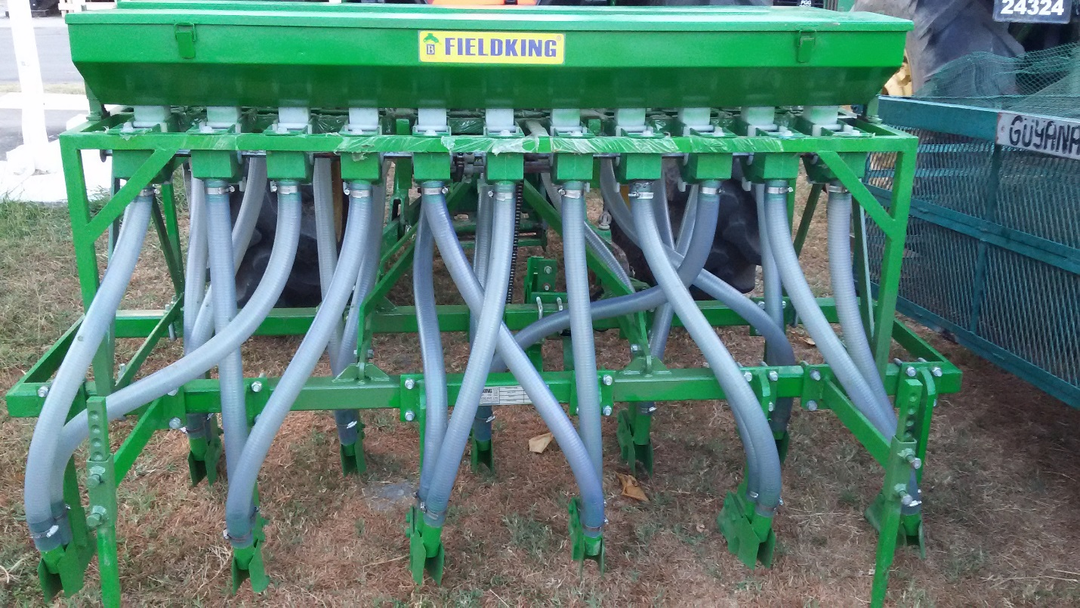

THE THRESHER DONATED BY GENEQUIP
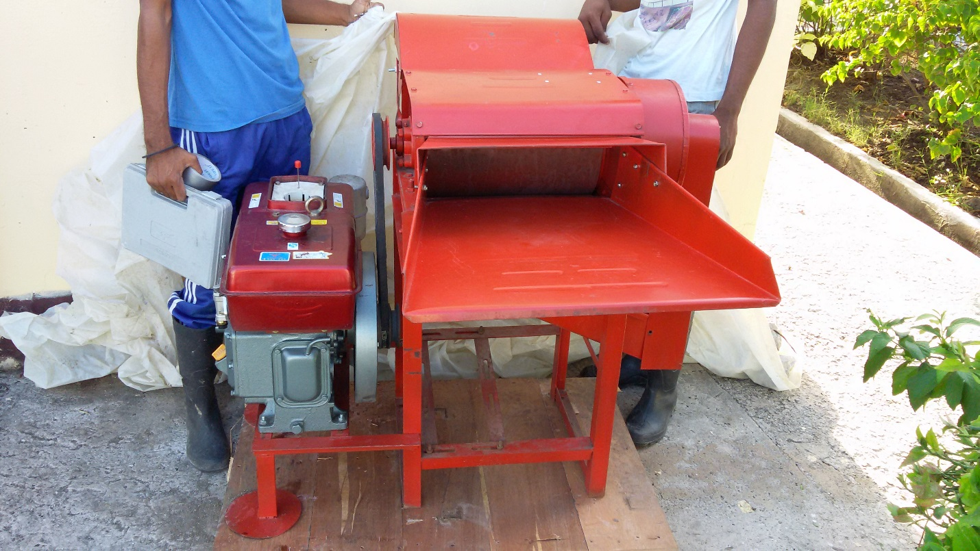

FINANCE AND CAPITAL WORKS

FINANCE
REVENUE

The school recorded a total recurrent revenue of $ 287,677,000 during the period January to
December 2015 of this amount $ 179,257,000 represented the recurrent subventions form
Central Government while the remaining sum $ 108,420,000 represented funds generated from
the School operations. The breakdown of the remaining $ 108,420,000 which was recorded
as revenue from operations is as follows:

School Fees and Fines |  |  |  |  | 42,156,000
Rental of Buildings |  |  |  |  | 626,000
Miscellaneous Receipts |  |  |  |  | 294,000
5% Arrears -Received from Gov't |  |  |  |  | 8,328,000
Sales -Livestock Farm |  |  |  |  | 46,236,000
Sales -Crop Farm |  |  |  |  | 1,250,000
Sales -Agro Processing Unit |  |  |  |  | 2,647,000
Security Service |  |  |  |  | 6,883,000
EXPENDITURE

Total recurrent expenditure during the period was $ 306,070,000.

Employment costs for the period was recorded as $ 154,575,000.
This figures also included the payment of $ 8,328,000, as 5% and 8% wages and
salaries arrears for 2015.

Wages and Salaries amounted to $ 119,250,000 while overhead expenditure totaled
$ 35,325,000.
Other charges for the period was recorded as $ 151,495,000. The breakdown is as
follows:
L / Stock - Expenses |  |  |  |  | 29,664,000
Expenses – Agro Processing Unit |  |  |  |  | 2,890,000
Expenses - Crop Farm |  |  |  |  | 1,455,000
Medical Supplies |  |  |  |  | 442,000
Laboratory & Academic Supplies |  |  |  |  | 30,000
Office Material & Supplies |  |  |  |  | 3,848,000
Newspapers & Periodicals |  |  |  |  | 394,000
Fuel & Lubricants |  |  |  |  | 4,308,000
Maintenance of Building  Maintenance of Infrastructure |  |  |  |  | 4,350,000  -----
Transportation, Travel & Postage |  |  |  |  | 2,506,000
Utility Charges |  |  |  |  | 12,875,000
Other Goods & Services Purchased |  |  |  |  | 12,286,000
Other Operating Expenses |  |  |  |  | 39,470,000
Subsides & Contributions |  |  |  |  | 27,649,000
Old age Pension |  |  |  |  | 8,435,000

CAPITAL WORKS

Capital Expenditure was $ 13,350,000, $ 12,350,000 at the Mon Repos Campus and $ 1,000,000 at the Essequibo Campus.

A number of activities were carried out under the Capital Works Programme. These included:

Mon Repos

- Purchase of Combination Chairs - $ 1,000,000
- Purchase of Reading Tables - $ 1,000,000
- Purchase of Desktop Computers, Server with Accessories - $ 5,050,000
- Purchase Industrial Stove and Oven - $ 1,800,000
- Procurement of Milking Machine - $ 2,000,000
- Procurement of Vacuum Packaging Equipment - $ 1,000,000
- Procurement of Biometric Equipment - $ 500,000
TOTAL $ 12,350,000

Essequibo

- Construction of Compost Unit - $ 500,000
- Construction of Plant Nursery - $ 500,000

TOTAL - $ 1,000,000

BUDGET SHORTFALL

A number of meeting were held to facilitate the School’s requirement for an advance from the Contingencies Fund to finance a Shortfall. This continued into December 2015.

SYSTEM REVIEW REPORT

The verification Unit of the Ministry of Agriculture conducted a systems review of the Guyana School of Agriculture for the period January 1, 20 August 15, 2015. The Unit presented its report to which the School provided its response as was requested. The Principal, during the absence of the Chief Executive Officer who was on annual vacation leave, was responsible for those implementation of the recommendations made by the Unit. He was supported by the Director of Administration, Director of Academic Affairs and the Accountant.

MAINTENANCE

General maintenance works were done throughout the year in all areas of the School. Some of these included:

- Repairs and painting of eastern wall of the Pre Fab dormitory.
- Replacement of windows on the eastern wall of the Pre Fab dormitory.
- Repairs and painting of eastern wall of the L/Shape dormitory.
- Repairs to cupboards in all dormitories.
- Replacement of louvre panes in L/Shape and 68 dormitories.
- Replacement of ten (10) double bunks in the L Shape and TC.
- Addition of twenty five (25) new class room chairs.
- Maintenance of plumbing systems in all dormitories.
- Repairs and painting of abolution area in Matron’s quarters.
- Construction of fence on southern boundary.
- Painting of Staff offices.
- Repairs to ceiling of Accounts Department.
- Installation of sheds over windows on eastern side of dormitories 20 and 68.
- Maintenance of perimeter lights at Main Campus, Livestock Farm.
- Treating building for termites.

PRODUCTIVE SECTORS
1. LIVESTOCK FARM

2. CROP FARM 1
ACTIVITIES TARGETED
During this period the Crop farm 1 focused on the following objectives.
- Cultivation of Hot peppers
- Cultivation of Red peas
- Cultivation of Sorrel
- Trained 200 students in 6 different skills set, relating to crop production and crop health
- Provided educational tours for 10 learning institutions to stimulate more interest in agriculture amongst youths
- Worked with other tertiary institutions to provide practical training and cropping area for scientific experiments of students
- Cultivated 100% of the farm area
- Maintained the farm’s environs
- Achieved 100% attendance from 85% of students
- Provide the cafeteria and food processing unit with produce

CROPS PLANTED DURING THIS PERIOD (2015)

- Cabbage
- Butternut squash
- Sweet corn
- Red peas
- Hot pepper
- Sorrel
- Poi
- Pigeon Peas
- Shallot

CROPS HARVESTED DURING THIS PERIOD (2015)

- Cherry
- Cabbage
- Butternut squash
- Sweet corn
- Papaya
- Hot pepper
- Red peas
- Poi
- Sweet pepper
- Pigeon peas
- Sorrel
- Thyme

STUDENTS INVOLVEMENT

Students were actively involved in practical’s, and different skills set, such as harvesting techniques and practices, land preparation, planting and transplant of seedlings etc.

ACTIVITIES DONE DURING THE PERIOD

- Cleaning and maintenance of main & infield drains
- Manual weed control
- Cultural and chemical disease control, while applying the concepts of Integrated Disease Management (IDM) and Integrated Pest Management (IPM).
- Hands on training on the correct steps and procedures to calibrate chemical application equipment. This training also included the correct steps to follow for dosage calculation and the importance of Personal Protective Equipment (PPE).

During the month of October we were fortunate enough on the crop farm to successfully develop a relationship with General Equipment Guyana Ltd. General Equipment Guyana Ltd. was founded on 22th of January 1993 and commenced business in the sales and service of new equipment in Guyana and in the wider Caribbean.

Mr. Schelte Van Dijk, Operations Manager at GENEQUIP was impressed with the operations of the Guyana School of Agriculture and had indicated his interest in being a part of the collaborative effort with the institution. This initiative will assist the institution in realizing its goals of becoming mechanize on the crop farm, employing modern technologies to improve the farms productivity.

On 28th October 2015, the Crop farm received a seed Planter and bean Thresher compliments of General Equipment Guyana Ltd. These implements will assist in the Crop farm 1 with, the timely completion of the planting program, a more efficient beans recovery and to expose the students to current technologies used in agriculture worldwide.

During 2015, the Crop Farm 1 successfully hosted various tours comprising of students from different learning institutions within the education sector.

FINANCIAL STATEMENT

The Crop Farm 1 generated a gross income of $ 633, 462 in 2015; with a total expenditure of $ 281, 420; reflecting a $ 352,042 net profit in 2015. February was the most productive month, which recorded a net income of $ 128, 700, followed by December. The least productive month was August which had no recorded sale of produce, due to the loss of crops in previous months.
In 2015, Sorrel was responsible for 28% of all crop sales followed by pigeon peas which accounted for 18% of the total income on the farm.
Temporary workers was the largest expense for the farm, followed by fertilizers.

GENERAL PERFORMANCE

The year 2015 was a very challenging one for Crop farm 1. Unfavourable weather patterns was the major cause of decreased yields. The farm was also affected by diseases which resulted in a decrease in the yield of various crops.

There was a noticeable improvement in students’ attendance and performance in 2015. Students were particularly interested in the various skills set taught on the farm and were anxious to get involved in these exercises.

Reflecting on the performance of Crop farm 1 in 2015, there is an urgent need to apply modern cropping techniques and systems on the farm. These systems will not only optimized the farms’ production, but will also prepare the students to be more capable to deal with technical situations in the agriculture sector where climate change is evident.

Even though the loss of crops due to excess precipitation or drought conditions had a negative impact on the farms’ productivity, it also aid in the teaching aspects, where students were able to appreciate the need for advance technology to remedy current climate constrains.

3. Crop Farm 2&3

Highlights 2015
The Crop Farm Two (2) performed fairly during the year 2015 despite negative effects of the weather on overall crop performance. Managing the effects of the climatic condition and skills training on the farm will be the main focus for 2016 in realizing its objectives.

Climate and Weather
Weather and climate continues to play a major role on the overall productivity of the crop farm.
During the earlier part of the year, wet weather prevailed, however during the latter part, dry weather was experienced.
The rainfall played an important role in the growth and development of the crops that were cultivated.

Activities and Agronomic Practices – 2015
The following activities and agronomic practices were carried out in 2015:
- Weed Control – Manual cleaning and chemical weed control exercises were carried out in the following areas:
  - Perimeter Drains
  - Central Drain
  - Internal Drains
  - Main Cultivation Area
  - Crop Museum
  - Other areas

- Land and Bed Preparation – Land and Bed preparation were carried out in order to facilitate the seeding and planting of crops. Beds were prepared i.e. bed and drain, holes, amelioration, fertilizing and weed control. The tractor and other implements was used in the later part of the year to prepare most of the land, however, wet weather prevented targeted land preparation to be completed.

- Nursery – Seedlings were produced in the nursery facility for the following crops: sweet pepper, cauliflower, broccoli, hot pepper, pigeon peas, cabbage, red stemmed poi and celery. Potting mixtures were used in the nursery which is made up of clay, paddy husk, burnt paddy husk, filter press and sand.

- Planting and Seeding – Some seeds were sown directly to the beds; these include ochro, bora, cucumber, pumpkin, squash, and while some crops were transplanted such as poi, pack choi, red stemmed poi, cabbage, cauliflower, broccoli, hot pepper, sweet pepper and celery.

- Pest Control –Chemical as well as cultural pest control were carried out on the following crops:
  - Cauliflower – White Fly
  - Bora – Leaf Miner/Aphids
  - Pak choi – Leaf Miner
  - Ochro - Leaf Miner/Aphids
  - Sapodilla – Ant/Fungus complex, Caterpillar
  - Soursop - Ant/Fungus complex
  - Cherry - Ant/Fungus complex
  - Banana – Black Sigatoka
  - Cucumbers – Mites/White Fly
  - Boulanger - White Fly/Phytophthora blight
  - Peppers - Mites/White Fly
  - Poi – Leaf miner
  - Tomatoes - Mites/White Fly/Bacterial wilt
  - Cabbages - Mites/White Fly/Diamond Back Moth
  - Celery – Aphids/Nematodes

- Fertilization and Soil Amelioration - Limestone, and N-P-K were applied to all the beds prepared for planting. Micro and Trace Elements, in the form of foliar application, were applied to the vegetables. Filter press, cow manure and chicken litter were used to fertilize the soil.

- Irrigation and Drainage –Some beds were irrigated with supplemental irrigation and others manually. Manual cleaning of the main drain and the inlet drains were carried out which contributed to the availability of water for irrigation purposes.

- Procurement of Chemicals and Fertilizers – Chemicals and fertilizers were procured during the reporting period. These included-: Limestone, 20:20:20 (NPK), 12:12:17: 2 (NPK, Mg); Murate of Potash (MOP); liquid trace elements, insecticides, herbicides and fungicides. The PTCCB assisted with the supply of weedicides such as Gromoxone, Glyposphate and 2-4-D.

- Maintenance of Equipment – Maintenance works were done on the brush cutter.

Crops under Cultivation/Grown - 2015
COMMON NAMES | BOTANICAL NAME
Bora | Vigna sesquipedalis
Boulanger | Solanum melongena
Cabbage | Brassica oleracea
Ochro | Abelmoschus esculentus
Pumpkin | Cucurbita pepo
Tomato | Lycopersicon escuelenta
Cassava | Manihot esculenta
Calaloo (poi) | Basella alba
Plantain | Musa spp.
Eschallot | Allium spp.
Hot Pepper | Capsicum frutescens
Sweet Pepper | Capsicum annuum
Pigeon Pea | Cajanus cajan
Banana | Musa acuminate
Mango | Mangifera indica
Sapodilla | Achras sapota
Papaw | Carica papaya
Passion Fruit | Passiflora edulis
Coconut | Cocos nucifera L.
Soursop | Annona muricata
Celery | Apium graveolens
Cauliflower | Brassica oleracea
Broccoli | Brassica oleracea alboglabra
Guava | Psidium guajava
Gooseberry | Emblica officinalis
Cucumber | Cucumis stavus
Golden Apple | Spondias cytherea L.
Squash | Cucurbita mellonia
Samee | Vieia aba
Thyme | Thymus vulgaris
Ginger | Zingiber officinale
Basil | Ocimum basilicum
Sijan | Moringa oleifera
Watermelon | Citrullus lanatus
Orange | Citrus sinesis
Lime | Citrus aurantifolia
Lemon | Citrus lemon
Karela | Momordica charantia
Corn | Zea maze

Research Projects Undertaken in 2015

- Market Survey
- Hydroponics
- Agro-Tourism
- Aquaculture

Other Activities – 2015

Apart from activities on the crop farm itself the crop farm activities staff of the crop farm participated/ coordinated in various other activities, some of these include:

- Skills Training – Farm Manager/Farm Supervisor- Coordinated
- School Tours – Participated – Farm Manager and Farm Supervisor

Income and Expenditure Statement – 2015

The Table below indicates income and expenditure for 2015

Months | Income | Expenditure | Net Profit
January | $127,480 | $13,812
February | $75,430
March | $83,980 | $151,960
April | $6,000
May | $35,780
June | $212,560 | $28,290
July | $130,740
August | $10,620
September | $2,100 | $35,500
October | $14,340
November | $38,900
December | $37,100
Total | $775,030 | $229,562 | $545,468

Activities Projection -2016

The following Activities are being projected for the Year 2016.

- Weed Control
- Land and Bed Preparation
- Nursery and procurement of Planting materials
- Planting and Seeding
- Pest Control – Mostly Insect and Disease Control
- Fertilization and Soil Amelioration
- Irrigation and Drainage
- Procurement of Chemicals and Fertilizers
- Maintainace of Equipment
- Skills Training
- Special Projects
- Compiling of Farm Diary

Limitations

- Unpredictable weather pattern affected farm operation and productivity
- Weeds re-infestation in some areas
- Unavailability of some seeds

Conclusion and Recommendations
The crop farm has performed well during 2015 taking into consideration the challenges outlined above. Analyses show that rainfall, and prolonged dry periods affect productivity on the farm. Therefore, drainage and irrigation are considered very important factors for better production.

4. AGRO PROCESSING UNIT
Academic Activity
The Agro Processing Facility facilitated the second year Diploma and Certificate in Agriculture classes in their practical sessions in Agro Processing during the reporting period. For the Essequibo campus the Manager travelled to the region and conducted those practical sessions there. Students from both campuses were exposed to making of Jams, Jellies, Sauces, Preserved Seasonings (Dehydrated & Bottled), Preserved Fruits and Vegetables, Dairy Products, and Preserved Meats and Fish Products.
Diploma in Agriculture
Students were asked to research and developed products for the local market. Products displayed were herbal tea bags from capadula, sweet sage, pear leaf and lemon, Ready to Eat Cassava Cake, Preserved Ginger Pieces, Pickled Ginger, Instant Eddoe Flakes, Pone Mix, Crushed Pineapple, Pine Apple Sauce and Dried Pineapple Pieces. An exhibition was held to show case all their products. The highlights of the Exhibition are as follows;
Diploma in Agriculture
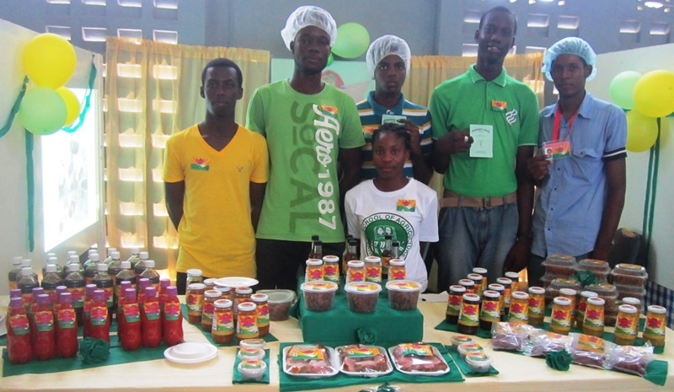 | 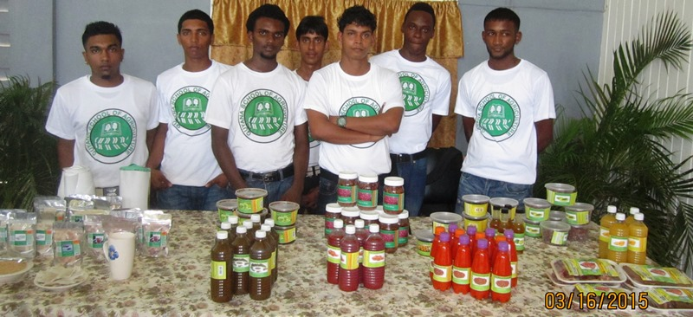
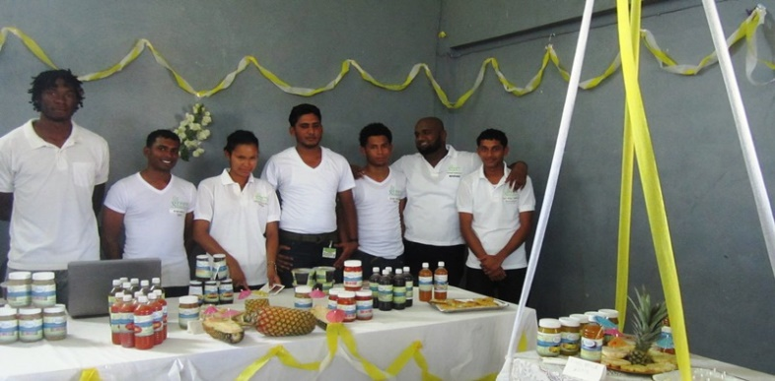 | 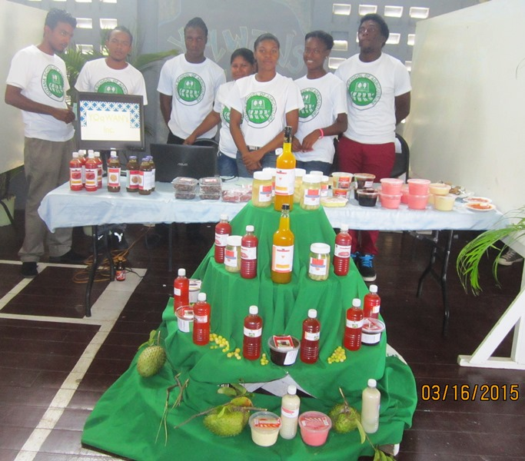
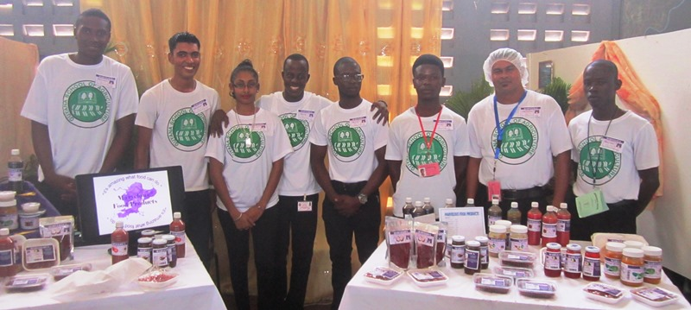 | 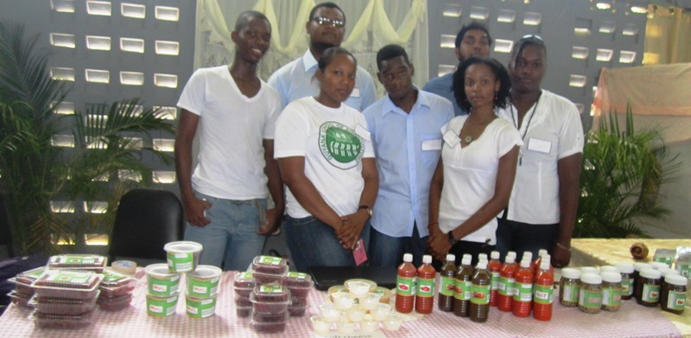
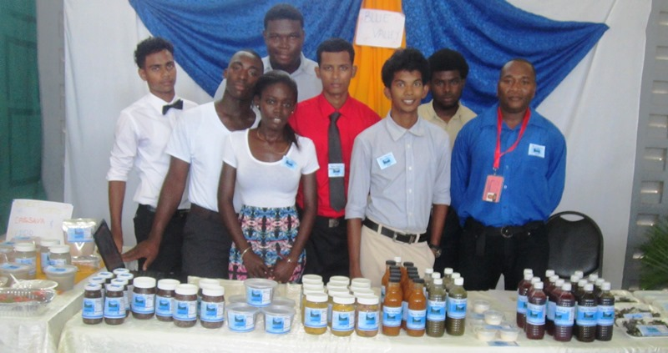 | 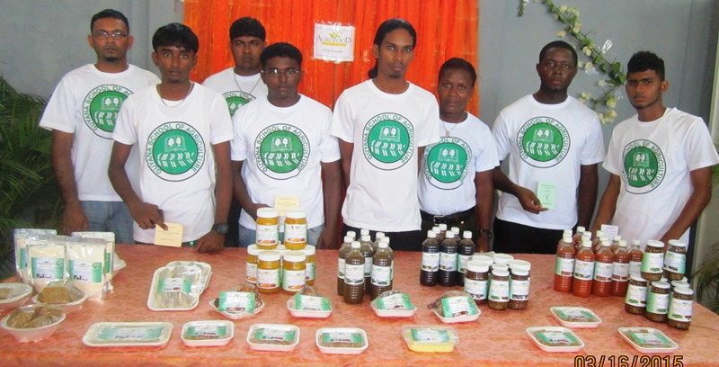
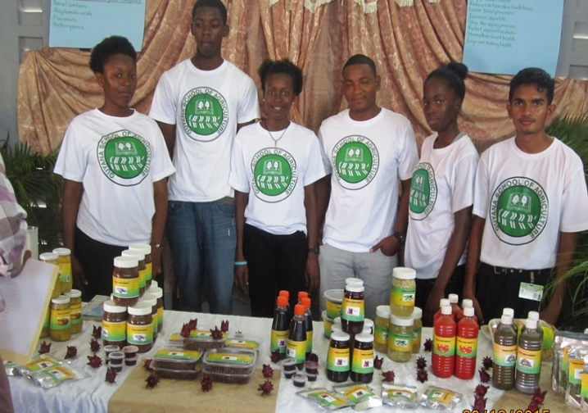 | 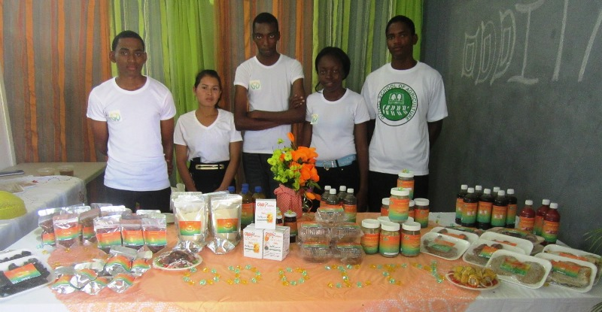

Certificate in Agriculture
Students were also taught to preserve fruits, vegetables, meats and milk. They also developed a new product form local produce. Products developed were Preserved Minced Beef, Preserved Minced Pork, Dried Whole Peppers, Breadfruit Chips, Breadfruit Flour, Breadfruit Chunks, Breadfruit Cookies, Sweet Potato Flour, Sweet Potato Flakes and Sweet Potato Cookies. An exhibition was held to show case all their products. The highlights of the Exhibition are as follows;
Certificate in Agriculture
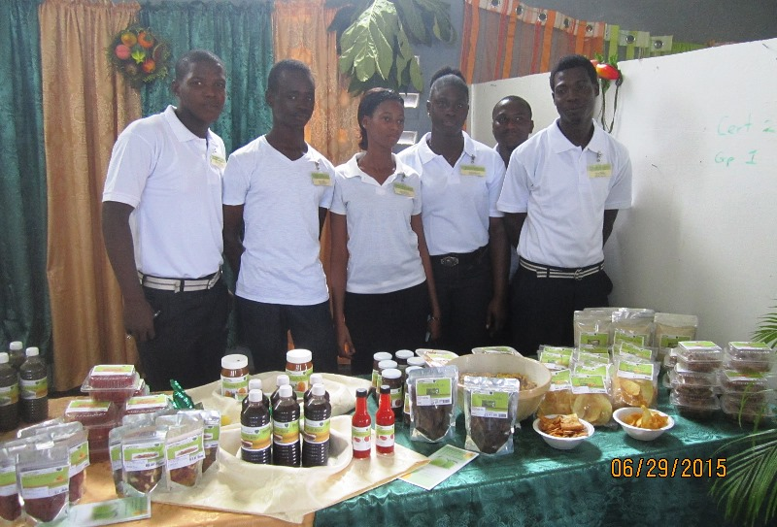
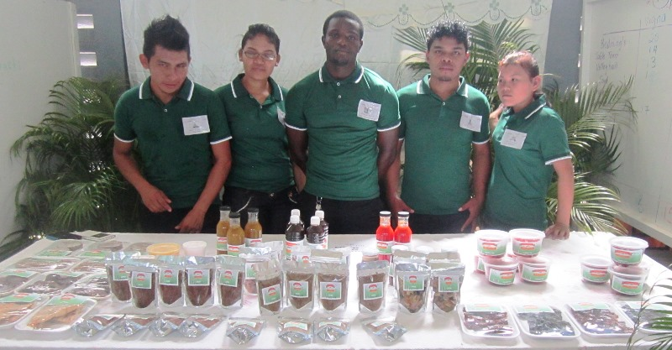

The students were taken on a number of field trips. The places visited were New Guyana Marketing Cooperation, Packaging facility at Parika and Sophia, Sterling Products Ltd, Demerara Distillers, Banks DIH and the National Milling Company. Essequibo campus visited the Golden Brook Coconut Oil Factory at Charity.

Certificate in Agro Processing
This reporting period saw the graduation of the second batch of Agro Processing students. They numbered eighteen (18) at the beginning of the program. These students were exposed to both the theory and practical of Agro processing and visited a number of related places such as the Food and Drug Department of the Ministry of Health, Banks DIH, UMAMI, several supermarkets and the wholesale and retail municipal markets.
Their products developed were Virgin Coconut Oil, Virgin Coconut Oil Infused With Ginger & Garlic, Coconut Vinegar, Coconut Drink, Frozen Fish Nuggets, Frozen Shrimp Patties, Pineapple & Rice Bar, Local Fruit & Vegetable Trail Mix, and Gluten Free Pasta.

Certificate In Agro Processing
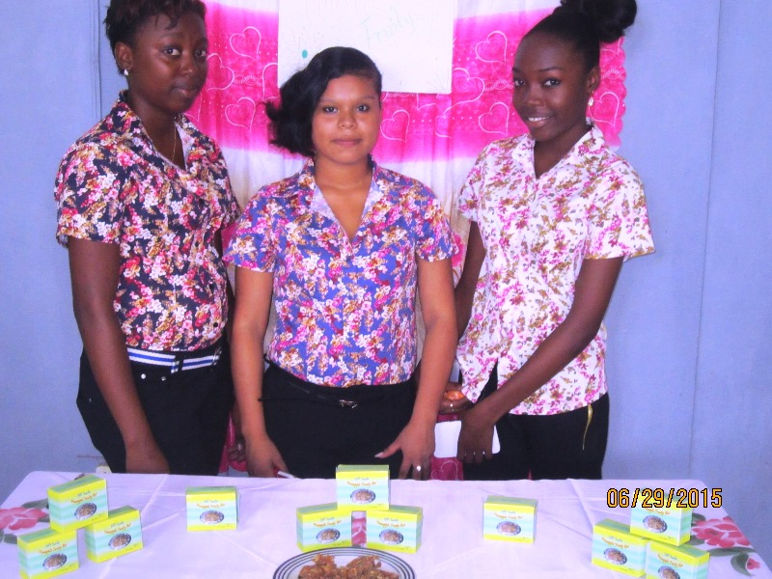 | 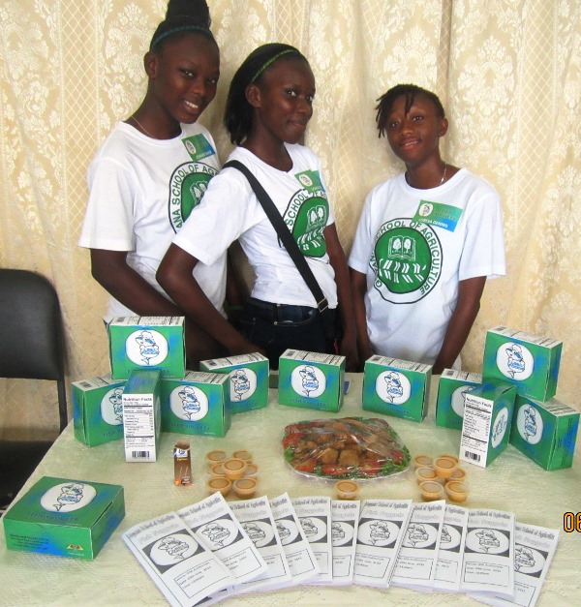
 | 
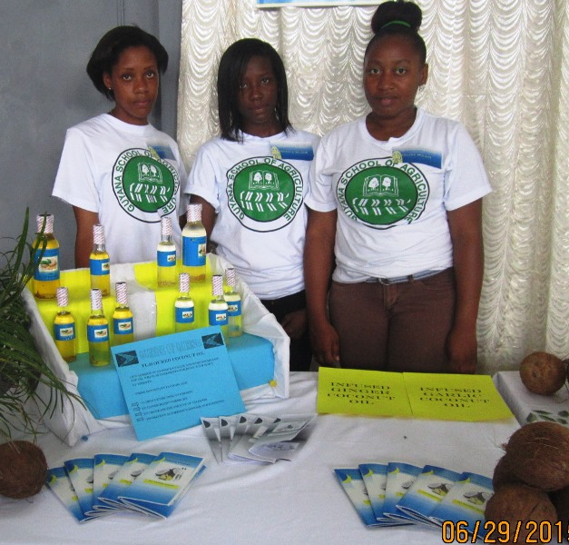 | 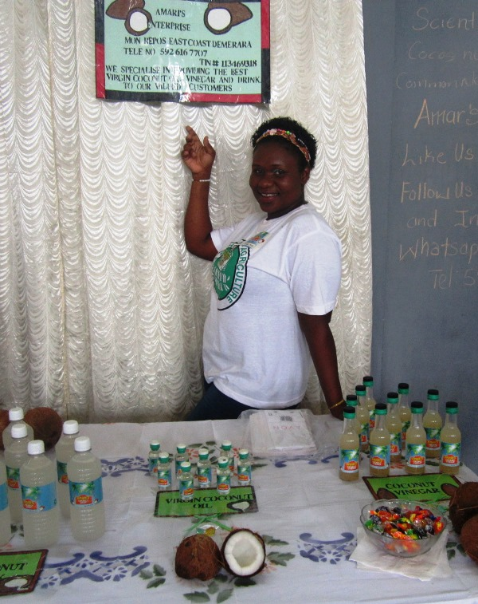

At the 2015 Graduation exercises two (2) graduating students who attained Distinction were presented with Exit kits that comprised of a kitchen scale, one thermometer, one pH meter, one set of measuring cups and spoons that had an average value of forty five thousand dollars ($45,000)
In September the Certificate in Agro Processing class began, there are a total of ten (10) students in the class. The first term of core courses were completed during the reporting period. Their practical educational experiences during the period under review were mainly in the production of porridge mix, hot sauce, dried and mixed fruits, and fruit juices. They were involved in the operations of sorting, washing, slicing, dicing and blending of raw materials for the production of the products previously mentioned.

Production
During the reporting period the department generated Two million three hundred and sixth one thousand seven hundred and seventy eight dollars (G$2,361,778), with Fruit Juice Production as the main source of income, followed by porridge mix, mixed fruits, hot sauce and chicken ham. The actual expenditure exceeded the budgeted expenditure this was due to the fluctuation in the market prices and the cost inputs including packaging materials which were sourced from overseas, the import duties had a significant impact on the cost of the packaging material. The Agro Processing Facility has earned a net profit of G$715,178 for the year 2015 in production activities.

The following is the summary of the Income and Expenditure for the period January – December 2015
Figure1: Summary of Income and Expenditure January - December 2015.

Figure 2: Budgeted and Actual Expenditure January to December 2015

Figure 3: Budgeted and Actual Income January to December 2015

Other Activities
Students from a number of schools visited the facility during the year these included, Mahaicony Secondary School, Abram’s Ville Secondary and Aurora Secondary School.
During the reporting period, the department participated in several Exhibitions hosted by various organisations these included, Canje Secondary school Career fair at Canje Berbice, Guyana School of Agriculture Open day, World Food Day, Agro Processors Street Fair, Mashramani Exhibition, the Ministry of Agriculture “cook off” , Berbice and Business Expo. Products displayed and sold were Porridge mix, Cassava crisps, Cassava chips, Hot Sauce, Green Seasoning, Mixed fruits, Toasted Pumpkin seeds, Preserved Carambola and Candied Papaw. Samples distributed were Porridge, Toasted Pumpkin Seeds and Vegifruits.
The department made several items for the Guyana Rice Development Board that were on display this included, shortbread and mettai made with rice flour and wheaten flour. Items displayed at the Ministry of Agriculture cook off, were Passionfruit Pie, Pumpkin Ice Cream, Corn Pone and Conkie.
The auditors from the Ministry of Agriculture also visited the department and made several recommendations, which the department in in the process of implementing.
The Manager represented Guyana and the School at the Codex Committee Meeting on Food Hygiene held November 09-13, 2015 in Boston, Massachusetts, United States of America. Material received were donated to the Library.
Maintenance
During the reporting period, the maintenance department was active, where they changed light bulbs, repaired drainage mesh and facilitated servicing of the stoves in the department.
Staff Matters
Staff members proceeded on annual leave at various times during the year and most of annual leave for the year 2015 was utilized.
On staff at the Agro processing Unit are seven (7) persons. The following is a summary of the staff at the Agro processing Facility.
Name | Designation
Grace Parris | Lecturer / Manager
Marian Stewart | Processing Assistant/Demonstrator
Stacia Nelson McDonald | Processing Assistant/Demonstrator
Amy Price | Processing Assistant/Demonstrator
Akeem Williams | Processing Assistant/Demonstrator
Kaye Rodriguez | Cleaner /Processing Assistant
Delroy Nelson | Labourer

LIVESTOCK FARM
GENERAL MAINTENANCE WORKS
Continual maintenance and repair work was an ongoing feature on the farm, in order to enhance and maintain the physical infrastructure so as to support the programmed productive pursuits.
The works done were accomplished utilizing the in house maintenance force thereby minimizing the expenditure associated with any of the initiatives undertaken in 2015.
POULTRY
BROILERS
Every two weeks a batch of broiler chicks is placed on the Livestock Farm.
Twenty six batches of broilers were reared in 2015.
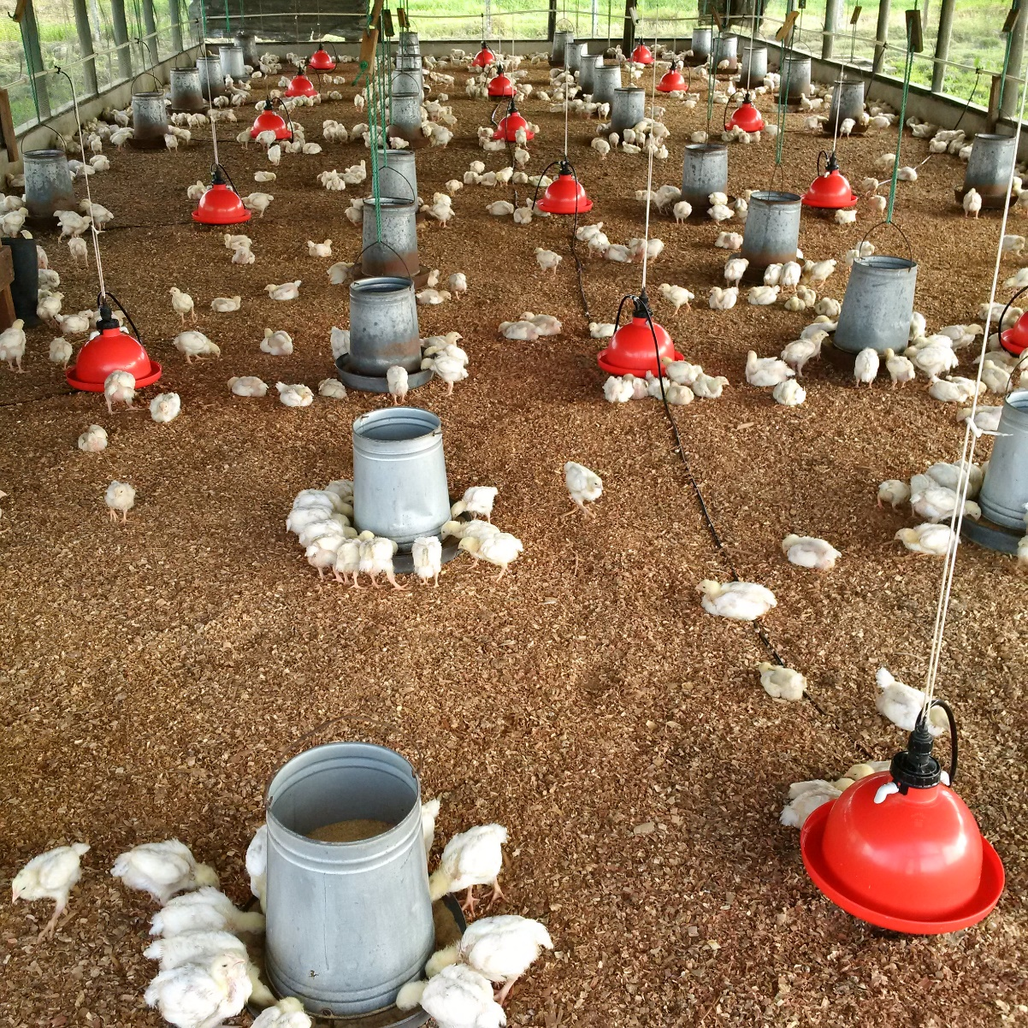
Flock Health
Both broiler chicks and broiler feed were procured from Bounty Farm Ltd,
The farm did not experience any major disease problems during the course of the year. Concerted efforts at disease prevention were made in this regard.
LAYERS
2800 Hy Line Brown chicks were procured from Edun’s Hatchery in
August 2015.
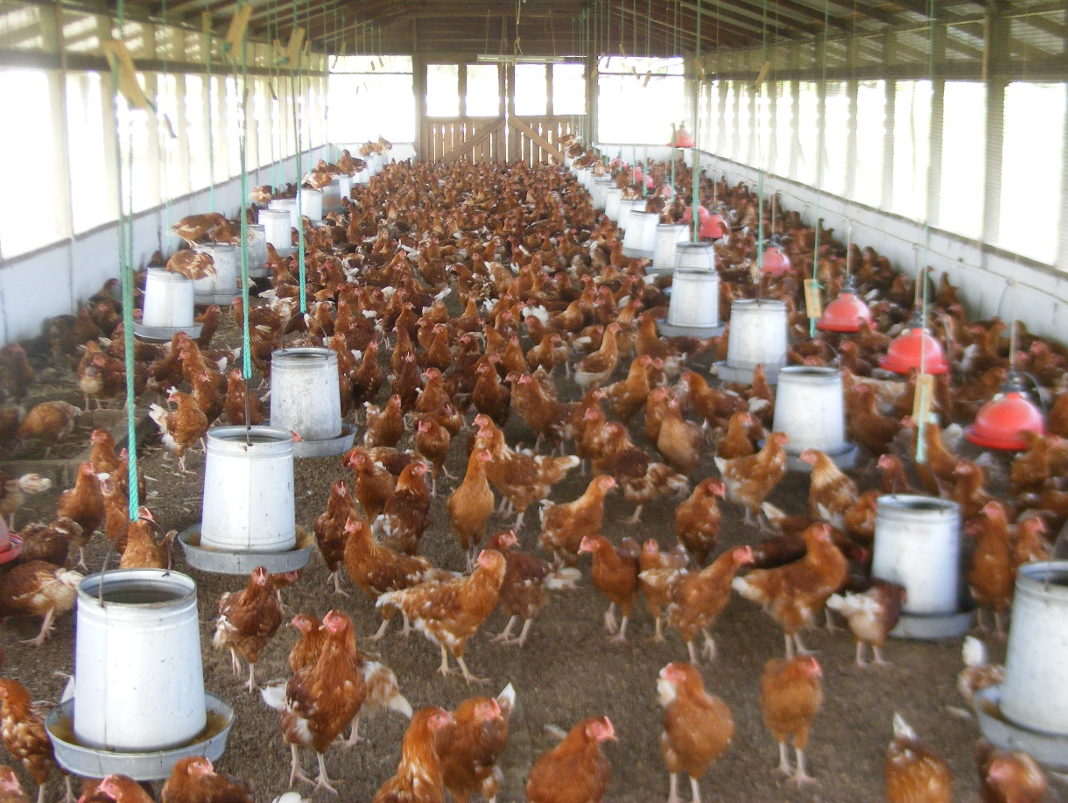
Marketing of eggs
The needs of the school’s Cafeteria were easily satisfied.
The majority of the eggs produced by the livestock farm were marketed externally. Eggs are also wholesaled in Region 1, at Bartica in Region 7, in Bourda Market in Georgetown and to various buyers along the East Coast of Demerara.
The farm has been successful in establishing and maintaining fairly stable relationships with a group of diverse buyers.
DAIRY
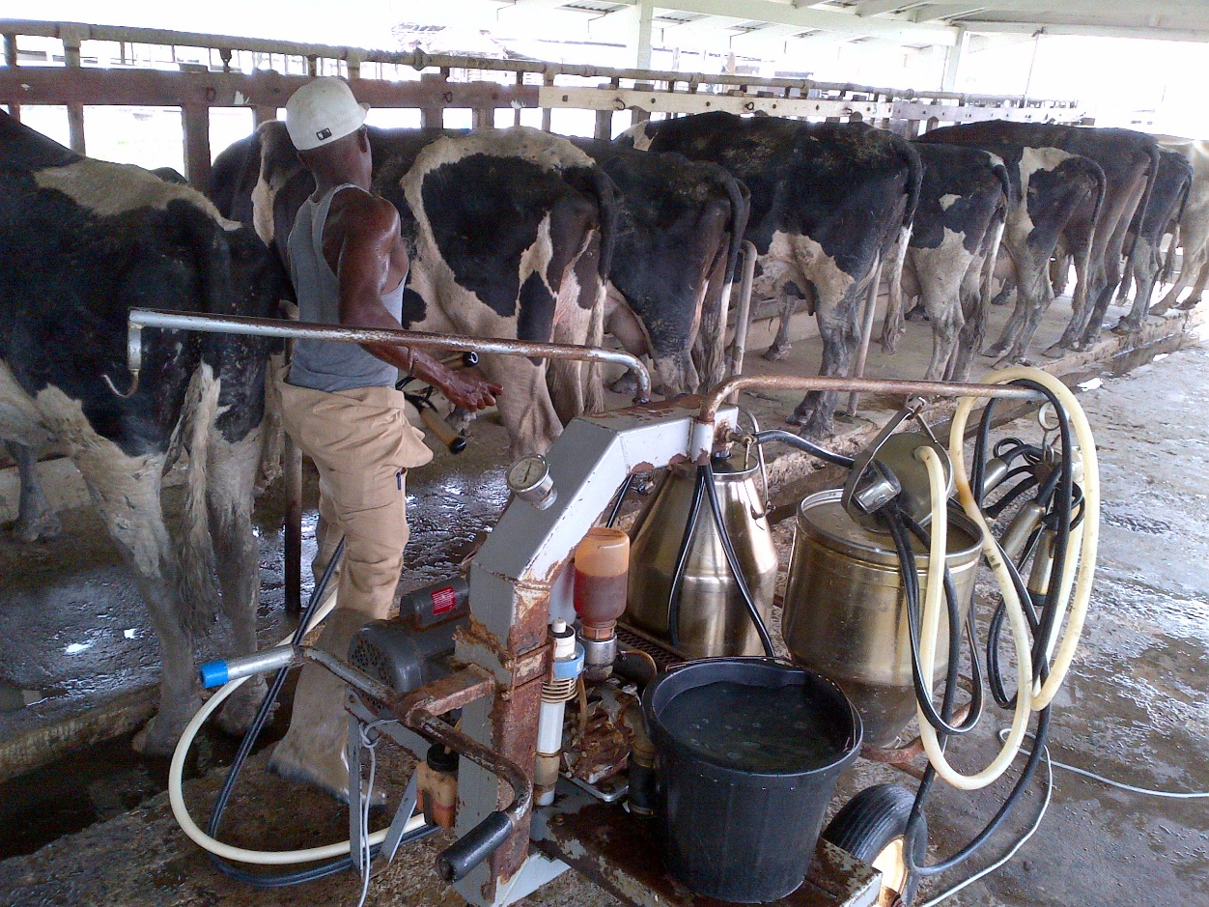

Breeding (Artificial Insemination)
The calves born on the Livestock Farm in 2015 were products of frozen semen sourced from SEMEX in Canada by the Guyana Livestock Development Authority (GLDA).
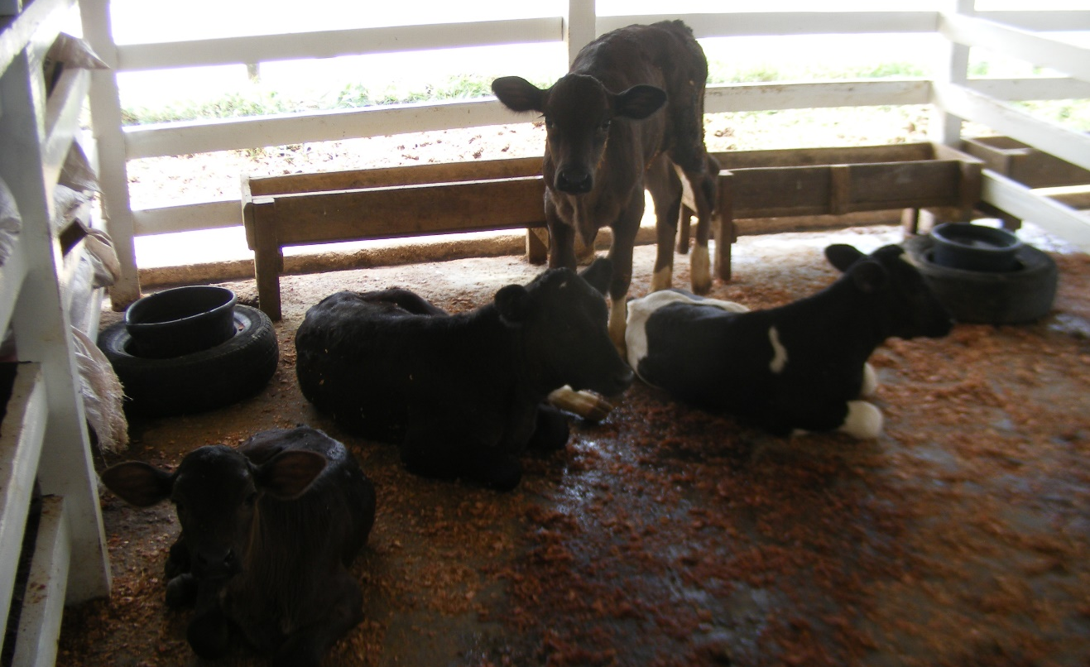
SWINE
Flock Health
The farm did not experience any major disease problems during the course of the year.
Marketing
The farm continued to supply breeding stock to livestock rearers in various parts
of the country.

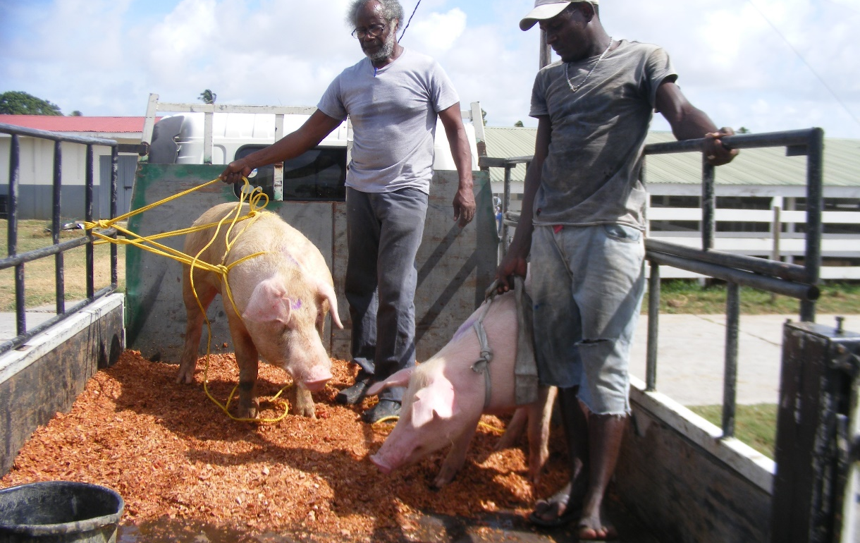
Practical Instruction on the Livestock Farm for GSA students
Castration in swine on the Livestock Farm
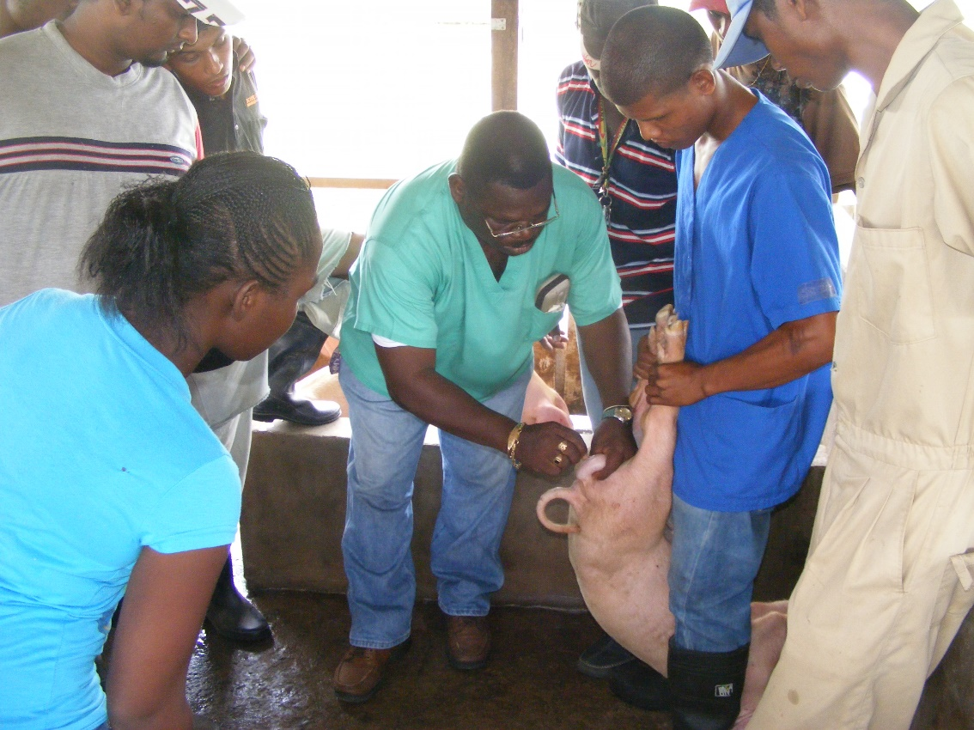
Educational Visits
The farm continued to host visits from primary, secondary and tertiary educational institutions. The University of Guyana’s Faculty of Agriculture continued to utilize the facilities of the farm for a part of the practical instruction component of its curricula.
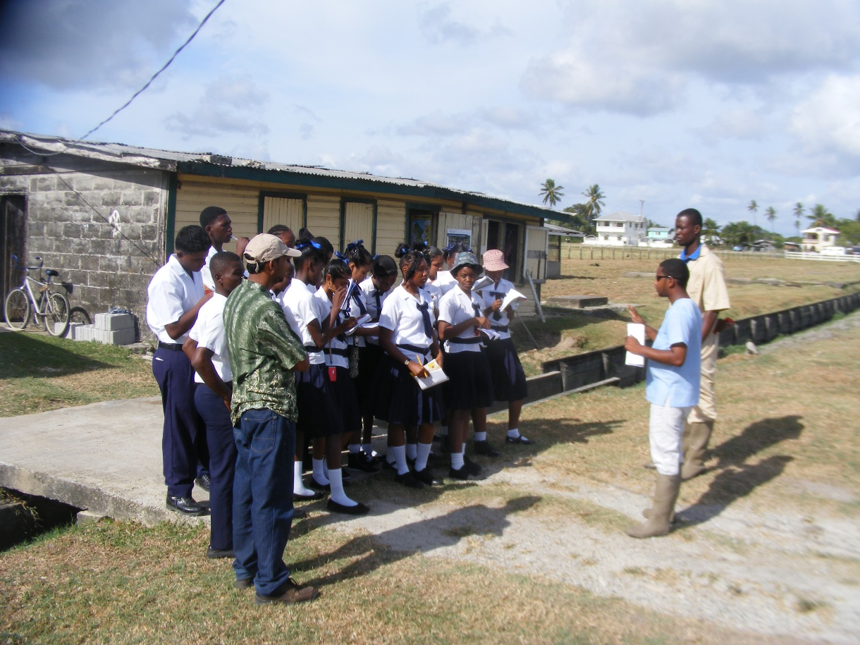
Provision of genetically improved breeding stock to farmers
The farm continued its traditional role of providing genetically improved breeding stock to livestock farmers. State institutions including the Ministry of Agriculture were also beneficiaries.

Appendix 1
ENROLMENT
MON REPOS CAMPUS
PROGRAMME | Males | Females | TOTAL
Diploma in Agriculture Yr.1 | 39 | 19 | 58
Diploma in Animal Health & V.P.H Yr. 1 | 07 | 09 | 16
Certificate in Agriculture Yr. 1 | 09 | 08 | 17
Certificate in Forestry | 17 | 07 | 24
Certificate in Agro-Processing | -- | 10 | 10
TOTAL | 72 | 53 | 125

ESSEQUIBO CAMPUS
Programme | Male | Female | TOTAL
Diploma in Agriculture Year I | 8 | 3 | 11
Certificate in Forestry | 7 | -- | 7
TOTAL | 15 | 3 | 18

CONTINUING STUDENTS
MON REPOS CAMPUS
PROGRAMME | Males | Females | TOTAL
Diploma in Agriculture Yr.2 | 42 | 13 | 55
Diploma in Animal Health & V.P.H Yr. 2 | 03 | 07 | 10
Certificate in Agriculture Yr. 2 | 08 | 07 | 15
TOTAL | 53 | 27 | 80

ESSEQUIBO CAMPUS

Programme | Male | Female | TOTAL
Diploma in Agriculture Year II | 6 | 4 | 10
TOTAL | 6 | 4 | 10

Appendix 2

LIST OF GRADUATES 2015

MON REPOS CAMPUS

DIPLOMA IN AGRICULTURE

# | NAME | GENDER | GRADE
1 | ALI, Zakeer | M | Distinction
2 | ALONZO, Eron | M | Pass
3 | BENJAMIN, Neil | M | Pass
4 | BHOLA, Alec | M | Lower Credit
5 | BHOOPAUL, Dhanraj | M | Higher Credit
6 | BRUCE, Nikosi | M | Higher Credit
7 | CHESNEY, Nicholas | M | Higher Credit
8 | CHESTER, Marvin | M | Distinction
9 | CHINAPA, Kelvin | M | Higher Credit
10 | CORT, Quacey | M | Distinction
11 | EMPTAGE, Amanda | F | Pass
12 | FLATTS, Tanisha | F | Higher Credit
13 | FORDE, John | M | Higher Credit
14 | FRASER, Seon | M | Pass
15 | FULLERTON, Shane | M | Lower Credit
16 | GLASGOW, Royston | M | Pass
17 | GRAY, Farrel | M | Higher Credit
18 | HANSRAJIEA, Kopchand | M | Higher Credit
19 | HARRIS, Paul | M | Distinction
20 | JACOBS, Makeba | F | Pass
21 | LEWIS, Roydel | M | Higher Credit
22 | MANGAL, Mahendra | M | Pass
23 | McDONALD, Josh | M | Higher Credit
24 | MICKLE, Stephan | M | Pass
25 | MITCHELL, Shafayne | F | Higher Credit
26 | MOHAMED, Ameer | M | Pass
27 | NELSON, Corcell | M | Higher Credit
28 | PARK, Eshauna | F | Pass
29 | PARKINSON, Don | M | Pass
30 | PERSAUD, Haresh | M | Pass
31 | PERSAUD, Varush | M | Higher Credit
32 | PETERS, Lisa | F | Pass
33 | RAMDAI, Anand | M | Higher Credit
34 | RAMJIT, Kharmeshwar | M | Pass
35 | RAMPERSAUD, Avinash | M | Higher Credit
36 | ROBERTS, Julian | M | Pass
37 | SHEPHERD, Darnsbry | M | Pass
38 | SINGH, Shennel | F | Pass
39 | STEPHENS, Shavale | F | Pass
40 | SUKHDEO, Ramdat | M | Higher Credit
41 | VENTURE, Nkosi | M | Higher Credit
42 | WONG, David | M | Pass
43 | WRAY, Shaquan | M | Lower Credit
44 | JAMES, Yoland | F | Higher Credit
45 | SINGH, Shivraj | M | Pass
46 | YUSUFF, Mohammed | M | Higher Credit
47 | ADRIDGE, Carlisa | F | Pass
48 | AMES, Olton | M | Pass
49 | CHAND, Daniel | M | Pass
50 | CHANGA, Mohan | M | Pass
51 | DEENO, Chaitram | M | Pass
52 | LONG, Anastacia | F | Pass
53 | MARKS, Randolph | M | Pass
54 | MONTAGUE, Keron | M | Pass
55 | RAMPERTAB, Harrischandra | M | Pass
56 | ROOPRAM, Lawan | M | Pass
57 | SMALL, Brian | M | Pass
58 | WILLIAMS, Jalen | M | Pass

CERTIFICATE IN AGRICULTURE

 | NAME | GENDER | GRADE
1 | BRUCE, Corwyn | M | Distinction
2 | COLLINS, Kester | M | Higher Credit
3 | DORRICK, Hernaman | M | Higher Credit
4 | HARVEY, Deion | M | Higher Credit
5 | HUNTER, Rachael | F | Higher Credit
6 | NOEL, Romario | M | Pass
7 | PHILLIPS, Travis | M | Pass
8 | REYNOLDS, Semol | F | Pass
9 | NYRON, Sookram | M | Lower Credit
10 | BRAITHWAITE, Twana | F | Pass
11 | BRANFORD, Rayon | M | Pass
12 | EDWARDS, Martine | F | Pass
13 | JOHN, Madonna | F | Pass
14 | LINDORE, Letesha | F | Pass
15 | PETERS, Patricia | F | Pass
16 | YUSUFF, Zeleena | F | Pass

DIPLOMA IN ANIMAL HEALTH & VETERINARY PUBLIC HEAALTH

 | NAME | GENDER | GRADE
1 | AIMRAM, Kesho | M | Pass
2 | HENRY, Charles | M | Pass
3 | MARQUES, Bianca | F | Higher Credit
4 | ROOPCHAND, Dilon | M | Pass
5 | VAUGHN, Ato | M | Lower Credit
6 | WILLIAMS, Elroy | M | Higher Credit
7 | MACEDO, Julius | M | Pass

CERTIFICATE IN FORESTRY

# | NAME | GENDER | GRADE
1 | ABRAHAM, James | M | Pass
2 | ALLI, Mohamed | M | Pass
3 | BARNES, Joel | M | Higher Credit
4 | CHISHOLM, Samantha | F | Distinction
5 | DeABREU, Vanetta | F | Higher Credit
6 | DENHART, Romario | M | Higher Credit
7 | HAYWOOD, Jason | M | Higher Credit
8 | HOLDER, Ronika | F | Higher Credit
9 | ISAACS, Ieolinda, | F | Higher Credit
10 | LA ROSE, Paul | M | Higher Credit
11 | LEWIS, Onica | F | Distinction
12 | LEWIS, Ronell | F | Distinction
13 | MEARNS, Felisa | F | Higher Credit
14 | PHILLIPS, Sherlock | M | Higher Credit
15 | RAGHUBEER, Renata | F | Pass
16 | RAWLINS, Jehu | M | Pass
17 | RICHARDSON, Ann-Marie | F | Higher Credit
18 | SIMON, Carla | F | Distinction
19 | SIMON, Yonnick | M | Higher Credit
20 | SINGH, Ryan | M | Higher Credit
21 | WEST, Oluntunde | M | Higher Credit
22 | WILSON, Ruel | M | Higher Credit
23 | WILLIAMS, Shemron | M | Pass
24 | DOUGLAS, Garvin | M | Higher Credit

CERTIFICATE IN AGRO PROCESSING

# | NAME | GENDER | GRADE
1 | BAKER, Joyann | F | Higher Credit
2 | DENNIS, Loresa | F | Lower Credit
3 | ELLIOTT, Kadien | F | Pass
4 | IFILL, Tonya | F | Distinction
5 | MULLIN, Kelisa | F | Lower Credit
6 | OUSELEY, Joenika | F | Higher Credit
7 | SEENARINE, Ahalhia | F | Pass
8 | STUART, Lucrecia | F | Lower Credit
9 | VAUGHAN, Saskia | F | Distinction
10 | WALLACE, Yonnique | F | Higher Credit
11 | WILSON, Saskeya | F | Higher Credit
12 | NORTH, Debbie | F | Pass

ESSEQUIBO CAMPUS
DIPLOMA IN AGRICULTURE

 | NAME | GENDER | GRADE
1 | BHOODHOO, Balraj | M | Pass
2 | COOBLALL, Chris | M | Higher Credit
3 | ELLIS, Richelle | F | Higher Credit
4 | GILKES, Floyd | M | Pass
5 | NANKISHORE, Ramlochan | M | Pass
6 | POONAM, Anela | F | Pass
7 | RAMONIE, Raymond | M | Pass
8 | RAMNARINE, Jhaipaul | M | Pass
9 | SOOKDEO, Rhoda | F | Pass
10 | VALENZUELA, Sherifa | F | Distinction
11 | DOODNAUTH, Shantie | F | Pass
12 | SAMSUNDAR, Lalita | F | Pass

CERTIFICATE IN FORESTRY

# | NAME | GENDER | GRADE
1 | BACCHUS, Ivarine | F | Pass
2 | CORBIN, Zellon | M | Lower Credit
3 | HARRYLALL, Lakesh | M | Higher Credit
4 | ISAACS, Gregory | M | Lower Credit
5 | NANDALALL, Shawn | M | Pass
6 | PERSAUD, Deolall | M | Pass
7 | RAM, Navindra | M | Higher Credit
8 | SOONINA, Sarojanie | F | Pass
Appendix 3

 | List of Employees - 2015
 | MON REPOS
 | NAME OF EMPLOYEE
No. | SURNAME | FIRST NAME | DESIGNATION
1 | Greenidge | Brian | Chief Executive Officer
2 | Permaul | Dindyal | Principal
3 | Allen | Dexter | Director of Administration
4 | Glasgow | Oscar | Director of Academic Affairs
5 | Ramdhani | Natashia | Academic Counsellor
6 | Parris | Grace | Lecturer/Manager, APU
7 | Pereira | Shemika | Lecturer
8 | Timmerman | Ulie | Lecturer
9 | Dass | Devwattie | Lecturer
10 | Lutchman | Mechelle | Lecturer
11 | Samsundar | Seeraj | Lecturer
12 | Sarran | Dave | Lecturer
13 | Nurse | Osbert | Assistant Farm Manager/Lecturer (MOA)
14 | Domer | Randy | Veterinarian/Lecturer (MOA)
15 | Squires | Melissa | Library Supervisor
16 | Hazel | Roxanne | Matron/Admin. Asst.
17 | Jones | Peter | Warden/Admin. Asst.
18 | Persaud | Soomdat | Accountant
19 | Nelson | Stacia | Demonstrator
20 | Bernarai | Bryan | C/Farm Supervisor
21 | Fraser | Cornel | L/Stock Farm Supervisor
22 | Jessamy | Ian | Maintenance Supervisor
23 | Rodney | Jacqueline | Head Cook (Ag)
24 | Richardson | Voneta | Laboratory Technician
25 | English | April | Laboratory Technician
26 | Sankar | Sanjay | Marketing Officer
27 | Daniels | Barbara | Storekeeper
28 | Persaud | Gaytri | Confidential Secretary
29 | Spencer | Risa | Senior Accounts Clerk
30 | Hale | Tenesha | Typist Clerk
31 | Loaknauth | Alisa | Typist Clerk
32 | James | Folake | Accounts Clerk
33 | Braithwaite | Rennautta | Library Clerk
34 | Persaud | Yashoda | Library Clerk
35 | Roopnaraine | Durga | Library Clerk
36 | Petrie | Wesley | Office Assistant
37 | Nunes | Joel | Stockman
38 | Goddett | Godfrey | Driver
39 | Persaud | Kalika | Driver
40 | Aaron | Troy | Labourer
41 | Aaron | Clarence | Slasher Operator
42 | Benjamin | Colin | Labourer
43 | Bovell | Lewani | Maid
44 | Calder | Brian | Senior Carpenter
45 | Solomon | Yonnette | Cafeteria Assistant
46 | Bovell | Joel | Cafeteria Assistant
47 | Hamer | Felicia | Maid
48 | Harry | Juelle | Cook
49 | Henry | Cleveland | Electrician
50 | Johnson | Kesha | Cafeteria Assistant
51 | Mc Pherson | Joan | Cafeteria Assistant
52 | Nelson | Ronald | Labourer
53 | Sampson | Shewika | Cook
54 | Paul | Oloufemi | Carpenter
55 | Persaud | Mohan | Labourer
56 | Johnson | Holly | Labourer
57 | Hooper | Beverley | Cook
58 | Sauers | Lionel | Maintenance Supervisor
59 | Shewram | Gangadai | Labourer
60 | Singh | Thakurdai | Cafeteria Assistant
61 | Singh (2) | Sugrim | Slasher Operator
62 | Softleigh | Yvonne | Senior Maid
63 | Thomas | Sean | Carpenter
64 | Williams | Trivfoza | Maid
65 | Cummings | Amos | Labourer
66 | Stewart | Marian | Demonstrator
67 | Rodrigues | Kay | Cafeteria Assistant
68 | Haripersaud | Sushila | Cafeteria Assistant
69 | Bishundat | Harry Ram | Labourer
70 | Wade | Clebert | Farm Supervisor (MOA)
71 | McDonald | Josh | Farm Supervisor
72 | Price | Amy | Demonstrator (MOA)
73 | Williams | Akeem | Demonstrator (MOA)
74 | North | Debbie | Demonstrator (MOA)
75 | Nelson | Corcell | Farm Supervisor (MOA)
76 | Bruce | Corwyn | Farm Supervisor
77 | Blackman | Dawn | Cook
78 | Beekham | Gangaram | Labourer
79 | Amjad | Bibi | Confidential Secretary
80 | Balgobin | Puranand | Driver
81 | Austin | Carl | Security
82 | Mingo | Antonio | Security
83 | Benjamin | Emile | Security
84 | Easton | Alecia | Security
85 | Easton | Norma | Security
86 | Nazreen | Yacoob | Security
87 | Gordon | Michael | Security
88 | Rodney | Rudolph | Security
89 | Thompson | Andre | Security
90 | Birkett | Colvin | Security
91 | Waldron | Stephen | Security
92 | Ramsaywack | Paul | Security
93 | Prashad | Ramharace | Security
94 | Hunte | Brandon | Security
95 | Talbot | Don | Security
96 | Singh | Surgrim | Security
97 | Somerset | Kenyatta | Security
98 | Yackoob | Mohammed | Security
99 | Bagot | Debra | Security
100 | Leon | Christine | Security
101 | James | Gregory | Security
102 | Mahamed | Raykhan | Security
103 | Cush | Waveney | Security
104 | Campbell | Aleen | Security
105 | December-Joseph | Simone | Security
106 | Perry | Henry | Security
107 | Zaman | Michael | Security
108 | Rajnarayan | Satyendra | Security
109 | Bisnauth | Roopnauth | Security
 | ESSEQUIBO CAMPUS
110 | Persaud | Kavendra | Lecturer
111 | Dookhit | Kevin | Lecturer
112 | Samad | Safraz | Lecturer
113 | Ramdass | Horatio | Farm Manager/Administrator
114 | Garraway | Jenella | Lecturer (MOA)
115 | Glen | Sabiena | Lecturer (MOA)
116 | Laurie | Aloma | Librarian
117 | Allicock | Sunita | Accounts Clerk
118 | Lall | Lokesh | Farm Supervisor
119 | Johnson | Natalye | Maid
120 | Anderson | Colin | Security
121 | Ramjattan | Oudit | Security
 | Mon Repos | 80
 | Security | 27
 |  | 105
 | Essequibo | 10
 | Security | 2
 |  | 12

